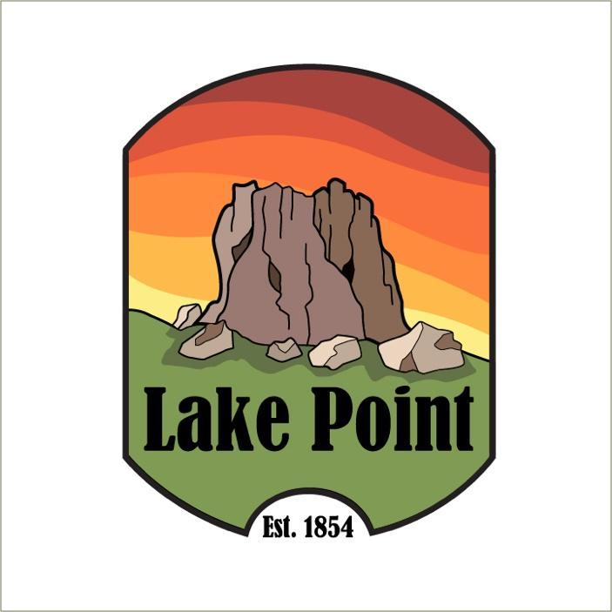

Notice of Public Hearing

Planning and Zoning Commission proposed
Land Use Regulations
for Commercial Zoning Districts, with Definitions
and the Commercial Zoning Map, assigning the zoning districts described below to certain properties, for the following-
Agricultural (A-20)
Commercial General (CG)
Commercial Highway (CH)
Commercial Neighborhood (CN)
Conservation (CRPO)
Industrial (IND)
Multiple Use (MU-40)

Being held
July 17, 2023 at 7 pm
Lake Point Fire Station
1528 Sunset Rd. Lake Point Ut

If you have any questions, please email planning@lakepoint.gov

