CITY OF OREM
PLANNING COMMISSION MEETING MINUTES
May 17, 2023

The following items are discussed in these minutes:
- PUBLIC HEARING – REZONE - Amending Section 22-5-3(A) and the zoning map of the City of Orem by changing the zone of approximately 4.4 acres from the C3 zone to the C2 zone located generally at 877 North State Street. – Continued, unanimous.
- PUBLIC HEARING – Vacating Lots 19, 21 and 23 of T&T Industrial Park, Plat B and approving the site plan and final plat of W3 Subdivision, Plat A located generally at 1113 North Industrial Park Road in the M2 zone. – Approved, unanimous.
- PRELIMINARY PLAT – Approving the Orem Center State Plaza Subdivision located generally at 40 West Center Street in the C2 zone. – Approved, unanimous.
- PUBLIC HEARING – Adopting the updated City of Orem Transportation Master Plan and amending the Orem City General Plan to include the updated City of Orem Transportation Master Plan in Appendix F. – Continued, unanimous.

STUDY SESSION

Place: City Council Conference Room

At 3:37 p.m. Chair Komen called the Study Session to order.

Those present: Gerald Crismon, Haysam Sakar, Madeline Komen, Murray Low, Mike Carpenter and Helena Kleinlein, Planning Commission members; Ryan L. Clark, Acting Assistant City Manager/Development Services Director; Jason W. Bench, Assistant Development Services Director; Makayla Wagstaff and Cheryl Vargas, Associate Planners; Matt Taylor and Grant Allen, Senior Planners; Sam Kelly, City Engineer; Steve Earl and Gary McGinn, Legal Counsel; Terry Peterson, City Council Liaison;

Those excused: James Hawkes, Planning Commission member

The Commission and staff briefly reviewed agenda items and minutes from the May 3, 2023 meeting.

Christie Oostema presented on the Station Area Plan.

The meeting was adjourned at 4:27 p.m. to the City Council Chambers for the regular meeting.

REGULAR MEETING

Place: Orem City Council Chambers

At 4:33 p.m. Chair Komen called the Planning Commission meeting to order and asked Mr. Low, Planning Commission member, to offer the invocation.

Those present: Gerald Crismon, Haysam Sakar, Madeline Komen, Murray Low, Mike Carpenter and Helena Kleinlein, Planning Commission members; Ryan L. Clark, Acting Assistant City Manager/Development Services Director; Jason W. Bench, Assistant Development Services Director; Makayla Wagstaff and Cheryl Vargas, Associate Planners; Matt Taylor and Grant Allen, Senior Planners; Sam Kelly, City Engineer; Steve Earl and Gary McGinn, Legal Counsel; Terry Peterson, City Council Liaison;

Those excused: James Hawkes, Planning Commission member

Chair Komen asked Ms. Vargas to introduce Agenda Item 3.1: (click here for recording)

PUBLIC HEARING – REZONE - Amending Section 22-5-3(A) and the zoning map of the City of Orem by changing the zone of approximately 4.4 acres from the C3 zone to the C2 zone located generally at 877 North State Street.

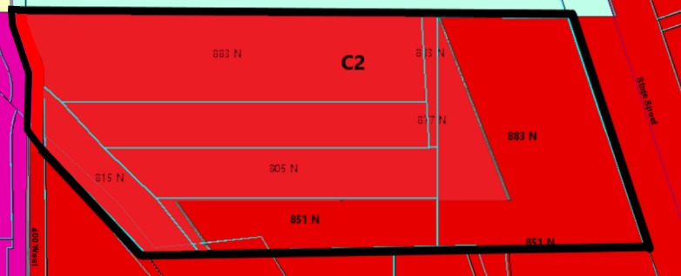
Staff Presentation:
A recommendation was sent to the City Council by the Planning Commission to partially approve this project to create two lots on March 15, 2023. The portion that is now being requested was continued at that time and is now coming back before the Planning Commission for approval with an updated concept plan.

There is a large parcel of vacant land at approximately 877 North State Street. The large parcel that fronts State Street is in the C2 zone. The four smaller parcels that front 400 West are in the C3 zone. The applicant would like the property to all be one zone, the C2 zone. The total acreage is 7.10 acres and the applicant would like to rezone approximately 4.4 acres from the C3 zone to the C2 zone.

As this entire piece of property is owned by one developer, it is difficult to deal with two different zones. The new commercial projects will be tied together with through access from State Street to 400 West. Having the entire property be one zone will make it easier to work the entire piece of property as one development.

This request is for the rezone only, not the preliminary and final plat. If the City Council approves the rezone application, the applicant will need to apply for a preliminary and final plat. However, a concept plan is provided to show potential development including the access from State Street to 400 West.

The concept plan shows a 2-story office building and a 2-story Center for Women and Children in Crisis, short-term transitional housing on the west side of the property, and two restaurants on the east side of the property fronting State Street. The non-profit would be classified as a Transitional Treatment Home (SLU Code 1262). This is not a permitted use in the C3 zone but is a permitted use in the C2 zone.

The Center for Women and Children in Crisis (DBA The Refuge Utah) has been in operation as a nonprofit victim services agency for 39 years. They provide a safe, caring, and therapeutic environment to assist victims of domestic violence, rape, and sexual assault in their recovery. With a focus on being trauma-informed, victim centered, and low barrier, the agency's goal is to facilitate healing and to advocate for victims with the intent to help decrease the incidence of such violence in the community in the future. Their services include a 24/7 hotline, a safe house for emergency short-term stays, transitional housing, temporary rental assistance, confidential victim advocates, 24/7 Hospital Response Team Advocates, victim educational support classes, therapy, and aftercare services that continue as individuals transition into permanent supportive housing around Utah County.

The office building would be used for victims seeking services to meet with advocates, case managers, and therapists to receive individualized services and resources. It would also be used to host educational support classes, volunteer trainings, staff trainings, and community advocate meetings. Along with these services, administrative staff would be housed who would run the financial and business operations of the non-profit agency.

Recommendation:
Staff recommends that the Planning Commission consider a recommendation to the City Council to amend Section 22-5-3(A) and the zoning map of the City of Orem by changing the zone of approximately 4.4 acres from the C3 zone to the C2 zone located generally at 877 North State Street.

Chair Komen invited the representatives of the Center for Women and Children in Crisis to come forward.

Paul Washburn and Ashley Taylor came forward, and presented about the Center for Women and Children in Crisis center.

Chair Komen asked if any Planning Commission members had questions for the applicant.

Mr. Carpenter expressed concern that if the area is rezoned, that there is no way to enforce that what is shown on the concept plan is what will go into the space.

Matt Neilson came forward to address this concern. The Center for Women and Children is currently under contract for this property, contingent on the rezone of the property.

Mr. Low asked if it were possible to do a Conditional Use or some other method which would prevent having to rezone the property to C2 in order to allow this use.

Mr. Bench addressed the concern by suggesting that an option would be to add the use to the C3 zone.

Ms. Komen stated that the Planning Commission is concerned about the future of the property rather than feeling hesitant about this particular proposed use.

Mr. Bench also addressed that an option would be to give a recommendation with a development agreement if that is something that would be of interest to the applicant.

Discussion was held among Planning Commission members regarding what the differences would be between the C2 and C3 zones.

Mr. Washburn stated that he is comfortable with a development agreement if that would help this to move forward. He also stated that it is important to focus on now instead of allowing fear of the future to guide.

Mr. Earl stated that if the Planning Commission would like to consider a development agreement that this item would need to be continued to allow for state requirements to be met.

Mr. Sakar asked what would need to be done to add the SLU which would allow this use to be added to the C3 zone.

Chair Komen opened the public hearing.

When no one came forward, Chair Komen closed the public hearing.

Mr. Clark asked Mr. Earl if they could move forward with rezoning the sliver of C3 at the front of the property if they would like to.

Ms. Komen stated that they are leaning to continue this item to address it all at the same time.

Chair Komen called for a motion on this item.

Planning Commission Action:
Ms. Komen moved to continue item 3.1 to a future meeting. Mr. Sakar seconded the motion. Those voting aye: Gerald Crismon, Haysam Sakar, Madeline Komen, Murray Low, Mike Carpenter and Helena Kleinlein.

Chair Komen asked Ms. Vargas to introduce Agenda Item 3.2: (click here for recording)

PUBLIC HEARING – Vacating Lots 19, 21 and 23 of T&T Industrial Park, Plat B and approving the site plan and final plat of W3 Subdivision, Plat A located generally at 1113 North Industrial Park Road in the M2 zone.

Staff Presentation:
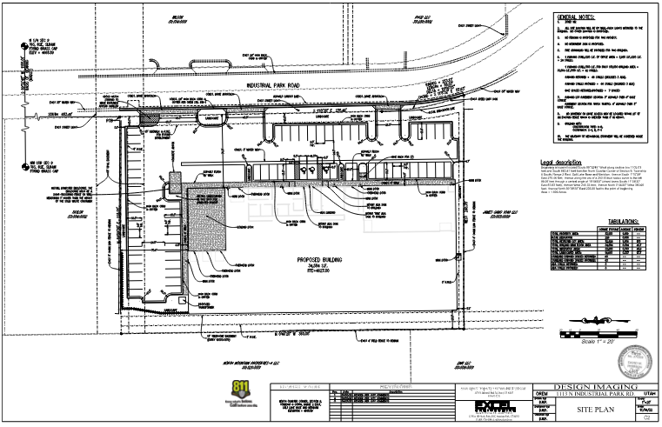
The applicant is proposing to demolish an existing warehouse structure currently located at 1113 North Industrial Park Road and construct a new warehouse that will better utilize the site. The warehouse will be used for warehousing and manufacturing activities. There are currently three (3) lots in the T&T Industrial Park, Plat B subdivision. These three lots will be combined into one (1) large lot to accommodate the new building.

Architecture: The building will be a pre-engineered metal building with insulated metal wall panels around the entire building. The color will be a light pearl gray with a darker charcoal gray around the windows, doors, building corners, gutters and down spouts. There will also be a couple of black metal awnings above the doors.

Parking: In the M2 zone, the required parking is one (1) space per seven hundred fifty (750) square feet of warehouse space and one (1) space per two hundred fifty (250) square feet of office space. This project meets those parking requirements as they are required to provide sixty-six (66) stalls and that is what they are providing:
- Warehouse: 31,554 square feet/750 = 42 Stalls
- Office: 5,950 square feet/250 = 24 Stalls

Recommendation:
The Development Review Committee determined this request complies with the Orem City Code. Staff recommends the Planning Commission vacate Lots 19, 21 and 23 of T&T Industrial Park, Plat B and approve the site plan and final plat of W3 Subdivision, Plat A located generally at 1113 North Industrial Park Road in the M2 zone.

Chair Komen asked the Planning Commission members if they had any questions for Ms. Vargas.

Chair Komen asked the applicant to come forward.

The applicant came forward to express their hope for this project and reasoning for needing this change.

Chair Komen opened the public hearing.

When no one came forward, Chair Komen closed the public hearing.

Chair Komen called for a motion on this item.

Planning Commission Action:
Mr. Low moved to vacate Lots 19, 21 and 23 of T&T Industrial Park, Plat B and approve the site plan and final plat of W3 Subdivision, Plat A located generally at 1113 North Industrial Park Road in the M2 zone. Mr. Crismon seconded the motion. Those voting aye: Gerald Crismon, Haysam Sakar, Madeline Komen, Murray Low, Mike Carpenter and Helena Kleinlein. Motion passed unanimously.

Chair Komen asked Ms. Vargas to introduce Agenda Item 3.3: (click here for recording)

PRELIMINARY PLAT – Approving the Orem Center State Plaza Subdivision located generally at 40 West Center Street in the C2 zone.

Staff Presentation:
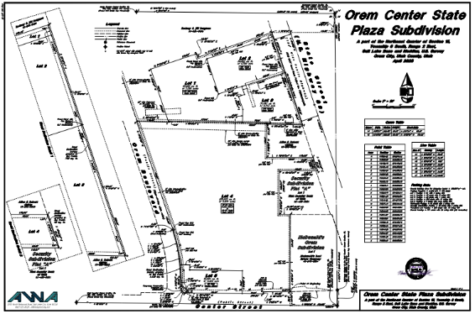
The property was previously two parcels of record, and for financial reasons the owner would like to divide the parcels into separate lots for each building. This division will go around existing improvements on the site.

Existing easements are in place for cross-access, drainage and utilities. There are also reciprocal parking easements in place to allow the lots to continue to share the parking areas and prevent parking issues.

Recommendation:
The Development Review Committee determined this request complies with the Orem City Code. Staff recommends the Planning Commission approve the Orem Center State Plaza Subdivision located generally at 40 West Center
street in the C2 zone.

Chair Komen asked if the Planning Commission members had questions for Ms. Vargas.

Mr. Carpenter asked if there is anything keeping them from vacating the reciprocal easements.

Mr. Bench offered that it is an option to add the language to the plat itself, or a condition to approving the plats.

Chair Komen invited the applicant to come forward.

Rick Magness came forward as the representative for the applicant. Mr. Magness discussed the reasoning for this request.

Mr. Sakar asked if any of the individual buildings would not meet the parking standards on its own and what would happen if someone removed an existing building what they would have to do.

Mr. Bench explained that if that happened that the new development would have to meet current requirements for parking.

Chair Komen called for a motion on this item.

Planning Commission Action:
Ms. Komen moved to approve the Orem Center State Plaza Subdivision located generally at 40 West Center
street in the C2 zone with the condition that the reciprocal easements will be listed on the plat. Mr. Sakar seconded the motion. Those voting aye: Gerald Crismon, Haysam Sakar, Madeline Komen, Murray Low, Mike Carpenter and Helena Kleinlein. Motion passed unanimously

Chair Komen asked Mr. Kelly to introduce Agenda Item 3.4: (click here for recording)

PUBLIC HEARING – Adopting the updated City of Orem Transportation Master Plan and amending the Orem City General Plan to include the updated City of Orem Transportation Master Plan in Appendix F.

A representative from Horrock’s Engineering briefly presented on the update to the Transportation Master Plan.

Staff Presentation:
The Orem Transportation Master Plan was adopted on December 8, 2015. Since that time the Master Plan has been used to:
1. Receive Federal, State, and County funding for regionally significant roadways and roadway improvements.
2. Provided direction for developers and residents for traffic impact studies, traffic calming, warrants for crosswalks, signals, and speed limits, and the plan has also identified acceptable levels of service (LOS). With the adopted LOS, projects both public and private are aware of the traffic mitigations needed for proposed improvements.
3. Identify a list of projects eligible for impact fee reimbursement and/or other master plan projects that have been completed as funding has become available as well as recognizing development opportunity to complete projects.

The revised plan maintains the same format from the current master plan and is intended to address existing conditions, priorities, levels of service and other considerations of a comprehensive transportation master plan. The master plan builds upon previous studies and plans, including the Orem City General Plan 2018 and the Bicycle and Pedestrian Plan 2010. The updated plan is organized into four chapters including an Executive Summary and seven Appendices.

The Transportation Advisory Commission (TAC) has unanimously approved the TMP update and has included a cover letter that outlines the values that need to be considered when implementing the TMP. The Public Works Advisory Commission has also unanimously approved the TMP update.

Recommendation:
The Development Services Department requests the Planning Commission provide a positive recommendation to the City Council regarding the approval of the City of Orem Transportation Master Plan update and adopting the updated plan in Appendix F of the Orem City General Plan.

Chair Komen asked if the Planning Commission members had questions for Mr. Kelly.

Planning Commission members discussed how the plan was developed with Mr. Kelly and the representative from Horrock’s engineering.

Ms. Kleinlein asked what the place of the Planning Commission is if they are meant to approve it without understanding the report.

Mr. Clark addressed this concern.

Mr. Kelly also addressed this concern.

Additional concerns were presented by members of the Planning Commission and discussion was held among Planning Commission members and members of staff.

Chair Komen invited Councilmember Terry Petersen to speak to how this update to the Transportation Master Plan has been received in the City Council work sessions.

Mr. Clark and Mr. Kelly addressed additional questions and concerns from the Planning Commission members.

Mr. Petersen came forward address that he wants to make sure that the City Council and Planning Commission maintain their independence from each other in working on education pertaining to the Transportation Master Plan.

Discussion was held regarding how the public hearing was noticed.

A plan was discussed to involve the Planning Commission members in an upcoming Transportation Advisory Committee (TAC) meeting to help educate on what is contained within the Transportation Master Plan update.

Chair Komen opened the public hearing.

When no one came forward, Chair Komen closed the public hearing.

Chair Komen called for a motion on this item.

Planning Commission Action:
Ms. Low moved to continue the public hearing without date and to continue item 3.4 to a future meeting. Mr. Carpenter seconded the motion. Those voting aye: Gerald Crismon, Haysam Sakar, Madeline Komen, Murray Low, Mike Carpenter and Helena Kleinlein.

Minutes: The Planning Commission reviewed the minutes from the previous meeting. Chair Komen then called for a motion to approve the minutes for May 3, 2023. Mr. Sakar moved to approve the meeting minutes for May 3, 2023. Ms. Kleinlein seconded the motion. Those voting aye: Gerald Crismon, Haysam Sakar, Madeline Komen, Murray Low, Mike Carpenter and Helena Kleinlein.

Mr. Clark briefly introduced the new assistant city attorney Gary McGinn.

Adjourn: Chair Komen called for a motion to adjourn. Mr. Low moved to adjourn. Mr. Sakar seconded the motion. Those voting aye: Gerald Crismon, Haysam Sakar, Madeline Komen, Murray Low, Mike Carpenter and Helena Kleinlein.

Adjourn: 6:15 p.m.

Ryan L. Clark
Planning Commission Secretary

Approved: June 7, 2023

