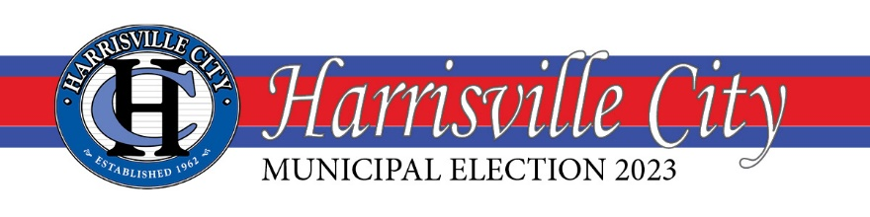

City Council (At Large) 4 Year Term
CANDIDACY FILINGS

- Karen Taylor-Fawcett
- Grover Wilhelmsen
- Dan Gilboy
- Blair A. Christensen
- Michael Shinsel

Candidacy filing period is from June 1, 2023 – June 7, 2023.
For more information, visit www.cityofharrisville.com/elections.

I, Jack Fogal, Harrisville City’s City Recorder, hereby certify the above candidacy filings have been verified for eligibility through the Weber County Elections office and are eligible to run in the 2023 Harrisville City Municipal Election process.

