Conditional Use Summary and Recommendation

Public Body: Erda City Planning Commission Meeting Date: May 23, 2023
Parcel IDs: 05-044-0-0077 Current Zone: RR-5 (Rural Residential) Property Address: 5300 N Stallion Way
Request: Tooele County School District is requesting conditional use approval for a Junior High School.
Planning Staff Recommendation: Approval Applicant Name: Tooele County School District

PROJECT DESCRIPTION

Tooele County School District is requesting conditional use approval for the proposed Stansbury Junior High School. The subject property is zoned RR-5 (Rural Residential 5 acre min) and is 18.99 acres. Public use facilities such as schools are allowed in the RR-5 zoning districts with a conditional use permit.

SITE & VICINITY DESCRIPTION

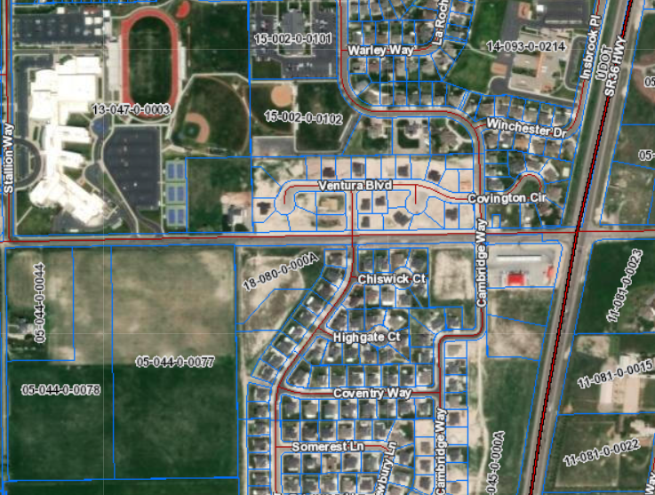
Subject Property

The subject property is located on Bates Canyon Rd immediately south of the Stansbury High School located within the RR-5 (Rural Residential 5 acre min) Zone. The subject property will be accessed off of Bates Canyon Road. The property has residential development in Stansbury Park to the immediate east and North. The applicant has completed a traffic study which is attached. Utilities will be provided by Stansbury Park Improvement District.

LAND USE CONSIDERATIONS (RR-5 Zone)

Per 15-4-1 Public facilities are conditionally exempt from frontage, width and area requirements of the zoning district.

GENERAL PLAN CONSIDERATIONS

The proposed use is consistent with the Erda City General Plan.

ISSUES OF CONCERN/PROPOSED MITIGATION

An issue of concern has been identified with the increased traffic that will be created by the Junior High School. There will be two secondary schools within close proximity to each other which will create increased bus and passenger traffic. The traffic study proposes some mitigating factors for this increase. It is recommended that the school district be required to construct the traffic mitigation measures as identified by the traffic study to include a new road.

NEIGHBORHOOD RESPONSE

Any comments that are received prior to the planning commission meeting on December 13, will be forwarded to the planning commission for review and summarized at the meeting.

PLANNING STAFF ANALYSIS

At the December Planning Commission meeting this item was tabled requesting that the school district work with a 3rd party traffic engineer to come up with the best possible solution for the increase in traffic on Bates Canyon Road due to the High school and Junior High both affecting that road. The school district met with a 3rd party traffic engineer and came up with a different round about location. They then went back and reevaluated the traffic study after taking into consideration the amount of students that will be moved from Stansbury High School to Deseret Peak High School once it opens. The traffic study then came back with the final recommendations. There is a recommendation that Bates Canyon Road be widened and that the lanes be narrowed to 11 ft to facilitate an extra lane in each direction. (Please see attached drawing) The school district has stated that they plan to make the recommended 2025 improvements to Bates Canyon Road. There is also a recommendation to make some striping changes on SR 36 and Bates Canyon Road. The school district is working with UDOT on the 2025 recommendations at that intersection.

The minimum required amount of parking stalls is 1 space per each 3 employees plus 5 spaces for a total required of 38 stalls. The total number of stalls provided on the site is 173 stalls.

PLANNING STAFF RECOMMENDATION

Planning Staff recommends that the Erda City Planning Commission makes a motion to approve the proposed conditional use for the Stansbury Junior High School with the following conditions:
- Traffic mitigation on Bates Canyon Road as recommended by the traffic engineer be constructed as part of the school construction.
- School district continue to work with UDOT to mitigate the traffic impacts on SR 36 and Bates Canyon Road as recommended by the traffic study.
- Engineer’s recommendations be included in the school construction.
- All lighting on the site be directed down to mitigate the impact to neighboring homes.

Conditional Use Approval for Stansbury Junior High School
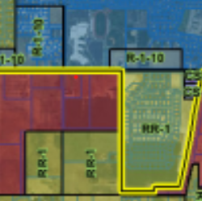
5300 N Stallion Way: (Parcel IDs: 05-044-0-0077)
Subject property
