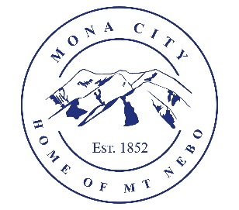
Mona City
435-623-4913
www.monacity.org
20 West Center Street Mona, Utah

Mona City Council Work Session
Tuesday, May 16, 2023
7:00 pm

Notice is hereby given that the Mona City Council will hold a work session on Tuesday, May 16, 2023, at 7:00 p.m. in the Mona City Council Chambers located at 20 West Center Street, Mona City. The purpose of this work session is discussion concerning:

- 120 Water, Lead, and Copper Rule (zoom presentation)
- Water Rate Study
- Gas Line on Main Street
- Municipal Energy Sales and Use Tax (taxing utility companies)
- Federal Sidewalk Grant
- Charging and Fueling Infrastructure (GFI) Discretionary Grant Program Application
- Mona Elementary Water Contract
- Tim Grange compliance date
- Fix It Notice for animal control issue
- Recreation Sponsorship Packet
- Scoreboard for ball field

CERTIFICATE OF POSTING

This agenda is hereby properly advertised this 15th day of May 2023, through posting of copies of this agenda at the Mona City Office, at the United States Post Office located in Mona City, on the Mona City website, and on the Utah Public Notice Website at www.utah.gov/pmn/index.html.

_______________________________________
Alicia Hills
Mona City Recorder

Upon Request, in compliance with the Americans with Disabilities Act, reasonable accommodations for individuals with disabilities will be provided. For assistance, please call 435-623-4913.

