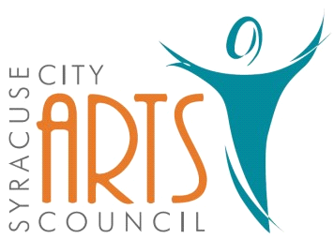
Syracuse City Arts Council Meeting Agenda
May 11, 2023 8pm
Meeting begins at 8pm
in the Syracuse Community Center
Classroom #3
located at 1912 West 1900 South.

1. Opening Business
- Call to Order
- Adoption of May 11, 2023 Agenda

2. Public Comment-This is an opportunity to address the Council regarding concerns or ideas. Please limit comments to three minutes.

3. Discussion and vote on ticket pricing for Freaky Friday & Battle of the Bands

4. Discussion and action items for Battle of the Bands

5. Discussion and action items for Boot Camp

6. Publicity: Syracuse Connection information & other publicity as needed.

7. Walk in items

8. Future Agenda Items

9. Adjournment

~~~~~~~~~~~~~~~~~~~~
In compliance with the Americans Disabilities Act, persons needing auxiliary communicative aids and services for this meeting should contact the City Offices at 801-825-1477 at least 48 hours in advance of the meeting.

CERTIFICATE OF POSTING
On May 9, 2023 this agenda was provided to the Standard Examiner and submitted to Syracuse City for posting on the Syracuse City Hall Notice Board and for publishing on the Syracuse City website, at http://www.syracuseut.com, and on the State Public Notice website, at http://www.utah.gov/pmn/indix.html. A copy was also submitted to the website manager for publishing on the Syracuse City Arts Council website, at http://www.syracuseutaharts.org/about-us/council-minutes. Libby Fawcett, Syracuse City Arts Council Chair

