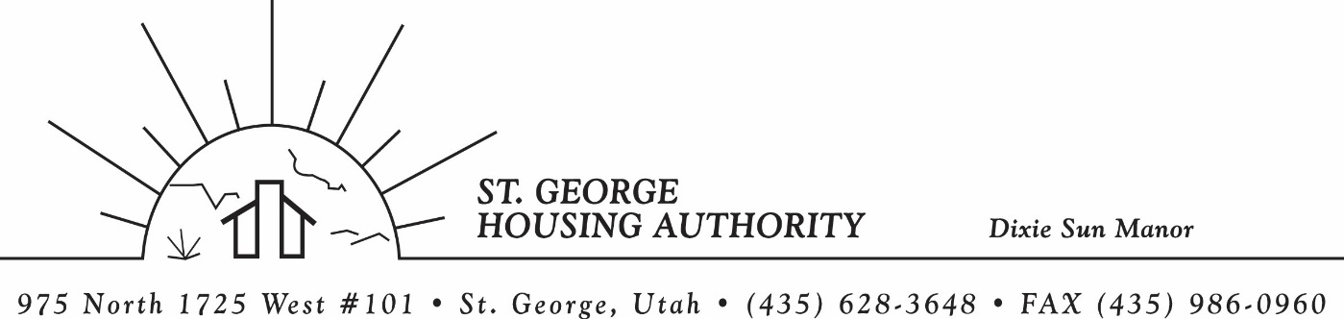
BOARD MEETING
DIXIE SUN MANOR 975 N. 1725 W. # 101
Tuesday April 11, 2023

PRESENT: Mike Barben, Greg Whitehead, Jimmie Hughes, Kenny Miller, Gloria Shakespeare. Tom Cover

EXCUSED: Jane Fehrenbacher

MINUTES: Minutes of Board Meeting held January 10, 2023 were reviewed. Motion made by Gloria Shakespeare to approve minutes as reviewed, motion seconded by Kenny Miller. Motion carried.

Review Housing Assistance Report for January 2023: Mike Barben handed out the HAP reports for February, March and April 2023. Board members were able to see the money spent for the months on rental assistance, see the average unit cost, and verify the units leased for the month. The board was also able to ask questions and have a discussion about portability, C of C, VASH, EHV, & Mainstream Vouchers. Each board member present signed off on the HAP payments and month end totals.

Review current 2022-2023 budget: Mike Barben handed the board a copy of the fiscal year 2022-2023 SGHA budget. The board was able to see how the SGHA is doing in the current fiscal year budget. Mike reported that for the most part, SGHA was right on budget, and let the board ask questions on any of the items on the report. The board has asked Mike to provide and present the most recent budget accounts at each board meeting. By providing the current budget monthly, the board can see how the SGHA is keeping up with the current budget throughout the whole year. The board thought it would be great to ask questions and be on top of what the SGHA is doing financially. Greg Whitehead asked Mike if he could get a history of the unit counts over the past couple of years. Mike said he would look into this and try and find a report. Mike agreed to do this.

Report on PHAS (Public Housing Assessment System) Score: Mike reported that he received his PHAS score from the office of Public and Indian Housing REAL Estate Assessment Center. SGHA received a 98 out of 100 score. The only deduction was on the physical assessment of DSM 38/40. Mike reported that SGHA is a high performing agency. Boar was happy with the score. Mike reported that he feels the SGHA is in a good position financially. Mike mentioned that the SGHA is in good standing with HUD and he plans to keep it that way.

PEHP Insurance Premium approval from Board: Mike reported a 5% increase in 2023-2024 insurance premiums. Mike asked for board approval of the new increased premiums. Greg Whitehead motioned for the approval of the new premiums. Jimmie Hughes seconded the motion. Jimmie mentioned that a 5% increase wasn’t too bad compared to the city’s increase this year. Motion carried.

Discuss 2023-2024 SGHA new budget: Mike reported that it was time to approve the 2023-2024 Fiscal budget. Mike reported that an add in the Spectrum newspaper was submitted and will run to the public on May 7-8. The add states that a Public Hearing to approve the new fiscal year budget will be held May 9, 2023 at 9:30 am. Mike said he would send a copy of the budget to the board member prior to the Board meeting on May 9th. The board will then discuss any changes or issues with the budget. The board meeting will end at 9:30 am and a separate public hearing will be open to the public for comment on the budget. Once the public hearing is over, Mike will have the Board chair sign off on the budget and Mike will submit the budget to the board.

Report on SGHA Bank Accounts: Mike gave copies of all SGHA bank accounts and CD’s. The board was able to see amounts in each account and ask questions. SGHA has 16 different accounts due to all the different programs. Mike reported that it is easier to separate the accounts to keep track of funds going in and out of each account and keeping them separated for accountant’s and auditors.

SGHA Environmental Review: Mike reported to the board that and environmental review was needed for DSM to receive CAP funding for this fiscal year. Mike said the study cost $1,700. Mike gave a copy o each board member to have. Mike reported once the review was finished, he furnished a copy to HUD and SGHA cap funding was approved for draw down. HUD approved the review and has a copy on file. Mike also has a copy on file in his office for future reference.

Utah NAHRO Conference in St. George on April 26-27: Mike reported that the Regional NAHRO conference will be held in St. George April 26-27. Mike is the Utah Chapter NAHRO president and offered the board admission to the conference if they wanted to attend. Greg Whitehead, Gloria Shakespeare, Jane Fehrenbacker, and Kenny Miller want to go to the conference. The SGHA will pay their registration fees.

Jane Fehrenbacker report on DSM: Mike reported that Jane asked to be excused for the meeting. Jane isn’t feeling well.

Report from Jimmie Hughes on City of St. George: Jimmie reported that the Month of April has been surprisingly quiet. Jimmie mentioned that the City Manager has been hired and feels really good about the chosen individual. Jimmie said there is a public hearing today at 2pm regarding public events held in city parks and recreation. He mentioned that every event must be submitted 6 weeks prior to the event, and permit must be given before any marketing of the evert. Jimmie mentioned a parcel of land on the St. George Boulevard is still open for business ideas. Possibly a hotel or business mall. Jimmie also mentioned that the city is looking for ways to help preserve the water in Southern Utah with new water meters and app that helps track the intake of water from your residence.

Motion made by Tom Cover to close the meeting. Kenny Miller seconded the motion. Motion carried. Meeting adjourned at 9:45 a.m.

Next board meeting will be held May 9, 2022 at 8:30 a.m. at the St. George Housing Authority office. A Public hearing will be held immediately following the board meeting to approve SGHA fiscal year budget 2023 – 2024. Public comment will begin at 9:30 am.

