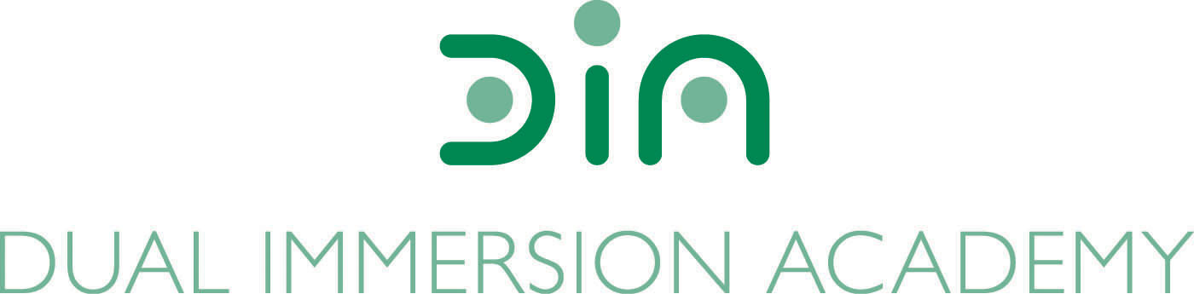

DIA Board of Directors Agenda
May 9, 2023
Dual Immersion Academy

Begin at 5:30 pm
In-person/Virtual
Roll Call

- Budget Report by Nate Adams, Red Apple
  - FY 2023 Budget (vote needed)
  - FY 2024 Budget (vote needed)

- Fraud Risk Assessment (discussion)

- Facilities by Rich Stowell

- DIA Rebrand (update)

- Policy Audit by Rich Stowell

- Board Candidates/Membership

- Board Officers

- Director’s Executive Report by Angela Fanjul

- Closed Session under UT 52-4-205 (as needed)
Re-open the meeting for board vote (as needed)

- Approval of minutes: April 11, 2023

- Motion to close the meeting

Conclude meeting by 7:00 pm

Next meeting:
June 13, 2023, at 5:30 pm

