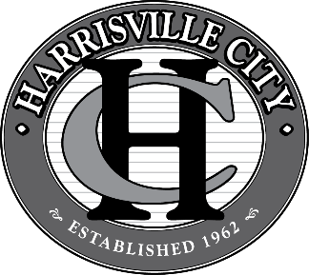
MAYOR:

Michelle N. Tait

COUNCIL MEMBERS:

Grover Wilhelmsen
Steve Weiss
Blair Christensen
Max Jackson
Kenny Loveland
HARRISVILLE CITY

363 West Independence $ Harrisville, Utah 84404 $ (801) 782-4100

Notice of Municipal Election
In accordance with Utah Code Annotated §10-3-301, Harrisville City will have three (3) City Council seats (4-year terms). Those interested in running for any of these seats must file a Declaration of Candidacy, in person, with the City Recorder at the Harrisville City Offices located at 363 West Independence Blvd, Harrisville, during office hours as prescribed by law between June 1, 2023 and June 7, 2023. A Nomination Petition may also be filed during the same time period. Filing fees apply. Any person filing a declaration of candidacy for a municipal office must meet the requirements of Utah Code Annotated §20A-9-203. Candidates must also file the campaign financial disclosures required by state law. For more information contact the City Recorder at 801-782-4100, Ext. 1027. Primary Election will be held August 15, 2023. General Election will be held November 7, 2023.

Qualifications for a Candidate are (UCA §20A-9-203):
1. United States Citizen.
2. Registered voter of the Municipality (Harrisville City)
3. Resident of the Municipality (Harrisville City) or recently annexed territory for a period of 12 consecutive months immediately before the date of the election.
4. In accordance with Utah Constitution Article IV, Section 6, any mentally incompetent person, and person convicted of a felony, or any person convicted of treason or a crime against the elective franchise may not hold office in this state until the right to hold elective office is restored.

