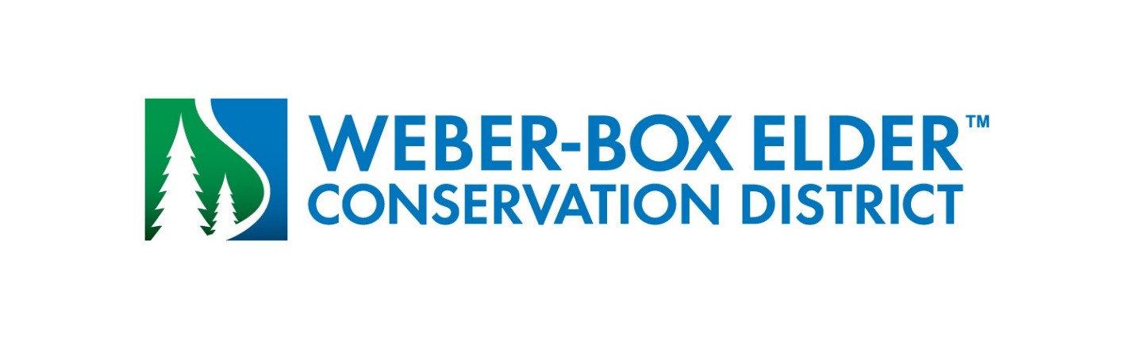
NOTICE OF ELECTIONS - BOARD OF TRUSTEES

Notice is hereby given that in accordance with Title 17B, Chapter 1. Special District Board Selection Procedures there are three (3) board member positions on the Board of Trustees of the Weber-Box Elder Conservation District, an irrigation district, to be filled at the 2023 regular general election. The positions are in precinct numbers 1, 3 and 5. Each is for a term of four (4) years.

Notice is further given that to be a candidate for trustee of the Weber-Box Elder Conservation District a candidate must be a qualified elector of the District. To be a qualified elector of the District an individual must own property within the District and have district water allotted to that property. A candidate’s property must be within the precinct where a position is to be filled. If a candidate owns property in more than one precinct the candidate must file within the precinct where the largest portion of the candidate’s property is located.

Notice is further given that to be a candidate for an elective position an individual must file a declaration of candidacy in person with the District between June 1, 2023 and June 8, 2023 during regular office hours from 8:00 a.m. t0 5:00 p.m. Our office is located at Pineview Water Systems 471 West 2nd Street, Ogden, Utah.

