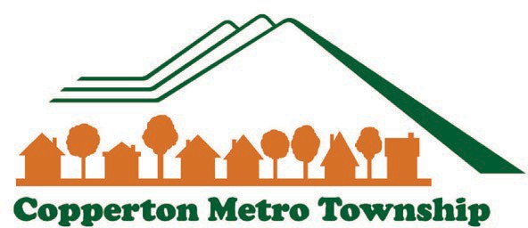

Copperton Metro Township Council - April 19, 2023
OAM2022-000737

Ordinance Summary and Recommendation
Request: Recommendation from the Planning Commission regarding the repeal and replacement of Title 18 Subdivisions and Title 19 Zoning of the Copperton Metro Township Code of Ordinances.

Planners: Curtis Woodward, Kayla Mauldin

Summary of Recommendation: Staff recommends the Planning Commission receive public input and vote on a recommendation regarding Title 18 Subdivisions and Title 19 Zoning, either as presented or with amendments as agreed upon by the member of the Planning Commission.

PROJECT DESCRIPTION

Description of Request: MSD Planning & Development Services Staff (“PDS”) have been tasked by the Metro Townships to lead ordinance update efforts for each respective community. Last year, Titles 18 and 19 were sent out in phases, and workshops were held with the planning commission to receive input regarding the drafts. Over the past three months, planning staff has continued to receive input from agencies such as the County Surveyor, MSD attorneys, Engineers, and other planners in an effort to refine the code to remove errors, clarify provisions as necessary, and to bring the code into compliance with applicable state codes and industry best practices. The draft ordinances sent out for the March 14 meeting included Titles 18 and 19 in their entirety, and showed the latest changes in blue, red, or green (depending on the author).

Land Use Ordinances determine the use, development, and subdivision of property within a municipality. A municipality’s right to implement land use ordinances is tied to its “Police Power” (or to the essential task of protecting public health, safety, and welfare). Private property rights are balanced with public needs, in order to ensure safe, equitable, and sustainable development.

The 2022 / 2023 Land Use Ordinance revisions are intended to accomplish several objectives, including:

- Ensuring compliance with State Legislation;
- Encouraging conformity with adopted General Plans;
- Promoting ease of use for both staff and residents; and
- Meeting the unique needs and preserving the character of the community.

Request: Ordinance Amendment File #: OAM2022-000737

Case History: The ordinances were drafted and sent to the planning commission members for review in 3 phases, beginning in September, 2022, with discussion meetings being held with the planning commission to discuss concerns and possible edits. A final combined set of ordinances was published for public notice, and a public hearing was held by the Metro Township Planning Commission April 11, 2023. During that meeting, several changes were discussed that had been suggested as a result of State Legislation as well as input from affected entities. After reviewing the amended drafts, the planning commission recommended their own changes (see below) and have forwarded the ordinances on to the Metro Council for approval.

GENERAL PLAN CONSIDERATIONS

Planning staff have worked with the Planning Commission to incorporate the goals and objectives of the Copperton General Plan into the proposed ordinances to the extent possible. There are some near-future changes currently in the draft stage (such as the subdivision connectivity ordinance) but those changes will be presented to the planning commission and the public later in the year when they are ready for review.

NEIGHBORHOOD RESPONSE

As of the date of this report, no citizen input has been received regarding the proposed ordinances.

PLANNING RECOMMENDATION

On April 11, 2023, the Copperton Metro Township Planning Commission voted to Recommend Approval of Titles 18 Subdivisions, and 19 Zoning as presented to them during the public hearing with the following Amendments:
- Remove the larger animals, cows, sheep, and goats, from the definition of “Family Food Production.”
- Amend Table 19.28.020 - Uses Allowed in Single Family Residential Zones to clarify the “Animals and Fowl for family food production established after May 1, 2023” is not allowed (making existing properties with those listed animals nonconforming uses).

ATTACHMENTS:
- Adoption Ordinance
- Proposed Title 18
- Proposed Title 19

Conditional Use Summary Page 2 of 2

