Draft 2023-2050
Regional Transportation Plan
Dixie Metropolitan Planning Organization

March 21, 2023 DRAFT

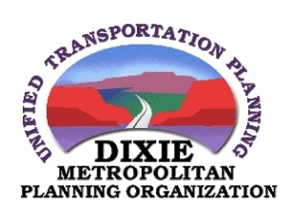
Table of Contents

Chapter 1 -- Executive Summary 1
Chapter 2 -- Need and Purpose 2
Chapter 3 – Vision and Mission 4
Chapter 4 – Projected Transportation Demand 7
Chapter 5 – Financial Plan 9
Chapter 6 – Existing and Proposed Transportation Facilities 14
Chapter 7 – Safety Management 21
Chapter 8 – Security 28
Chapter 9 – Congestion Management 30
Chapter 10 – Corridor Preservation 32
Chapter 11 – Environmental Mitigation 33
Chapter 13 – Transit Service 40
Chapter 14 – Public Involvement 45
Chapter 15 – Freight 46

Chapter 1 -- Executive Summary

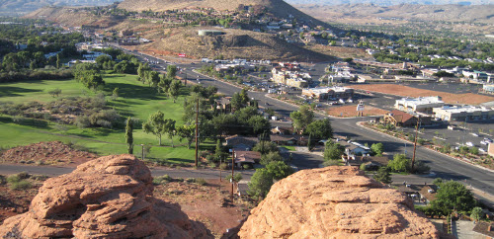
This Regional Transportation Plan (RTP) is the culmination of planning efforts undertaken by Dixie Metropolitan Planning Organization (MPO) for the Census Bureaus’ designated urban areas in Washington County, Utah – including the St. George Urbanized Area and the Hurricane Urban Cluster. The RTP objective is to foster coordination of community leaders, the public, and stakeholders to plan for the transportation of people, goods, and services through goals centered on safety, air quality, transportation facilities, congestion management, corridor preservation, public transit, pedestrian movement, and respect for environmental constraints.

The plan is updated every four years in coordination with the Utah Department of Transportation, three other MPOs in Utah, Washington County, and the cities within the urban areas noted above. Transportation planning in Washington County follows local visioning goals in collaboration with other planning efforts such as Utah’s Unified Transportation Plan, Vision Dixie, the Utah Strategic Highway Safety Plan, Homeland Security plans, etc.

The cities of Ivins, Hurricane, LaVerkin, Leeds, St. George, Santa Clara, Toquerville, and Washington, are included in the planning boundary Map #2 in Appendix B.

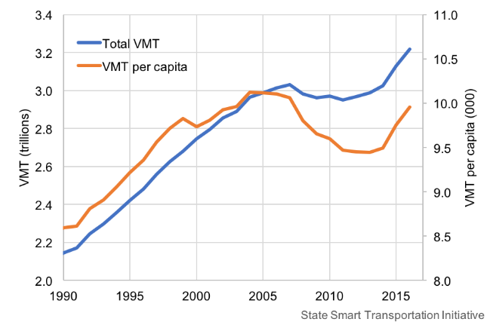
This plan relies on principals defined in Vision Dixie, a visioning effort undertaken in 2006-08 to document the vision of Dixie’s desired future development as defined by the public, elected officials, public service agencies, business interests, and other socioeconomic forces. From a transportation perspective, Vision Dixie calls for a variety of roads, transit, and pedestrian facilities, community connectivity and access to a greater variety of human services, businesses, and residential units.

Projected transportation demand in the St. George area was modeled using state-approved computer programs and verifies the Vision Dixie call for a variety of future transportation facilities including roads, transit routes, and active transportation routes.

Washington County’s estimated population growth over the next 25 years combined with limited amounts of federal, state, and local funds available to accommodate their needs indicate that revenue streams will need to be incrementally increased and changed over time to generate sufficient resources to accommodate anticipated needs. The funding sources and future funding assumptions are explained in Chapter 5.

A summary of proposed transportation facilities, including a comprehensive list of road improvements over the next 25 years is noted in Chapter 6 and depicted on Map 1 in Appendix A. Exceptional evidence also points to the need for expanded bicycle facilities, pedestrian facilities, and regional transit systems throughout the Urbanized Area as outlined in Chapters 12 and 13.

Special attention must also be given to safety, congestion, and corridor preservation over the next 25 years. And of utmost importance is affording appropriate environmental protections of and respect for the varied “threatened and endangered species” (plant and animal) present in southwestern Utah as discussed in Chapter 11.

Taken together the chapters within the Regional Transportation Plan identify needs, issues, and potential solutions to facilitate transportation planning excellence.

Chapter 2 -- Need and Purpose
According to the U.S. Census, the 2020 estimated population of Washington County, Utah is 182,111 people. That population is expected to grow to 265,864 by 2030; to 337,326 by 2040; and to 401,757 by 2050 according to the Kem C. Gardner Policy Institute and the Utah State Governors’ Office of Management and Budget.

As the population continues to grow, so too will the demand for transportation facilities and services.

This 2023-2050 Regional Transportation Plan outlines how various jurisdictions within the Dixie MPO intend to meet the area’s transportation demands and needs over the next 30 years. The area has many geographical features (hills, bluffs, and rivers) that challenge the circulation of people and freight and the creation of various transportation systems. The area is also habitat to threatened and endangered plant and wildlife species and is governed by county, state, and federal regulations.

The expected population growth, coupled with the community’s desire to retain mobility for people, goods, and services defines the need for this plan. This plan’s purpose is to outline how these needs could be addressed over the next 30 years with consideration of geography, environment, socioeconomic trends, and anticipated transportation demand (needs).

The Dixie MPO was designated by the Governor of Utah on September 20, 2002. In compliance with federal guidelines the Dixie MPO develops and approves processes and procedures for conducting long range planning. This responsibility involves identifying proposed transportation projects for consideration in the Transportation Improvement Program (TIP), considering the economic and environmental implications of transportation system improvements, and addressing the traffic growth anticipated in the future.

The Infrastructure Investment and Jobs Act (IIJA), most commonly known as the Bipartisan Infrastructure Bill, is a United States federal statute enacted by the 117th United States Congress and signed into law by President Joe Biden on November 15, 2021.

The Bill funds surface transportation programs—including, but not limited to, Federal-aid highways, other transportation facilities, and transit programs. It provides long-term funding certainty for surface transportation programs.

Performance Measures
Federal performance measures enable a federal summary and comparison between states. The Utah performance measures are derived from local goals (MPOs, Transit, DOT) and used for decision-making within Utah. A Performance-Based Planning & Programming Memorandum of Agreement is provided in Appendix A of this plan.
Dixie MPO has chosen to adopt the state targets for the St. George Urbanized Area and the Hurricane Urban Cluster and will coordinate directly with the Utah Department of Transportation to support the statewide targets. Current performance measures address the reduction of fatal and serious-injury crashes (Highway Safety), infrastructure condition, congestion reduction, system reliability, freight movement, economic vitality, and environmental sustainability on road source emissions. For a more detailed explanation of these performance measures see https://udot.utah.gov/connect/about-us/technology-innovation/transportation-performance-management-division/performance-management/.

Chapter 3 – Vision and Mission

“Vision” is the guidepost for all efforts of the Dixie Metropolitan Planning Organization. Simply stated the “Vision” is rooted in sound planning practice: to Achieve Transportation Planning Excellence.

“Achieve Transportation Planning Excellence”

Through “Vision Dixie”, over three thousand residents created a framework in which future development and transportation can work together to create communities, and a region that preserves Southern Utah’s quality of life. The “Vision” looks forward to an affordable, sustainable, and livable future.
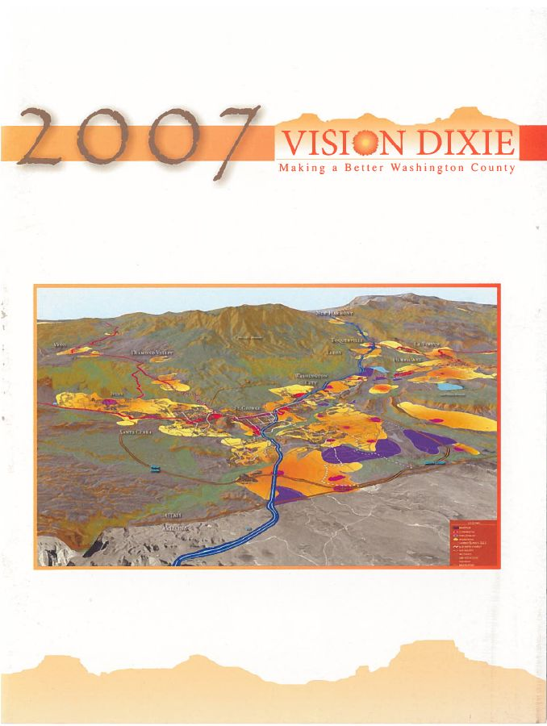
The public preferences are summarized in a series of Vision Dixie Principles that illustrate how growth might occur as cooperative efforts are made to implement the principles identified through the process. The Vision Dixie Principles provide a framework for voluntary local implementation. Local officials have committed to work with residents to determine how these principles fit with local plans for the future.

The process was kicked off on October 18, 2006 when nearly 400 residents joined the Washington County Commission in a county wide process of workshops, technical research and analysis.

Over 1,200 residents attended workshops in the fall of 2006 to voice their preferences for how the county should grow. This input coupled with technical guidance from local planners, led to the creation of four scenarios that were unveiled at nine “Dixie Dialogue” meetings in May and June 2007. More than 500 residents attended these meetings to identify which ideas, contained in the scenarios, they favor. An additional 800 residents evaluated these scenarios on-line. Also, in June 2007, an independent polling firm contacted 400 representative county residents to ask their opinions on growth issues and strategies.

Based on these citizen input initiatives, a steering committee made up of mayors from throughout the urbanizing area, established ten Vision Dixie Principles.

The Vision Dixie Principles:

Principle 1: Plan Regionally, Implement Locally
Principle 2: Maintain Air and Water Quality and Conserve Water
Principle 3: Guard our ‘Signature’ Scenic Landscapes
Principle 4: Provide Rich, Connected Natural Recreation and Open Space
Principle 5: Build balanced Transportation that includes a System of Public Transportation, Connected Roads, and Meaningful Opportunities to Bike and Walk.
Principle 6: Get ‘Centered’ by Focusing Growth on Walkable, Mixed-Use Centers.
Principle 7: Direct Growth Inward.
Principle 8: Provide a Broad Range of Housing Types to Meet the Needs of All Income Levels, Family Types, and Stages of Life.
Principle 9: Reserve Key Areas for Industry to Grow the "Economic Pie".
Principle 10: Focused Public Land Conversion Should Sustain Community Goals and Preserve Critical Lands.

Land Use / Transportation Relationship

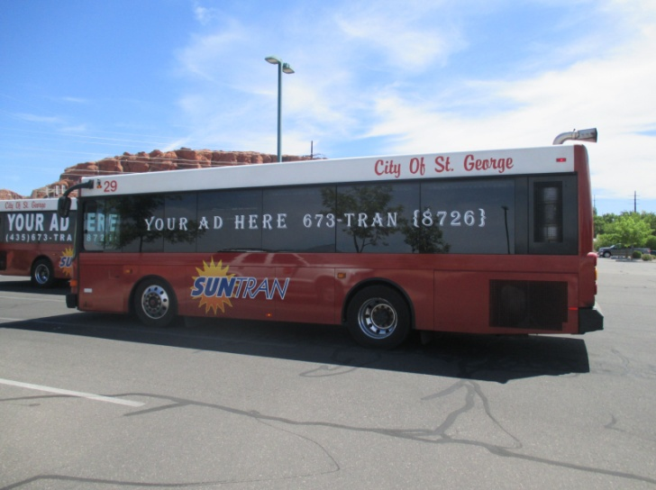
Because of Dixie’s (unique) geography, transportation corridors in Dixie must accommodate more traffic than in a typical transportation grid-system. Thus, each transportation corridor in Dixie may be more susceptible to potential congestion. While auto use will continue to be dominant, roads will not be able to meet all our mobility needs decades into the future. Public transportation is especially important to keep us from being overwhelmed by gridlock. Putting in place a transit backbone will help our downtowns, major centers, and Utah Tech University (formerly Dixie State University) flourish. A viable public transit system could also help air quality and relieve household expenses associated with day-to-day travel. (Vision Dixie 2035: Land-Use & Transportation Vision, p. 26)

A vibrant “center” includes multiple ingredients: a mix of uses, pedestrian-oriented buildings, focused density, connected streets, and context sensitive streets. (Vision Dixie 2035: Land-Use & Transportation Vision, p. 31)

Vision Dixie calls for corridor preservation for roads and transit, street connectivity, and the creation of community-friendly collector and arterial roads to reduce congestion and accommodate a growing population with the following long-term recommendations:

- Work together to identify and preserve transit corridors and potential station locations.
- Explore the creation of a transit district and a local option sales tax for transit.
- Adopt the road corridors of Utah Department of Transportation, Dixie MPO, and Five County Association of Governments into local general plan updates. Corridor preservation should address road needs, transit needs, utilities, bicycle facilities and trails. Formalize local government ordinances and negotiation procedures to preserve corridors as development happens.
- Revise street connectivity standards in updated subdivision ordinances.
- Coordinate local street plans in sub-area plans to assure optimum connectivity.
- Coordinate local street plans between jurisdictions.
- Amend local policies and construction standards to comply with “complete streets” criteria (that include provision for pedestrians, bicycles and parking) consistent with street segments mapped in the general plan.

Vision Dixie principles 6-8 encourage “Walk-able, Mixed-Use Centers”, “Directing Growth Inward,” and “Enabling the Housing Market to Meet Housing Wants and Needs,” with the following long-term recommendations:

- Approximate areas for future mixed-use centers, remove zoning and subdivision barriers to mixed-use centers, and update community general plans to include these centers.
- Include mapped priority land re-use areas in general plans to signify to developers and nearby landowners that development in those areas helps fulfill city-wide goals (of inward growth first).
- Modify edge-of-town standards and annexation policies to encourage contiguous development and discourage leap-frog development through market-based mechanisms that charge leap-frog development consistent with its higher level of impacts (e.g., longer streets per home).
- Amend the zoning map and ordinances to allow a greater range of (housing) densities.

These recommendations are supported by the 2019-2050 Regional Transportation Plan.

This Vision can be realized through a strong day-by-day effort to attain goals and objectives, as stated in the Regional Transportation Plan with the Mission to: “Foster coordination of community leaders, the public, and stakeholders to reach transportation goals centered around safety, air quality, congestion management, freight movement, corridor preservation, public transit, pedestrian movement, and respect for environmental constraints.”

Chapter 4 – Projected Transportation Demand

The Dixie MPO Travel Demand Model was created in 2010 using the CITILABS CUBE Model platform to forecast future traffic demands throughout Washington County. The computer-based planning platform allows the MPO to better predict traffic movements based on our unique terrain, environment, and land-uses. A rigorous effort to calibrate and validate the model and update socio-economic data has followed since 2010 to assure the model includes the best information available. The CUBE model is the platform also used by the Utah Department of Transportation and other MPO’s within Utah.

In 2013 and again in 2018-2019, and most recently in 2022 – the Dixie MPO commissioned an extensive update of the Dixie MPO Travel Demand Model. This recent update is a major effort in bringing the model to the most currently used platforms as used throughout the state. This work includes updating the model structure, updating the model supply-side data and model calibration/validation of each model step. The update incorporates revised Traffic Analysis Zones, recent Population and Household data, updated Employment data, University and School data and many other supply-side data requirements. The 2020 Census, and other population estimates were used in the update. Calibration /Validation will be done to meet UDOT and industry standards. This version of the Dixie MPO Travel Demand Model is scheduled to be fully complete in 2023.

Model Structure
Travel demand models are computer-based mathematical models that use socioeconomic and roadway network, local geometry, and land use data to forecast traffic under various scenarios. To forecast traffic the Dixie Travel Demand Model uses the traditional 4-step process. The four basic phases are:

- Trip Generation – Trip generation determines how many trips are made in a region. To simplify the process, large geographical areas are broken up into smaller areas called traffic analysis zones (TAZ). Using information from sources like the Census Bureau and city land use plans, each TAZ is given certain attributes such as the number of households, employees, and average income levels. These attributes are then used to calculate the number of trip productions and attractions for each TAZ.

- Trip Distribution –Trip distribution determines where the trips are going. Trip productions and attractions from different TAZ’s are linked together using a gravity model to form origin-destination patterns. The gravity model states that the trip attraction between two zones is proportional to the size of the zones (number of households/employees) and the distance between them.

- Mode Choice –What modal method of reaching a trip’s destination is determined in step 3. Looking at factors such as cost, convenience, and travel time it is determined if the trip will be made by walking, transit or vehicle.

- Trip Assignment – The route the trip will take to reach its destination is then determined. Link attributes contained in the highway network such as capacity and travel speed are used to determine the shortest travel path to a destination. The trips are then assigned to the roadway network.

Each step of the process is calibrated to observed travel behavior. Base model forecasts are checked against observed traffic counts to ensure reasonable accuracy. Once the model is developed so that it replicates existing travel behavior, it is then used to evaluate future scenarios and alternatives.

Socio-Economic Characteristics

In addition to population growth, the characteristics of population distribution within the MPO are vital considerations in the development of a viable transportation network. More than 88% of the Washington County population resides within the Dixie MPO census defined "Urban" boundaries. Other, more rural, cities and towns within the County include Apple Valley Town, Enterprise City, Hildale City, New Harmony Town, Rockville Town, Springdale Town, and Virgin Town as well as unincorporated County.

The distribution of the current population and projected growth are illustrated on Map 3 “Population Change Map” in Appendix B at the back of this plan. The mapping includes a 2018 population distribution and the future population of projected growth areas through 2050.

Employment and Commuting

Over 7,500 employment establishments were operating in Washington County in 2021 (see Appendix A for table of major employers). More than 98 of these establishments had over 100 employees, according to the Utah Division of Workforce Services. The highest demand for transportation facilities and services comes during the morning and evening commutes as people travel from home to work and back. Companies come and go, and seasonal peaks in tourism and retail activity affect the number of commuters.

As of 2022 Washington County growth dynamics remain strong including employment expansion. September 2022 Year-to-Year change in Nonfarm Jobs increased over 3,200 jobs with all sectors increasing except for Financial Activities, it is anticipated that additions to the county's employment base will continue to strengthen Washington County's economic and growth numbers in the months ahead. As growth continues, so too will the need for adequate transportation facilities.

Objectives and Goals
To plan for future transportation demands, the Dixie MPO will strive to meet necessary goals and objectives to recognize the impacts of the area growth on transportation.

Objective
To recognize population growth and land uses as the key drivers of future transportation demand.

Goals
- Stay abreast of changes in population growth and projections in the area.
- Be aware of changes in land development patterns and how those changes affect population growth and transportation demand.
- Stay current on socio-economic factors and changes that may affect the demand for transportation.
- Provide for regular updates of the Transportation Demand Model and look for opportunities to update the model within localized studies.
- Keep up with Model platform updates and changes in technology that can improve the accuracy of the Transportation Demand Model.
- Become more educated and efficient in the execution and use of the Transportation Demand Model in keeping the model current and useful to the Dixie MPO and its partners.

Chapter 5 – Financial Plan

Current Funding Sources, Gas Taxes, Fees
Funding sources for transportation facilities and services in the Washington County area include federal, state, and local government funds as well as private developer contributions for transportation improvements. The projects noted in Chapter 6 of this plan are required to be fiscally restrained (meaning planned projects cannot exceed planned revenue).

Federal Funds:
The current federal highway and transit bill (Bipartisan Infrastructure Law or BIL) continues to fund federal transportation programs. As the BIL matures in 2026, future infrastructure and transportation bills are expected to continue federal funding for these programs.

Congressionally Directed Spending packages are also available through direct application by sponsoring agencies to individual state and federal Congressional Representative.

State Funds:
The Utah Department of Transportation receives state highway user revenues as well as state general funds for highway construction and maintenance projects. The highway user revenues sources include motor fuel taxes, special fuel taxes, vehicle registration fees, driver license fees, and other fees. General fund revenues are also used for transportation and the state has the authority to issue bonds for specific highway projects.

A portion of the state highway user funds are made available to local governments for highway construction. Seventy (70) percent of these funds are kept by the UDOT for their construction and maintenance programs. The remaining 30 percent of funds are made available to the cities and counties in the state through the Class B and C Program for road maintenance or construction.

State Legislature Directed Spending packages are also available through direct application by sponsoring agencies to individual State Legislative Representatives.

Local Funds:
In addition to B&C funds, local governments may use a variety of other funding sources to build transportation projects. These sources include (but are not limited to) local sales tax options, local impact fees paid by developers, general fund contributions (sales and property taxes), bonding arrangements, the Local Corridor Preservation Fund (vehicle registration fees), and special service district fees.

Private Sources
Private interests may also provide transportation improvements. As developers construct the local streets within their own subdivisions, they may also be required to dedicate rights-of-way for the construction of collector and arterial streets adjacent to their developments. Developers are also considered as possible sources of funding for projects needed because of the impacts of the development, such as the need for traffic signals or arterial street widening.

Private sources may also be considered for public transit improvements which could provide benefits to their particular interests. For example, businesses or developers may be willing to or required to support capital expenses or operating costs for transit services that provide special benefits to their development such as a reduced need for parking or increased accessibility.

Following is a brief list of programs used to fund transportation projects within the Dixie MPO:

FEDERAL HIGHWAY ADMINISTRATION
- Surface Transportation Program (STP)
  - Dixie MPO cities
- Congestion Mitigation / Air Quality (CMAQ) (Available only after Dixie MPO reaches non-attainment status)
- Carbon Reduction Program Funds (CRP)
- Interstate Maintenance (IM)
- National Highway System (NHS)
- Surface Transportation Program
- Urbanized Area
- Small Urban
- Flexible (Any-Area)
- Transportation Enhancements
- Highway Safety Improvement Program (HSIP)
- Hazard Elimination
- Bridge Replacement
- Off System - Local
- Off System - Optional
- Federal Lands Access Program funds (FLAP)
- High Priority Projects (HPP)
- Transportation Improvement Projects (TI)
- Recreational Trails
- Transportation Alternatives Program (TAP)

FEDERAL TRANSIT ADMINISTRATION
- (5307) Block Grant Funds
- (5309) Discretionary Funds
- (5310) Services for elderly and disabled
- (5311) Grants for Outside Urban Area
- (5340) High Density States Program
- (5316) Job Access and Reverse Commute
- (5317) New Freedom Program
- (5339) Bus and Bus Facilities Grant Program

STATE OF UTAH
- State Construction
- State General Funds
- State Traffic
- Corridor Preservation Funds
- Transportation Investment Funds (TIF)
- TIF Active Program
- Transit TIF Program
- Legislature Directed Spending packages

LOCAL
- County (B Funds)
- City (C Funds)
- General Funds
- Transit Sales Tax
- Corridor Preservation Fund
- Local Option Sales Taxes for Transportation
- Local Option Sales Taxes for Transit
- Building impact fees

PRIVATE
- Donations / User Fee
- Developer Funded Projects
- Public/Private Partnerships

Unified Plan Process
To create a fiscally constrained long-range transportation plan, the Dixie MPO joined with the Utah Department of Transportation, the Utah Transit Authority and other MPOs to create the Utah Unified Plan Financial Working group to make common assumptions regarding current and future funding sources available for transportation. This effort projected revenues, inflation rates, estimated construction costs, and the cost of future rights-of-way. The Dixie MPO Executive Committee also examined local funding options and adopted a series of additional future funding assumptions associated with transportation. Below is a discussion of these assumptions, an outline of current funding sources, and a policy document supporting acquisition of future federal, state, and local funding for transportation projects.

State (Future) Funding Assumptions
Expenditure assumptions are based upon uniform costing of projects by each MPO, UDOT, and UTA. Revenue projections are based upon assumptions agreed upon by the parties for each major revenue stream from federal, state and local revenues. The parties involved met on several occasions to review and finalize the following assumptions. The major discussion points focused on the growth assumptions from the previous update, information from state agencies including the consensus committee at state level, and other long-range forecasting methods developed by the group. The following table provides a summary of the major assumptions used to generate revenue projections and the source and/or methodology used to generate the projections.

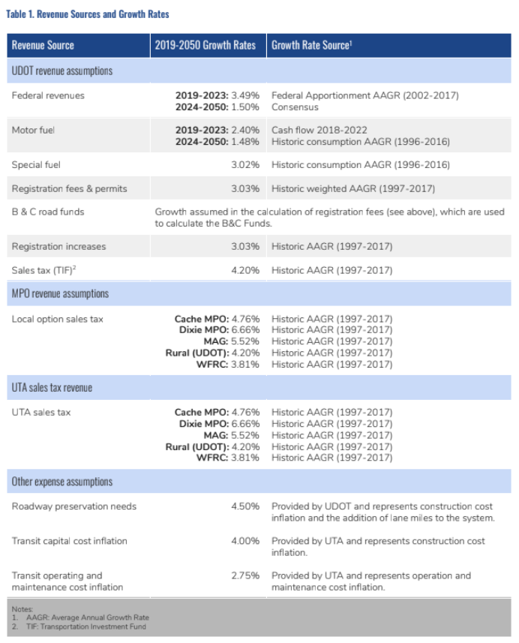

Local (Future) Funding Assumptions
The Dixie MPO Executive Committee agreed that in addition to current funding sources, it was reasonable to expect the following local revenues to become available for transportation in the future:
- The equivalent of a county-wide sales tax increase of “one quarter of one percent” implemented by the end of 2029.
- The equivalent of county-wide vehicle registration fee increases of $10 by the year 2027.

Constraints through 30-year planning phases

These future funding assumptions, taken together with existing funding sources were calculated and documented in a “Regional Transportation Plan Financial Report” as agreed upon through the Unified Plan Financial Working Group and endorsed by the Dixie MPO Transportation Executive Council.

The Financial Report projected an annual inflation rate of 3.49 percent to 5 percent on all cost projections (a conservatively high estimate based on past experience). Future revenues were also forecast using a conservatively low estimate. Utah’s shifting population was also figured into these assumptions based on projections by the Governors’ Office of Management and Budget (GOMB). Currently the Dixie MPO is home to 6 percent of the state’s population. The Governor’s Office projects the Dixie MPO population will reach 7.8 percent of state the population by 2050. This plan presumes that state revenue will flow to Washington County proportionate to population growth.

Federal formula funds also provide subsidies to the Dixie MPO for planning, environmental assessments and project seed money. These federal dollars come from FHWA’s Surface Transportation Program and FTA’s Transit Programs with an approved 2% inflation rate.

Projected Transportation Revenues
 | Phase 1 | Phase 2 | Phase 3 | Total
 | 2023-2032 | 2033-2042 | 2034-2050 | 2023-2050
State Road New/Capacity | $485,060,256 | $591,284,845 | $361,714,025 | $1,438,059,126
Local Roads of Regional Significance | $571,118,987 | $611,243,895 | $611,766,749 | $1,794,129,631
Total | $1,056,179,243 | $1,202,528,740 | $973,480,774 | $3,232,188,757

The table at the right shows the total revenues assumed for projects in all three phases of the long-range plan. Total expenditures are detailed in the “Project & Phasing List” in Chapter 6.

When compared with the needs list and anticipated costs in Chapter 6, these funding assumptions seem adequate in Phase 1 of the RTP. However, a re-evaluation of revenue needs may be appropriate in 2027 when this plan is updated.

Chapter 6 – Existing and Proposed Transportation Facilities

Methodology
As discussed in Chapter 4, the Dixie MPO’s CUBE modeling platform was used to analyze the transformation of traffic demands as conditions change in the future. The CUBE Model applied mathematical forecasting formulas to population growth, job growth, land use changes, socio-economic data, expected trip generations, trip distributions, and mode choice of travelers (transit vs. cars vs. walking/biking).

These forecasts were then imposed on the existing road networks, transit facilities, and pedestrian trails. Then projects were conceptualized to address the forecast changes in traffic congestion by identifying “hotspots” in each phase of the plan.

Phase One looked at the changes expected in years 2023 to 2032. The associated project list was then created to address traffic congestion hotspots anticipated by 2032 together with the forecast changes in population, job creation, etc.

Phase Two looked at travel demand changes from 2033 to 2042 with a similar project list to address those additional traffic demands anticipated by 2042.

Likewise, Phase Three looks to the 2050 horizon.

Current Network
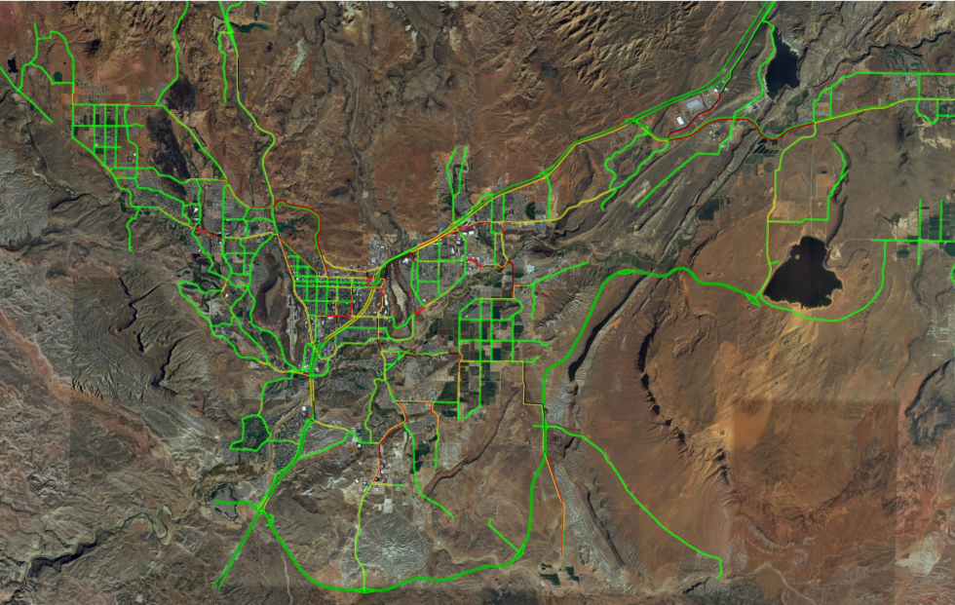
An inventory of the current MPO road network is best noted through use of the Traffic Congestion 2050 - No-Build map in Appendix B. The roads noted in red and black indicate areas of concern or traffic congestion in 2050 if no additional projects are built.

Future Network
The Traffic Congestion 2050 - Build map, also included in Appendix B illustrates areas of concern, or traffic congestion in the year 2050 assuming that the plan projects are all built and in use at that time. Again, roads noted in red and black indicate areas of concern or traffic congestion in 2050 after all planned projects are built.
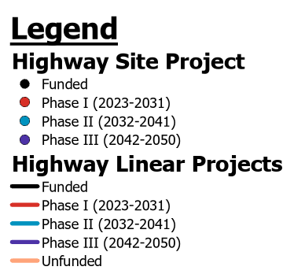
Projects and Phasing
The next several pages list a variety of transportation projects identified using the methodology outlined in chapters 3, 4, and 5 above. Projects range from highway widening to bridge and overpass construction, as well as proposed new corridors. Additionally, some UDOT projects of interest are listed even though they may lie outside the MPO boundaries because those corridors provide vital transportation connections to Urban area residents.

The Projects and Phasing Map is also included in Appendix B. The legend to the right is used for project phase identification on the Projects and Phasing Map and in the list below:

2023 Draft Plan
Phase 1 (2023-2032)
February 7, 2023
Project # | Route | Category | City | Project Description | Project Concept | Estimated Cost in 2022 dollars
1.a |  | Regional | I | Old Highway 91 (I), 200 E to 600 W | Reconstruction | $10,000,000
1.b |  | Regional | I | Old Highway 91 (I), 600 W to Shivwits Reservation |  | $24,804,000
3 |  | Regional | SC | Red Mountain Drive, Pioneer Parkway to Western Corridor | New Construction | $8,550,000
5 | I-15 | State | UDOT | I-15 MP 4 Interchange phase II improvements w/sign bridge | Widen/Reconstruct | $22,000,000
6 |  | Regional | SG | Gap Canyon Pkwy -- from Sunbrook Drive to Dixie Drive | New Construction | $18,720,000
7 | SR-8 | State | UDOT | Sunset Blvd. widen to 6-lanes from Valley View Dr to 1400 W | Minor Widen/Striping | $6,552,000
8 |  | Regional | SG | Little Valley Road, Widen from 2830 South to Commerce Drive | Widen/Reconstruct | $4,770,000
9 |  | Regional | SG | Southern Hills Parkway Phase I, Banded Hills Dr. to Commerce Dr. | New Construction | $6,344,000
11 |  | Regional | SG | Tech Ridge Dr. to Black ridge Dr. | Developer New Const. | $ -
12.a | SR-18 | State | UDOT | SR-18 Segment 1: from St. George Blvd to Main Street / Drainage & Intersections | Intersection Improvements | $28,000,000
13 |  | Regional | SG | Desert Color Pkwy from Lagoon Pkwy to So. Pkwy Exit 3 w/interchange | Developer New Const. | $ -
15 |  | Regional | SG | 100 South, Widen from 700 East to Bluff St | Re-Striping | $27,000
17 |  | Regional | SG | 700 South, Widen from 700 East to Bluff St | Re-Striping | $20,400
23 |  | Regional | SG | Commerce Drive- extend road from Little Valley Rd. to Southern Hills Pkwy w/bridge | Widen/Reconstruct | $900,000
25 |  | Regional | W | Red Hills Parkway (W), Middleton Dr. to Green Springs | Widen/Reconstruct | $4,680,000
27 |  | Regional | SG | Southern Hills Pkwy from Commerce Drive to Southern Parkway Exit 5 /bridge | New Construction | $24,752,000
30 |  | Regional | W | Green Springs and Telegraph Intersection Improvements | Widen/Reconstruct | $2,080,000
31 |  | Regional | SG | 3000 East from 1580 South to Horseman Park Dr. - 5 Lane Road | Developer New Const. | $ -
32 |  | Regional | SG | Wal-Mart / Home Depot Connection between Washington & St. George | New Construction | $1,890,000
34.b |  | Regional | W | George Washington Blvd. from 240 West to Washington Fields Road | Developer New Const. | $ -
34.c |  | Regional | W | George Washington Blvd. from Camioreal Rd Southern Corridor | New Construction | $10,400,000
35 |  | Regional | SG / W | Merrill Road from 3000 E. (SG) to 20 E (W) | Widen/Reconstruct | $11,700,000
36 | I-15 | State | UDOT | I-15 Milepost 11 Interchange and Corridor Lane Widening, MP 10 to MP 13 | New Construction | $73,600,000
37 |  | Regional | W | Washington Fields Road, Lost Ridge Dr. to George Wash Blvd. (Phase IV A & B) Widening | Developer New Const. | $10,608,000
39 |  | Regional | W | Washington Fields Road from Warner Valley Road to Airport Parkway | Developer New Const. | $ -
42 |  | Regional | H | Purgatory Road | New Construction | $39,936,000
43.b | SR-9 | State | UDOT | SR-9 Segment 3: Telegraph Street Interchange | New Interchange | $55,000,000
43a | SR-9 | State | UDOT | SR-9 Segment 2: Purgatory Rd. (5300 W) Interchange | New Interchange | $50,325,000
46 |  | Regional | H | Turf Sod Road from 4300 West to Southern Parkway | New Construction | $31,680,000
48 |  | Regional | H | 2800 West, SR-9 to 600 North | New Construction | $6,656,000
50 |  | Regional | H | 2300 South from 3400 West to 700 West (Phase I-III along sewer ROW) | Widen/Reconstruct | $37,024,000
51 |  | Regional | H | 3000 South from 1150 West to 3000 West | New Construction | $23,040,000
52 |  | Regional | H | 1400 West Street from SR-9 to 600 North | New Construction | $5,310,000
53 |  | Regional | H | 1150 West Street, from 600 North to SR-9 | Widen/Reconstruct | $2,655,000
54 |  | Regional | H | 700 West from 600 North to Airport Road | Widen/Reconstruct | $7,920,000
55 |  | Regional | SG | Traffic Control Center ITS | ITS | $600,000
58 |  | Regional | H | 3400 West from Dixie Springs Drive to SR-9 | New Construction | $23,130,000
60 |  | Regional | SG | 100 South Underpass at I-15 in St. George | Widen/Reconstruct | $14,040,000
61.a |  | Regional | I | Western Corridor North (I), Old Highway 91 to 400 East | New Construction | $4,888,000
61.b |  | Regional | SC/I | Western Corridor North, 400 East City Boundary to City Boundary | New Construction | $8,528,000
61.c |  | Regional | I | Western Corridor North (I), City Boundary to Snow Canyon Parkway | New Construction | $11,440,000
62 |  | Regional | SG/SC | Connector road from Old Hwy 91 to Gap Canyon Pkwy in St. George | New Construction | $22,152,000
64 |  | Regional | SG | Cloud Drive Phase 2 - Indian Hills Drive to Dixie Drive | New Construction | $3,780,000
66 |  | Regional | SG | Hidden Valley Drive Frontage Road - east side of I-15 from MP 2 to MP 4 | New Construction | $16,016,000
68 |  | State | UDOT | Northern Corridor Phase 1 (First 2 Lanes) | New Construction | $45,760,000
69.a |  | Regional | SG | River Road, Widening/intersection improvements, Blvd. to Riverside Dr. | Widening | $15,392,000
69.b |  | Regional | SG | River Rd, Widening/intersection improvements, Boulder Springs Rd to Brigham Rd | Widening | $25,480,000
75 | SR-7 | State | UDOT | SR-7 Segment II, Desert Canyon Dr to Airport Access (2nd barrel) | New Construction | $18,512,000
83 |  | State | UDOT | I-15 Widening from MP 6-8 | Widen | $68,700,000
90 |  | Regional | SG | 1450 South Extension to Crosby Way | New Construction | $13,832,000
95 | SR-9 | State | UDOT | SR-9, increase capacity from SR-59 to Southern Parkway | Widen/Reconstruct | $65,000,000
97 |  | Regional | SG | Cottonwood Springs Dr from Red Hills Pkwy to Northern Corridor | New Construction | $10,080,000
113 |  | Regional | W | Long Valley Road | Developer New Const. | -
116 |  | Regional | H | Sand Hollow Road from SR-9 to Southern Parkway | Widening | $97,400,000
117 |  | Regional | SG | Airport Parkway from North Airport Access to West Airport Rd | New Construction | $12,150,000
127 |  | State | UDOT | Construct Toquerville Bypass or Widen/Reconstruct SR-17 from MP1.1 to I-15 | New Construction | $33,000,000
129 |  | Regional | SG | 700 South widening under I-15 in St. George | Widen/Reconstruct | $13,624,000
130 |  | Regional | W | 4750 South from Airport Parkway to Washington Fields Road | Developer New Const. | $4,160,000
143 | SR-34 | State | UDOT | SG Blvd/Red Cliffs Dr - Intersection improvements | Widen/Reconstruct | $5,000,000
144 |  | Regional | SG | 1000 East- Widen to 5-lanes from SG Blvd to Red Hills Parkway | Widen/Reconstruct | $3,000,000
145 | I-15 | State | UDOT | I-15 New Exit 7 Interchange | New Interchange | $50,000,000
150 |  | Regional | SC | Santa Clara Dr to Western Corridor Connector Road | New Construction | $3,870,000
151 |  | Regional | SG | Crimson Ridge Dr (SG/W) from 3300 East to 2450 S | Developer New Const. | $ -
154 | I-15 | State | UDOT | I-15 Interchange Improvements at MP 4 | Widen/Reconstruct | $22,000,000
160 |  | Regional | SG | White Dome Rd. from River Road to Southern Hills Parkway | New Construction | $3,240,000
172 |  | Regional | W | New Interchange at Southern Parkway and 1450 South | Developer New Const. | $ -
173 | SR-9 | State | UDOT | SR-9 Segment 1: VR Bridge to SR-7 Reconstruct / Split Diamond Interchange | Reconstruct w/ Interchange | $77,656,000
176 |  | Regional | W | Foothill Drive Extension from 100 E (W) to 750 North (SG) | New Construction | $5,760,000
177 |  | Regional | W | 240 West from Merrill Road to Southern City Limits | Developer New Const. | $ -
178 |  | Regional | W | 300 East from Merrill Road to 3650 South | Developer New Const. | $ -
179 |  | Regional | W | Tortoise Rock Road from Buena Vista Boulevard to Washington Parkway | Developer New Const. | $ -
180 |  | Regional | W | 20 East from Merrill Road to Southern City Limits | Developer New Const. | $ -
181 |  | Regional | W | Washington Fields Road and Washington Dam Road Intersection Improvements | Intersection | $ -
182 |  | Regional | W | 850 North Extension from 3050 E (SG) to 840 S (W) | Developer New Const. | $ -
183 |  | Regional | SG | SR-7 Frontage Road from Exit 5 to Exit 6 | SG City / Developer | $4,455,000
 |  |  |  |  | Phase 1
 |  |  |  |  | State Needs | $611,483,400
 |  |  |  |  | Regional Needs | $621,105,000
 |  |  |  | Continued on Other Side
Phase 2 (2033-2042)
Project # | Route | Category | City | Project Description | Project Concept
2 |  | Regional | I | Red Mountain Blvd. (200 East) (I), Old Highway 91 to Center Street | Reconstruction | $13,230,000
12.b | SR-18 | State | UDOT | (Bluff St.) SR-18 Segment 2: from 100 S to Main Street Widen to 7 Lanes | Widen/Reconstruct | $34,200,000
78 |  | Regional | SC | Pioneer Parkway, Lava Flow Drive to Red Mountain Drive | Widen to 5 lanes | $23,800,000
79 | SR-18 | State | UDOT | SR-18, Red Hills Parkway to Winchester Hills | Widen/Reconstruct | $112,400,000
80 |  | Regional | SG | Dixie Dr - Widen to 7-lane section from Gap Canyon Pkwy Dr to Blackridge | New Construction | $20,400,000
81 |  | Regional | SG | New Interchange at West end of Northern Corridor | Widen/Reconstruct | $55,000,000
82 |  | State | UDOT | Northern Corridor - Phase 2 (Second 2 Lanes) | New Construction | $45,760,000
84 | I-15 | State | UDOT | I-15 Widening (4th Lane) in Southbound direction from MP 16-13 | Widen/Reconstruct | $20,240,000
85 |  | Regional | SG | Man O WarI-15 Crossing between Pioneer Rd to Hidden Valley Dr | New Construction | $35,000,000
87 |  | Regional | SG | Quality Drive from Commerce Dr to Hidden Valley Rd | New Construction | $13,860,000
88 | I-15 | State | UDOT | Leeds North Interchange @ MP 23.7 | Interchange Upgrade | $74,000,000
92 |  | Regional | H | 3300 South from Rlington Parkway to 3000 West | New Construction | $9,720,000
93 |  | Regional | H | 1500 South from 700 West to 3000 West | New Construction | $25,740,000
94 |  | Regional | SG | River Road, Widen to 5-lane section from Enterprise Dr to So. Pkwy | Widening | $40,600,000
96 |  | Regional | EWC | Toquerville to Leeds Connector Road | New Construction | $49,200,000
98 |  | Regional | H | 1500 West from 1300 South to 3000 South | New Construction | $20,160,000
100 |  | Regional | SG | Connector Road from Southern Hills Pkwy to West Airport Rd | New Construction | $16,600,000
101 |  | Regional | H | 1150 West from 2300 South to 4700 South (Phase III) | New Construction | $35,460,000
103 |  | Regional | SG | Airport Loop Road from Banded Hills to Airport Parkway | New Construction | $26,200,000
104 | SR-59 | State | UDOT | SR-59 from MP 22 to Big Plain Junction | Widening | $127,600,000
106 |  | Regional | W | Extend Main Street to 100 East, south of 400 South | New Construction | $2,160,000
107 |  | Regional | W | Washington Fields Rd. - 3650 So. to Stucki Farms widen to 5-lanes (Phase V.b) | Developer New Const. | $0
108 |  | Regional | W | Wash. Fields Road - Stucki Farms to Warner Valley Rd. 5-lane section (Phase VI.b) | Developer New Const. | $0
109 | SR-7 | State | UDOT | So. Parkway Segment IIIa (SG & W), Airport to Warner Valley Road (2nd Barrel) | New Construction | $64,800,000
110 |  | Regional | SG/W | So. Pkwy East Frontage Road from Deseret Canyon Dr to So. Pkwy Interchange 9 | New Construction | $63,400,000
112 | SR-7 | State | UDOT | So. Parkway Segment IIIb, Warner Valley Rd. to Washington Dam Rd. (2nd Barrel) | New Construction | $88,200,000
115 | SR-7 | State | UDOT | So. Parkway Segment IVa, Wash. Dam Rd to Sand Hollow (2nd barrel) | New Construction | $65,400,000
118 |  | Regional | H | 130 North from 3400 West to 3700 West | New Construction | $3,510,000
119 |  | Regional | H | 200 North from 2800 West to 3400 West | New Construction | $10,440,000
120 |  | Regional | H | 3000 West from 150 South to Southern Parkway | New Construction | $47,700,000
121 | SR-7 | State | UDOT | So. Parkway Segment IVb, Sand Hollow to 3000 S (2nd Barrel) | New Construction | $90,200,000
122 | SR-7 | State | UDOT | So. Parkway Segment V, 3000 S to SR-9 (2nd Barrel) | New Construction | $66,200,000
123 |  | Regional | H | 2750 West from 150 South to 3000 West | New Construction | $69,840,000
124 |  | Regional | H | 1300 South from 200 West to 3000 West | New Construction | $30,060,000
125.a |  | Regional | H | Rlington Parkway from 400 South to 3000 South | New Construction | $53,190,000
125.b |  | Regional | H | Rlington Parkway from 3000 South to 4700 South/1100 West Intersection | New Construction
126 |  | Regional | H | 1150 West from 400 South to 2300 South (Phase II) | Reconstruction | $18,270,000
128 |  | Regional | SG | Traffic Control Center ITS | ITS | $600,000
131 |  | Regional | W | Interchange 8 Road from Airport Parkway to SP East Frontage Road | New/Developer | $0
134 | I-15 | State | UDOT | I-15 MP Exit 16 to Exit 27 Widening to 3 lanes | Widening | $173,800,000
135 | SR-9 | State | UDOT | SR-9 (LV), Widen from SR-17 to La Verkin eastern city limit | New Construction | $31,600,000
137 | SR-59 | State | UDOT | SR-59 - Widen from Main St to Hurricane City limits | Widen/Reconstruct | $115,600,000
138 | SR-9 | State | UDOT | SR-9 Segment 4 - Widen to 6-Lanes from I-15 to Southern Parkway | Widen/Reconstruct | $127,000,000
140 |  | Regional | SG | Snow Canyon Parkway- Widen to 7-lane section from 2000 N to SR-18 | Widen/Reconstruct | $29,200,000
147 |  | Regional | SG/W | George Washington Blvd. from River Road to Washington Fields Road | Widen to 7 Lanes | $63,200,000
149 | SR-18 | State | UDOT | SB Flyover at the Sunset/Bluff St intersection | Widen/Reconstruct | $18,000,000
153 | I-15 | State | UDOT | I-15 Lane Widening from MP 2-4 | Widen | $55,440,000
157 |  | Regional | H | SR-9 South Frontage Road, Southern Parkway to Sand Hollow Road | Developer New Const. | $32,400,000
158 |  | Regional | H | 3000 West, 200 North to 600 North | Developer New Const. | $6,120,000
159 | I-15 | State | UDOT | I-15 MP 8 Industrial Road direct connect | New Construction | $9,600,000
161 | I-15 | State | UDOT | I-15 MP 13 to MP 16 NB (4th Lane) with 3-lane exit at MP 16 | New Construction | $26,290,000
162 |  | Regional | SG | Sunset Blvd, widen to 7-lanes from 1400 West to Dixie Drive | Widening | $11,200,000
167 |  | Regional | H | 2800 West, 600 North to North City Limits | Shared City/Developer New | $0
168 |  | Regional | L | North Babylon Road from Leeds/Toquerville Connector to Leeds Main Street | New Construction | $21,200,000
170 | I-15 | State | UDOT | Addition of NB & SB Aux lanes from Exit 13 to Exit 16 | Widening | $47,080,000
175 |  | Regional | W | 2000 South Widening (Wash. City) | Developer Widening | $0
 |  |  |  |  | Phase 2
 |  |  |  |  | State Needs | $1,393,410,000
 |  |  |  |  | Regional Needs | $847,460,000
Phase 3 (2043-2050)
Project # | Route | Category | City | Project Description | Project Concept
76 |  | Regional | I | Kwavasa Drive (I) in Kayenta | Widen/Reconstruct | $37,800,000
77 |  | State | UDOT | Western Corridor, Sun River Parkway to Gap Canyon Pkwy (1st Barrel) | New Construction | $79,352,000
86 |  | Regional | W | Pecan Road through Warner Valley (Warner Valley Road to So. Parkway) | New Construction | $89,000,000
89 |  | Regional | SG | 400 East I-15 Ped Tunnel Crossing | New Construction | $14,080,000
114 |  | Regional | W | Warner Valley Road from Southern Parkway to the road through Warner Valley | New Construction | $28,400,000
136 |  | Regional | SG | Traffic Control Center ITS | ITS | $0
139 |  | Regional | H | Warner Valley Road - Extend from Pecan Road to Honeymoon Trail Road | New Construction | $82,800,000
146 |  | State | H | I-15 - Install interchange at 5500 West | New Construction | $74,000,000
152 |  | Regional | W | Washington Fields Road - Widen from Warner Valley to 3650 S to 7-lane section | Widening | $34,200,000
156 |  | Regional | H | Turf Sod Connector Road, Turf Sod Road to Purgatory Road | New Construction | $3,870,000
166 |  | Regional | I | Old Highway 91 (I), Pioneer Parkway to Shivwits | Widen to 5 Lanes | $66,000,000
169 | I-15 | State | UDOT | Addition of Aux lanes from Port of Entry to Southern Parkway | Widening | $18,700,000
91 |  | state | TBD | Babylon Road | New Construction | $59,800,000
148 |  | State | TBD | Honeymoon Trail Road from south end of Warner Valley and Southern Parkway | New Construction | $42,300,000
184 |  | Regional | W.County | Sheep Bridge Road hard surface | New Construction
 |  |  |  |  | Phase 3
 |  |  |  |  | State Needs | $274,152,000
 |  |  |  |  | Regional Needs | $356,150,000

Chapter 7 – Safety Management

Introduction
The Dixie MPO is committed to excellence in transportation planning. One area of planning will be given a lot of attention is ‘Safety Management’. On the pages to follow, data and information will be presented that illustrates issues related to ‘Safety and Security’ as well as ‘Traffic Safety’. Some ways those issues can be mitigated through objective identification and specific strategies or projects intended to lessen their impact are also presented.

The UDOT has put significant efforts into safety related data and campaigns. That information is used as a part of the Dixie MPO planning effort. For more information on the UDOT campaign, please refer to the UDOT web site at http://www.udot.utah.gov.

Safety Performance Measures

As of 2019, the Federal Highway Administration has released performance measures to aid MPOs in planning and goal setting activities as long-range plans are drafted. The performance measure for “Safety” involves a look at “Serious Injury and Fatal Crashes,” combined with the goal of reducing the number and rate of these crashes over time. The Dixie MPO agrees with this guidance and has set goals accordingly.

Consideration of projects that increase safety or that may lead to the reduction of serious injury and fatal crashes is integrated into the Dixie MPO project selection process. Furthermore, the MPO annually reviews the Utah Safety Index Map to identify potential projects for the Highway Safety Improvement Program.

State Safety Leadership Team

UDOT’s Office of Traffic and Safety is facilitating an on-going safety plan and strategy in cooperation with many local, regional, state, and federal partners. Each MPO in Utah is a member of this leadership team. One of the most visible projects has been the “ZERO Fatalities: A Goal We Can All Live With” program. Receiving national attention, this icon is quickly becoming known throughout the entire state.

The primary program goals and objectives endorsed by the team and MPO boards will rely on education, outreach, and multi-agency partnering to accomplish them. Current Emphasis Areas include increasing use of safety restraints, improving intersection safety, and reducing aggressive driving and distracted driving, drowsy driving, truck safety, pedestrian and bicycle safety, and impaired driving. Various safety groups and governmental agencies have partnered on this statewide media campaign.

Continuing Safety Areas include enhancement of child safety, older driver safety, and transit system safety. Ongoing planning to improve pedestrian safety, bicycle safety, motorcycle safety, younger driver safety, and rural road safety will be coincided with increasing work zone safety and promoting safer truck travel. Special areas that may be visited and promoted periodically include enhancement of safety management systems, crash data systems, and emergency services capabilities.

UDOT, in conjunction with several road safety partners has created initiatives to promote road safety in Utah. One of those initiatives is the Utah Comprehensive Safety Plan. As noted on UDOT's website:
"The Utah Comprehensive Safety Plan was developed by the Utah Safety Leadership Team, which consists of approximately 20 different private and governmental groups (including UDOT) interested in promoting roadway safety. The plan outlines (several) different roadway safety emphasis areas and notes what needs to be done from an engineering, education, and enforcement standpoint to achieve a reduction in fatalities for each emphasis area. Implementation and evaluation of the plan are also discussed." This plan can be accessed from the UDOT link noted above. Additionally, the State Freight Plan, addressed in Chapter 15 focuses on the safe movement of freight through the state.

Traffic Safety
The frequency and severity of traffic accidents is of major concern as transportation facilities are planned and developed. Crash data is now available to the MPO that identifies the location and contributing factors of traffic crashes throughout the area. Serious and fatal crash information is summarized on Map No. 5 - Traffic Crashes in Appendix B.

UDOT continues to provide crash data to the Dixie MPO for planning purposes. Map 5 in Appendix B and the chart below illustrate the incidence of severe injury and fatal crashes in Washington County between 2010-2022 categorized by severity and contributing factors.

Washington County – Serious Injury and Fatal Crashes by Contributing Factor2010-2022.

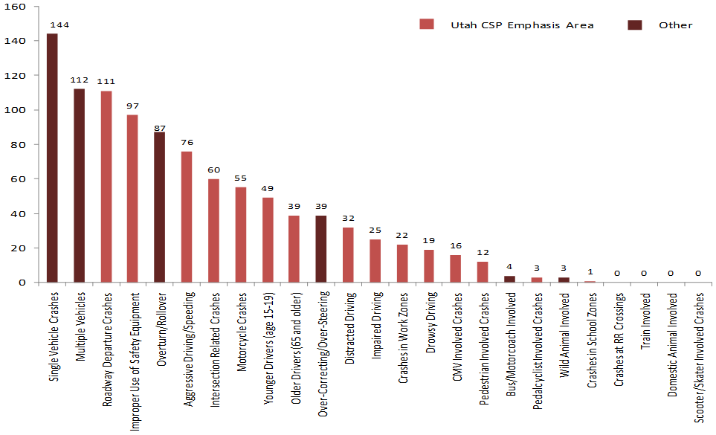

Figure 1 - Incidence of Severe and Fatal Crashes - 2010 - 2022 - Source: UDOT, protected under 23 USC 409
An analysis completed by Cambridge Systematics shows several contributing factors to crashes in Washington County. Common crash factors for our area include: multiple vehicles, intersection related crashes, aggressive driving/speeding, young drivers, single vehicle crashes, older drivers, roadway departure crashes, improper use of safety equipment, distracted driving, CMV involved crashes, overturn/rollover, crashes in work zones, and impaired driving.

From that analysis several possible focus areas were identified. The following are areas that will be given greater review:

Roadway Departures

The 2018 statistics from the Fatality Analysis Reporting System (FARS) show that national, there were 33,654 fatal crashes resulting in 36,560 fatalities. 45% of the fatalities were in rural areas while 53% were in urban areas. The fatality rate per 100 million vehicle miles traveled was 2 times higher in rural areas than un urban areas (1.68 and 0.86, respectively).

Nearly 36 percent of the fatal crashes were single-vehicle Run-Off-the-Road (ROR) crashes on various road types.

For two-lane, undivided, non-interchange, non-junction roadways exclusively, there were
8,901 (24 percent) single-vehicle ROR crashes recorded. There are more than twice as many ROR fatal crashes on rural roads than on urban roads, partly due to the higher speeds on rural roads, and the greater mileage, and lack of additional lanes, and median separation.

Some of the most prevalent contributing factors are listed below with a brief explanation of the problem. Objectives and strategies to address these factors also follow.

Restraint Use
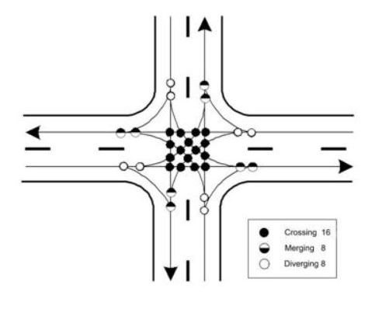
Figure 2 Intersection Conflict Point Diagram

Of the 22,215 passenger vehicle occupants killed in motor vehicle crashes in 2019, 47% were not wearing seat belts. NHTSA estimates that 14,955 lives were saved in 2017 through the proper use of seat belts. An additional 2,549 people could have been saved if they had been wearing a seat belt.

Intersection Accidents
Un-signalized
Intersections constitute only a small part of the overall highway system, yet intersection-related crashes constitute more than 50 percent of all crashes within urban areas and over 30 percent in rural areas (Kuciemba and Cirillo, 1992). Fatal intersection crashes are a smaller portion of the total picture, suggesting that severity of crashes at intersections is lower than elsewhere.

Signalized
Intersections constitute only a small part of the overall highway system, yet intersection related crashes constitute more than 20 percent of fatal crashes. It is not unusual that crashes are concentrated at intersections, because intersections are the point on the roadway system where traffic movements most frequently conflict with one another. Good geometric design combined with good traffic control can result in an intersection that operates efficiently and safely.

Aggressive Driving
While estimates of the problem vary, perceptions among both law enforcement and drivers are that aggressive driving is becoming more prevalent. According to a National Highway Transportation Safety Administration (NHTSA) survey about aggressive driving attitudes and behaviors, more than 60 percent of drivers see unsafe driving by others, including speeding, as a major personal threat to themselves and their families. More than half admitted to driving aggressively on occasion. The Surface Transportation Policy Project estimated that aggressive actions contributed to 56 percent of all fatal crashes. However, without a clear definition of aggressive driving, these broad assertions are difficult to support.

Older Drivers
Between 2012 and 2050, the United States will experience considerable growth in its older population. In 2050, the population aged 65 and over is projected to be 83.7 million almost double the estimated population of 54 million in 2019, according to the US Census Bureau. By 2030, one in five Americans will be age 65 or older. In 2019, there were 5,195 people 70 and older killed. In 2017, older people made up 17 18 percent of all traffic fatalities during the year. As people age, a decline in sensory, cognitive, or physical functioning can make them less-safe drivers, as well as more vulnerable to injury once in a crash. Yet older Americans depend on automobiles for meeting their transportation needs.

The real safety concern for the older driver arises when one also takes into consideration their increased likelihood of being injured or killed in a crash. The older population traffic fatality rate per 100,000 US resident was 14.2 in 2019 vs 14.7 in 2010.

Objectives & Strategies
The Dixie MPO is focusing on the above contributing factors because of the impacts they pose in our area. Although these factors pose significant concerns it is possible to help alleviate those concerns through the adoption and implementation of objectives and strategies addressing each area. The listing below includes strategies which if implemented will help the Dixie MPO to address each focus area:

Roadway Departures (RD)
RD1 Keep vehicles from encroaching on the roadside
    - Install shoulder, edge-line, or mid-lane rumble strips where needed
    - Provide improved highway geometry for horizontal curves
    - Provide enhanced pavement markings
    - Provide skid-resistant pavement surfaces
    - Apply shoulder treatments
    - Eliminate shoulder drop-offs
    - Widen and/or pave shoulders
    - Add medians or median separation where appropriate
RD2 Minimize the likelihood of crashing into an object or overturning if the vehicle travels off the shoulder
- Design safer slopes and ditches to prevent rollovers
- Provide appropriate clear zones
- Remove/relocate objects in hazardous locations
- Delineate trees or utility poles with retro-reflective tape
RD3 Reduce the severity of the crash
- Improve design of roadside hardware
- Improve design and application of barrier and attenuation

Intersections
Un-signalized
I.1 Management of access points near un-signalized intersections
- Implement driveway closures/relocations
- Implement driveway turn restrictions
I.2 Reduce the frequency and severity of intersection conflicts through geometric design improvements
- Provide left-turn lanes at intersections
- Provide bypass lanes at T-intersections (Hi-T designs)
- Provide deceleration lanes and right-turn lanes at intersections
- Provide right-turn acceleration lanes at intersections
- Provide full-width paved shoulders in intersection areas
- Restrict or eliminate turning maneuvers by use of medians
- Restrict or eliminate turning maneuvers by providing channelization or closing median openings
- Close or relocate “high-risk” intersections
- Reduce lane off-sets through intersections
- Improve pedestrian and bicycle facilities to reduce conflicts between motorists and non-motorists
I.2 Improve sight distance at un-signalized intersections
- Clear sight triangles on stop- or yield-controlled approaches to intersections
- Clear sight triangles in the medians of divided highways near intersections
- Eliminate parking that restricts sight distance
I.3 Improve driver awareness of intersections as viewed from the intersection approach for both daytime and nighttime driving
- Improve visibility of intersections by providing enhanced signing and delineation
- Improve visibility of the intersection by providing lighting
- Improve sight distances around intersections
- Provide a stop bar on minor road approaches
- Install larger regulatory and warning signs at intersections
I.4 Choose appropriate intersection traffic control to minimize crash frequency and severity
- Provide all-way stop-control at appropriate intersections
- Eliminate all-way stop control where not warranted
- Provide roundabouts at appropriate locations
I.5 Improve driver compliance with traffic control devices and traffic laws at intersections
- Provide targeted public information and education on safety problems at specific intersections
I.6 Reduce operating speeds on specific intersection approaches
- Post appropriate speed limit on intersection approaches
I.7 Guide motorists more effectively through complex intersections
- Provide turn path markings
- Provide lane assignment signing or marking at complex intersections
- Meet or exceed MUTCD signing and striping requirements

Signalized intersection
I.8 Reduce frequency and severity of intersection conflicts through traffic control and operational improvements
- Restrict or eliminate turning maneuvers
- Employ signal coordination
- Improve operation of pedestrian and bicycle facilities at signalized intersections
- Remove unwarranted signals
- Provide advance intersection warnings where needed on higher speed road

I.9 Reduce frequency and severity of intersection conflicts through geometric improvements
- Provide/improve left-turn channelization
- Provide/improve right-turn channelization
- Improve geometry of pedestrian and bicycle facilities
- Reduce un-necessary delays
- Reduce lane off-sets through the intersection
- Improve night-time signing and visibility
I.10 Improve sight distance at signalized intersections
- Clear sight triangles
- Avoid curved approach roads
- Adjust median landscaping to allow for proper sight distance
- Add back plates to enhance contrast between signals and their surroundings
- Add supplemental signal heads to enhance signal visibility

Aggressive Driving

AD.1 Deter aggressive driving in specific populations, including those with a history of such behavior, and at specific locations
- Conduct educational and public information campaigns
AD.2 Improve the driving environment to eliminate or minimize the external triggers of aggressive drivers
- Change or mitigate the effects of identified elements in the environment
- Reduce nonrecurring delays and provide better information about these delays

Older Drivers

OD.1 Plan for an aging population
- Establish a broad-based coalition to plan to address older adults’ transportation needs
OD.2 Improve the roadway and driving environment to better accommodate the special needs of older drivers
- Provide advance warning signs
- Provide advance-guide and street name signs
- Provide all-red clearance intervals at signalized intersections
- Provide more protected left turn signal phases at high-volume intersections
- Provide offset left-turn lanes at intersections
- Improve lighting at intersections, horizontal curves, and railroad grade crossings
- Increase overall sign size (letters and numbers)
- Use higher reflective sign sheeting to provide improved recognition
- Encourage compliance with new retro-reflectivity standards
- Improve roadway delineation
- Replace painted channelization with raised channelization
- Reduce intersection skew angle
- Improve traffic control at work zones
OD.3 Reduce the risk of injury and death to older drivers and passengers involved in crashes
- Increase seatbelt use by older drivers and passengers through public education campaigns
- Provide "mature driver" stickers for all drivers over 65

Dixie MPO SS4A Safety Action Plan Promise

As of 2023, the Dixie MPO received a $1 million award from the Safe Streets and Roads Discretionary Grant Program (provided by Bipartisan Infrastructure Law under the Biden administration) to develop a Safety Action Plan in Washington County, Utah. This funding will be available through FY2023-2026. The Safety Action Plan Grant will allow the MPO to analyze all roadway safety and roadway fatality concerns within Washington County and how to plan to reduce roadway fatalities and serious injuries.

Chapter 8 – Security

The world has come to understand, since September 11, 2001, that our security is of utmost importance. We are fortunate to have a very active and comprehensive Emergency Management Office in Washington County that addresses road infrastructure as it relates to emergency evacuation.

Washington County Emergency Management
The Washington County Emergency Management Office has developed an Emergency Management Plan. The plan includes a County response to a variety of emergency situations which may occur in and around our communities. An evacuation Annex portion of the plan identifies procedures to coordinate evacuation needs during times of a natural, man-made, technological, and Homeland Security emergencies or disaster. The following information is intended to provide information about the Washington County Emergency Management plan and not be a comprehensive report. Please reach out to Washington County Emergency Services for the entire plan or to speak with the County Emergency Manager. 435-301-7360

The portion of the Washington County Emergency Management Plan as it relates to transportation coordination is referred to as the Evacuation Annex and is outlined below. The purpose of Annex B, Evacuation, is to coordinate evacuation needs during times of a natural, man-made, or technological Homeland Security emergency or disaster.

The Evacuation Annex includes information regarding action, coordination, and preparation. The sections of this annex are:

Situation and Assumption
- Situation
- Assumptions

Concept of Operation
- General
- Mitigation Phase
- Preparation Phase
- Response Phase
- Recovery Phase

Direction and Control

Organization and Assignment

The organization for protective action decision-making and implementation is the same as the emergency response, law enforcement, and support organizations used during emergencies and daily operations as defined in the basic plan. These responsibilities fall under the categories listed below, each with their own list of responsibilities. The full list of responsibilities is found in the Washington County Emergency Management Plan.
- Incident Commander
- Washington County Emergency Services
- Transportation Unit
- Washington County Council on Aging
- Washington County Sheriff’s Office
- Utah Highway Patrol
- Fire, Rescue and Emergency Medical Services
- Washington County School District
- Washington County Public Works
- Washington County Road Department
- Southwest Utah Health Department
- Washington County Public Information Officer
- American Red Cross
- Utah Department of Transportation

Administration and Logistics

Evacuation planning also will include consideration of:
1. The area to be evacuated.

2. Pick-up points where persons without private transportation will gather for evacuation by public transport.

3. Designated evacuation routes to be used by all vehicles during the evacuation.

4. Location of traffic control points.

5. Safe areas or buildings which provide some temporary measure of protection for evacuees from an actual or threatening disaster.

6. Location of reception centers where evacuees will be sent prior to moving to shelters or mass care shelters.

7. Designated mass care shelters that provide emergency sheltering and feeding of large numbers of evacuees.

8. Location of medical aid stations on evacuation routes, at temporary safe areas, and mass care shelters.

9. The time available for a reasonably risk-free evacuation.

10. Any personal belongings for the evacuated public.

Coordination with professional emergency managers
It is important to reach out to potential partners and develop a relationship in order to develop and foster a solid and lasting relationship. Building a network of professionals that work in the areas of security and emergency management that coordinates on a routine basis, regardless of whether a specific project is being developed, is critical to being able to smoothly incorporate these partners when beginning a new project.

The Washington County Emergency Management Office has worked diligently over the years to coordinate with all emergency management professionals.

Objective and Goals
To help to maintain a safe and secure environment the Dixie MPO will work towards meeting goals in cooperation with the Washington County Emergency Management Office and as stated below.

Objective
Work within existing networks to support the efforts of the Washington County Emergency Management Office.

Goals
1 Become more aware of the efforts of the Washington County Emergency Management Office.

2 Use the County Emergency Management contact list to begin a dialogue regarding evacuation planning for applicable projects.

3 Work with emergency managers to identify the best evacuation routes through the transportation network.

Chapter 9 – Congestion Management

A primary measure of a transportation system’s success is that system’s ability to accommodate traffic demands while minimizing traffic delay and congestion. The Dixie MPO Travel Demand Model forecasts growth in future traffic demands due primarily to the area’s expected population growth. Following is a brief analysis of impacts associated with traffic congestion:

For this 2023 plan update, the 2050 “Build” Scenario (meaning all planned projects are constructed by 2050) and the 2050 “No-Build” Scenario (meaning no additional projects are constructed) were compared to render two outputs:
- The “Network Vehicle Delay” comparing the number of vehicle hour delays in 2050 under the two scenarios (chart at the right).
- The “total travel time” or a collective measure of the hours people would spend traveling on an average day in 2050 under each of the two scenarios (chart below).

The build scenario shows an overall reduction in Network Vehicle Delays of 38,500 hours per day (less idling/delayed vehicles). The build scenario also shows a reduction 41,600 hours a day of in Network Travel Times (more efficient travel throughout the network).

The societal cost of travel time delays includes an increase of air pollution as vehicles sit idling in traffic, a loss of productivity as motorists spend more time on the road, an increase in fuel costs, decreased safety, and an increase in motorist stress levels.

Managing congestion on a constrained transportation network (while accommodating population growth) requires careful decision making and the addition of network connections. The proper mix of highways, surface roads, public and private transit, bicycle and pedestrian facilities must be found to help maintain the quality of life and economic vitality desired in Utah’s Dixie.

Condition | 2050 Daily Network Hours Traveled  Travel Time (hours)
No Build | 294,900
Build | 253,300

Objectives and Goals
The Dixie MPO recognizes the potential for extreme traffic congestion and will strive to support congestion reducing efforts.
Objective
The Dixie MPO will encourage the reduction and management of traffic congestion through the implementation of useful transportation tools as well as construction of appropriate infrastructure.
Goals
- Support the use of transportation tools including ITS Message Boards, the Traffic Control Center (TOC), Traffic Management efforts, Ramp Metering, Reversible Lanes, Cross-over left turn lanes and other state of the art tools.
- Support the use of appropriate Transit Projects including the implementation of a Transit line from St. George to Springdale and possibly to from St. George to the local airport.
- Identify and support the construction of Transportation infrastructure projects aimed at reducing congestion.
- Encourage and recommend congestion reducing tools in each new project.
- Use the Travel Demand Model to identify congestion delay and measure the reduction progress.

Chapter 10 – Corridor Preservation
Corridor preservation is the practice of purchasing future rights of way many years ahead of planned transportation projects as an effort to reduce overall costs to taxpayers. Estimates indicate that the early and well-planned purchase of transportation corridors can result in significant cost savings in the acquisition of right of way. The degree of importance for corridor preservation increases in areas like the Dixie MPO where high population growth is anticipated as developers and homebuilders are not always cognizant of the impacts their actions could have on the overall transportation community.

In 2009, the Washington County Board of Commissioners implemented a “$10 per vehicle” annual registration fee to endow a corridor preservation fund that is administered by the county-wide Council of Governments (COG). The Dixie MPO encourages all municipalities to anticipate and address corridor preservation needs within their own boarders – and to utilize the Washington County Corridor Preservation Fund:

The COG is made up of elected leaders from throughout Washington County. The Council meets at least annually to review a list of priority projects and program funds from the Local Transportation Corridor Preservation Fund. The Fund is accumulating about $1.5 million of revenues annually for acquisition of future rights-of-way. To receive funding, projects must be on the COG project priority list and be supported by a majority of Council members.

Objectives and Goals
Preservation of future transportation corridors is critical now and in the future; the Dixie MPO will work towards meeting goals and objectives to assist this worthy cause.
Objective
Coordinate with the COG to edit the list of priority projects and select right-of-way acquisitions that maximize the effective use of the Washington County Corridor Preservation Fund.
Goals
- Encourage all municipalities to anticipate and address corridor preservation needs within their own boarders.
- Assist with the efforts of Washington County Public Works in preparing the Annual Master Priority Corridor Preservation Project List.
- Notify Dixie MPO members aware of opportunities to use the Preservation Fund.
- Become more aware of project needs and look for opportunities to preserve important transportation corridors through use of the Fund.
- Work with Dixie MPO partners to identify opportunities for corridor preservation.

Chapter 11 – Environmental Mitigation

The primary purpose of the Dixie Regional Transportation Plan is to identify what transportation projects are needed in accordance with the values of safety, increased mobility, decreased traffic congestion, quality of life, economic development, and limited financial constraints.

Dixie MPO recognizes that transit, road, and trail projects bring positive and negative impacts to the natural and built environments. While corridor planning requires only a broad consideration of environmental impacts, Dixie MPO respects the more detailed environmental analyses required of each project prior to final design and construction. The MPO strives to establish steering and stakeholder committees to guide early corridor planning studies. Committees are comprised of resource agencies that consider impacts to air quality, farmland, fish and wildlife, historical/archeological resources, geologic hazards, floodplains, water quality, and wetlands.

Following is a brief discussion of potential environmental issues that may require further consideration, impact analysis, and environmental mitigation on a project by project basis prior to final alignment selection, design engineering, and construction:

Impacts

Farmland Impacts
Preservation of farmland is increasingly difficult in the Dixie Region. The shrinking availability of land, incentives to sell and give way to development, and the area’s harsh desert environment are combining to reduce the supply of farmable land within the Dixie MPO planning boundary. Incentives for jurisdictions to protect and preserve farm environments may not be strong enough to overcome these market forces that are driving a growth in population and consuming once farmable land for commercial and residential use.

Geologic Hazards
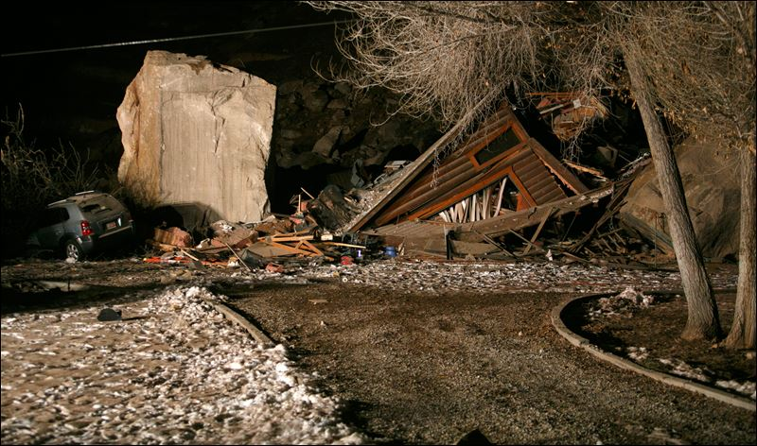
The geologic diversity within the State of Utah is well known and much of that diversity and topographical constraint exists in the Dixie MPO area. The region is susceptible to earthquakes, rock fall, landslides, expansive soils, etc. Due to recent area events, natural hazards have become an increasing concern for area planners and constructors. Natural Hazard information can be obtained by visiting the Five County Natural Hazard Mitigation Plan website (hazardmitigationplan.org). The MPO encourages transportation solutions to take in to account the known geologic hazards in plans, designs, and construction to prevent, avoid, or mitigate as much as possible current, ongoing, and future geologic events.

Fish and Wildlife Impacts
The following table presents federally threatened and endangered species, State sensitive species found throughout the Dixie Region. Although these species are identified for planning purposes and early corridor preservation studies, more detailed investigation of impacts, avoidance, or mitigation are generally required as individual projects advance through the environmental clearance process.

Federally Listed Species in the Dixie MPO planning area
This list was compiled using the Information for Planning and Construction (IPaC*) tool from the U.S. Fish & Wildlife Service; other federally listed species likely occur in Utah Counties. This list is the current list from IPaC as of March 14, 2023.
Common Name | Scientific Name | Status | Critical Habitats
Utah Prairie Dog | Cynomys parvidens | Threatened
California Condor | Gymnogyps californianus | EXPN**
California Least Tern | Sterna antillarum browni | Endangered
Mexican Spotted Owl | Strix occidentalis lucida | Threatened | Y / Final
Southwestern Willow Flycatcher | Empidonax traillii extimus | Endangered | Y / Final
Yellow-billed Cuckoo | Coccyzus americanus | Threatened
Desert Tortoise | Gopherus agassizii | Threatened | Y / Final
Northern Mexican Gartersnake | Thamnophis eques megalops | Threatened
Virgin River Chub | Gila seminuda | Endangered | Y / Final
Woundfin | Plagopterus argentissimus | Endangered | Y / Final
Monarch Butterfly | Danaus plexippus | Candidate
Dwarf Bearclaw-poppy | Arctomecon humilis | Endangered
Fickeisen Plains Cactus | Pediocactus peeblesianus ssp. fickeiseniae | Endangered
Gierisch Mallow | Sphaeralcea gierischii | Endangered | Y / Final
Holmgren Milk-vetch | Astragalus holmgreniorum | Endangered | Y / Final
Jones Cycladenia | Cycladenia humilis var. jonesii | Threatened
Shivwits Milkvetch | Astragalus ampullarioides | Endangered | Y / Final
Siler Pincushion Cactus | Pediocactus (=Echinocactus,=Utahia) sileri | Threatened
Ute Ladies'-tresses | Spiranthes diluvialis | Threatened
* Information for Planning and Construction (IPaC) from the U.S. Fish & Wildlife Service – March 14, 2023
** Experimental Population Non-Essential

Note: Please contact the U.S. Fish and Wildlife Service (801-975-3330) for the purpose of consultation under the Endangered Species Act.

“Certain birds are protected under the Migratory Bird Treaty Act and the Bald and Golden Eagle Protection Act.
“Any person or organization who plans or conducts activities that may result in impacts to migratory birds, eagles, and their habitats should follow appropriate regulations and consider implementing appropriate conservation measures [ . . . ].
“The birds listed below are birds of particular concern either because they occur on the USFWS Birds of Conservation Concern (BCC) list or warrant special attention in [the] project location. [ . . . ] This is not a list of every bird found in this location, nor a guarantee that every bird on this list will be found in your project area. [ . . . ]
“For guidance on when to schedule activities or implement avoidance and minimization measures to reduce impacts to migratory birds” on this list please visit the IPaC tool.” (IPaC U.S. Fish & Wildlife Service)

Birds of Conservation Concern
Common Name | Scientific Name | Level of Concern | Breading Season
Bald Eagle | Haliaeetus leucocephalus | Non-BCC Vulnerable | Breeds Oct 15 to Aug 31
Bendire's Thrasher | Toxostoma bendirei | BCC Rangewide (CON) | Breeds Mar 15 to Jul 31
Black Swift | Cypseloides niger | BCC Rangewide (CON) | Breeds Jun 15 to Sep 10
Black-chinned Sparrow | Spizella atrogularis | BCC Rangewide (CON) | Breeds Apr 15 to Jul 31
California Gull | Larus californicus | BCC Rangewide (CON) | Breeds Mar 1 to Jul 31
Cassin's Finch | Carpodacus cassinii | BCC Rangewide (CON) | Breeds May 15 to Jul 15
Clark's Grebe | Aechmophorus clarkii | BCC Rangewide (CON) | Breeds Jun 1 to Aug 31
Clark's Nutcracker | Nucifraga columbiana | BCC - BCR | Breeds Jan 15 to Jul 15
Costa's Hummingbird | Calypte costae | BCC - BCR | Breeds Jan 15 to Jun 10
Evening Grosbeak | Coccothraustes vespertinus | BCC Rangewide (CON) | Breeds May 15 to Aug 10
Golden Eagle | Aquila chrysaetos | Non-BCC Vulnerable | Breeds Dec 1 to Aug 31
Grace's Warbler | Dendroica graciae | BCC - BCR | Breeds May 20 to Jul 20
Lesser Yellowlegs | Tringa flavipes | BCC Rangewide (CON) | Breeds elsewhere
Lewis's Woodpecker | Melanerpes lewis | BCC Rangewide (CON) | Breeds Apr 20 to Sep 30
Long-eared Owl | asio otus | BCC Rangewide (CON) | Breeds Mar 1 to Jul 15
Marbled Godwit | Limosa fedoa | BCC Rangewide (CON) | Breeds elsewhere
Olive-sided Flycatcher | Contopus cooperi | BCC Rangewide (CON) | Breeds May 20 to Aug 31
Pinyon Jay | Gymnorhinus cyanocephalus | BCC Rangewide (CON) | Breeds Feb 15 to Jul 15
Rufous-winged Sparrow | Aimophila carpalis | BCC Rangewide (CON) | Breeds Jun 15 to Sep 30
Virginia's Warbler | Vermivora virginiae | BCC Rangewide (CON) | Breeds May 1 to Jul 31
Western Grebe | aechmophorus occidentalis | BCC Rangewide (CON) | Breeds Jun 1 to Aug 31
Willet | Tringa semipalmata | BCC Rangewide (CON) | Breeds elsewhere
BCC - Birds of Conservation Concern; CON - Birds of Conservation Concern in Continental USA; BCRs - Bird Conservation Regions

Historical/Archeological Impacts
Historical and archeological sites are other components that are not easily measured, but add character and quality of life in the Dixie Region. Avoidance, mitigation, and restorations are options to consider as planned solutions reach the environmental analysis phase.

Although the Dixie Region has not been completely surveyed for archaeological resources, the MPO boundary areas are likely to contain numerous archaeological sites.

The ancestral Southern Paiute are believed to have moved into this region sometime between AD 1000 and 1300. They were hunters and gatherers who practiced a seasonal round of resource collection and processing over a broad and diverse landscape. In southern Utah, however, some Southern Paiute groups became small-scale farmers and diverted water from the Virgin and Santa Clara Rivers and other smaller streams to cultivate garden plots. Euro-American explorers to this region, including Dominguez and Escalante in 1776 and Jedidiah Smith in the 1820s, reported seeing irrigation ditches and small check dams constructed by the Southern Paiute to divert water from the rivers and streams onto their fields of corn, beans, and squash. A Southern Paiute site, located on private land near the study area, was excavated by archaeologists from Brigham Young University in the 1980s. This site contained evidence of maize cultivation that dated to AD 1700 and 1830 (Allison 1988).

As part of the NEPA process, consultation will be required with Native American tribes that may have an interest in the study area. Final determination of tribes to include in the consultation process will be made during the NEPA process. The tribes with interest in the study area include the Hopi Tribe; the Navajo Nation; the Paiute Indian Tribe of Utah and its Shivwits, Cedar, Indian Peak, and Kanosh Bands; the Uintah/Ouray Ute; the Las Vegas Paiute; the Moapa Paiute; and the Kaibab Paiute.

Few surveys of historic resources have occurred within the study area. Historic resources in the study area relate to the 18th and 19th century Euro-American explorations. In 1776, two Franciscan priests from New Mexico, Dominguez and Escalante, traveled through southern Utah looking for an overland route to the Spanish colonies in California. This travel route came to be known as the Old Spanish Trail. The main branch of the Old Spanish Trail followed the Santa Clara River south from Mountain Meadows and then veered to the west over the low pass of Utah Hill (old Highway 91). In 2001, the Old Spanish Trail was designated as a National Historic Trail.

By the early 1850s, the first colonies were being established by members of the Church of Jesus Christ of Latter-day Saints in southern Utah. Some of the structures built by these colonies may be found in the study area; these structures include irrigation systems along the Santa Clara and Virgin Rivers and sites associated with stock animals.

Water-body and Floodplain Modification
Washington County in cooperation with FEMA and other agencies has produced an updated floodplain plan to deal with the aftermath of the January 2005 Flood in Dixie and to prevent and control floodwaters in future significant storm events. This plan is available at the offices of Washington County. The FEMA Digital Flood Insurance Maps greatly assist planning around and through flood plain areas. These and other maps are available at the FEMA web site or through any of the Washington County City offices that participate in the Federal Flood Insurance Program. The Washington County Flood Control Authority was formed as an intergovernmental body that deals with regional flood control issues within the county. Transportation needs solutions/projects must be planned designed and built with these requirements and conditions in mind.

Water Quality Impacts
Water quality can be greatly impacted by the number of impermeable surfaces (including roadways) in a region. Hard surfaces lead to polluted runoff instead of the water table’s natural percolation cycle. Most of the larger communities within the MPO boundaries participate in the Utah Pollutant Discharge Elimination System (UPDES) programs. These programs administered through the Utah Department of Environmental Quality (DEQ) are designed to reduce or eliminate pollutants from surface runoff in conjunction with the EPA Clean Water Act.

Wetland Impacts
Wetlands provide an invaluable resource to our ecosystem. Section 404 of the Clean Water Act protects wetlands from development without a permit issued by the Army Corps of Engineers. Designing the roadways to protect the wetlands within the Dixie Region is in accordance with the requirements of the Clean Water Act and leads to a more sustainable community. A local office of the Army Corps of Engineers has been established and is available for further information.

Climate Change
While local discussions of climate change effects are minimal within the Dixie MPO, more and more attention is being directed within the state concerning this issue. MPO executives and planners regularly discuss flood control plans and recognize the need to construct roads and bridges to accommodate heavy runoff volumes and to facilitate the local needs for drainage; however, climate change may also have an effect on this and other aspects of transportation. Flooding events in 2005 and 2011 stimulated local awareness of potential hydrology concerns in a changing environment and validated the need to over-plan bridge facilities and other flood treatments within the flood plains and waterways of Southwestern Utah. Changes in temperature, precipitation and extreme weather events have the potential to negatively affect the populations throughout the MPO.

A document titled "Climate Change and Public Health in Utah" provides an accessible overview and description of the influence of environmental factors on climate change and health in Utah. Many identified indicators could have an effect on how transportation is looked at and planned in the future.

Air Quality
Washington County, Utah, is currently considered an attainment area as defined by the Clean Air Act and therefore is not regulated by the EPA or the Utah Division of Air Quality. However, proper planning will be required if the region reaches non-attainment status in the coming years. In non-attainment status, plans to reduce personal automobile dependency would become vital. Although there are many sources of air pollution, including ambient air moving in from other parts of the region, auto emissions, vapor gases, and dust are common contributors to air pollution locally. Mode/trip decisions, reducing single occupancy vehicles, improving traffic flow and recovering gaseous vapors are some of the ways to protect the quality of air. These and other strategies will be looked at and recommended to local governments for their consideration and adoption. The Dixie area has been growing rapidly for many years and will continue to grow to build-out conditions and must look seriously at protecting its air shed quality.

The MPO anticipates continued growth in vehicle miles of travel, and the associated congestion and traffic delays that come with population growth. Some societal trends are catching hold toward the use of more energy efficient vehicles, and alternate modes of transportation such as bicycles, but the potential for air quality problems, especially for Ozone, is real for Utah's Dixie. The MPO will continue to endorse air-quality protection initiatives.

Integration of NEPA into the Planning Process
While the above elements are important components of the natural and built environment in the Dixie Region, each deserves its own thoughtful and comprehensive analysis on a project by project basis. At this point in the planning process, the Regional Transportation Plan does not attempt to perform a comprehensive Environmental Analysis or Environmental Impact Statement. Rather, the RTP is a list of projects that are deemed necessary to meet the growing regional transportation demands through 2050. Project alignments are mapped for planning and modeling purposes only with the expectation that adjustments may be necessary, or mitigation remedies required, as individual projects move through the environmental clearance processes as regulated by the National Environmental Policy Act (NEPA). Likewise, individual projects are not fully designed, engineered or final alignments set until that project is selected for funding priority and, where necessary, justified through an environmental clearance process.

Unified and Cooperative Planning Processes
In 2009, public and private planners throughout Utah began creating the unified planning tool “U-Plan” – a web-based information platform designed to allow road and utility planners to jointly access information on rights-of-way, infrastructure lines, environmental concern areas, habitat areas, and other built and natural resources. The Dixie MPO views U-Plan as an integral tool within the transportation planning process and encourages outside agencies to participate.

Objective and Goals
The Dixie MPO recognizes that there are many environmental challenges throughout its planning boundary that must be considered when planning and constructing regional transportation corridors. As a result, a number of strategies have been identified throughout this chapter.

Objective
The Dixie MPO understands the need consider these environmental challenges in the planning stages and will strive to incorporate environmental solutions into its planning process.

Goals
- To support the environmental processes associated with requirements for federally funded projects.
- To become more aware of the historical and geological issues of the area.
- Commission necessary studies and investigations to support the planning process.
- Stay abreast of changes in environmental requirements throughout the planning area and specifically those related to air quality with special emphasis on ozone.
- Support the plans, strategies, and Task Force identified in this chapter.
- Be committed to the Dixie MPO work plan as described above.

Chapter 12 – Active Transportation
As noted in the Chapter 3, pedestrian, bicycle, and micromobility facilities are an integral part of the area’s transportation system. Active transportation provides a myriad of economic, environmental and social benefits for the region. Vision Dixie calls for the implementation of “complete streets” criteria to ensure streets and roads accommodate all users including drivers, transit riders, pedestrians, and bicyclists, as well as for older people, children, and people with disabilities. Complete Street designs are also intended to improve motorist attitude and behavior toward other street users.

Dixie MPO Staff and the Technical Advisory Committee have been coordinating efforts to develop a more safe, attractive, and better-connected system of active transportation infrastructure. The region already includes an extensive array of trails, and some shared roadways and bike lanes. However, walking and cycling for transportation purposes is often inconvenient and unsafe, as the current transportation system lacks meaningful connections to destinations.

The Dixie MPO Regional Active Transportation Plan. Identifies projects and policies in the region that can create a transportation network conducive to cycling, walking, and micromobility. Dixie MPO has continued to implement long-range active transportation planning efforts by updating and adopting the Regional Active Transportation Plan. The 2023-2050 Plan was put together through coordinating with local municipalities, applying project to general phasing, identifying priorities, and aligning it with the UDOT Unified Plan. The plan is located at this web link:

The Active Transportation Plan recommends a network of connected facility types, including bike lanes, shared roadways, shared-use paths, and various crossing improvements. Map 8 illustrates those projects.

The Dixie MPO Active Transportation Plan has been introduced into each municipality’s transportation plan, with some cities opting to improve or further develop a more localized Active Transportation Plan. The Cities of St. George, Washington, and Hurricane have adopted Active Transportation Plans that are wrapped into their Master Transportation Plans.

Objectives and Goals

Objective
Improve conditions to make cycling and walking for transportation more safe, attractive, and convenient.

Goals

- Facilitate the appropriate design, construction, and maintenance of bicycle and pedestrian facilities.
- Support a multimodal transportation system for all new construction and reconstruction projects.
- Encourage policies and programs that improve bicycle and pedestrian safety.

Chapter 13 – Transit Service
SunTran provides transit service for the City of St. George, Washington and Ivins, currently operating fixed bus routes and paratransit (ADA) service between 6:00 AM and 8:00 PM Monday through Saturday. There is no service on Sundays or major holidays. The system consists of seven fixed bus routes, five of which operate on 40-minute headways with two operating on 80-minute headways. SunTran has experienced significant ridership growth since its inception in 2003 (See graph below). Areas being served by transit include: downtown St. George, Red Cliffs Mall, Dixie State University, the Dixie Center, the Dixie Downs area, Bloomington, Washington City and Ivins City. Map 9 shows the seven existing fixed SunTran routes, as well as potential routes for expansion.

SunTran continues to grow substantially in ridership and several studies and plans point to the need for expanded and improved transit service in the Dixie region to develop a more balanced transportation system and provide a greater range of transportation choices, particularly for those with limited mobility. In a past onboard transit survey, 90% of respondents stated it was important to expand SunTran service to new places in the area. This survey also indicated that the majority of SunTran riders rely on the service to meet their daily transportation needs, with 76% of respondents stating that they did not have another option (besides riding SunTran) for making their trip.

Subsequent studies have shown that additional transit lines to Santa Clara, La Verkin, Hurricane City and Zion National Park are feasible if public support, financing, and governance issues can be ironed out. In 2018 and 2019 Washington County and the Washington County Council of Governments have been actively working to resolved financing and governance issues in order to expand transit services from St. George to Springdale. Washington City elected officials have also sought funding to support local transit needs.

Potential Transit Expansion Areas
Transit expansion areas have been identified within St. George City, Washington City, Hurricane City and Springdale. Planners and elected officials throughout the Dixie Area continue to value public transit services to low-wage earners and to tourists to the area. Public support for expanded transit services is also growing.

St. George to Springdale
Under state legislation, elected officials within Washington County implement a one quarter of one percent sales tax in 2019 to fund transportation projects (including transit services) as requested by a contingency of cities within the County. The elected officials’ intent was to create a new funding stream for roads and to establish a transit line between St. George City and Springdale. The Utah Department of Transportation granted $16,000,000 toward the establishment of a Springdale transit line to enhance the economy, support tourism, and reduce congestion. The intent in establishing transit services to Springdale is to serve the local workforce who live outside the area, and to reduce visitor demand on the limited number of parking stalls within Springdale City

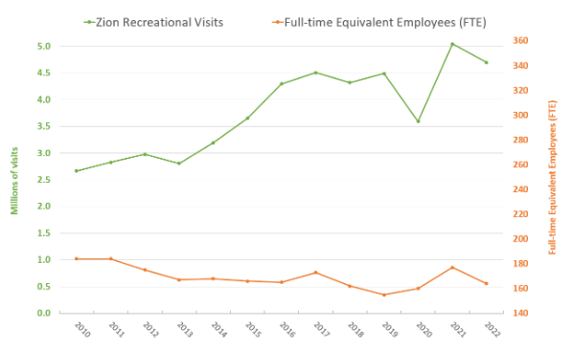
In 2016 The St. George to Springdale Public Transit Feasibility Study recommended that a route between Springdale and St. George is viable and could attract an annual ridership of 272,000 trips. Zion National Park sees over four million visitors annually (see chart at right). Once inside the park visitors are required to use a transit service to reach their final trailhead destinations. The 2016 study suggested that these visitors are already competent and accepting of transit use and would likely embrace transit lines prior to reaching the Park if they were established. Service sector employees would also benefit from transit services between the two areas.

Hurricane and Zion National Park Corridor
The Dixie Bus Rapid Transit Feasibility Study (BRT study) and the Hurricane to Zion Canyon Transit Study both point to the potential short term and long-term viability of transit service in this corridor. The BRT study evaluated the potential for long-term feasibility of transit service between central St George City and Hurricane City and central St George City and the airport. The study suggests that when the service area reaches 252,000 people and 143,000 jobs, BRT service will be viable. However, conventional bus service should be implemented to serve existing demand. Map 9 displays the potential alignments for these routes.

The Hurricane to Zion Canyon Transit Study evaluates and recommends transit service between Hurricane and Zion National Park. After analyzing demand in the corridor, the study recommends implementing fixed-route transit service with 60-minute headways. The study emphasizes that transit would only be viable in this corridor provided that a transit connection is also provided between St George and Hurricane.

The next step toward implementing transit in this corridor is to provide an implementation plan for transit service in the short term, which identifies service characteristics, fare structure, and funding, given resources that are available at the present time. This service is likely to be provided initially through an inter-local agreement with St George City, Hurricane, Springdale, and other communities in the corridor.

Hurricane City
Transit expansion in Hurricane has been considered for implementation in phases between 2023-2053. Phase 1 will begin with transit stops as suggested by the 2016 St. George to Springdale Public Transit Feasibility Study along SR 9 for the purpose of servicing local use and use of transit to Springdale and Zion National Park. Phase 2 of the transit plan will implement a second line creating a transit loop system like those in neighboring cities. Phase 3 include multiple lines of transit servicing Hurricane’s high traffic routes.

La Verkin City
With addition of the Springdale Transit Service Line, a transit stop for the route to Springdale will be provided in La Verkin. As transit ridership is studied after the Springdale line is completed, additional local stops in La Verkin will be taken into consideration but ultimately deemed necessary by the level of demand as needed.

Touquerville City
Due to budget constraints, service to Tourqueville was not feasible at the time of planning. With exception to a possible service stop for the Springdale Transit Line, the City of Touquerville does see the expansion of bus transit as a likely outcome within the next 20 to 30 years. However, at the current rate of change, expansion of roadway networks and possible housing development growth, transit services could be seen as beneficial for future connections to surrounding areas in La Verkin and Hurricane to meet accessibility needs.

Leeds City
With anticipated rapid growth of new development in Leeds, likelihood of transit being implemented also grows. Allow the expected time of Leeds receiving transit will not be until more development and residential growth expands to the necessary standards for services needed to be met. Further study and growth in Leeds must be done to determine the feasibility of transit expansion before any decisions are made.

Washington City
A concept route to Washington City was presented in the Dixie MPO Regional Transit Study. In 2014, Washington City began the process of formulating an agreement with SunTran to institute a fixed route that connects to the existing bus system with complementary para-transit service. Washington City Council was successful in establishing transit services in 2019 and anticipates additional service in coming years.

Santa Clara City
Due to budget constraints, service to Ivins City was initially instituted without service to Santa Clara City, which the bus passes through “doors closed” on the route. However, service to this community would benefit a large population of residents, not currently being served. The Dixie MPO will support coordination efforts between Ivins, St George City, and Santa Clara City to provide public transit service to Santa Clara City, given adequate funding and public support.

St George Airport
As noted above, a bus rapid transit line, servicing St George Airport is a viable service in the long term. However, in the short-term interim bus service should be provided to begin phasing toward a BRT line. The St George Urbanized Area Short Range and Long-Range Transit Plan (2006) identifies an express route to the airport. To maximize efficiency, the route schedule should be coordinated with air service.

Coordination of Transportation Modes
As regional transit service is improved and expanded, coordination with other modes of transportation is essential to offering alternative transportation options. Every trip on fixed-route public transportation begins and ends with another mode, whether it be cycling, walking or driving. Due to additional demand, SunTran has recently purchased additional capacity on its bicycle racks. SunTran Management indicates that demand for wheelchair users on transit has also risen substantially in recent years. In addition, SunTran is partnering with the Five County Association of Governments to improve conditions for passengers at bus stops by installing bus shelters. The Southwest Utah Coordinated Human Service Public Transportation Plan identifies the need for a last mile study to identify needed improvements for transit users on roadways near transit. Furthermore, as transit expands to Hurricane, Zion National Park and the Airport, consideration for Park-and-ride locations should be given.

Improved connections to inter-city bus and shuttle services are necessary to connect residents with the greater region. Greyhound, St George Shuttle, and Salt Lake Express currently offer services to Salt Lake City, Las Vegas and other nearby cities. However, these services are not well-connected to SunTran. Coordination with each entity is needed to improve the experience of transit users.

Coordination among providers to match users to the appropriate transit service or services is the focus of the Five County AOG Mobility Management Program. The Five County Regional Mobility Council guides this program, while coordinating human service and public transportation services throughout the region. The Dixie MPO will continue to support mobility management efforts to coordinate and expand services to meet the needs of seniors, persons with disabilities, and low-income individuals, as well as the greater community. The Coordinated Human Service Transportation Plan includes mobility management and other strategies to meet these needs.

Funding and Governance for Expanded Transit Service
In 2012, a Dixie MPO Regional Transit Study was completed to evaluate the governance and funding options available to the Dixie region for expansion and diversification of transit service. The study includes a case study of six transit organizations of similar size to illustrate the variety of governance and funding options for public transportation.

The study recommends a phased approach toward developing a regional transit service, beginning with improved service in St George and initial service to adjacent cities through inter-local agreements, followed by the establishment of a Regional Transit District, which is supported with a dedicated multi-jurisdictional funding for transit. This is only possible through public support, which should be gauged throughout the process.

As noted above, the first phase is currently being implemented through inter-local agreements in Ivins, with the initial phases of such agreements occurring in Washington City and the Hurricane/Zion Corridor. In 2018 the Utah Department of Transportation granted $15 million to expand transit services from St. George to Springdale contingent on local support to continue the service for at least 10 years. The Washington County Commission passed a one quarter of one percent sales tax increase in June 2019 to demonstrate that support. The Dixie MPO supports the region’s elected officials as they plan for improved regional transit services.

Objectives and Goals
Objective

Enhance and expand public transportation to build a more balanced transportation system

Goals

- Provide technical assistance to SunTran and cities in the region to plan for and implement expanded transit service
- Support efforts to develop a regional transit district or authority
- Identify sustainable funding sources for public transportation and assist with procuring funds
- Support the mobility management program to coordinate transportation services and meet the needs of residents with limited mobility

Chapter 14 – Public Involvement

Commitment to Public Involvement
The International Association of Public Participation defines five levels of public involvement in the IAP2 Spectrum of Public Participation. These five levels are 1) Inform, 2) Consult, 3) Involve, 4) Collaborate, and 5) Empower.

Public involvement is vital as the Dixie MPO plans transportation facilities through 2050. The MPO uses a web site, legal notices of meetings, news releases and a variety of newsletters to inform constituents of meetings, studies, plans, and opportunities to become involved in the planning process.

The MPO also sponsors an annual “Dixie Transportation Expo” to gather public comments and respond to inquiries, consult with citizen groups, and collaborate with them to realize potential solutions. An estimated 400 to 1,000 people attend the “Expo” annually to ask questions and comment on individual projects, plans, studies, environmental issues, future initiatives, etc. as transportation plans are laid and as projects move forward through the process from concept to construction. The “Expo” is scheduled annually the second Tuesday of February.

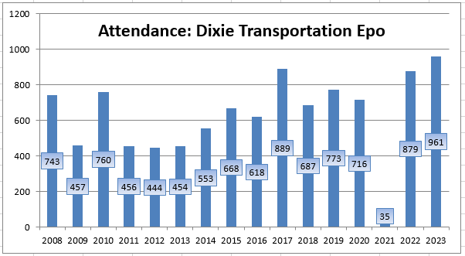

In some areas, the MPO has also found ways to empower citizen committees to directly influence plans for the future. The Vision Dixie process discussed earlier in this document was based on citizen input and attempts to capture the public’s vision for the metropolitan area of the future – and then plan to that vision. The bicycle/pedestrian trail section of this plan was also reviewed and expanded through the efforts of a citizen’s committee. In addition, the Southern Utah Truckers Association has given comments about roadway improvements that can be made to help freight move more smoothly through our communities.

Moving forward, the MPO is committed to include public involvement initiatives in its decision-making efforts, to communicate public concerns to MPO voting members, and to educate the public on MPO deliberation, options, strategies, and plans of regional significance.

Public Comments:

Public comments are currently being taken for this 2023-2050 Regional Transportation Plan and will be summarized in a separate document.

Chapter 15 – Freight
As a small MPO, the Dixie MPO has a seat on the State-wide Freight Mobility Group. The group is charged with the drafting of a State-wide Freight Plan including a Primary Freight Network Map. That plan is the backbone of this chapter and the map is found here as Map 11 (Appendix B). The state-wide plan is being drafted and currently includes the information below:

Purpose of Freight Planning
The primary purpose of the freight planning effort is to guide cost effective capital and operating investments in the state freight system to ensure maximum benefit and efficient movement of goods. This plan makes a case for the importance of investing federal and state funds in freight priority projects and programs through the following: an overview of the essential role of freight to our economy; a discussion on the condition and performance of Utah’s transportation’s assets and system; and a summary of the policies, strategies, and institutions that support freight.

This chapter incorporates key points, findings, and projects from Utah’s Unified Transportation Plan 2019-2050, and the Dixie MPO Long-Range Plan. Please refer to Chapter Four of this plan and the State Freight Plan for demographic, population and other specific information

Utah’s Freight Employment
There are a variety of jobs within the transportation industry here in Utah. Notice in the following table that the highest paying jobs are in the pipeline industry, but it also has the fewest people employed. The highest numbers of jobs are in the trucking industry, but they also have the second lowest annual income.

2022 Freight Employment and Salary by Transportation Industry
Industry | Number Employed |  | Average Annual Salary
Aviation | 7,780 |  | $91,920
Railroad | 1,021 |  | $77,772
Pipeline | 286 |  | $116,844
Trucking | 19,612 |  | $57,936
Warehousing | 13,486 |  | $51,120
 | Total | 42,185 | Average | $79,118
Source: Utah Department of Workforce Services, 2022 1st Quarter Industry Data.

Trucking
According to FHWA’s Highway Statistics, Utah has the highest percentage of truck traffic in the U.S. at 23 percent, while the average is 12 percent nationwide. Utah businesses have quick access to competitive trucking services to meet any logistics needs across the continent.

Utah’s Primary Freight Network (Highways)
Originally defined in 2005 as Utah Primary Freight Corridors, Utah has amended the name to be consistent with the FAST ACT and to distinguish between highway and railroad corridors. Utah’s PFN highways consist of Interstate Routes, Critical Rural Freight Routes, Critical Urban Freight Routes, and Energy Routes. The following table shows the number of miles by route type in Utah.

Utah’s Primary Freight Network Highway Mileage 2017
Route Type | Mileage
Interstate Routes | 904.90
Critical Rural Freight Routes | 182.10
Critical Urban Freight Routes | 91.2
Secondary Routes | 911,32
Intermodal Connectors | 18.28
Total | 2,107.80

Map #11 shows Utah’s PFN highways.

The PFN highways are statewide and include routes within the boundaries of the four MPOs, which include Cache MPO, Dixie MPO, Mountainland Association of Governments (MAG), and the Wasatch Front Regional Council (WFRC). Only 14 percent of Utah’s PFN highways are located within the MPO areas. The following table shows the route types and number of miles by MPO.

Metropolitan Planning Organizations and Statewide Highway Freight Network Mileage
Route Type | Cache | Dixie | MAG | WFRC | Statewide Rural | Total
Interstate Routes | 0 | 28.17 | 44.35 | 145.22 | 687.16 | 904.90
Critical Rural Freight Routes | 0.00 | 0.00 | 0.00 | 0.00 | 182.10 | 182.10
Critical Urban Freight Routes | 6.80 | 5.43 | 5.43 | 72.15 | 0.00 | 91.20
Secondary Routes | 28.24 | 22.39 | 6.14 | 15.76 | 838.79 | 911.32
Intermodal Connectors | 0.00 | 0.00 | 0.00 | 6.78 | 11.50 | 18.28
Total Route Miles | 35.04 | 57.38 | 55.92 | 239.91 | 1,719.55 | 2,107.80

There are four main grants or loan programs that are available to Utah counties and incorporated municipalities for highway related infrastructure improvements. While these programs do not specifically identify the use of these funds for freight improvements, it does not prohibit them either. The four main programs include the following:

Class B & C Road Funds
State Infrastructure Bank Loan Fund
UDOT Flexible Match on Federal-Aid Projects
Off-System Bridge Soft Match Credit Program

Strengths & Needs
As one of the first states to identify its PFN highways way back in 2005, Utah early on focused its research and improvement funding on those routes with the highest truck traffic volumes. Over the last decade UDOT has conducted extensive outreach and research with the trucking industry including the Southern Utah Truckers Association (SUTA). Many of the system improvement projects across the state and most of the projects in Washington County had direct input from SUBA and have been included on the State Freight Project List – excerpt shown below:

