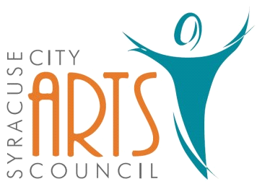
Syracuse City Arts Council Meeting Agenda
April 5, 2023 8pm
Meeting begins at 8pm
in the Syracuse City Municipal Building’s large conference room
located at 1979 West 1900 South.

1. Opening Business
- Call to Order
- Adoption of April 5, 2023 Agenda
- Review and Adoption of March 1, 2023 Minutes
- Approve Budget Expenditures since March 1, 2023

2. Public Comment-This is an opportunity to address the Council regarding concerns or ideas. Please limit comments to three minutes.
.
3. Remaining 2022-2023 SCAC Season Events
Orchestra: April 10, 2023 (Broadway or Musical Review)
Jazz Band: Spring Performance TBD, North Ogden Jazz Festival (June 2023), Heritage days
Jr. Theatre: Summer Camp (June 2023)
Theatre: Freaky Friday (July 2023)
Fundraisers: Battle of the Bands 2023
Other:

4. Date and details for Battle of the Bands

5. Update on storage - Dave

6. Boot Camp sign-ups and pricing

7. Orchestra desired purchases – electronic mallet controller & logo shirts. Vote as needed.

8. Publicity: Syracuse Connection information & other publicity as needed.

WORK SESSION
9. Committee/Board Member Updates/Discussion

10. Future Agenda Items

11. Adjournment

~~~~~~~~~~~~~~~~~~~~
In compliance with the Americans Disabilities Act, persons needing auxiliary communicative aids and services for this meeting should contact the City Offices at 801-825-1477 at least 48 hours in advance of the meeting.

CERTIFICATE OF POSTING
On February 27, 2023 this agenda was provided to the Standard Examiner and submitted to Syracuse City for posting on the Syracuse City Hall Notice Board and for publishing on the Syracuse City website, at http://www.syracuseut.com, and on the State Public Notice website, at http://www.utah.gov/pmn/indix.html. A copy was also submitted to the website manager for publishing on the Syracuse City Arts Council website, at http://www.syracuseutaharts.org/about-us/council-minutes. Libby Fawcett, Syracuse City Arts Council Chair

