MINUTES
Weber School Foundation Board Meeting
02/16/2023 12:00 PM | Meeting held at Weber School District Office and called to order by Josh Skidmore

Attendance
Present: Craig Adams, Mark Adams, Jenna Andrascik, Bryan Benard, Lindee Bess, Gina Butters, Flora Cassity, Craig Dearden, Michelle Darrington, Scott Dixon, Jeremy Dunn, Jamie Ellison, Kimberli Green, Bryan Hurst, Matt Jensen, Brett Karras, Steve Kier, Ashley Loftus, Clyde Moore, Emily Oyler, Kathy Saunders, Josh Skidmore, Phill Swanson, Jennie Taylor & Kerry Wahlen
Excused: Dave Andersen, Matt Bell, Dave Broadbent, Troy Bullard, Jan Burrell, Tyler Buxton, Tony Divino, Jen Dunyon, Kori Ann Edwards, Ryan Olsen & Angie Towns

Welcome
President Josh Skidmore welcomed everyone to the meeting and thanked them for getting their pictures taken.

Approval of Minutes
Phill Swanson made a motion to approve the minutes from the January 19, 2023 meeting with a second from Kathy Saunders. The minutes were unanimously approved.

Committee Reports
Special Needs—Flora Cassity reported since the last Board Meeting we have received four Special Needs requests. The first request was for a Rifton Mobile Stander for Denver Wasuita for $3,835.00. The next request was for a Touch Chat App for Fabion Rios for $799.95. The Special Needs Committee met before Board Meeting to discuss two larger requests. The first being a request for a fully-electric medical bed with hi-lo elevation and multi-height assist rails and comfort pressure mattress for Emylie Parker. The total for this request is $6,997.00. The second request is for an automotive vehicle adaption for Ben Petersen. This request is for $23,000.00. The committee approved the medical bed request but not the automotive vehicle adaption request. The total for these three requests is $11,631.95. Jeremy Dunn made the motion to approve these projects with a second from Steve Kier. The board unanimously approved.
Finance Report-Craig Adams reported that we had a good January with our investments which were up 5%. Our auditors asked if we had a formal deposit policy? We do because we only use depositories that are on the list that the state puts out quarterly. The Finance Committee discussed adding a line to our Investment Policy stating that we will only use qualified depositories to deposit our cash. We are in compliance with the State Money Management Act and are FDIC Insured up to $250,000.00.
Projects-Kathy Saunders reported we have received 30 Class Grant requests since our last meeting. Five requests are for Class Grants Non Donorschoose totaling $2,521.00. 25 requests are DonorsChoose totaling $9,907.40. Total combined for January and February=$12,428.40.
Year to Date Totals are:
School Grants $13,200.00
Class Grants Non DonorsChoose $5,921.00
DonorsChoose $27,158.57
Total of $46,279.57
We have received 11 Special Education Class Grants since our last meeting. Three requests are for Non DonorsChoose totaling $1,500.00. Eight requests are DonorsChoose totaling $3,799.25. Total combined for January and February=$5,299.25.
Year to Date Totals are:
Special Education Class Grants Non DonorsChoose $7,801.48
Special Education Class Grants DonorsChoose $16,261.56
Total=$24,063.04
Craig Dearden made the motion to approve these projects with a second from Phil Swanson. The board unanimously approved.

Director’s Report
New Executive Committee Member-Josh Skidmore informed the board that Foundation board member Troy Bullard is stepping down from the Foundation Executive Committee. He has left Larry H. Miller Company and has moved to Idaho. He is now working for the Young Automotive Group and would like to remain on our Foundation Board. The Executive Committee has asked board member Kimberli Green to replace Troy on the Executive Committee. Kimberli has accepted this position.
Teen Center Marketing Plan-Emily presented our Teen Centers Marketing Plan:
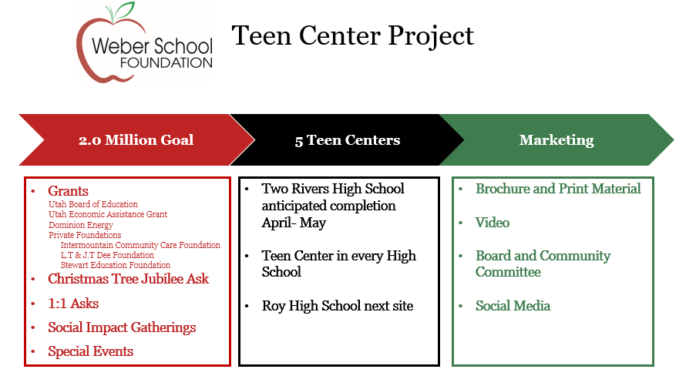
The Teen Center at Two Rivers is coming along! A walk-through video was shown to the board.
This Teen Center is being funded through the $250,000.00 Legislative Grant we received and funds raised from the Jubilee Ask. We are hoping to raise 2 million dollars for additional Teen Centers in our district. We are applying for additional grants through the Governor’s Office and Dominion Energy and plan on reaching out to private foundations as well. We would like to work with The Policy Project, a nonprofit organization, on hosting a community event at the Weber State University Alumni Center to spread awareness and help to raise funds for these centers. After the Two Rivers Teen Center is complete our next center will be at Roy High School. We are working with Jill Koford on brochures and print material and meeting with video production companies on producing a video about Teen Centers. We feel this investment will be very beneficial.
We are putting together a Teen Center Community Committee that will inform and educate community members on the need for Teen Centers in Weber School District.
2023-2024 Board Meeting Schedule-Emily informed the board that we usually begin meeting in September for the new school year. We would like to hold our first Board Meeting for next year on August 24, 2023 at the new Two Rivers Teen Center. We will take a tour and then break up into working groups to discuss Foundation topics.
Golf Tournament-June 12, 2023-The Gifts from the Heart Golf Tournament will be held on Monday, June 12, 2023 at the Ogden Golf and Country Club. We have 19 teams confirmed so far. Emily and Craig Dearden will be meeting with Bob from the Country Club soon to discuss tournament details.
Eccles Art Center Funding Request- The Eccles Art Center requested a $5,000.00 sponsorship from the Foundation again this year for their 58th Annual Art Auction Gala. This funding will be used for scholarships, Art on the Go for school classes, Art to Go bags and a table at the Gala. Director Pat Poce sponsors a Live Auction tree for us every year at the Jubilee and the Art Center hosts the Weber School District Art Show. This is a partnership we would like to continue. The Executive Committee has approved this request. Kathy Saunders made the motion to approve this request with a second from Mark Adams. The board unanimously approved.
President’s Award Nominations-These awards will be presented at the President’s Award Banquet which will be held on May 16, 2023 at the Timbermine. If you would like to nominate someone for this award please email Emily. Jamie will email out the Award Criteria as well as the list of previous recipients. The Executive Committee will make the final decision on these recipients.
Other Business-
-President’s Award Banquet-May 16, 2023-Our Foundation Annual President’s Award Banquet will be help on Tuesday, May 16, 2023 at 6:00 p.m. at the Timbermine.
Ribbon Cutting Dates
-Bonneville High Resource Center-March 21, 2023 4:00 p.m.
-Weber High Resource Center-March 29, 2023 4:00 p.m.
All board members are invited to attend these!
Youth of the Year Breakfast-Emily sits on the Boys & Girls Club of Weber-Davis Board. Every year they hold a Youth of the Year Breakfast. This is a state-wide honor and this year Aubrey Guerrero, Latino’s in Action leader at Roy High School won this $5,000.00 scholarship! Congratulations to Aubrey who will be attending our Board Meeting next month to deliver her acceptance speech.
Adjourn

Next Meeting
March 16, 2023
11:45 a.m. at Weber School District Office

