BEAVER FIRE DISTRICT
BOARD MINUTES
December 20, 2022
MEETING TIME: | 7:00 p.m.
BOARD MEMBERS PRESENT: | Jack Erwig, Board Chairperson  Larry Weaver, Fire Dept. Representative  Wade Hollingshead, County Commissioner  Leslie White, EMT Representative  Owen Spencer, City Council  Walt Kerksiek, EMT Representative  Kathy Hendricks, Fire District Secretary
REPRESENTATIVES PRESENT: | George Humphreys, Fire Chief  Jennifer Mcllnay, EMS Director  Von Christiansen, County Attorney
EXCUSED: | Paul Elieson, Citizen at Large
OTHERS IN ATTENDANCE: | Curtis Tonks, Utah Local Governments Trust
Jack welcomed everyone and called the meeting to order at 7:02 p.m.
- The regular meeting minutes from November 21 , 2022, were reviewed. Larry made a motion to approve them. Wade seconded the motion. Vote was unanimous. Motion carried.
- No conflict of interests was voiced regarding the items on this agenda.
- The November 2022 bills for the fire department were reviewed. Wade made a motion to approve the bills. Owen seconded. Vote was unanimous. Motion carried.
- The November 2022 bills for the ambulance service were reviewed. Wade made a motion to approve the bills. Larry seconded. Vote was unanimous. Motion carried.

OLD BUSINESS
- Jennifer discussed her thoughts on what she would like to have approved for the EMTs hourly pay raises. Larry made a motion to approve the hourly
27
pay raises at $13 Drivers; $14 Basic EMTs; $16 Advanced EMTs; and $18 for Paramedics. Wade seconded the motion. Vote was unanimous. Motion carried.
- Curtis Tonks came to our meeting and explained how the Utah Local Government Trust works regarding their insurance and submitted a bid in the amount of $23,543 annually for the BFD #1. They do however, bill from July through June for their fiscal year. The other one came from White Insurance Agency. They actually submitted three different bids, depending on the agency that they were going through. They were for: $40,985; $42,337; and $47,270. The board thoroughly discussed the insurance proposals that had been received. Wade made a motion to approve the purchase of insurance through the Utah Local Governments Trust and to split the cost between the Fire Dept and EMS Service according to what they have to insure; usually it's around a 70/30 split with the Fire Department having the most to insure. He also stated that his motion included giving Jack the authority to approve the signing of the paperwork between meetings. Owen seconded the motion. Vote was unanimous. Motion carried.
- Kathy noted that an Audit Proposal Request had been sent to the following agencies:
  - Kimball Roberts; Richfield, UT
  - Larsen & Co.; Spanish Fork, UT
  - Miller & co.; Richfield, UT
They have until February 1, 2023, to submit proposals to her, which in turn will be forwarded to each board member.

NEW BUSINESS
9. Between BFD #1 board meetings, another meeting was held which included the County Commissioners, County Attorney's Office, Fire Department personnel, Elk Meadows Special Service District board members and citizens to discuss Beaver Service District #1 taking over the Elk Meadows Service District #6 as far as fire is concerned. The Commissioners approved Beaver County Resolution #2022-07 turning everything over on the mountain to Beaver Fire District #1 including tax monies, building, vehicle, land, etc. before January 1, 2023.
1 0. George brought up that he would like to see our board meetings go from monthly to quarterly. There was a discussion and the board members agreed. Starting in January 2023, our meeting dates will be the third Monday of every third month, unless it lands on a holiday, then it will be held the following Monday. Meetings will be held on the following dates:
March 20, June 26, September 18, and December 18 at 7:00 p.m. Kathy will place an article in the newspaper stating the dates and times of our meetings for the next year.
28
1 1 George discussed the following items with the board members for the fire department.
Our department has a lot of good people and active fire fighters involved in on our fire department.
- Andrew Penman, a highway patrolman/fire fighter, was made Fire Fighter of the Year in the department plus he was also made the Utah Hot Zone Champion locally.
- The Christmas party went very well last Saturday night. Many of the fire fighters received promotions and awards.
- Nick is the Battalion Chief over the fire department at Elk Meadows. Just a note: We did not receive the grant George applied for through Homeland Security.
Received bottles that had been ordered.
12. Jennifer discussed the following items with the board members for the ambulance service:
a. Medic IV has been having some major problems. It has broken down on the road three different times. Patients have had to be picked up from the broken-down ambulance and transported by other means. Jennifer has requested bids from a few different places to get the ambulance fixed. To date she has received two bids and she is waiting on one more. The two she received was 1) Anytime Road Service & Repair for $19,778.32; and 2) RKL Diesel for $17,568.32 plus they offer a warranty. Owen made a motion to allow Jen the discrepancy to decide which bid would be best for her department. Leslie seconded the motion. Vote was unanimous. Motion carried.

PUBLIC HEARING
- Walt made a motion to move into the Public Hearing at 8:14 p.m. Larry seconded the motion. Vote was unanimous. Motion carried.
- A discussion was held to amend the 2022 budget for both the fire department and the ambulance service. Also discussed were the 2023 proposed budgets. Leslie made a motion to go out of the Public Hearing at 8:20 p.m. Walt seconded. Vote was unanimous. Motion carried.
1 5. Leslie made a motion to approve the amended 2022 budget for both the fire department and ambulance service. Wade seconded. Vote was unanimous. Motion carried. See the attached Resolution No. 2022-1 Amending the Beaver Fire District #1 Budget for the Year 2022.
29
- Leslie made a motion to adopt the 2023 proposed budget for the fire department and ambulance service. Wade seconded. Vote was unanimous. Motion carried. See the attached Resolution No. 2022-2 Amending the Beaver Fire District #1 Budget for the Year 2023.
- Meeting was adjourned at 8:25 p.m. The next regularly scheduled meeting will be held on Monday, March 20, 2023, at 7:00 p.m.
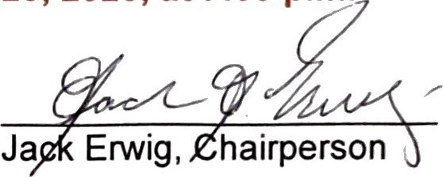
30
BEAVER FIRE DISTRICT NO. 1 RESOLUTION NO. 2022-1:

A RESOLUTION AMENDING THE BEAVER FIRE DISTRICT NO. 1

BUDGET FOR THE YEAR 2022
WHEREAS, Utah Code Ann. S 17B-1-621 grants the administrative control board of a local district legal authority to amend a service district budget.
WHEREAS, in keeping with Utah code Ann. SS 17B-1-609 and 610, correct legal notice has been given and a public hearing properly held regarding the amended budget.
NOW THEREFORE, The Administrative Control Board of Beaver Fire District No. 1 hereby resolves as follows:
SECTION 1: The Beaver Fire District No. 1 Budget for 2022 is hereby amended, and a copy of the amended budget is attached hereto and incorporated by reference;
SECTION 2: This resolution shall take effect immediately upon approval by the Administrative Control Board of Beaver Fire District No. 1, and execution of this Resolution by the Board Chair and attestation of the same by the secretary of the same.
PASSED this 20th day of December 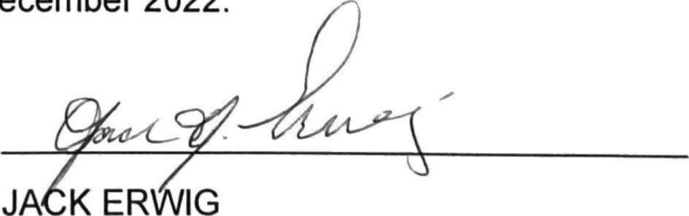2022.
JA
IG
Chairperson, Beaver Fire District No. 1
Attest:
KATHY HEN |  |  | R | KS
Secretary
BEAVER FIRE DISTRICT NO. 1 RESOLUTION NO. 2022-2:
A RESOLUTION ADOPTING THE BEAVER FIRE DISTRICT NO. 1
BUDGET FOR THE YEAR 2023
WHEREAS, Utah Code Ann. S 17B-1-614 grants the administrative control board of a local district legal authority to adopt a service district budget by resolution.
WHEREAS, in keeping with Utah Code Ann. SS 17B-1-609 and 610, correct legal notice has been given and a public hearing properly held regarding the proposed budget.
NOW THEREFORE, The Administrative Control Board of Beaver Fire District No. 1 hereby resolves as follows:
SECTION 1: The Beaver Fire District No. 1 Budget for 2023 is hereby adopted, and a copy of the budget is attached hereto and incorporated by refe re n ;
SECTION 2: This resolution shall take effect immediately upon approval by the Administrative Control Board of Beaver Fire District No. 1, and execution of this Resolution by the Board Chair and attestation of the same by the secretary of the same.
PASSED this 20th day of December 2022.
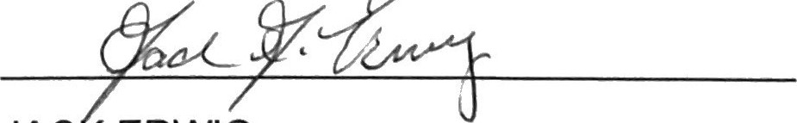
JAC ERWIG
Chairperson, Beaver Fire District No. 1
Attest:

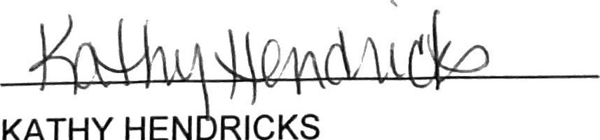KATHY
HEN
RICKS
Secretary

