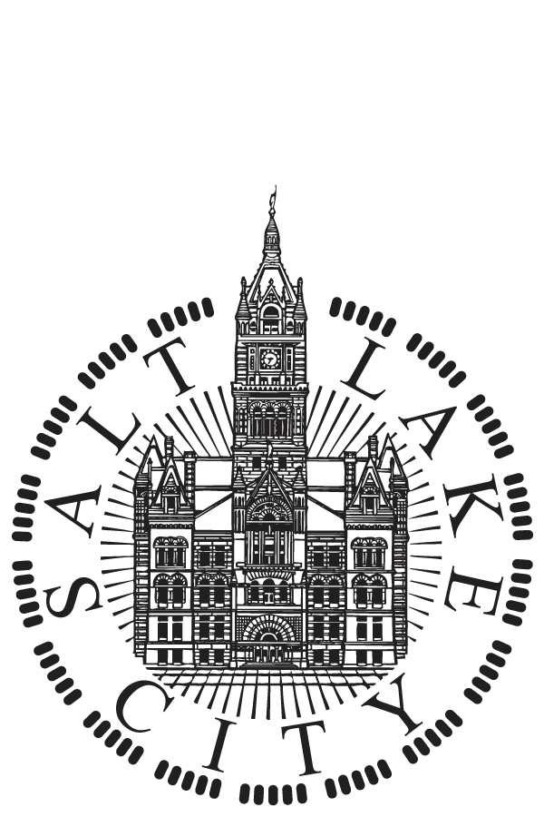 | SALT LAKE CITY  NOTICE OF  PUBLIC HEARING  March 21, 2023, at 7:00 p.m.

NOTICE IS HEREBY GIVENT THAT ON Tuesday, March 21, 2023, at 7:00 p.m. a public hearing will be held before the Salt Lake City Council to accept public comment on proposed projects and activities to be undertaken with 2023-2024 federal funds under the following U.S. Department of Housing and Urban Development (HUD) programs:

- Community Development Block Grant (CDBG)
CDBG funds may be used for the development of viable urban communities by providing decent housing and suitable living environments for persons of low- and moderate-income.
- Emergency Solutions Grant (ESG)
ESG funds may be used to assist individuals and families regain housing stability after experiencing a housing or homelessness crisis.
- HOME Investment Partnerships Program (HOME)
HOME funds may be used to create affordable housing opportunities for low- and moderate-income households.
- Housing Opportunities for Persons With AIDS (HOPWA)
HOPWA funds may be used to provide housing assistance and related supportive services to persons living with HIV/AIDS and their families.

This Public Hearing will use a hybrid meeting format. Hybrid meetings allow people to join online through Webex or in-person at the City & County Building, located at 451 South State Street, Room 326, Salt Lake City, Utah 84111.

Prior to making funding decisions on the 2023-2024 program year, the Salt Lake City Council will consider and review all public comments, as well as funding recommendations provided by Mayor Erin Mendenhall and resident advisory boards. Information about funding recommendations can be found on Salt Lake City’s Housing Stability website at https://www.slc.gov/housingstability/

To send comments directly to the Council, email council.comments@slcgov.com, leave a message on the 24-hour comment line 801-535-7654, mail written comments to the Salt Lake City Council office at 451 South State Street, Room 304, PO Box 145476, Salt Lake City, Utah 84111, visit https://www.slc.gov/council/contact-us/ or see Webex instructions to learn how to participate live, https://www.slc.gov/council/virtual-meetings/. Comments may also be submitted to the City’s Housing Stability Division at dillon.hase@slcgov.com, 801-535-6402, which will be provided to the Council. All comments received through any source are shared with the Council and added to the public record. The public comment period for this meeting starts on March 21st, 2023, and ends on April 18th, 2023 at 5:00 pm. Comments received after that date will still be shared with the Council.

The City & County Building is an accessible facility. People with disabilities may make requests for reasonable accommodation, which may include alternate formats, interpreters, and other auxiliary aids and services. Please make requests to the City Council Office at least two business days in advance.

Formal Meeting @2 pm
https://tinyurl.com/FormalMeeting0321
Event Number: 2491 919 2831
Event Password: 0321

EQUAL OPPORTUNITY PROGRAM

Salt Lake City Corporation is committed to ensuring we are accessible to all members of the public to review and provide comments to publicly noticed information. This includes, but is not limited to, individuals with disabilities, all racial and ethnic populations, and non-English speaking individuals. To request Americans with Disabilities Act accommodations, contact Ashley Lichtle by email at ada@slcgov.com or by phone at 801.535.7697. Over the phone TTY relay services are available by dialing 7-1-1. For non-English speaking individuals, contact Roxanna Orellana by email at roxana.orellana@slcgov.com, or by phone at 801.535.6381.

