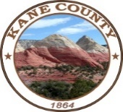
Kane County
Recreation & Transportation
Special Service District
76 North Main Street ▪ Kanab, UT 84741
435.644.4964

Board Meeting
March 21, 2023
10:00 AM
Location:
Kanab Center
School Board Room
20 N. 100 E. Kanab, UT

Agenda
- Business: Approval of 01-17-2023 RTSSD meeting minutes

- Financial: Signatures - Checks & Invoices – Clayton Cutler

- Financial: Account Updates & Overview – Clayton Cutler

- Discussion/Possible Action for Kanab City Little League Lights Funding Request – JD Wright

- Discussion/Possible Action for Church Wells SSD Road Improvement Project – Kevin Barnes

- Discussion/Possible Action for East Zion Trails Resurvey Project- Kelly Stowell

- Updates: Board members/Other

- This meeting will be available electronically: https://us02web.zoom.us/j/82172541301
Meeting ID: 821 7254 1301

