NOTICE OF PUBLIC HEARING

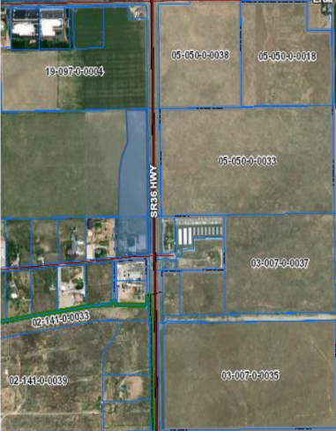
Subject property

Subject Property

- MMD Properties and Michael Pressley are requesting to rezone 09-023-R-0030 (5.01 acres) and a portion of 01-421-0-0012 (13.31 acres) from RR-5 (Rural Residential) to CG (Commercial General)

On Tuesday, March 28, 2023, the Erda City Planning Commission will hold a public hearing regarding the request described above. The meeting will be held at 7:00 p.m. at the Erda City Office located at 2163 West Erda Way, next to the Erda Fire Station.

You have the right to attend and speak at the public hearing. Please be aware, however, that in making its decision the Planning Commission can only rely on evidence, not opinion or conjecture. You may also submit comments in writing, but please do so at least 24 hours before the hearing so that your comments can be provided to the Planning Commission and to the applicant in an appropriate manner. For questions or additional information, please contact Erda City at 435-243-5577 or Jennifer Poole at jpoole@erda.gov.

