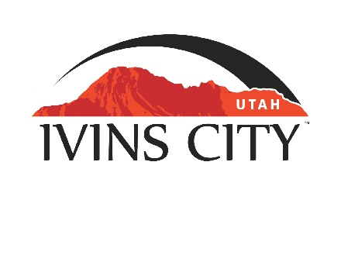
IVINS CITY

COUNCIL MEETING

*AMENDED AGENDA

March 2, 2023

Mayor Chris Hart

City Council Members

Lance Anderson

Jenny Johnson

Dennis Mehr

Adel Murphy

Mike Scott

City Manager/Attorney:

Dale Coulam

The Ivins City Council will hold a regular meeting in the City Council Chambers, 85 N. Main St., Ivins, UT, on Thursday, March 2, 2023. The meeting will begin at 5:30 P.M.

NOTICE: This meeting will be held in person and electronically. You may watch the live audio and video feed by going to www.ivins.com under “Upcoming Events”. When the meeting is live, it will reflect “In Progress” – click on the “In Progress” link to watch the meeting live. The Mayor and/or City Council Members may attend via telephone conference if they are unable to attend in person. The anchor location will be the Ivins City Council chambers located at 85 North Main Street, Ivins City, Utah 84738.

Note: The order of items discussed on this amended agenda is subject to change.

- WELCOME AND CALL TO ORDER
- Acknowledgement of Quorum
- Flag Salute
- Invocation
- Disclosures

- REPORTS, PRESENTATIONS AND APPOINTMENTS
- Concept Plan Report for the Arava Subdivision, located at approximately 200 North and 500 East Kamas-Outback, LLC-Owner. Tim Anderson-Applicant
- Concept Plan Report for Black Desert Resort Boardwalk Village, located at approximately Snow Canyon Parkway and East Black Desert Drive Enlaw, LLC-Owner. Stephenie Nast-Applicant
- Concept Plan Report for Movara Villas Amended and Extended Final Plat, located at approximately 290 Fitness Way Movara Fitness, LLC-Owner. Cameron Kelsch-Applicant
- Department Reports: Parks and Recreation; Public Safety
- Planning Commission Report

- CITIZEN REQUEST FOR FUTURE AGENDA ITEMS REGARDING ORDINANCES, POLICIES OR OTHER LEGISLATIVE ITEMS
Any person wishing to bring a legislative item not otherwise on the Agenda to the attention of the Mayor and City Council may address the City Council at this point by stepping to the microphone and giving their name and address for the record. Citizen Request for Future Agenda Item forms should be filled out in advance and given to the City Recorder. Remarks should be limited to no more than two minutes, unless the Governing Body allocates additional time. The Mayor and City Council will take no action this evening.
- PUBLIC HEARING AND ACTION ITEMS - NONE

- DISCUSSION AND POTENTIAL ACTION ITEMS
- *Discussion to confirm that Ivins City desires to continue with the Interlocal Agreement with Santa Clara regarding Fire and EMS
- *Continued discussion and approval regarding Ivins City increasing funding for the Old Highway 91 project and consider possible changes to project scope
- Continued discussion to approve an agreement between William Roberts and Ivins City
- Discuss and consider approval of sewer easement abandonment in Santa Clara for Solace SC, LLC
- Discuss and consider approval of a Franchise Renewal Agreement between Ivins City and TDS Broadband Service, LLC
- Discussion regarding the Water Talk About held at Rocky Vista University on February 22, 2023

6) CONSENT AGENDA
- Approval of City Council Meeting Minutes for February 16, 2023

7) CONSENT AGENDA ITEMS FOR DISCUSSION

8) REPORTS
- Council
- Mayor
- City Manager/Attorney Dale Coulam
- Items to be placed on future agendas

9) CLOSED MEETING

10) ADJOURNMENT

Reasonable accommodation: Ivins City will make efforts to provide reasonable accommodation to disabled members of the public in accessing City programs. Please contact the City Recorder at least 24 hours in advance if you have special needs.
I hereby certify that I have posted copies of the amended agenda in the following public and conspicuous places on March 1, 2023. Ivins City Hall, the Ivins Post Office, SCI Center Street Fire Station, Ivins City UNITY Park and Ivins City Animal Shelter. I have also sent a copy of this agenda to St. George News and posted it on the Utah Public Notice website.

Kari Jimenez, MMC
City Recorder

