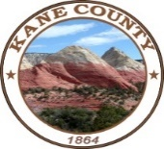
76 North Main Street ▪ Kanab, UT 84741
435.644.4964

Kane County
Public Lands Department

Interagency Meeting
Agenda

February 21, 2023
9:00 AM
Kane County Commission Chambers

• Call to Order
• Invocation
• Pledge of Allegiance

• Updates:
- Congressional
- BLM
- Forest Service
- National Parks
- PLPCO
- Kanab City
- County
- Other

• Adjourn

