INVITATION TO BID
Tooele City
90 North Main
Tooele City, Utah 84074

Notice is hereby given that Tooele City Corporation (OWNER) will accept bids for internet service at the following locations:

Location 1: Wigwam Park 4 Canyon Rd Tooele, Utah 84074. Pavilion needing service has conduit running to gate at 40.517346, -112.301024. See included maps for approximate locations

Location 2: England Acres 400 E Tooele, Utah 84074. Building needing service located at 40.548489, -112.284047.

Location 3: Elton Park 400 North Broadway Tooele, Utah 84074. Building needing service located at 40.537615, -112.286249.

Location 4: Rancho Park 900 Timple Rd Tooele, Utah 84074. See attached Map for approximate building location.

Service requested must be able to support multiple devices on the network with an upload/download speed of at least 35/10 mbps. Bids including multiple pricing tiers will be given preference. Fiber lines preferable but other methods of internet service will be considered.

Separate bids will be received by the Tooele City IT Department located at 90 North Main, Tooele, Utah 84074 or through email sent to chrisn@tooelecity.org until 2:30 PM on February 3rd, 2023 at which point they will be reviewed. Winning bids will be notified by February 8th, 2023 by 5pm. Please be aware that we may award bids to multiple companies based on price and speeds available at each location.

Internet must be installed by winning bidder by March 1st, 2023.

Bidders are encouraged to email questions to the IT Director at chrisn@tooelecity.org or 435-843-2130. The deadline for submittal of bid questions will be 3:00 PM on Wednesday, February 1st, 2023.

The OWNER reserves the right to reject any or all bids; or to accept or reject the whole or any part of any bid; to award schedules separately or together to contractors, or to waive any informality or technicality in any bid in the best interest of the City. Only bids giving a firm quotation properly signed will be accepted.

Wigwam:
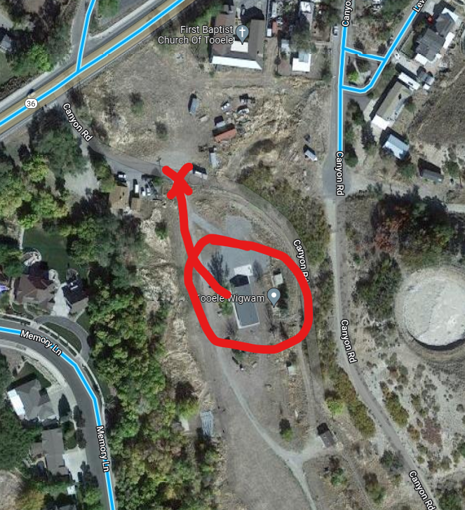

England Acres
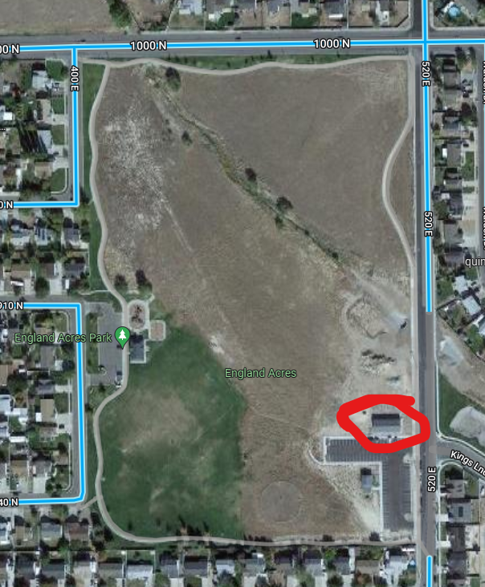
Elton Park
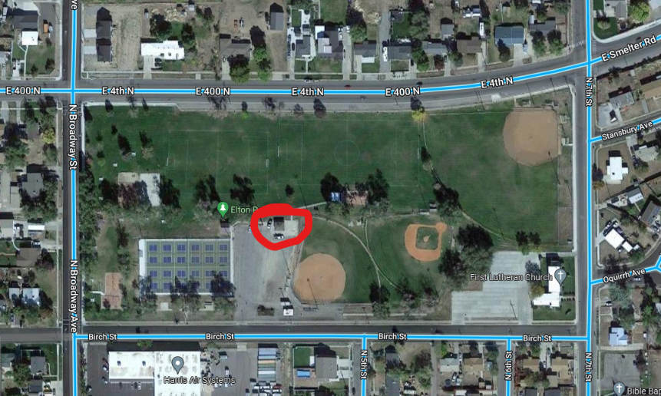

Rancho Park:
