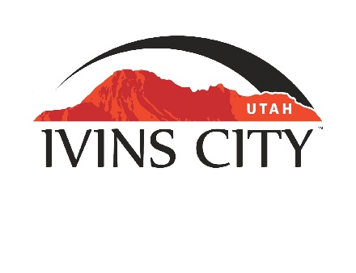
IVINS CITY

COUNCIL MEETING

*AMENDED AGENDA

December 15, 2022

Mayor Chris Hart

City Council Members

Lance Anderson

Jenny Johnson

Dennis Mehr

Adel Murphy

Mike Scott

City Manager/Attorney:

Dale Coulam

The Ivins City Council will hold a regular meeting in the City Council Chambers, 85 N. Main St., Ivins, UT, on Thursday, December 15, 2022. The meeting will begin at 5:30 P.M.

NOTICE: This meeting will be held in person and electronically. You may watch the live audio and video feed by going to www.ivins.com under “Upcoming Events”. When the meeting is live, it will reflect “In Progress” – click on the “In Progress” link to watch the meeting live. The Mayor and/or City Council Members may attend via telephone conference if they are unable to attend in person. The anchor location will be the Ivins City Council chambers located at 85 North Main Street, Ivins City, Utah 84738.

The links for electronic attendance are provided below:

Granicus: https://ivins.granicus.com/GeneratedAgendaViewer.php?view_id=2&event_id=1084

Zoom: https://us02web.zoom.us/j/82796293285

YouTube: https://www.youtube.com/watch?v=1D05Tgf-q5M

Note: The order of items discussed on this amended agenda is subject to change

- WELCOME AND CALL TO ORDER
- Acknowledgement of Quorum
- Flag Salute
- Invocation
- Disclosures

- REPORTS, PRESENTATIONS AND APPOINTMENTS
- Washington County Solid Waste District Report – Cheyne McDonald
- Concept Plan Report for the Horsehead Subdivision, located at approximately 130 South and 800 West. Kayenta Development, Inc.-Owner. Lance Anderson-Applicant

- Department Reports: Building Department; Public Works/Engineering; Finance


- CITIZEN REQUEST FOR FUTURE AGENDA ITEMS REGARDING ORDINANCES, POLICIES OR OTHER LEGISLATIVE ITEMS
Any person wishing to bring a legislative item not otherwise on the Agenda to the attention of the Mayor and City Council may address the City Council at this point by stepping to the microphone and giving their name and address for the record. Citizen Request for Future Agenda Item forms should be filled out in advance and given to the City Recorder. Remarks should be limited to no more than two minutes, unless the Governing Body allocates additional time. The Mayor and City Council will take no action this evening.

- PUBLIC HEARING AND ACTION ITEMS - NONE

- DISCUSSION AND POTENTIAL ACTION ITEMS
- Presentation and discussion of the executive summary of the General Plan Survey – Patty Dupre – results are on Ivins website and posted to this meeting’s agenda
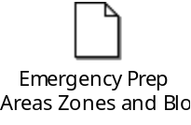
- Discuss and consider the Planning Commission’s recommendation to approve a Preliminary Plan for Black Desert Family Village, located at approximately Snow Canyon Parkway and East Black Desert Drive. Enlaw, LLC-Owner. Stephenie Nast-Applicant
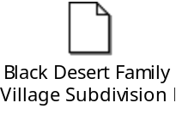
- Discuss and consider approval of Easement Maintenance Agreement for Sewer Dosing Station at Kayenta Village
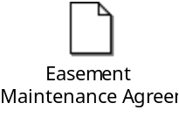
- Continued discussion to consider approval of expenditure for Guy Lane roadway improvements

- *Approval of Ordinance No. 2022-17, an Ordinance of Ivins City, Utah, approving a Zone Change for the “Horsehead” shaped parcel on Exhibit “A” from RA-5 to RE-15 (with lot averaging), as a formality to the motion approving this Zone Change made at the City Council on December 1, 2022
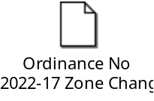
6) CONSENT AGENDA
- Approval of City Council Meeting Minutes for December 1, 2022
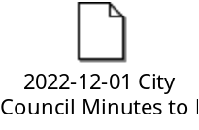
7) CONSENT AGENDA ITEMS FOR DISCUSSION

8) REPORTS
- Council
- Mayor
- City Manager/Attorney Dale Coulam
- Items to be placed on future agendas
9) CLOSED MEETING

10) ADJOURNMENT

Reasonable accommodation: Ivins City will make efforts to provide reasonable accommodation to disabled members of the public in accessing City programs. Please contact the City Recorder at least 24 hours in advance if you have special needs.
I hereby certify that I have posted copies of the amended agenda in the following public and conspicuous places on December 14, 2022. Ivins City Hall, the Ivins Post Office, SCI Center Street Fire Station, Ivins City UNITY Park and Ivins City Animal Shelter. I have also sent a copy of this agenda to St. George News and posted it on the Utah Public Notice website.

Kari Jimenez, MMC
City Recorder

