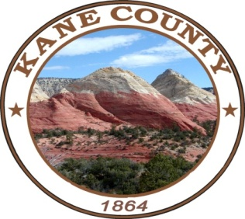
NOTICE AND AGENDA OF A SPECIAL MEETING OF THE KANE COUNTY COMMISSION
***************************************

PUBLIC NOTICE IS HEREBY GIVEN that the Commissioners of Kane County, State of Utah, will hold a Commission Meeting on Thursday December 22, 2022, immediately following the Kane County Redevelopment Agency Public Hearing and Agency Meeting held at 6:00 pm in the Town Council Room at the Big Water Town Hall located at 60 Aaron Burr Big Water, UT 84741.

*The Commission Chair, in his discretion, may accept public comment on any listed agenda item unless more notice is required by the Open and Public Meetings Act.

CALL MEETING TO ORDER
WELCOME
INVOCATION
PLEDGE OF ALLEGIANCE

SPECIAL SESSION:

- Kane County Ordinance No. 2022-64: an Ordinance of the Kane County Commission adopting the Glen Canyon Solar A Project – Community Reinvestment Project Area Plan as the “Official” Project Area Plan of the Project Area; and related matters.

- Diversion of Property Tax for a Community Reinvestment Project Area: Discussion and Consideration to Authorize Kane County to enter into an Interlocal Agreement with Kane County Redevelopment Agency, related to the Glen Canyon Solar A Project – Community Reinvestment Project Area

NOTICE OF SPECIAL ACCOMMODATION DURING PUBLIC MEETINGS:
In compliance with the Americans with Disabilities Act, individuals needing special accommodations (including auxiliary communicative aids and services) during this meeting should notify Karla Johnson at (435) 644-2458. Agenda items may be accelerated or taken out of order without notice as the Administration deems appropriate. All items to be placed on the agenda must be submitted to the Clerk’s office by noon Thursday, prior to the meeting.

