Kanosh Town Corporation held a Public Hearing on Wednesday, November 9, 2022, electronically and in the town office at 7:00 p.m.

Members present:
Mayor Scott McDonald, Council members: Neil Shumway, Hayden George, David Whitaker, Brandon Stephenson, Kanosh Town Clerk: Cindy Turner. Kanosh Town Treasurer DeniAnn Whitaker.

Others in attendance: Town Employee Lorin Shumway, Planning and Zoning Chairman Stoyan Kolev, Stan Koyle, CERT Captain Geri Minton, Barney, Josh Whitaker, Jim Kooy, Bart Whatcott, Shonda Robison

Council member David Whitaker motioned to open the Public Hearing, Council member Brandon Stephenson provided a second to the motion, and all councilmember's voted in favor as noted below:
Mayor Scott McDonald Aye
Council members:
David Whitaker Aye
Neil Shumway Aye
Hayden George Aye
Brandon Stephenson Aye

This public hearing was called for the purpose of discussing and setting the culinary rates and hook-up fees, through a review of a draft ordinance.

This public hearing primarily served as an informational meeting with an explanation of the reasoning for the increase.

Councilmember Hayden George has been in touch with Mr. Lynn Wall concerning updating the Kanosh Town water impact fee. If the new Impact Fee schedule is complete, this too will be presented as well.

It is noted that there were no public comments offered in this public hearing.

The Public Hearing concluded at 7:19 p.m. Kanosh Town Corporation will hold another Public Hearing next month, at which time the water ordinance setting the increase for the culinary hookup fees will be presented for approval. Councilmember Brandon Stephenson motioned to move out of Public Hearing, Councilmember Neil Shumway seconded this motion, and all councilmember's voted in favor as noted below:
Mayor Scott McDonald Aye
Council members:
David Whitaker Aye
Neil Shumway Aye
Hayden George Aye
Brandon Stephenson Aye

Kanosh Town Corporation held the regular council meeting on Wednesday, November 9, 2022, electronically and in the town office at 7:00 p.m.

Members present:
Mayor Scott McDonald, Council members: Neil Shumway, Hayden George, David Whitaker, Brandon Stephenson, Kanosh Town Clerk: Cindy Turner. Kanosh Town Treasurer DeniAnn Whitaker.

Others in attendance: Town Employee Lorin Shumway, Planning and Zoning Chairman Stoyan Kolev, Stan Koyle, CERT Captain Geri Minton, Barney, Josh Whitaker, Jim Kooy, Bart Whatcott, Shonda Robison

Councilmember Neil Shumway offered the opening ceremonies through an invocation.

Mayor Scott McDonald led everyone in attendance in the Pledge of allegiance.

Mayor Scott McDonald opened the council meeting and welcomed all in attendance.

Minutes of the October 2022 meeting were read and approved as amended through a motion by Councilmember David Whitaker, Councilmember Brandon Stephenson provided a second to the motion, and all Council members voted in favor as noted below:
Mayor Scott McDonald Aye
Council members:
David Whitaker Aye
Neil Shumway Aye
Brandon Stephenson Aye
Hayden George Abstained from voting.

Warrants for November 2022 were read, discussed, and approved to be paid through a motion by Councilmember David Whitaker, Council member Brandon Stephenson seconded the motion, and all Council members voted in favor as noted below:
Mayor Scott McDonald Aye
Council members:
David Whitaker Aye
Neil Shumway Aye
Hayden George Aye
Brandon Stephenson Aye
CERT:
CERT Captain Geri Minton reported Halloween went great, CERT volunteers were available and helpful in their efforts of keeping the children safe.

They are still looking for a speaker for the CERT conference.

Our CERT team has continued to take inventory of the medical supplies and their needs.

Fire Dept:
Fire Chief Lorin Shumway reported our department will be participating in training with the Fillmore Fire Department, and the focus of the training addresses electric vehicles.

One of our Fire engines had a recall. Some of the older vehicles may need new tires.

Planning and Zoning:
Planning Committee member Stoyan Kolev presented the remodel permit for John and Carol Kimball.

Council member Brandon Stephenson motioned to approve the remodel permit as presented, Council member Neil Shumway seconded the motion, and all Council members voted in favor as noted below:
Mayor Scott McDonald Aye
Council members:
David Whitaker Aye
Neil Shumway Aye
Hayden George Aye
Brandon Stephenson Aye
.
Planning Committee member Stan Koyle questioned what the Council has agreed to do with electrical utility hook-up fees? Councilmember Hayden George and Councilmember Neil Shumway have had conversations with Brandon Cummings at Dixie Power, and they stated that Dixie Power routinely does electrical estimates for people turning in their plans to the building inspector, then the prospective homeowner knows what to plan on, they can include the associated costs in their loan if they choose, this electrical cost estimate from Dixie Power should be obtained before submission of the permits to the Planning and Zoning Commission.
On top of what Dixie Power charges there should also be a hook-up fee assessed, to include the town employees' time, roughly $350.00.
It is important to understand that this fee is just an estimate and is subject to change.
Next month Councilmember Neil Shumway will have Resolution#121422 an electrical hook-up flat fee ready to be presented at the public hearing, giving ample opportunity for public comment.
*Deposit fees:
Reviewed the application form for utility power connections, the one Kanosh Town attorney Justin Wayment provided and the one put together by our planning and zoning. A copy of each form was presented to each member of the council for review. It was suggested to take the best of each form to create the "one" to better serve our needs.

* Water Impact Fees: Moving forward with the Water Impact fees through Lynn Wall.
* Street widths: the legal descriptions in some areas of town do not match the current boundary surveys, it is unclear what the street widths are, it is the recommendation to do a boundary survey, as they are very expensive. We need to know what the street widths are to be able to enforce encroachment ordinances, as well as other ordinances that are currently on the books. Councilmember Brandon Stephenson will get a cost estimate for a boundary survey.
* Shonda Robison lot: how does she proceed? Mayor McDonald responded, Kanosh needs to understand exactly what our steps are and how that works and who initiates those steps, who pays for those steps if the plan is to move forward with annexation down that line if the town has to survey that there would be no need for an individual to incur those costs for their single property if we are moving forward with annexation on that whole line. We need to find out who is responsible for any fees associated with annexation and how far west Kanosh would annex.
*Annexation:
Is it within the law to say "we are not moving forward with annexation until Kanosh Town resolves some of the other problems, can Kanosh refuse an annexation petition? Mayor Scott McDonald confirmed the assumption stating that yes, Kanosh Town can refuse an annexation petition.

It was discussed in last month's meeting that it can be a requirement of annexation into the town, that the individual brings in water.

*Dog Ordinance:
Ongoing dog issues continue to plague our community, dogs running loose, killing rabbits, and guinea fowl, harassment of people and animals, etc. There is also an issue of noise or constant barking. We have no zoning restrictions for kennels. Councilmembers agreed the place we can start would be to enforce the noise ordinance and/or dog ordinances we have on the books by contacting law enforcement. Following further discussion Councilmembers agreed to address this problem first by sending a letter to everyone in the town with a copy of the ordinance, requesting individuals be responsible pet owners and be better neighbors in governing their pets' behaviors better. Mayor McDonald will draft this letter for the community.

Fraud risk assessment:
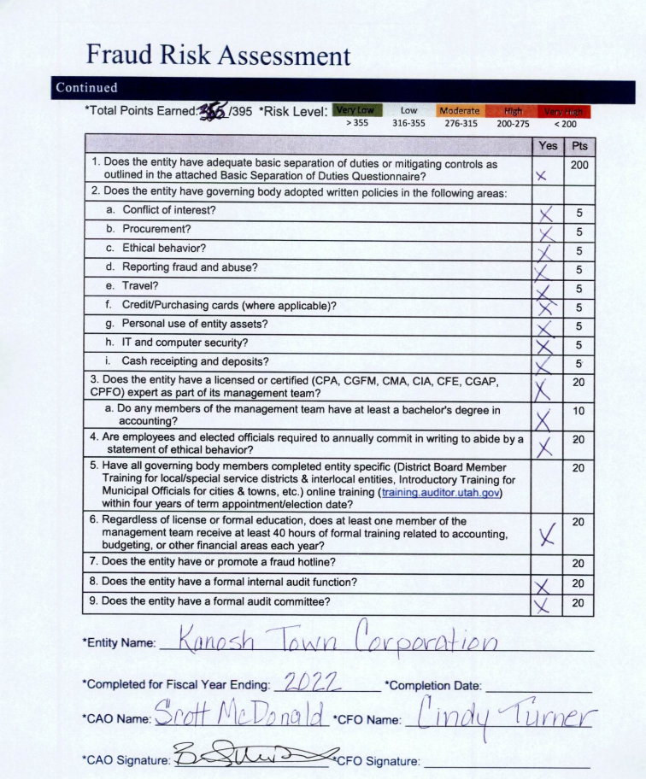
Councilmember Brandon Stephenson motioned in approval of the Fraud Risk Assessment, Councilmember Hayden George seconded the motion, all in favor.
Resolution #11922 Kanosh Town Fee schedule:
Following the Kanosh Town audit, it was learned that the Kanosh Town Fees and Charges are supposed to be posted on the Kanosh Town website.
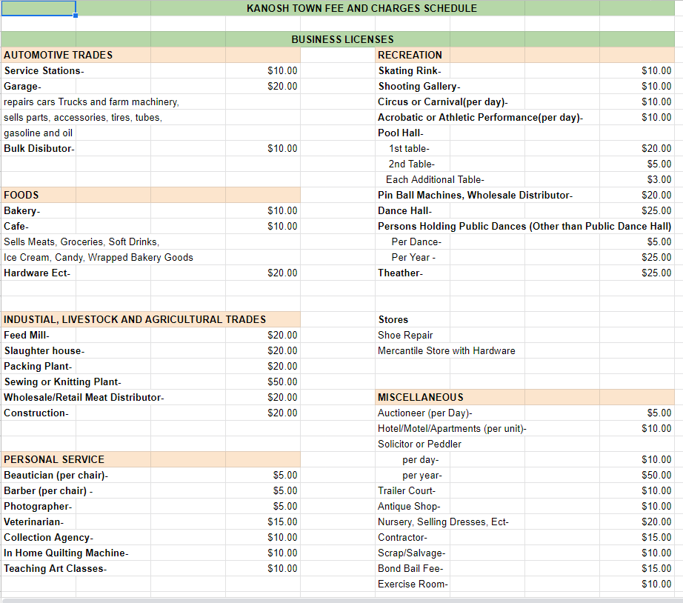
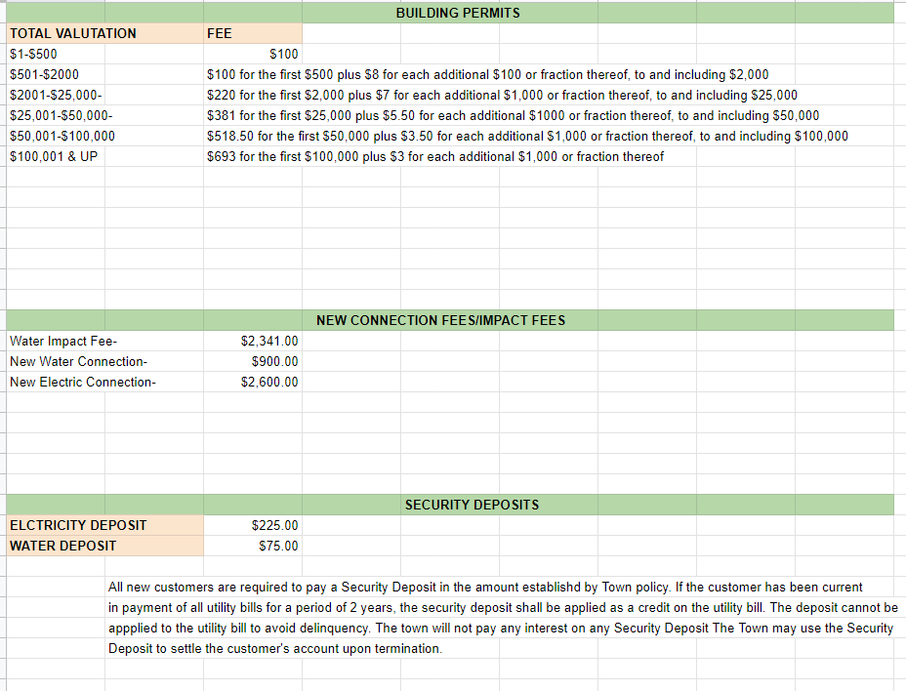
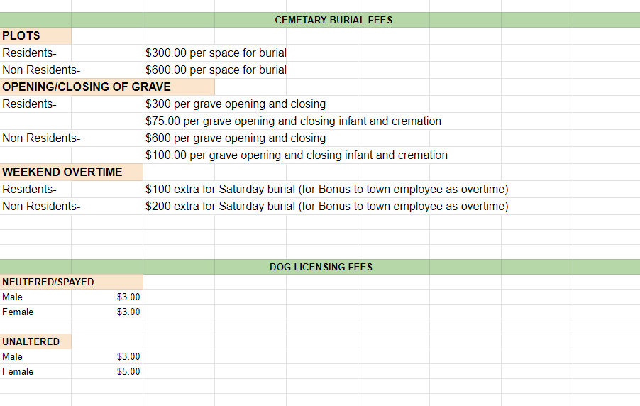
A discussion of the code associated with charging for business licenses:

Effective 5/4/2022
17-53-216. Business license fees and taxes -- Application information to be transmitted to the county assessor.

(1) | As used in this section, "business" means any enterprise carried on for the purpose of gain or economic profit, except that the acts of employees rendering services to employers are not included in this definition.

(2) | Except as provided in Subsection (4), the legislative body of a county may by ordinance provide for the licensing of businesses within the unincorporated areas of the county for the purpose of regulation and may impose fees on businesses to recover the county's costs of regulation.

(3) | All license fees and taxes shall be uniform in respect to the class upon which they are imposed.

(4) | A county may not:  (a) require a license or permit for a business that is operated: (i) only occasionally; and (ii) by an individual who is under 18 years old;  (b) charge a license fee for a home based business unless the combined offsite impact of the home based business and the primary residential use materially exceeds the offsite impact of the primary residential use alone; or  (c) require, as a condition of obtaining or maintaining a license or permit for a business: (i) that an employee or agent of a business complete education, continuing education, or training that is in addition to requirements under state law or state licensing requirements; or (ii) that a business disclose financial information, inventory amounts, or proprietary business information except as specifically authorized under state or federal law.

(5) | The county business licensing agency shall transmit the information from each approved business license application to the county assessor within 60 days following the approval of the application.

(6) | This section may not be construed to enhance, diminish, or otherwise alter the taxing power of counties existing prior to the effective date of the Laws of Utah 1988, Chapter 144.

Councilmember agreed to seek legal clarification from the Kanosh Town Attorney, Justin Wayment about the business licenses. Mayor McDonald will also forward Mr. Wayment the Kanosh Town Fee Schedule for approval before the document is posted on the Kanosh Town website.
No action taken to approve the Fee Schedule at this time.
Wood Clean-Up at the Debris Basin:
Mr. Stan Koyle: Can the Town provide any support or help in cleaning up the wood at the debris basin? It was suggested that the wood be dragged into piles and burn it, it is on the irrigation company's radar. There is a lot of "stuff", limbs, etc. It was agreed that a big fire would be the better avenue to take at this time. Efforts will be coordinated between the Community, Fire Department, the Irrigation Company, and the Town to take care of this cleanup.

Centracom:
Mayor Scott McDonald had a conversation with Centracom, they applied for a grant, it took longer to obtain the grant approval than anticipated, however they did get the grant. They plan to start with fiber optic lines in the spring. They would like to go ariel with a lot of the lines to speed things up. It is doubtful that this would work in our area, first our poles are too low. Dixie Power is not in favor of Kanosh sharing the poles. Kanosh Town has been working to get all of the lines underground, and with that we would also prefer the fiber optic lines to also be underground. Kanosh would also like to insure that Centracom will service the whole town.

Utility Delinquency Review:
Council members reviewed the monthly delinquency list. It was determined, again, to handle those accounts in arrears according to established Town policy.

Departmental Reports
*Electrical Department:
Councilmember Neil Shumway commented, in relation to Martha Stott's surprise bill from Dixie Power, she was not wanting to pay that because she thought she was billed at a different rate. Councilmember Shumway met with Mrs. Stott and clarified that she was only billed exactly what Dixie Power charged us. They spoke about where they split off Dixie went along her property so they would not have to dig it up if anyone used or added power on one side or the other. She did not feel comfortable in paying for that and was asking if we could make an adjustment there. Councilmember Shumway spoke to Brandon Cummings at Dixie Power and he said that they would not have done it any other way than the way they did, it actually could have cost her more money because they would have had to run the main line all the way to her house which would have been more expensive than the way they did it. Mr. Cummings could not supply a "breakdown" of what we could take off for her. In all actuality she actually got 4 lots connected for $10,000.00 since she owns those lots. Councilmember Neil Shumway will again contact Mrs. Stott and provide an additional explanation of the associated costs.

Councilmember Neil Shumway counted that there are 9 street lights out. He has talked to Dixie Power, they have some new LED ones that they could install for around $500.00 each. Dixie Power has 8 of these lights and would be willing to give us 6, and if he could do all 6 in one day it would be less than $500.00/each. We would still have 3 or 4 needing replacement, but this would be a really good start.

*Roads:
Councilmember Brandon Stephenson reported we have got a plow down. Town Employee Lorin Shumway is looking into the repairs we need.

Question of the possibility of exploring speed bumps on 300 South on the east side of town? This is a heavily traveled road in our town, there are little kids all up and down that road. Installation of waterways has been discussed in depth in past meetings however placed on the back shelf due to the cost. Other options to take care of this problem were discussed.

*Park and Cemetery:
Councilmember Hayden George was approached by Mr. Pete Davis inquiring if the Town wants him to take care of the cemetery next year, if so, he would like to get the equipment all serviced and ready for the summer. Councilmember George ask him how much he would charge to do the cemetery, park, ball field, mow, trim, water and trash, and bathrooms. He said we could bundle the two together 5 days/40 hrs @ roughly $16/hour resulting in $2500.00/month as a seasonal full-time position. Mr. Davis was paid $1,000.00/ month for taking care of the cemetery. *No action has been taken at this time.

*General Government:
Mayor Scott McDonald met with town employee Stephen Adams and his parents, in talking to him about his responsibilities. Mayor McDonald sought clarity why Steven doesn't want to clean the restrooms, Steven does not like cleaning restrooms but he would have no problem cleaning the men's restroom, he isn't excited about cleaning restrooms but he would do it. His issue is around the women's restroom concerning what he experienced at the fire department and that scandal. He is really worried about covering himself in the women's restroom. His sister, Kathy stated she would even go with him to do the women's restroom if that is what the job requires.

*Water:
Councilmember David Whitaker reported he has submitted the UAMPS annual report:
Councilmember Whitaker also reported there is a big coal mine fire, the Lila Canyon Mine fire near Price, Utah, that started Sept. 20, 2022. If unaddressed, the fire could result in the disruption of electricity service to up to 37 percent of customers in the State of Utah. Lila Canyon Mine produces 3.47 million tons of coal per year, about 28 percent of Utah’s coal total. Approximately 40 percent of the coal produced by the Lila Canyon Mine services the Hunter and Huntington power plants, which generated 15,513-gigawatt hours (GWh) in 2021 that is utilized in Utah and throughout the west. They had now decided to curtail production, the peak season is during the summer months, with this knowledge they have opted to stockpile the coal they have for the peak season.
UAMPS stated there is concern that there will not be enough power to service their customers i.e. Kanosh Town. With this curtail of production, we may have to go out on the open market to purchase power. We do not want to be in a circumstance where we are forced to buy emergency power at an extremely high rate. UAMPS has recommended that Kanosh purchase a month’s worth of power on the open market at a time, a week and a half ago power on the open market cost about .07/kw, today we had the opportunity to purchase power at .092/kw. In normal circumstance, we pay .035/kw.
With the likely escalation in the purchase price of power, there is the subsequent potential of an increase adjustment to the electrical rates for our Kanosh town residents.
Following the discussion council members agreed to follow through with UAMPS recommendation of purchasing enough power on the open market for one month.
*Storage Container:
Councilmember David Whitaker reported a good deal on a storage container, we were able to get one with double doors at a very reasonable price. The final cost of the container was $8,600.00.
*Public Comment:
Stan Koyle: There was a conversation from the attorney last month about contacting legislature money for the right of ways, is there any update? Councilmember Brandon Stephenson responded, about the dam project the local NRCS is still working with the federal NRCS in trying to re-evaluate their requirements. No one on the council has reached out to the Legislature yet, Councilmember Hayden George recalled he had agreed to reach out and make contact with our State Senator Derrin R. Owens, however, contact was not made.

Mr. Koyle also requested that when the Town sends out the letter addressing the Noise Ordinance that the letter includes the issues of encroachment as well.

*Old Business:
*Corn Creek Project, progress is stalled between the federal NRCS organization and a state NRCS organization.

*Well project: Councilmember Stephenson reported that we are just waiting, we are in the protest period. This protest period ends on November 22.

*Christmas celebration: candy has been ordered, and the official sacking of the Christmas candy will be determined as soon as the candy arrives!

There being no further business to come before the board, the meeting adjourned.

Scott McDonald Cindy Turner,
Kanosh Town Mayor Kanosh Town Clerk

Public Hearing next month, at which time the water ordinance setting the increase for the culinary hookup fees will be presented for approval.

**Resolution for an electrical hook-up fee: with the public hearing.
AGENDA: Waterways on 300 East. Several ideas to address the speeding on 300 south up the canyon

