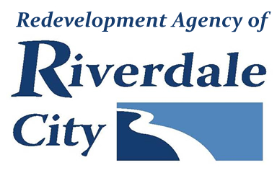
RIVERDALE CITY RDA BOARD
CIVIC CENTER - 4600 S. WEBER RIVER DR.
Tuesday, December 6, 2022

Board Meeting (Time approximate following City Council meeting which starts at 6:00 p.m.)

A. Welcome & Roll Call

B. Public Comment

(This is an opportunity to address the Riverdale Redevelopment Agency regarding your concerns or ideas. Please try to limit your comments to three minutes.)
C. Presentations & Reports
1. Senior housing update.
Presented by Steve Brooks

D. Consent Items

E. Action Items

- Consideration to adjourn into a closed executive session pursuant to UCA 52-4-205 (d) and (e): Purchase, exchange, or lease of real property.

F. Comments
G. Adjournment
________________________________________________________________________________________________In compliance with the Americans with Disabilities Act, persons in need of special accommodation should contact the City Offices (801) 394-5541 X 1232 at least 48 hours in advance of the meeting. The Public is invited to attend City Council Meetings.
Certificate of Posting
The undersigned, duly appointed City Recorder, does hereby certify that the above notice and agenda was posted on this 2nd day of December, 2022 at the following places: 1) the Riverdale City Hall Noticing Board, 2) the Riverdale City Website at http://www.riverdalecity.com/, 3) the Public Notice Website: http://www.utah.gov/pmn/index.html, 4) the Standard-Examiner via email.
Michelle Marigoni
Riverdale City Recorder

