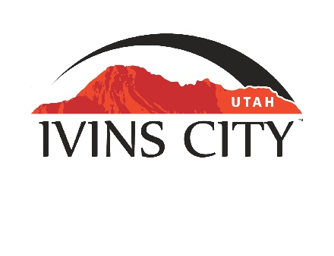
IVINS CITY

COUNCIL MEETING

*AMENDED AGENDA

November 17, 2022

Mayor Chris Hart

City Council Members

Lance Anderson

Jenny Johnson

Dennis Mehr

Adel Murphy

Mike Scott

City Manager/Attorney:

Dale Coulam

The Ivins City Council will hold a regular meeting in the City Council Chambers, 85 N. Main St., Ivins, UT, on Thursday, November 17, 2022. The meeting will begin at 5:30 P.M.

NOTICE: This meeting will be held in person and electronically. You may watch the live audio and video feed by going to www.ivins.com under “Upcoming Events”. When the meeting is live, it will reflect “In Progress” – click on the “In Progress” link to watch the meeting live. The Mayor and/or City Council Members may attend via telephone conference if they are unable to attend in person. The anchor location will be the Ivins City Council chambers located at 85 North Main Street, Ivins City, Utah 84738.

Note: The order of items discussed on this amended agenda is subject to change

- WELCOME AND CALL TO ORDER
- Acknowledgement of Quorum
- Flag Salute
- Invocation
- Disclosures

- REPORTS, PRESENTATIONS AND APPOINTMENTS
- Fiscal Year Ending 2022 Audit Report – Larson and Company
- Youth Council Report – Jamy Dahle
- Concept Plan Report for Mojave Village Subdivision located at approximately the southeast corner of Guy Lane and Fitness Way. Teancum Properties, LLC-Owner. Lance Anderson-Applicant
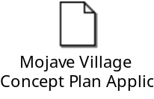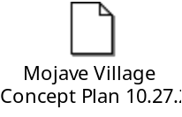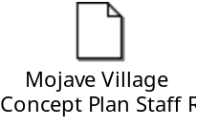
- Department Reports: Building Department; Public Works/Engineering; Finance
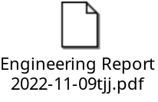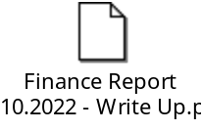
- Planning Commission Report

- CITIZEN REQUEST FOR FUTURE AGENDA ITEMS REGARDING ORDINANCES, POLICIES OR OTHER LEGISLATIVE ITEMS
Any person wishing to bring a legislative item not otherwise on the Agenda to the attention of the Mayor and City Council may address the City Council at this point by stepping to the microphone and giving their name and address for the record. Citizen Request for Future Agenda Item forms should be filled out in advance and given to the City Recorder. Remarks should be limited to no more than two minutes, unless the Governing Body allocates additional time. The Mayor and City Council will take no action this evening.

- PUBLIC HEARING AND ACTION ITEMS - NONE

- DISCUSSION AND POTENTIAL ACTION ITEMS
- Discuss and consider approval of Resolution No. 2022-24R, a Resolution of Ivins City, Utah, Appointing a Member to the Arts Commission
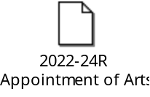
- Discuss and consider approval of Resolution No. 2022-25R, a Resolution of Ivins City, Utah, Appointing a Member of the Arts Commission
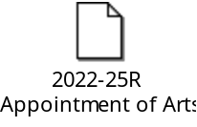
- Discuss and consider award for the Old Highway 91 Improvement Project [TAB TO FOLLOW]
- Discuss and consider approval of Water System AMI (Automated Metering Infrastructure) Project Costs and Funding [TAB TO FOLLOW]
- Discuss Subdivision/Development Permitting Process and Fee Restructuring due to water availability concerns [TAB TO FOLLOW]
- Discuss and consider approval of expenditure for Guy Lane roadway improvements [TAB TO FOLLOW]
- Continued discussion regarding a zone change from RA-5 to RE-15 (with lot averaging) on the horsehead portion that was withdrawn from consideration in Ordinance No. 2021-16, on September 2, 2021
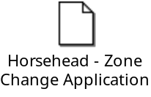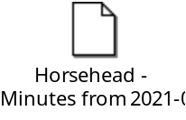
- Discuss and consider approval of Ordinance No. 2022-16, an Ordinance of Ivins City, Utah, amending Maximum Building Height Regulations for One or Two Family Dwellings
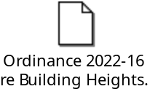
- Discuss and consider approval of Resolution No. 2022-23R, a Resolution of Ivins City, Utah, approving a General Fund Transfer to Fund Pay Increase for SCI Law Enforcement Officers
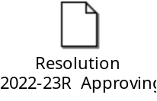
- Discuss and consider approval of holidays for calendar year 2023


6) CONSENT AGENDA
- Approval of City Council Meeting Minutes for October 20, 2022 [TAB TO FOLLOW]

7) CONSENT AGENDA ITEMS FOR DISCUSSION

8) REPORTS
- Council
- Mayor
- City Manager/Attorney Dale Coulam
- Items to be placed on future agendas
9) CLOSED MEETING

10) ADJOURNMENT
Reasonable accommodation: Ivins City will make efforts to provide reasonable accommodation to disabled members of the public in accessing City programs. Please contact the City Recorder at least 24 hours in advance if you have special needs.
I hereby certify that I have posted copies of the amended agenda in the following public and conspicuous places on November 15, 2022. Ivins City Hall, the Ivins Post Office, SCI Center Street Fire Station, Ivins City UNITY Park and Ivins City Animal Shelter. I have also sent a copy of this agenda to St. George News and posted it on the Utah Public Notice website.

Kari Jimenez, MMC
City Recorder

