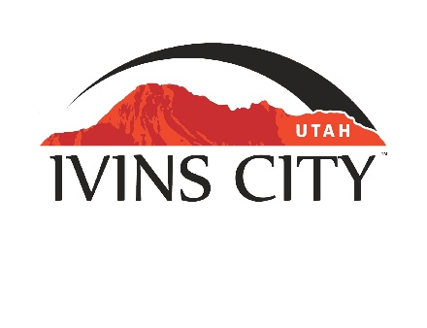
IVINS CITY

COUNCIL MEETING

AGENDA

October 20, 2022

Mayor Chris Hart

City Council Members

Lance Anderson

Jenny Johnson

Dennis Mehr

Adel Murphy

Mike Scott

City Manager/Attorney:

Dale Coulam

The Ivins City Council will hold a regular meeting in the City Council Chambers, 85 N. Main St., Ivins, UT, on Thursday, October 20, 2022. The meeting will begin at 5:30 P.M.

NOTICE: This meeting will be held in person and electronically. You may watch the live audio and video feed by going to www.ivins.com under “Upcoming Events”. When the meeting is live, it will reflect “In Progress” – click on the “In Progress” link to watch the meeting live. The Mayor and/or City Council Members may attend via telephone conference if they are unable to attend in person. The anchor location will be the Ivins City Council chambers located at 85 North Main Street, Ivins City, Utah 84738.

Note: The order of items discussed on this agenda is subject to change

- WELCOME AND CALL TO ORDER
- Acknowledgement of Quorum
- Flag Salute
- Invocation
- Disclosures

- REPORTS, PRESENTATIONS AND APPOINTMENTS
- Department Reports: Building Department; Public Works/Engineering; Finance
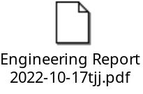
- Quarterly Finance Report
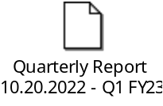
- Planning Commission Report

- CITIZEN REQUEST FOR FUTURE AGENDA ITEMS REGARDING ORDINANCES, POLICIES OR OTHER LEGISLATIVE ITEMS
Any person wishing to bring a legislative item not otherwise on the Agenda to the attention of the Mayor and City Council may address the City Council at this point by stepping to the microphone and giving their name and address for the record. Citizen Request for Future Agenda Item forms should be filled out in advance and given to the City Recorder. Remarks should be limited to no more than two minutes, unless the Governing Body allocates additional time. The Mayor and City Council will take no action this evening.

- PUBLIC HEARING AND ACTION ITEMS

- DISCUSSION AND POTENTIAL ACTION ITEMS
- Discuss and consider approval of a Proclamation regarding Domestic Violence Awareness Month
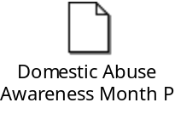
- Continued discussion and consideration to approve Ordinance No. 2022-12, an Ordinance of Ivins City, Utah, approving a Zone Change for approximately 9.618 acres near Guy Lane and Fitness Way from R-1-5 and R-M to RC
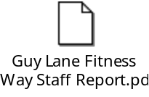
- Continued discussion and consideration on the Planning Commission's recommendation not to amend Chapter 16 of the Zoning Ordinance regarding Building Heights
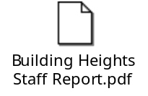
- Discuss and consider approval of Ordinance No. 2022-14, an Ordinance of Ivins City, Utah, amending Chapter 16 of the Zoning Ordinance, striking the ability to request a STRO in the future in a residential zone
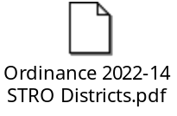
- Discussion regarding parking and other requirements for Short-Term rentals
- Discuss and consider approval of a survey for updating the General Plan

- Update on the water situation
- Discuss and consider approval of Resolution No. 2022-18R, a Resolution of Ivins City, Utah, adopting the 2022 Five County Association of Governments Multi-Jurisdictional Natural Hazard Mitigation Plan
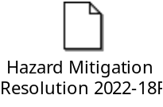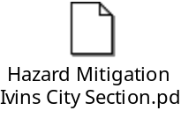
- Discuss and consider approval of Resolution No. 2022-19R, a Resolution of Ivins City, Utah, approving Employee Core Benefits

6) CONSENT AGENDA
- Approval of expenditure for streets pavement maintenance – crack seal materials
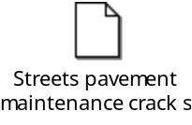
- Approval of expenditure for video inspection of sewer lines
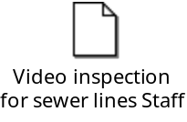
- Approval of expenditure for leasing sonar sewer inspection equipment
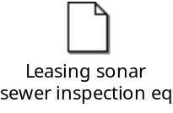
- Approval of City Council Meeting Minutes for September 15, 2022
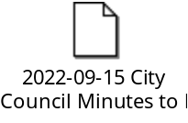
7) CONSENT AGENDA ITEMS FOR DISCUSSION

8) REPORTS
- Council
- Mayor
- City Manager/Attorney Dale Coulam
- Items to be placed on future agendas
9) CLOSED MEETING

10) ADJOURNMENT
Reasonable accommodation: Ivins City will make efforts to provide reasonable accommodation to disabled members of the public in accessing City programs. Please contact the City Recorder at least 24 hours in advance if you have special needs.
I hereby certify that I have posted copies of the agenda in the following public and conspicuous places on October 14, 2022. Ivins City Hall, the Ivins Post Office, SCI Center Street Fire Station, Ivins City UNITY Park and Ivins City Animal Shelter. I have also sent a copy of this agenda to St. George News and posted it on the Utah Public Notice website.

Kari Jimenez, MMC
City Recorder

