Magna Mixed-Use Zoning Districts – Staff Summary
Purposes:
- Establish a new chapter that provides for mixed-use development at a compact, walkable scale.
- Promote successful business by integrating a customer base (residential uses) close by.
- Create new gathering places within existing communities.
Applicability:
- The DH Zone is intended only for areas in and around the Magna Historic District.
- The NMU Zone is for small-scale mixed use at a variety of locations. The NMU could be integrated on corners surrounding residential neighborhoods in order to expand services and access to goods.
- The CMU Zone is the highest-intensity mixed-use zoning district and should be implemented along transit routes. Preferably, this zone would be reserved for Major Transit Investment Corridors (places with 15min or less transit frequency). This zone would be applied primarily along the non-historical portions of Magna Main Street
Resources Utilized:
- Portland Zoning Ordinance
- Vineyard Zoning Ordinance
- Magna Historic District Existing Building Fabric
- Missing Middle Housing – Type Dimensions
- Principles of Urban Retail – Robert Gibbs
- Albany, OR Zoning Ordinance
- Holladay Zoning Ordinance
Changes to Note:
This Chapter expands upon the existing historic district mixed use zone, creating other opportunities for mixed use projects.

CHAPTER 19.36: MIXED-USE ZONES
DRAFT for Review Purposes Only – August 2nd, 2022
Sections:
19.36.010 – Purpose of Provisions.
The mixed-use zones are intended for areas within the community where a combination of residential, commercial, civic, and other uses is desirable to strengthen local tax base and employment opportunities, provide diverse housing types, create gathering places, and connect businesses with nearby customers. The mixed-use zones are distinguished by the uses they allow as well as their development standards, which are intended to promote a high-quality, compact, walkable, and interesting built environment.
19.36.020 – Establishment of Mixed-Use Zoning Districts.
In order to anticipate and respond to the changing needs of our community and implement mixed-use and livability concepts included in the adopted General Plan, the following zoning districts are established:
  - Downtown Historic District (DH): The DH Zone is intended to promote a dense mixture of uses consistent with the District’s historic role in Magna. Emphasis is placed on entertainment, theaters, restaurants, retail, and specialty shops. Medium-density residential and office infill on upper floors is encouraged, as is the continued presence of the library, museum, senior center, and supporting uses. The purpose of this Zone is to implement the vision of the Magna General Plan (2021) and further the municipality’s Main Street Program.
  - Neighborhood Mixed Use District (NMU): The NMU Zone is intended to create a residential district that allows a small-scale, horizontal or vertical mixture of neighborhood commercial uses to serve the daily needs of area residents. This Zone is intended only for small-scale, low-impact uses, to promote a better mixture of uses close to home and within a walkable environment.
  - Corridor Mixed Use District (CMU): The CMU Zone is intended to promote compact and walkable development, diverse housing options, and proximity to shopping and services along transit corridors, especially where infill development is desirable. The CMU allows for greater intensity of uses and building footprints without disrupting surrounding neighborhoods.
19.36.030 – Schedule of Permitted Uses.
- Schedule of Permitted Uses. The specific uses listed in the following schedule are permitted in the zones as indicated, subject to the general provisions, special conditions, additional restrictions, and exceptions set forth in this Title.
- Procedure for Multiple Uses (Combination of Uses). If a development proposal involves a combination of uses other than accessory uses as identified in Table 19.XX.030, the more restrictive provisions of this Title shall apply. For example, if a portion of a development is subject to Conditional Use (“C”) approval and the other portion is subject only to Permitted Use (“P) review, the entire development shall be reviewed and approved by the Conditional Use process.
- Abbreviations. The abbreviations used in the schedule mean:
- P = Permitted Use. This use is allowed in the zone but may be subject to additional restrictions and approval processes as provided in this Title.
- C = Conditional Use. This use is conditional because of the unique characteristics or potential impacts on the municipality, surrounding neighbors, or adjacent uses, incompatibility in some areas of the zone, or compatibility only if special provisions or conditions are required to mitigate the detrimental impacts of the use. The Planning Commission is the land use authority for uses with this designation.
- X = Prohibited Use. This use is prohibited in this zone. Any use not specifically identified in Table 19.36.030 is prohibited in this zone.

Table 19.36.030. Uses.
Use Categories | DH | NMU | CMU
RESIDENTIAL USES:
Accessory Dwelling Unit, Detached or Internal | X | P | X
Dwelling, Multiple Family | P | X | P
Dwelling, Single Family | X | P | X
Dwelling, Single Family Attached | X | P | P
Dwelling, Three- and Four-Family | P | P | P
Dwelling, Two-Family (Duplex) | P | P | X
Educational Facility with Residential Accommodation | X | X | P
RETAIL AND SERVICE:
Bank, Credit Union, or Other Financial Institution | P | P | P
Car and Light Truck Wash | X | X | P
Child or Adult Care Facility | P | P | P
Laundry Cleaning, Automatic Self-Help | P | P | P
Laundry Cleaning Drop-Off | P | P | P
Liquor and/or Wine Store | X | X | P
Mobile Store | P | X | P
Personal Care Services | P | P | P
Personal Instruction Services | P | P | P
Post Office | P | P | P
Reception Hall, Reception Center | P | X | P
Retail Sales | P | P | P
Retail Shops or Galleries where Primary Product is Produced On-Site | C | C | C
Self-Service Gas Station, with or without Convenience Store | X | X | P
Shopping Center | X | X | CU
FOOD AND DRINK:
Bars and Clubs | P | X | P
Breweries and Distilleries, with or without restaurant | P | X | P
Food Truck, Mobile Restaurant, Food Cart | P | X | P
Restaurant, Fast Food | P | P | P
Restaurant, Sit Down with or without Alcohol | P | P | P
LODGING:
Bed and Breakfast | P | P | P
Hotel/Motel | P | X | P
OFFICE:
Offices – General, Professional, and Trade Services | P | P | P
RECREATIONAL:
Commercial Recreation and Entertainment, Indoor | P | X | P
Outdoor Recreation, Small Scale | X | X | P
Theatres and Concert Halls (Indoor) | P | X | P
INDUSTRIAL USES:
Light or Heavy Industry | X | X | X
INSTITUTIONAL USES:
Animal Hospital or Clinic | C | X | C
Church, Synagogue, Mosque, Temple, Cathedral, or other religious buildings | P | P | P
Community Garden | P | P | P
Educational Facility | P | P | P
Public or Quasi-Public Use | P | P | P
Public Park | P | P | P
SPECIALTY:
Medical, Urgent Care, and Dental Clinic | P | X | P
Mortuary or Funeral Home | P | X | P
Park and Ride | X | X | P
Parking Lot (not associated with other use) | X | X | X
ACCESSORY USES:
Accessory Buildings, Garages, Carports, and Structures subject to 19.XX. | P | P | P
Drive-Thru and Drive-Up Facilities ^{E} | X | P | P
Home Business, subject to 19.XX. | P | P | P
Sidewalk Displays and Sidewalk Cafes | C | C | C
NONCONFORMING USES:
Pre-Existing Lot | P | P | P

19.36.040 – Development Standards.
- Any development in the DH, NMU, or CMU Zones shall comply with the development standards shown in Table 19.36.040 and any other applicable standards in this Title.
- Buildings in any Mixed-Use Zone shall be oriented so as to be front-facing on the public street.
- Exception for Historic District Contributing Buildings. A development standard in Table 19.36.050 may be waived by the Director or Designee only if the Director or Designee finds that complying with that standard would result in a building that currently contributes to Magna’s National Historic District no longer contributing to the District designation.
19.36.050 – Development Standards.
- Buildings in any Mixed-Use Zoning District shall be oriented so as to be front-facing on the public street.
- Exception for Historic District Contributing Buildings. A development standard in Table 19.36.050 may be waived by the Planning Director or Designee only if the Director or Designee finds that complying with that standard would result in a building that currently contributes to Magna’s National Historic District no longer contributing to the District designation.
Table 19.36.050 – Mixed Use Zoning District Development Standards.
Standard | DH | NMU | CMU
Maximum Building Size, in square feet (sq. ft.)
Non-Grocery | 25,000 | 5,000
Grocery-Anchored | NA | 5,000 | NA
Height Limitations, in feet (ft)
Minimum | 25 | 25 | 20
Maximum ⁴ ⁵ | 50 | 35 | 60
Ground Floor Height Minimum for Commercial / Mixed Use Buildings Only | 12 | 12 | 12
Floor Area Ratio
Maximum FAR | NA | 1.5:1 | NA
Minimum FAR | 1.5:1 | 1:1 | 2:1
Minimum Transparency Requirements ¹
First Floor / Ground Story | 70% | 50% | 70%
Additional Floors | 35% | 25% | 35%
Entries
Maximum distance between ground floor entries on the primary façade, in feet (ft). ² | 35; Entrances shall also be present at each corner.
Primary Façade Entries, Articulation. | Recessed a minimum of 4’ depth and 5’ width. A canopy or awning is required. | NA | Recessed a minimum of 4’ depth and 7’ width. A permanent overhang is required.
Non-primary Façade Entries | 1 entry minimum at the ground floor is required on each non-primary façade, excluding those with a shared common wall.
Articulation
Horizontal Articulation | Structural columns or variation in façade (depth/change in material) shall be articulated at the primary façade for the full height of the building to the cornice (or to the full height of the building to the first stepback); minimum 50’ spacing.
Vertical Articulation | Cornice/Frieze Banding is required between the second and third floors on buildings with three or more stories.
Roof | Pitched roofs are prohibited. Cornice at roof line is required. | NA | Pitched roofs are prohibited. Cornice at roof line is required.
Usable Outdoor Space, minimum requirement per unit in square feet (sq. ft) ³
Single-Family Attached or Detached | 150 | 150 | NA
Two-, Three-, or Four-Family | 75 | 100 | 60
Multi-Family | 40 | 45 | 40

- Transparency: Transparency means the use of materials that allow for persons from the street to see into the active uses of the building. Areas covered by menus, murals, or other signage that prevents visibility into the active use do not count toward the required transparency, unless the municipality has authorized a temporary advertisement or other festive decoration.
- Entries on Corner Lots: Buildings on corner lots shall be oriented to the corner that faces on two public streets. Corner entries are required. Corner entries shall be angled toward the intersection of the two public streets in order to emphasize the corner.
- Usable Outdoor Space: Means outdoor space provided for the enjoyment of the tenant. The required outdoor space may be provided through private outdoor balconies or patios attached to the unit or may be combined in an outdoor community space shared by all residents / units.
  - Balconies: If balconies are provided, they shall be recessed or incorporated into the horizontal setback.
- Stepbacks: A sixteen-foot (16’) stepback shall be required for any height above forty feet (40’). See Figure 19.36.050 A for reference.
Figure 19.36.050 A: Stepback Illustration.
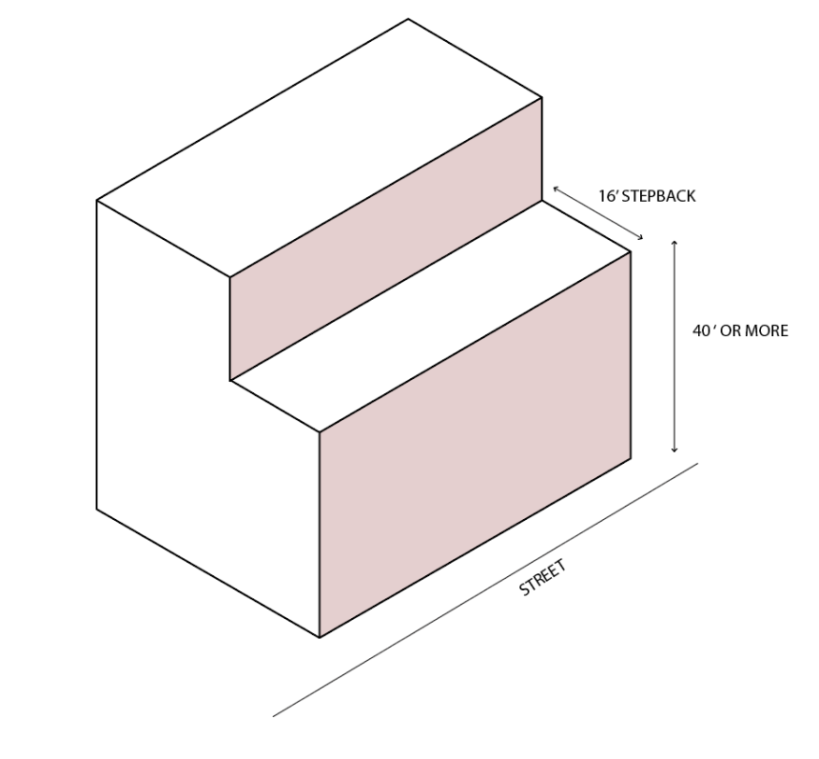
- Step-down Height Adjacent to Residential Areas: Within forty feet (40’) of sites zoned residential, the following standards shall apply. Stepped-down height is not required in the CMU Zone:
  - On the portion of the site within forty feet (40’) of a site zoned R-1, the maximum height shall be thirty-five feet (35’).
  - On the portion of the site within forty feet (40’) of a site zoned R-2, R-4, RM, or RMH the maximum height shall be forty-five feet (45’).
Figure 19.36.050 B: Step-down Heights Illustrated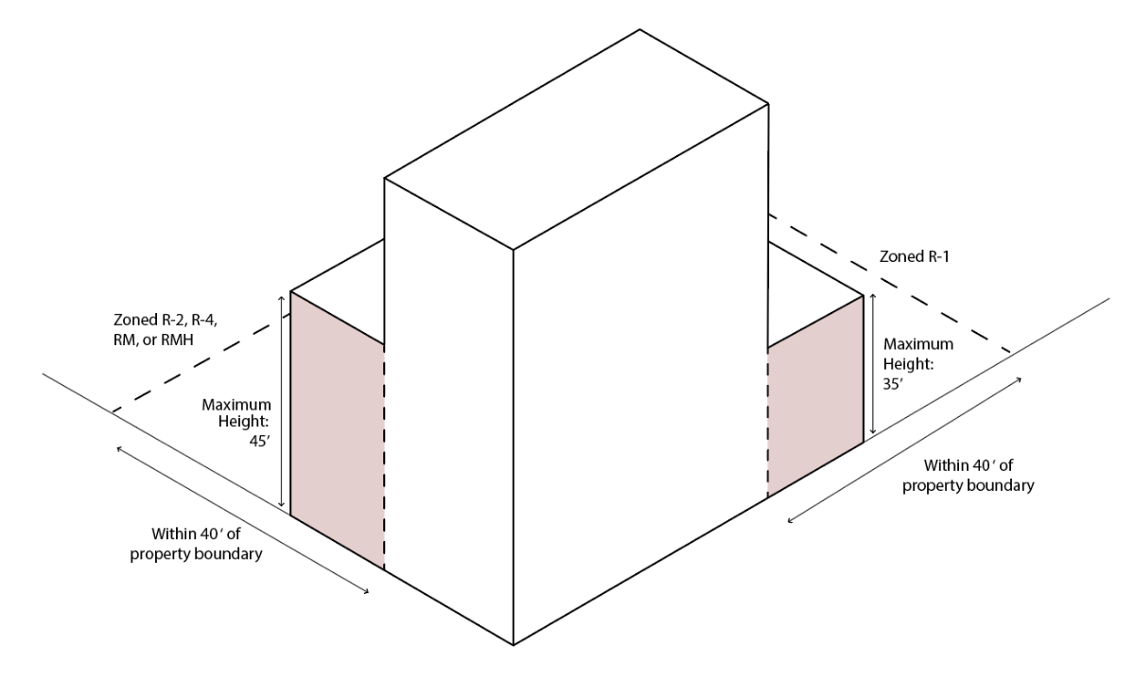

19.36.060 – Required Yards and Setbacks.
- Purpose: The purpose of the standards in this section is to create and maintain street frontages that are attractive, promote a walkable environment, and create sense of safety and comfort through appropriate scale.
- The minimum yard requirements for buildings within the Mixed-Use Zones are presented in Table 19.36.060.
- Exception for Historic District Contributing Buildings. A lot width, yard, or setback standard in Table 19.36.060 may be waived by the Director or Designee only if the Director or Designee finds that complying with that standard would result in a building that currently contributes to a National Historic District Designation or National Historic Landmark no longer contributing to the District Designation or Landmark.
- Exception for Setbacks for Common Walls. The side setback is zero feet (0’) for any building which shares a side common wall.
Table 19.36.060 – Lot Width, Yard, and Setback Requirements.
 | DH | NMU | CMU
Minimum Lot Frontage Along Public Street | 18 | 25 | 20
Minimum Setbacks, in feet (ft.)
Front Yard | 0 | 10 | 0
Side Yard, Interior | 0 | 10 | 10
Side Yard, Corner Lot | 0 | 10 | 0
Rear Yard | 10 | 10 | 10
Maximum Setbacks, in feet (ft.)
Front Yard | 5 | 20 | 10
Side Yard, Interior | 10 | 10 | 10
Side Yard, Corner Lot | 5 | 10 | 10
Rear Yard | 20 | 20 | 30
Minimum Distance Between Main and Accessory Buildings, in feet (ft) | 10 | 6 | 10

19.36.070 – Height Exceptions.
Exceptions to the building heights specified in Table 19.XX.050 apply, in accordance with 19.76.190.

19.36.080 – Off Street Parking Standards.
All provisions of Chapter 19.XX shall apply to development in any of the Mixed-Use Zones. For developments that combine multiple uses, parking requirements shall be calculated for each specific use according to the criteria in 19.XX. The Director or Designee may authorize shared parking for combined uses if those uses are found to operate at distinct hours of the day or night.

19.36.090 – Additional Standards.
It is the responsibility of the applicant to comply with all other standards of Title 19 and all other municipal ordinances.
- 19.40: Specific Use Standards
- 19.46: Site Development Standards
- 19.48: Off Street Parking Requirements
- 19.50: Landscaping and Screening
- 19.51: Supplementary and Qualifying Regulations
- 19.52: Signs

