Manufacturing Zoning Districts – Staff Summary
Purposes:
- Further distinguish between the M-1 and M-2 Zones.
- Tailor the M-1 Zone to support flex industrial uses.
- Increase development standards associated with the M-1 and M-2 Districts to ensure compatible, high-quality development.
Applicability:
The M-1 Zone is intended to be applied within the fabric of communities, where industrial flex spaces (at a smaller scale) are desired. The M-2 Zone is meant for the outskirts of developed areas, where more intensive industrial uses (such as resource extraction and processing) are desired and feasible.
Resources Utilized:
- Portland Zoning Ordinance
- Vineyard Zoning Ordinance
- South Jordan Zoning Ordinance
- Salt Lake City Zoning Ordinance
- Conversations with Kearns PC and Council regarding Warehouse District
Changes to Note:
- The M-1 Zone is renamed from ‘Manufacturing - Light’ to ‘Manufacturing - Flex’ as a way to repurpose this zone for modern needs.
- The use table furthers distinctions between the M-1 and M-2 Zones. The M-2 Zone allows for heavier industrial uses. The M-1 Zone incorporates more amenities for employees and focuses on uses that could be integrated into the fabric of an existing community.
- Development standards are added, including height limitations: 60 feet for the M-1 and 80 feet for the M-2. Such requirements were previously lacking from the Manufacturing Zones.
- Parking and Loading Standards are added to provide more specificity than what previously existed in the ordinance. This helps ensure development is adaptable to changing uses over time.
- New Landscaping and Screening standards are added to ensure views are protected and transitions between industrial zones and other uses are as seamless as possible.

Chapter 19.34: Manufacturing Zones
DRAFT for Review Purposes Only – August 2nd, 2022
Chapter 19.34 Contents
19.34.010 – Purpose of Provisions. 2
19.34.020 – Establishment of Manufacturing Zones. 2
19.34.030 – Schedule of Permitted Uses. 3
19.34.040 – Development Standards. 5
19.34.050 – Required Yards and Setbacks. 7
19.34.060 – Height Exceptions. 7
19.34.070 – Parking and Loading Requirements. 7
19.34.080 – Landscaping and Screening Standards. 8
19.34.090 – Additional Standards. 8

Sections:

19.34.010 – Purpose of Provisions.
The purpose of the manufacturing zones is to provide places in the municipality for industrial, warehousing, wholesale, and other uses that contribute to the economic stability of the community and wellbeing of its employees and residents. The zones intend to provide employment opportunities and expand the municipal tax base while also encouraging sustainable development and providing an attractive transition between residential and non-residential uses.

19.34.020 – Establishment of Manufacturing Zones.
To anticipate and respond to the changing needs of our community and implement industrial and employment center concepts included in the adopted General Plan, Kearns establishes the following zones:
- Manufacturing Zone – Flex (M-1): The M-1 Zone is intended to provide a flexible mix of industrial uses, including light manufacturing, warehousing, wholesale, and accessory uses that contribute to employee wellbeing and quality development.
- Manufacturing Zone – Heavy (M-2): The M-2 Zone is reserved for areas of the municipality that support more intense industrial uses, such as distribution centers, resource processing, and energy production. Development standards are intended to minimize adverse impacts of these uses and protect the surrounding environment.

19.34.030 – Schedule of Permitted Uses.
- Schedule of Permitted Uses. The specific uses listed in the following schedule are permitted in the zones as indicated, subject to the general provisions, special conditions, additional restrictions, and exceptions set forth in this Title.
- Special Conditions. Any special conditions related to a specific use are in Chapter 19.XX Specific Use Standards.
- Procedure for Multiple Uses (Combination of Uses). If a development proposal involves a combination of uses other than accessory uses as identified in Table 19.XX.030, the more restrictive provisions of this Title shall apply. For example, if a portion of a development is subject to Conditional Use (“C”) approval and the other portion is subject only to Permitted Use (“P) review, the entire development shall be reviewed and approved by the Conditional Use process.
- Abbreviations. The abbreviations used in the schedule mean:
  - P = Permitted Use. This use is allowed in the zone but may be subject to additional restrictions and approval processes as provided in this Title.
  - C = Conditional Use. This use is conditional because of the unique characteristics or potential impacts on the municipality, surrounding neighbors, or adjacent uses, incompatibility in some areas of the zone, or compatibility only if special provisions or conditions are required to mitigate the detrimental impacts of the use. The Planning Commission is the land use authority for uses with this designation.
  - X = Prohibited Use. This use is prohibited in this zone. Any use not specifically identified in Table 19.34.030 is prohibited in this zone.
Table 19.34.030: Table of Uses for M-1 and M-2 Zones.
Use Categories | M-1 | M-2
RESIDENTIAL USES:
Rail-Transit Mixed Use | P | X
RETAIL AND SERVICE:
Animal Control or Rescue Facility | P | X
Animal Hospital or Clinic with or without Outdoor Boarding Facilities | P | X
Child Care Center | P | X
Commercial Plant Nursery | X | P
Contractor’s Office | X | P
Vehicle and Equipment Repair – All Types | P | P
FOOD AND DRINK:
See Accessory Uses.
RECREATIONAL:
Open Space | P | P
See also Accessory Uses.
LODGING:
No Lodging Uses are allowed in the Manufacturing Zoning Districts.
OFFICE:
Office – Intensive or Medical | P | X
INDUSTRIAL:
Agricultural Products Processing | X | P
Assembly Use | P | P
Breweries and Distilleries, Industrial | P | P
Freight Service | X | C
Industrial Flex Space | P | X
Machine Shop | P | P
Manufacturing, Heavy | X | C
Manufacturing, Light | P | P
Meat or Poultry Processing Facility | X | P
Recycling Processing Facility | X | P
Resource Recycling Collection Point | P | P
Self-Service Storage Facilities, Enclosed or Outdoor | P | X
Storage Yard | X | P
Underground Record Storage Vaults | X | C
Vertical Indoor Agriculture | P | P
Vehicle Assembly | X | P
Warehouse and Distribution Facilities | X | P
INSTITUTIONAL:
Micromobility Support Infrastructure | P | P
Public Service Training Facility | P | P
Public Use | P | P
Public Utility, Major | C | P
Public Utility, Minor | P | P
Water Treatment Facility | X | P
Wireless Telecommunication Site, Facility, or Equipment Shelter | X | P
SPECIALTY:
Crematorium | P | P
Hospital | C | X
Laboratory, Medical or Dental | P | X
Laboratory, Research and Development | P | X
Park-and-Ride | P | P
Solar Energy System, Commercial | X | C
Wind Energy System, Commercial | X | C
ACCESSORY USES:
Accessory Uses, including Employee Amenities and Accessory Outdoor Storage | P | P

19.34.040 – Development Standards.
- General Design Standards: The following building design requirements apply in the M-1 and M-2 Zones:
  - View Protection. The proportion and massing of buildings shall be designed to minimize the obstruction of all views. No vertical design elements, dominant rooflines, or other features which exaggerate building height shall be used.
  - Building Massing. In order to maximize the integration of buildings and features with the natural environment and surrounding neighborhoods, all developments in the M-1 and M-2 Zones shall incorporate techniques for reducing the apparent size and bulk of buildings and structures. The following methods are required:
    - A consistent level of detail and finish on all sides of a building shall be provided.
    - Continuous building wall surfaces shall be relieved with variations of wall planes or overhangs that create shadow areas and add visual interest.
- Development in the M-1 or M-2 Zones shall comply with the development standards of Table 19.34.040 and all other applicable standards in this Title.
Table 19.34.040: M-1 and M-2 Zone Development Standards.
Standard | M-1 | M-2
Minimum Lot Size (in square feet) ^{C} | 12,000 | 25,000
Minimum Lot Width (in feet) ^{C} | 75 | 100
Building Height (in feet) ^{D} | Minimum: No primary building within this zone shall be erected to a height less than fifteen feet (15’) above grade.  Maximum: No building within this zone may exceed sixty feet (60’) above grade. | Minimum: No primary building within this zone shall be erected to a height less than fifteen feet (15’) above grade.  Maximum: 80
Minimum Floor Area Ratio | 0.5:1 | NA
Maximum Building Lot Coverage | 80% | 80%

- Existing Lots: Lots legally existing as of [adoption date of this ordinance], shall be considered legal conforming lots.
- Step-down Height Adjacent to Residential Areas: Within one hundred feet (100’) of sites zoned residential, the following standards shall apply:
  - On the portion of the site within one hundred feet (100’) of a site zoned R-1, including any sub-zone of R-1, no structure or any portion thereof may exceed thirty-five feet (35’) in height.
  - On the portion of the site within one hundred feet (100’) of a site zoned R-2, R-4, RM, or RMH, no structure or any portion thereof may exceed forty-five feet (45’) in height.
Figure 19.34.040: Stepdown Heights Adjacent to Residential Areas.
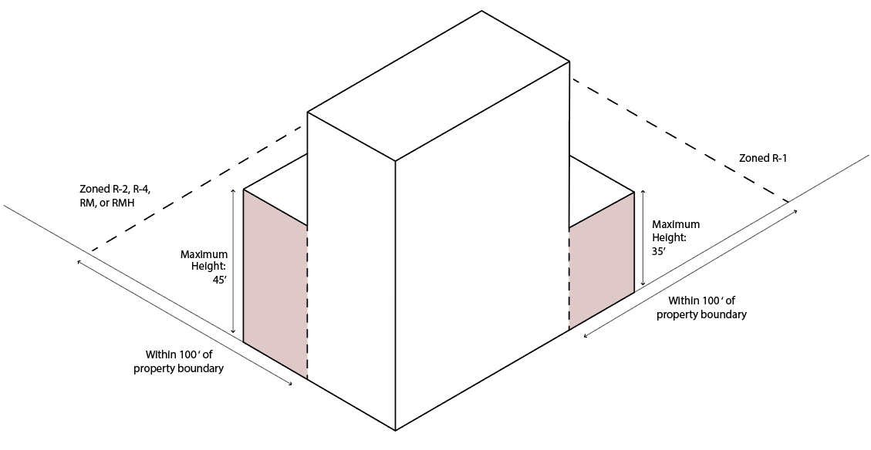

19.34.050 – Required Yards and Setbacks.
Development in the M-1 or M-2 Zones shall comply with the yard and setback standards shown in Table 19.34.050 and all other applicable standards in this Title.
Table 19.34.050: Required Yards and Setbacks for M-1 and M-2 Zones.
Standard | M-1 | M-2
Front Yard Setback (in feet) | Minimum: 20  Maximum: NA | Minimum: 25  Maximum: NA
Side Yard Setback – Interior Lots (in feet) | Minimum: 20  Maximum: NA | Minimum: 20  Maximum: NA
Side Yard Setback – Corner Lots (in feet) | Minimum: 20  Maximum: NA | Minimum: 25  Maximum: NA
Rear Yard Setback (in feet) | Minimum: 25  Maximum: NA | Minimum: 35  Maximum: NA
Minimum Distance between Primary and Accessory Buildings (in feet) | 10 | 10

19.34.060 – Height Exceptions.
Exceptions to the building heights specified in Table 19.34.040 apply, in accordance with 19.XX.XXX.

19.34.070 – Parking and Loading Requirements.
In addition to the standards specified in 19.XX.XX, the following parking and loading standards shall apply in the M-1 and M-2 Zones:
- Loading spaces and berths shall be at least thirty-five feet (35’) in length, ten feet (10’) in width, and fourteen feet (14’) in height, exclusive of aisle and maneuvering space and required parking space;
- Loading spaces and berths may occupy all or any part of any required yard space, except front and corner side yards, and may not be located closer than fifty feet (50’) to any property zoned residential unless screened by a masonry wall not less than ten feet (10’) in height. And loading spaces or berths located in side yards may not be visible from a public street;
- Each required off-street loading berth shall be designed with appropriate means of vehicular access to a street or alley – subject to approval by the Director or Designee - in a manner which will eliminate or minimize conflicts with traffic movement and prevent loading vehicles from traversing residential zones. Maneuvering and backing space to the loading dock shall be accommodated on site whenever possible;
- All loading areas, aisles, and access drives shall be paved so as to provide a durable, dust-proof surface and shall be so graded and drained so as to dispose of surface and storm water without damage to private or public properties, streets, or alleys;
- If the loading or parking area is illuminated, lighting shall be deflected down and/or away from abutting residential sites so as to not cause nuisance, glare, or light pollution;
- Off-street loading facilities shall be located on the same site with the use for which the loading spaces and berths are required; and
- Space allocated to any off-street loading berth may not be used to satisfy the space requirements for any off-street parking facility. The minimum number of loading berths required in the M-1 and M-2 Zones is shown in Table 19.34.070:
Table 19.34.070: Minimum Number of Loading Berths Required by Usable Floor Area.
Usable Floor Area (in square feet) | Minimum Number of Berths Required
 | M-1 | M-2
5,000 to 40,000 | 1 | 1
40,001 to 100,000 |  | 2
Each Additional 100,000 | Add 1 | Add 1

19.34.080 – Landscaping and Screening Standards.
In addition to the standards in 19.XX.XX, the following landscaping and screening standards apply:
- Mechanical Equipment and Refuse Containers: Air conditioning units, generators, waste and recycling containers, and other auxiliary mechanical and building equipment shall be placed on the site so as to minimize noise, appearance, and odors, particularly for adjacent properties and public rights-of-way.
  - Screening: Mechanical equipment and refuse containers shall be screened from public rights-of-way and adjacent properties by screening walls, landscaping, and other screening treatments.
  - Color: All building-mounted mechanical or communications equipment shall be a color that blends with the color and design details of the primary building.
  - Material: High-quality screening materials shall be used to enhance site design and minimize impacts on adjacent properties. Chain-link fencing is prohibited in front yards and side yards of corner-lots and does not count towards meeting the screening requirements of this section. Where feasible, landscaping is preferred to other screening methods.

19.34.090 – Additional Standards.
It is the responsibility of the applicant to comply with all other standards of Title 19 and all other municipal ordinances.
- 19.40: Specific Use Standards
- 19.46: Site Development Standards
- 19.48: Off Street Parking Requirements
- 19.50: Landscaping and Screening
- 19.51: Supplementary and Qualifying Regulations
- 19.52: Signs

