Parks and Open Space Zoning Districts – Staff Summary
Purposes:
- Create new zoning districts that adequately preserve and enhance communities’ parks and open spaces.
- Distinguish between improved/developed park spaces and more natural open spaces.
- Establish standards for lighting, landscaping, and other elements that enhance park and open space areas.
Applicability:
The PR Zone is intended to be applied to existing park areas, especially those that have been enhanced through paved trails and other recreational amenities.
The OS Zone is meant for more natural open spaces such as wildlife corridors, sensitive lands, and viewsheds. This should be applied in areas where the primary goal is conservation. Only limited improvements – such as non-paved trails – are allowed.
Resources Utilized:
- Vineyard Zoning Ordinance
- Salt Lake City Zoning Ordinance
- South Jordan Zoning Ordinance
- Portland Zoning Ordinance
Changes to Note:
This Chapter is entirely new. There are no changes to note. Parks and open spaces were previously held under different zoning designations that did not necessarily protect them from development.

Chapter 19.22: Parks and Recreation Zone
DRAFT for Review Purposes Only – August 1st, 2022
Chapter 19.22 Contents
19.22.010 – Purpose of Provisions. 2
19.22.020 – Establishment of Parks and Recreation Zone. 2
19.22.030 – Schedule of Permitted Uses. 3
19.22.040 – Schedule of Uses, Special Conditions. 4
19.22.050 – Development Standards. 4
19.22.060 – Required Yards and Setbacks. 5
19.22.070 – Height Exceptions. 5
19.22.080 – Parking Requirements. 5
19.22.090 – Landscaping and Screening Standards. 6
19.22.100 – Lighting Standards. 6
19.22.110 – General Information. 7

Sections:

19.22.010 – Purpose of Provisions.
The purpose of the Parks and Recreation Zone is to preserve and enhance public and private open space, natural areas and habitats, and improved park and recreational areas. The Zone provides opportunities for active and passive outdoor recreation; provides contrasts to and relief from the built environment; preserves scenic qualities and viewsheds; protects sensitive or fragile environmental areas such as wetlands, steep slopes, ridge lines, meadows, and stream corridors; encourages sustainability and conservation; and provides transportation connections for people walking, biking, scootering, or using other forms of active transportation.

19.22.020 – Establishment of Parks and Recreation Zone.
To anticipate and respond to the changing needs of the municipality and implement greenway, natural resource preservation, and health and recreation concepts included in the adopted General Plan, Magna establishes the following zone:
- Parks and Recreation District (PR): The PR Zone is intended for improved parks, recreational areas, and other public and private open spaces which can accommodate human use and visitation. Encouraged uses in this Zone include public parks, multi-use trails, ball fields, special uses such as mobile food carts and festivals, and landscaping and equipment sheds.
- Natural Open Space District (OS): The OS Zone is intended for preserving natural areas of the municipality, including sensitive lands, critical habitats, wildlife corridors, viewsheds, and stream corridors. Limited, unimproved recreational uses may be allowed in the OS Zone when negative impacts of recreation and visitation can be mitigated.

19.22.030 – Schedule of Permitted Uses.
- Schedule of Permitted Uses. The specific uses listed in the following schedule are permitted in the zones as indicated, subject to the general provisions, special conditions, additional restrictions, and exceptions set forth in this Title.
- Procedure for Multiple Uses (Combination of Uses). If a development proposal involves a combination of uses other than accessory uses as identified in Table 19.22.030, the more restrictive provisions of this Title shall apply. For example, if a portion of a development is subject to Conditional Use (“C”) approval and the other portion is subject only to Permitted Use (“P) review, the entire development shall be reviewed and approved by the Conditional Use process.
- Abbreviations. The abbreviations used in the schedule mean:
  - P = Permitted Use. This use is allowed in the zone but may be subject to additional restrictions and approval processes as provided in this Title.
  - C = Conditional Use. This use is conditional because of the unique characteristics or potential impacts on the municipality, surrounding neighbors, or adjacent uses, incompatibility in some areas of the zone, or compatibility only if special provisions or conditions are required to mitigate the detrimental impacts of the use. The Planning Commission is the land use authority for uses with this designation.
  - X = Prohibited Use. This use is prohibited in this zone. Any use not specifically identified in Table 19.XX.030 is prohibited in this zone.
Table 19.XX.030: Schedule of Uses for PR and OS Zones.
Use Categories | PR | OS
AGRICULTURAL:
Agricultural Building | P | X
Agriculture | P | X
Agritourism | C | X
Apiary | P | C
Aviary | P | X
RESIDENTIAL USES:
No residential uses are permitted in these zones.
RETAIL AND SERVICES:
Child Care | P | X
FOOD AND DRINK:
Food Truck | P | X
RECREATIONAL:
Campground | C | X
Commercial Recreation | P | X
Multi-use Trail, Paved | P | X
Multi-use Trail, Unpaved | P | P
Open Space | P | P
Private, Non-Profit Recreational Grounds and Facilities | C | X
Recreation Facility - Private, Public, or Commercial | P | X
Stable, Public | C | X
Trailhead Infrastructure, Large Scale: paved parking, restrooms, wayfinding and interpretive signage, trash receptacles, other improvements | P | X
Trailhead Infrastructure, Small Scale: unpaved parking (10 or less spaces), pit toilet, wooden trail signage. | P | P
LODGING:
INDUSTRIAL:
No industrial uses are permitted in these zones.
INSTITUTIONAL USES:
Church, Synagogue, Mosque, Temple, Cathedral, or Other Religious Buildings | P | X
Cemetery | X | P
Community Garden | P | X
Micromobility Support Infrastructure | P | X
Public Parks | P | X
Public Use | P | X
Solar Energy System, Accessory | P | X
Wind Energy System, Accessory | P | X
SPECIALTY:
Park and Ride | P | X
ACCESSORY USES:
Sidewalk Displays and Cafes | P | X

19.22.040 – Schedule of Uses, Special Conditions.
See Chapter 19.XX: Specific Use Standards for conditions and regulations related to specific uses.

19.22.050 – Development Standards.
Development in the PR Zone shall comply with the development standards of Table 19.XX.050 and all other applicable standards in this Title.
Table 19.XX.050: Development Standards for PR and OS Zones.
Standard | PR | OS
Minimum Lot Size (in square feet) | NA | NA
Minimum Frontage | Any parcel in the Parks and Recreation Zone shall have a minimum frontage of 30’ on a public street. | NA
Minimum Lot Width (in feet) | NA | NA
Maximum Building Height (in feet) ^{A} | For lot areas of 5 acres or greater, the maximum is 45’.  For lot areas smaller than 5 acres, the maximum is 35’. | 15
Minimum Floor Area Ratio | NA | NA
Maximum Building Lot Coverage | 30% | NA

- Height Exception for Recreational Equipment: In the PR Zone, if necessary to ensure protection of public health, safety, or welfare, recreation equipment heights are permitted up to eighty feet (80’). For example, nets around batting cages or fences at driving ranges may exceed thirty-five feet (35’) as necessary and as approved by the Director or Designee.

19.22.060 – Required Yards and Setbacks.
Development in the PR Zone shall comply with the yard and setback standards shown in Table 19.22.060 and all other applicable standards in this Title.
Table 19.22.060: Yards and Setbacks for PR and OS Zones.
Standard | PR | OS
Front Yard Setback (in feet) | Minimum: 20  Maximum: NA | Minimum: 20  Maximum: NA
Side Yard Setback – Interior Lots (in feet) | Minimum: 20  Maximum: NA | Minimum: 20  Maximum: NA
Side Yard Setback – Corner Lots (in feet) | Minimum: 20  Maximum: NA | Minimum: 20  Maximum: NA
Rear Yad Setback (in feet) | Minimum: 20  Maximum: NA | Minimum: 20  Maximum: NA
Minimum Distance between Primary and Accessory Buildings (in feet) | 10 | 10

19.22.070 – Height Exceptions.
Exceptions to the building heights specified in Table 19.22.050 apply, in accordance with 19.XX.XXX.

19.22.080 – Parking Requirements.
In addition to the requirements in 19.XX, the following shall apply:
- In the PR Zone:
- Landscaped Strips: All parking areas for a commercial, institutional, or other public use that are adjacent to a public street shall have a landscaped strip of at least ten feet (10’) placed between the sidewalk and the parking area. This strip shall contain drought-resistant vegetation, and at least one native or drought-friendly tree shall be placed every fifty feet (50’).
- Pedestrian Access: Any parking lot with an area greater than twenty-thousand square feet (20,000 sq. ft.) shall provide dedicated ADA-compliant walkways, at least six feet (6’) wide, for pedestrians navigating from their vehicles to a building or park entrance. At a minimum, walkways shall be placed through the center of the parking area and in front of the building(s) to serve as pedestrian access to the area. Walkways shall be landscaped with trees at least every fifty feet (50’). Walkways shall be easily accessed from designated ADA parking stalls.
- In the OS Zone:
- Size Limitation: A parking area may not exceed ten (10) spaces in the OS Zone or one tenth of an acre (1/10th acre).
- Surfacing: Parking areas shall utilize low-impact surfacing materials, such as dirt or crushed gravel. The applicant shall demonstrate proper grading and drainage to dispose of excess surface water accumulated within the area and shall provide for the long-term maintenance of the parking area.
- Seasonality: Parking areas shall be closed during winter months if snow removal and maintenance is unable to be provided within twenty-four hours (24 hr) after a major snow event.

19.22.090 – Landscaping and Screening Standards.
- All landscaping and screening standards found in Chapter 19.XX shall apply in the PR Zone. In addition, the following fencing standards shall apply:
  - Fencing: Fencing may be allowed in the PR Zone where desirable to establish sense of privacy, protect children and pets, provide a buffer from street traffic, or enhance property appearance. The following standards apply to fencing in the PR Zone:
    - Height: Fences may be up to six feet (6’) tall at the property line. Fences taller than six feet (6’) must be set back from the property line an additional foot for each foot of fence over six feet (6’).
    - Materials: Fences in the PR Zone shall be designed to enhance the visual appearance of the area.
B. The intent of the OS Zone is to preserve critical habitats and natural spaces within the municipality. Any landscaping efforts shall facilitate ecosystem management for the benefit of native plant and animal species. The landscape and screening standards of Chapter 19.XX do not apply to this Zone.

19.22.100 – Lighting Standards.
All uses and developments in the PR Zone must comply with the following lighting standards, in addition to any other applicable standards in this Title:
- Lighting shall be located and installed to minimize any adverse impact on the natural environment, including avoiding lighting in critical habitat areas or where it may pose traffic safety problems.
- All lighting shall be fully shielded to eliminate glare, prevent light trespass onto neighboring properties, and protect views of the night sky.
- Lights for outdoor recreation equipment and infrastructure may be permitted up to eighty feet (80’) in height, provided they are set back from any residential use at least fifty feet (50’). Such lights shall be directed in a manner that minimizes light trespass onto adjacent properties.
Figure 19.22.110 – Types of Lighting.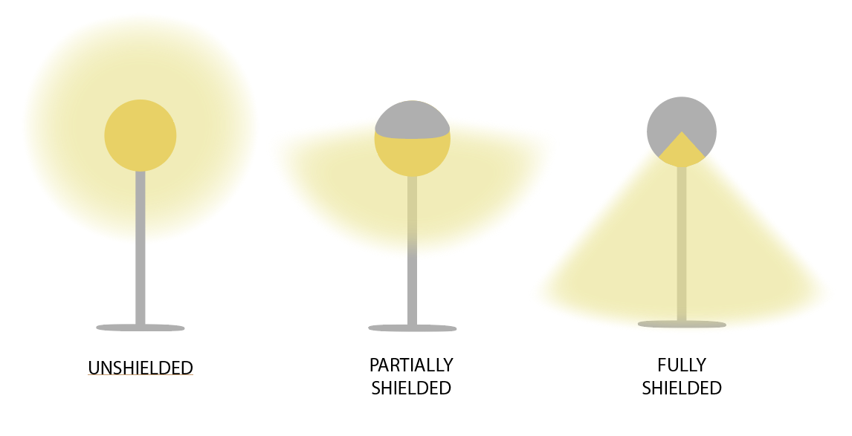

19.22.110 – General Information.
It is the responsibility of the applicant to comply with all other standards of Title 19 and all other municipal ordinances, including:
- 19.XX: Specific Use Standards
- 19.XX: Site Development Standards
- 19.XX: Off Street Parking Requirements
- 19.XX: Signs

