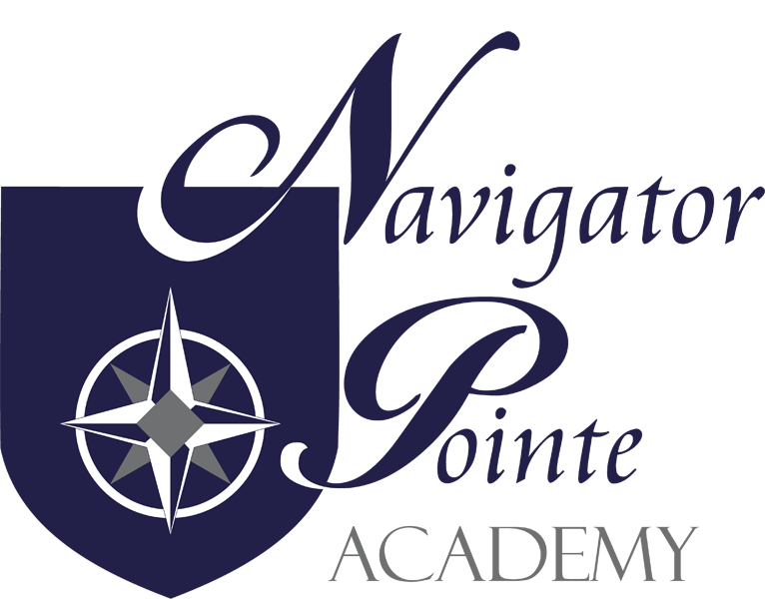
Governing Board Meeting
6844 South Navigator Drive West Jordan, Utah
THURSDAY, OCTOBER 20, 2022 6:00 p.m. – 7:00 p.m.
Kristi Anderson
Jake Montague
Fernando Cruz DRAFT
Judy Farris
Rich Eccles
I. Call to Order/Welcome @ 6:23 P.M.
II. Public Comment None
III. Governance
- Board Governance Training
  - Always Carry Dry Socks – 6 lessons I learned in the Marine Core reviewed by Fernando Cruz
- Monthly Board Meeting Minutes Approval (Board action may be required)
  - Jake made a motion to approve the September 2022 Board Meeting minutes – Kristi seconded the motion. Roll Call: Jake – yes; Kristi – yes; Fernando – abstain. Motion passes.
- NPA Teacher and Student Success Plan 2022-2023 (Board action may be
required)
  - This is a continuing plan that we determine if we still want to continue with the current plan. Student performance and student achievement. In the past we have hired a behavior specialist to help students improve their social skills. Also used the funds to train teachers so they have more support.

- Review of NPA School Policies (UAPCS Training)
  - There are trainings that they make available to directors and board members. It’s possible that they have recordings of their trainings on their website.

E. “Closed Session, as necessary, to discuss allowed items”
(Board action may be required) - None

IV. Director’s Report
- Enrollment is at 410 students currently. Volunteer hours are at 279 hours. Working on coming up with ideas for volunteer hours while still making sure that student data is protected while volunteers are in the school. They appreciate the patience of parents while they work on trying to figure out a way to utilize volunteers in the school. The new information for guidelines is coming from the federal government and the USBE is sending those to us – it is FIRPA. Everything is up and running well from the beginning of the school year. Hired another paraprofessional this week. Hoping to get one more special education paraprofessional.
V. Finance Report
A. Teachers must go through a letters training. This is an expensive training. We
made a cohort with other schools/teachers and paid for the training now and will
now start to get reimbursed for trainings for the teachers not at our school. Line
47 is more revenue that we were not expecting. Audit should come back in November sometime.
Fernando motioned to accept the September 2022 financial report. Jake seconded
the motion. Roll Call: Jake – yes; Kristi – yes; Fernando – yes. Motion passes.
VI. Next Meeting Schedule November 17, 2022
VII. Adjourn @ 7:13 P.M.

