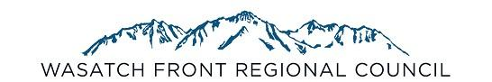
WFRC Funding Programs

The Wasatch Front Regional Council is responsible for administering and assisting with nine programs that provide funding and resources for local governments. These are briefly described below, with additional detail on timelines, eligibility, etc. shown on the following pages.

The Surface Transportation Program (STP) provides funding that may be used for projects on Federal-aid eligible highways, transit capital improvements, and active transportation projects.

The Congestion Mitigation Air Quality (CMAQ) provides funding for transportation projects that improve air quality.

The Transportation Alternatives Program (TAP) funds construction and planning of bicycle and pedestrian facilities.

The Carbon Reduction Program (CRP) provides funding for transportation projects that reduce on-road carbon dioxide emissions.

The Transportation and Land Use Connection (TLC) supports local governments with technical assistance to integrate land use planning and regional transportation, implementing the Wasatch Choice Vision. The TLC program is made available through a partnership with Salt Lake County, the Utah Transit Authority, and the Utah Department of Transportation.

Station Area Plan Technical Assistance (SAP) is available through WFRC on a rolling basis from July 2022 to July 2024, in partnership with the Governor’s Office of Economic Opportunity, the Utah Transit Authority, and the Mountainland Association of Governments. As of 2022 cities with a fixed-guideway public transit station (rail or BRT) must develop a Station Area Plan for that station and update their general plan and zoning to implement the Station Area Plan.

The Community Development Block Grant (CDBG) Small Cities Program provides funding to local governments and public service providers for a variety of housing, infrastructure, public service, and community development projects that principally benefit low to moderate-income persons in Morgan, Tooele, and Weber Counties, excluding the entitlement city of Ogden.

The Community Impact Board Program provides grants and low interest loans to communities that have federally leased land used for mineral extraction to help make up for a loss of tax revenue that cannot be collected on that leased land.

The Wasatch Front Economic Development District (WFEDD) is a federally recognized Economic Development District created to foster regional economic developments and assist eligible entities in developing competitive grant applications from the U.S. Department of Commerce Economic Development Administration.

General application milestones for the first five programs are: Letter of Intent due September 29, 2022
Application due December 8, 2022
Application Information

Funding Program | Purpose | Letter of Intent Due Date | Application Due Date | Year Funds Available | Approximate Funds Available to the Region Annually | Selection Process | Contact
Surface Transportation Program (STP) | Surface Transportation Improvements | September 29, 2022 | December 8, 2022 | 2029 | $29,000,000 - $33,000,000 | Competitive | Ben Wuthrich bwuthrich@wfrc.org
Congestion Mitigation Air Quality (CMAQ) | Projects that reduce mobile source emissions | September 29, 2022 | December 8, 2022 | 2029 | $7,000,000 - $8,000,000 | Competitive | Ben Wuthrich bwuthrich@wfrc.org
Transportation Alternatives Program (TAP) | Bicycle and Pedestrian Facilities | September 29, 2022 | December 8, 2022 | 2025 | $3,000,000 | Competitive | Ben Wuthrich bwuthrich@wfrc.org
Carbon Reduction Program (CRP) | Projects that reduce on-road CO2 emissions | September 29, 2022 | December 8, 2022 | 2025 | $3,000,000 - $4,000,000 | Competitive | Ben Wuthrich bwuthrich@wfrc.org
Transportation and Land Use Connection (TLC) | Planning Assistance | September 29, 2022 | December 8, 2022 | 2023 | $1,900,000 | Competitive | Megan Townsend mtownsend@wfrc.org
Station Area Planning (SAP) | Planning Assistance for SAPs | N/A | Deadlines every 2 months | 2022 | Up to $5million over 2 years | Non-Competitive | Megan Townsend mtownsend@wfrc.org
Community Development Block Grant Program (CDBG) | Housing and Community Development Activities | Mandatory  How to Apply Workshop: 10/20/22, 3pm | January 31, 2023 | 2023 | $1,000,000 | Competitive | Christy Dahlberg christy@wfrc.org
Community Impact Board (CIB) | Planning and Infrastructure Loans/Grants | Updated Capital Improvement Plan Each March | February, June, October | Ongoing | N/A | Competitive | Christy Dahlberg  christy@wfrc.org
Economic Development Administration | Economic Development and Marketing Strategies | N/A | Ongoing | Ongoing | $100,000+ | Competitive | Marcia White  mwhite@wfrc.org

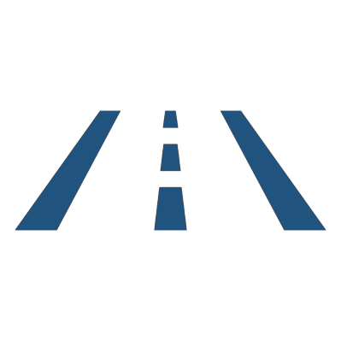
Surface Transportation Program (STP)

Program Description
Provides funding that may be used for projects on Federal-aid eligible highways, transit capital improvements, and active transportation projects.

Program Eligibility
An eligible project sponsor must be a local government in the Ogden/ Layton Urbanized or Salt Lake/ West Valley Urbanized Area, the department of transportation, or the transit authority, or submit a letter in cooperation with one of these entities.

Eligible Activities
STP funds may be used for constructing new streets or widening, improving, or reconstructing existing streets classified as Federal Aid Eligible (FAE) freeways, highways, arterials or collectors (click here for the latest version of the FAE facilities map in your Urban Area). In addition, STP funds can be used for bridge replacement, intersection improvements, projects which reduce traffic demand, such as transit capital improvements and active transportation, and other projects as provided for in federal legislation. Major highway and transit capacity improvements must be identified in the first phase of the 2019-2050 RTP.

Funding
By population formula, the federal government currently apportions approximately $10,000,000 - $12,000,000 in Urban STP funds each year to the Ogden/ Layton Urbanized Area, and approximately $20,000,000 - $22,000,000 in the Salt Lake/ West Valley Urbanized Area. Funds are programmed over a six-year period and applicants currently will be competing for funds available in the federal fiscal year 2029.

Letters of Intent
In order for the WFRC staff to recommend whether a sponsor should submit an application, the “Letter of Intent” must include the project name, project limits, a brief project description, and an estimated cost. A list of all the projects appropriately submitted will be distributed to members of the Councils of Governments (COGs) and then reviewed by WFRC to determine program eligibility. Letters of Intent are due September 29, 2022 electronically. Form available here. This letter should be signed by the Mayor, Commissioner, or executive director of the sponsoring agency.

Applications
Sponsors of eligible projects will be notified and required to submit a new and/or updated “Project Evaluation Concept Report” and “Cost Estimation Form” for each project by December 8, 2022. These reports will be reviewed for completeness. The projects will be evaluated and scored by the WFRC staff according to the approved criteria prior to presenting information to the Technical Advisory Committees for review and recommendation. The projects and the recommendations will then be presented to the COGs for discussion and review, as well as to Trans Com for recommendation to the Regional Council.

Staff Contact Ben Wuthrich, bwuthrich@wfrc.org, (801) 363-4230 x1121


Congestion Mitigation/Air Quality (CMAQ)

Program Overview
CMAQ provides federal funding for transportation projects and programs that reduce congestion and improve air quality.

Program Eligibility
An eligible project sponsor must be a local government in the Ogden/ Layton or Salt Lake/ West Valley Urbanized Area, the Utah Department of Transportation, or the Utah Transit Authority. Other entities can partner with eligible applicants.

Eligible Activities
Funds must be used for transportation projects which improve air quality within the Urbanized Area. Examples of eligible projects include transportation control measures in the State Air Quality Implementation Plan (SIP); construction/ purchase of new public transportation facilities and equipment; construction of bicycle or pedestrian facilities serving commuter transportation needs; promotion of alternative travel modes, including ridesharing; Intelligent Transportation Systems (ITS); and certain traffic control measures, such as traffic signal coordination, intersection improvements, and incident management. The funds may not be used for major road widening.

Funding
By population formula, the U.S. Department of Transportation currently apportions approximately $3,000,000 in CMAQ funds each year to the Ogden/ Layton Urbanized Area and approximately $5,600,000 in the Salt Lake/ West Valley Urbanized Area. Funds are programmed over a six-year period and applicants currently will be applying for funds available in federal fiscal year 2029.

Letters of Intent
In order for the WFRC staff to recommend whether a sponsor should submit an application, the “Letter of Intent” must include the project name, project limits, a brief project description, and an estimated total project cost. A list of all the projects appropriately submitted will be distributed to members of the Councils of Governments (COGs) and will be reviewed by WFRC to determine program eligibility. Letters of Intent are due September 29, 2022 electronically. Form available here. This letter should be signed by the Mayor, County Commissioner, or executive director of the sponsoring agency.

Applications
Sponsors of eligible projects will be notified and required to submit a new and/or updated “Project Evaluation Concept Report,” “Cost Estimation Form,” and “Emissions Analysis Form” for each project by December 8, 2022. These forms will be reviewed for completeness and supporting documentation. The projects will be evaluated and scored by the WFRC staff according to the approved criteria prior to presenting information to the WFRC Technical Advisory Committees for review and recommendation. After this, the projects and recommendations will be presented to the COGs for input, and then to Trans Com for recommendation to the Regional Council.

Project Evaluation
Projects submitted to compete for CMAQ funds are scored based on annual emissions reduction benefit divided by project cost. The length of the project’s effective life in years is included in the benefit/ cost calculation. Other benefits of a project such as safety, congestion relief, or synergy with other improvements, are also considered. Because the principal purpose of the CMAQ Program is to improve air quality by reducing mobile source emissions, applicants are encouraged to submit a project that will generate a significant air quality benefit. Examples of the air quality benefits from some past CMAQ-funded projects are included in this graph. Each project submitted is evaluated independently for its air quality benefit.

Staff Contact Ben Wuthrich, bwuthrich@wfrc.org, (801) 363-4230 x1121

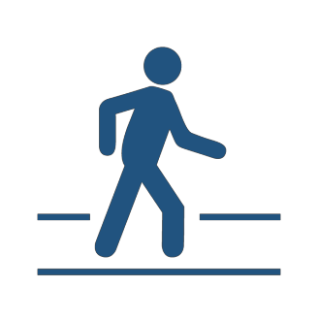
Transportation Alternatives Program (TAP)

Program Description
TAP funds are for the construction and planning of bicycle and pedestrian facilities.

Program Eligibility
An eligible project sponsor must be a local government in the Ogden/ Layton or Salt Lake/ West Valley Urbanized Area, the department of transportation, or the transit authority, or submit a letter in cooperation with one of these entities.

Eligible Activities
Funds may be used for construction, planning, and design of on-road and off-road trail facilities for pedestrians, bicyclists, and other non-motorized forms of transportation, including sidewalks, bicycle infrastructure, pedestrian and bicycle signals, traffic calming techniques, lighting and other safety-related infrastructure that will provide safe routes for non- drivers, and transportation projects to achieve compliance with the Americans with Disabilities Act of 1990. Funding eligibility includes Safe Routes to School infrastructure projects.

Funding
By population formula, the federal government currently apportions approximately $1,100,000 in TAP funds each year to the Ogden/ Layton Urbanized Area and approximately $2,000,000 to the Salt Lake/ West Valley Urbanized Area. Applicants will be competing for funds available in the federal fiscal year 2025.

Letters of Intent
In order for the WFRC staff to recommend whether a sponsor should submit an application, the “Letter of Intent” must include the project name, project limits, a brief project description, and an estimated cost. A list of all the projects appropriately submitted will be distributed to members of the Councils of Governments (COGs) and then reviewed by WFRC to determine program eligibility. Letters of Intent are due September 29, 2022 electronically. Form available here. This letter should be signed by the Mayor, Commissioner, or executive director of the sponsoring agency.

Applications
Sponsors of eligible projects will be notified and required to submit a new and/or updated “TAP Concept Report” and “Cost Estimation Form” for each project by December 8, 2022. These reports will be reviewed for completeness. The projects will be evaluated and scored by the WFRC staff according to the approved criteria prior to presenting information to the Technical Committees for review and recommendation. The projects and the recommendations will be presented to the COGs and the Active Transportation Committee for discussion and review, and then to Trans Com for recommendation to the Regional Council.

Staff Contact Ben Wuthrich, bwuthrich@wfrc.org, (801) 363-4230 x1121

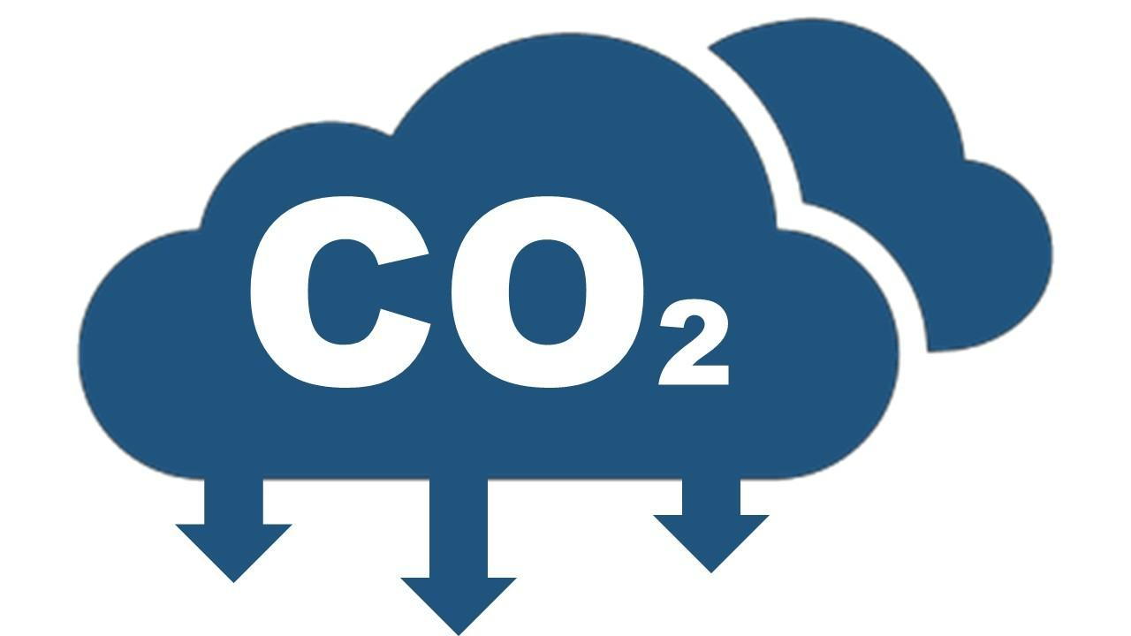
Carbon Reduction Program (CRP)

Program Overview
CRP funding may be used on a wide range of projects that support the reduction of on-road CO2 emissions.

Program Eligibility
An eligible project sponsor must be a local government in the Ogden/ Layton or Salt Lake/ West Valley Urbanized Area, the Utah Department of Transportation, or the Utah Transit Authority. Other entities can partner with eligible applicants.

Eligible Activities
Funds must be used to reduce on-road CO2 emissions, which may include projects and strategies for safe, reliable, and cost-effective options to reduce traffic congestion by facilitating the use of alternatives to single-occupant vehicle trips, including public transportation facilities, pedestrian facilities, bicycle facilities, and shared or pooled vehicle trips within the Urbanized Area. Examples of eligible projects include traffic monitoring management, advanced truck stop electrification systems, construction/ purchase of new public transportation facilities and equipment; construction of bicycle or pedestrian facilities, promotion of alternative travel modes, including ridesharing; Intelligent Transportation Systems (ITS); and certain traffic control measures such as traffic signal coordination, intersection improvements, and incident management. and certain types of projects to improve traffic flow that are eligible under the CMAQ program.

Funding
By population formula, the U.S. Department of Transportation currently apportions approximately $1,400,000 in CRP funds each year to the Ogden/ Layton Urbanized Area and approximately $2,600,000 in the Salt Lake/ West Valley Urbanized Area. Funds are programmed over a six-year period and applicants currently will be applying for funds available in federal fiscal year 2025.

Letters of Intent
In order for the WFRC staff to recommend whether a sponsor should submit an application, the “Letter of Intent” must include the project name, project limits, a brief project description, and an estimated total project cost. A list of all the projects appropriately submitted will be distributed to members of the Councils of Governments (COGs) and will be reviewed by WFRC to determine program eligibility. Letters of Intent are due September 29, 2022 electronically. Form available here. This letter should be signed by the Mayor, County Commissioner, or executive director of the sponsoring agency.

Applications
Sponsors of eligible projects will be notified and required to submit a new and/or updated “Project Evaluation Concept Report,” “Cost Estimation Form,” and “Emissions Analysis Form” for each project by December 8, 2022. These forms will be reviewed for completeness and supporting documentation. The projects will be evaluated and scored by the WFRC staff according to the approved criteria prior to presenting information to the WFRC Technical Advisory Committees for review and recommendation. After this, the projects and recommendations will be presented to the COGs for input, and then to Trans Com for recommendation to the Regional Council.

Project Evaluation
Because the principal purpose of the CRP Program is to reduce on-road CO2 emissions, applicants are encouraged to submit a project that will generate a significant air quality benefit; however, other benefits of a project such as safety of all roadway users, congestion relief, and consideration of unique circumstances affecting community members’ mobility needs, or synergy with other improvements, are also considered.

Staff Contact Ben Wuthrich, bwuthrich@wfrc.org, (801) 363-4230 x1121

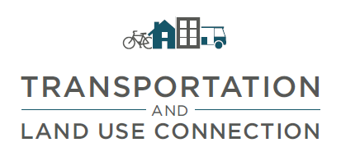
Transportation and Land Use Connection

Program Description
The Transportation and Land Use Connection (TLC) program is a partnership between the Wasatch Front Regional Council (WFRC), Salt Lake County, Utah Department of Transportation, and Utah Transit Authority.

The TLC program provides planning technical assistance to local communities to help them achieve their goals and plan for growth. The program helps communities implement changes to the built environment that reduce traffic on roads and enable more people to easily walk, bike, and use transit. This approach is consistent with the Wasatch Choice Vision and helps residents living throughout the region enjoy a high quality of life through enhanced mobility, better air quality, and improved economic opportunities.

Program Eligibility
An eligible project sponsor must be a local government in Davis, Morgan, Salt Lake, Southern Box Elder, Tooele or Weber
County. Multi-jurisdictional projects are encouraged.

Program Goals
- Maximize the value of investment in public infrastructure.
- Enhance access to opportunities.
- Increase travel options to optimize mobility.
- Create communities with opportunities to live, work, and play.

Eligible Activities
Funds may be used to provide technical assistance to complete visioning efforts, produce plans, conduct studies, amend policy, or engage in any pre-development activities that support the program goals.

Funding
Program funds have grown to $1,900,000. The program is funded by the Wasatch Front Regional Council, Salt Lake County, the Utah Department of Transportation, and the Utah Transit Authority. Our partners have an active voice in the program and are integral to the successful implementation of TLC projects.

Application Process
A list of all the projects appropriately submitted will be distributed to members of the Councils of Governments (COGs) and then reviewed by a selection committee made up of program partners to determine program eligibility. Letters of Intent are due September 29, 2022. This letter should be signed by the chief elected official of the sponsoring community(ies). Sponsors of eligible projects will be notified and required to submit a new application for each project by December 8, 2022.

For more information
More details can be found on the program website available here. If you have any further questions or concerns regarding the program or project eligibility, please contact Megan Townsend, mtownsend@wfrc.org.

Station Area Planning Technical Assistance

Program Description
Station Area Plan Technical Assistance (SAP) is available through WFRC on a rolling basis from July 2022 to July 2024, in partnership with the Governor’s Office of Economic Opportunity, the Utah Transit Authority, and the Mountainland Association of Governments. As of 2022 cities with a fixed-guideway public transit station (rail or BRT) must develop a Station Area Plan for that station and update its general plan and zoning to implement the Station Area Plan.

Program Eligibility
Cities impacted by the Station Area Plan provisions of HB462.

Program Goals
- Increase the availability and affordability of housing, including moderate income housing.
- Promote sustainable environmental conditions.
- Enhance access to opportunities.
- Increase transportation choices and connections.

Eligible Activities
Projects must fulfill all or some of the SAP statutory requirements, help a city in preparing to do so, or implement any component of the city’s SAP implementation plan. SAPs must include all of the elements summarized here.

Funding
WFRC and the Mountainland Association of Governments will work with the Utah Transit Authority and Governor’s OFfice of Economic Opportunity to program $5 million over two years.

Application Process
Funds will be programmed on a rolling basis, with review periods roughly every two months. The application will remain open until funds have run out.

For more information
More details can be found on the program website available here. If you have any further questions or concerns regarding the program or project eligibility, please contact Megan Townsend, mtownsend@wfrc.org.

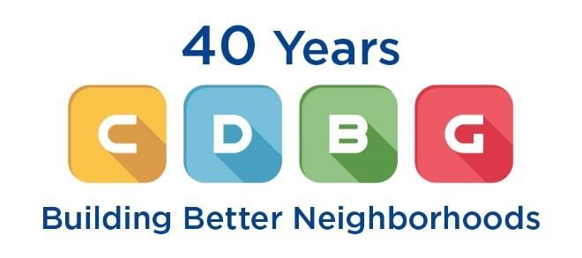
Community Development Block

Grant Program (CDBG)

Program Description
CDBG is funded under the Housing and Community Development Act of 1974 by the U.S. Department of Housing and Urban Development. The Governor elects to administer the program and delegates the administration to the Department of Workforce Services, Housing and Community Development Division. The purpose of the CDBG program is to assist in developing viable urban communities by providing decent housing, a suitable living environment, and expanding economic opportunities, principally for persons of low and moderate income.

Eligibility
Cities with a population of 50,000 or less and counties with a population of 200,000 or less qualify for the small cities program. Eligible entities in the Wasatch Front region include Morgan, Tooele, and Weber Counties and the cities within (excluding Ogden City). Nonprofits and Special Service Districts in these counties are eligible for up to 15% of WFRC's allocation, provided they are sponsored by an eligible city or county.

Eligible Activities
The following activities are eligible for funding: public services; planning; assistance to not-for-profits for community development activities; removal of barriers that restrict the accessibility of the elderly or handicapped; property acquisition for public purposes; construction or reconstruction of streets, water and sewer facilities, construction or reconstruction of parks and other public works in low income areas; demolition of buildings and improvements; rehabilitation of public and private buildings; and slum and blight removal.

Funding
The Wasatch Front region received approximately $1,038,000 of CDBG funds in fiscal year 2022. The program is a competitive grant program; all applicants are required to submit an application for funding. All interested persons wishing to make an application must attend the region’s How-to-Apply workshop on October 20, 2022 at 3:00 pm (likely virtually). In Utah, project prioritization is delegated to the local elected officials that make up a Regional Review Committee (RRC). This local rating and ranking process provides for maximum involvement of the public and local governments. In the Wasatch Front, the RRC is made up of two members from each county, nominated by their respective County Council of Governments. The RRC determines project eligibility, project ranking, and funding recommendations to the Utah Division of Housing and Community Development.

For More Information
Christy Dahlberg | 801-363-4250 x5005 | christy@wfrc.org

Community Impact Board
Program Description
CIB is a federal program that provides low interest loan and/or grant opportunities to communities that have federally leased land used for mineral extraction. The funding opportunities are to mitigate impacts due to the loss of tax revenue on these federally leased lands.

Eligibility
Communities with federally leased land used for mineral extraction. These communities are required to submit a capital improvement plan (CIP) each year outlining their funding priorities for the upcoming year and the next five years.

Eligible Activities
The following activities are eligible for funding: planning; construction or reconstruction of streets, water and sewer facilities, construction or reconstruction of parks and other public works; demolition of buildings and improvements; and rehabilitation of public buildings.

Funding
The Wasatch Front region is not very competitive for grants due to the small amount of federally leased land used for mineral extraction, but more so for low interest loans. If a community (Tooele County and Morgan County) have their CIP submitted each spring, the Board meets every February, June, and October to review applications.

For More Information
Christy Dahlberg | 801-363-4250 x5005 | christy@wfrc.org
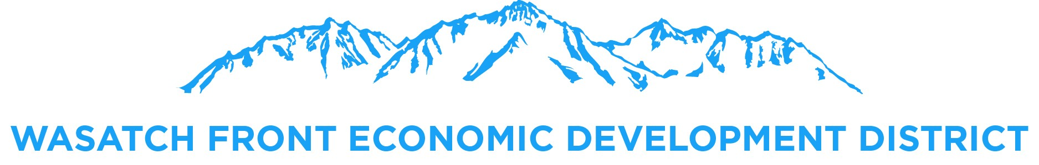
Wasatch Front Economic
Development District

Description
The Wasatch Front Economic Development District undertakes a regional approach to economic development with support of its member counties including Davis, Morgan, Salt Lake, Tooele, and Weber. The District operates under the auspice of the Wasatch Front Regional Council. The District received designation as the region’s Economic Development District (EDD) from the U.S. Department of Commerce Economic Development Administration (EDA) in August 2014. The Wasatch Front Economic Development District is one of seven federally recognized economic development districts in Utah - every county in the State of Utah is now represented by a Regional Economic Development District.

Mission and Focus
The District’s mission is to support economic development plans, promote long-term economic competitiveness, and attract federal monies in order to implement local plans. The District implements its mission through four key strategies that include: 1) Link development with transportation and other infrastructure, 2) Create fiscally sustainable places, 3) Provide amenities, and 4) Attract and retain businesses, and encourage innovation.

The District’s focus is to further regional economic development activities through coordination of long-term planning activities, collaboration and partnerships, and the implementation of the region’s regional economic development strategy known as a Comprehensive Economic Development Strategy (CEDS). The CEDS analyzes the region’s strengths, weaknesses, opportunities, and challenges. This analysis allows the District to foster and implement local and regional goals that further comprehensive planning, economies of scale, capital investment, and regional competitiveness.

Eligibility
Eligible applicants include the state, political subdivisions of the state, Indian tribes, institutions of higher education, non-profit organizations acting in coordination with political subdivisions of the state, areas that are economically distressed, or import-impacted U.S. firms.

Investment Programs
The District assists entities in coordinating and developing competitive grant applications for the Economic Development Administration’s investment programs. EDA is the only federal government agency focused exclusively on economic development. The EDD in partnership with EDA can play a critical role in fostering local and regional economic development efforts across the Wasatch Front region by supporting strategic investments that foster job creation and attract private investment particularly in economically distressed areas. EDA’s investment programs 1) help distressed communities attract new industry and encourage business expansion, 2) build local and regional knowledge base, 3) assist in planning efforts, 4) analyze feasibility of potential economic developments, 5) fund market and/or environmental studies, planning / construction grants, revolving loan funds, 6) develop and implement business recovery strategies for the global marketplace.

Application Process
Filling out the CEDS Project Form is the first step in making a formal application to the U.S. Economic Development Administration. The District reviews and approves projects quarterly (February, May, August, and November) for inclusion into the region’s Comprehensive Economic Development Strategy.

For More Information
Marcia White | 801-363-4250 x1126 | mwhite@wfrc.org | www.wfrc.org

