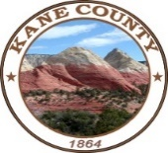
Kane County
Public Lands Department

76 North Main Street ▪ Kanab, UT 84741
435.644.4964

Resource Development Committee Meeting

November 21, 2022
10:00 AM
Agenda

- Approval of 10-18-2022 Interagency meeting minutes.

Updates:
- GSENM Planning updates.
- Coordination meeting dates with BLM.
- Discuss Committee planning strategies on the GSENM RMP.

General:

- Committee Updates.
- County Updates.

Adjourn.

