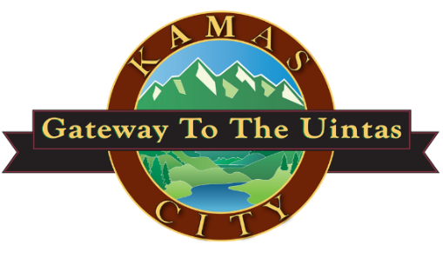

Join the Kamas City Council for the

kamas city
event center
GRAND OPENING

Tuesday November 22, 2022
50 East 400 South
7:00 p.m.

Light refreshments will be served

