SUMMARY OF STR DENSITY SURVEY RESULTS: 11/11/2022
Q.1 Name (not included
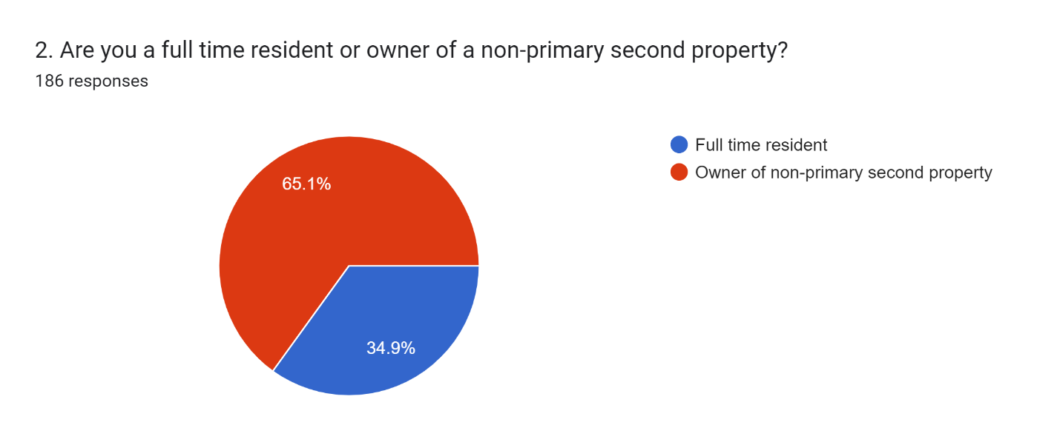
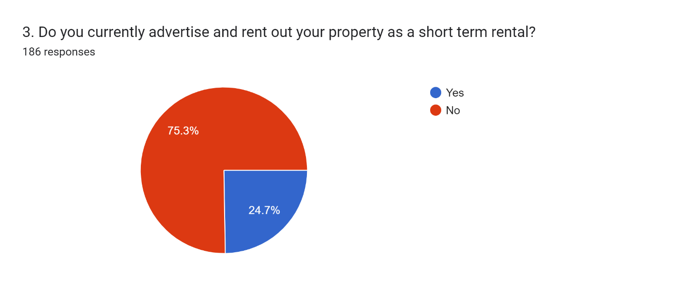
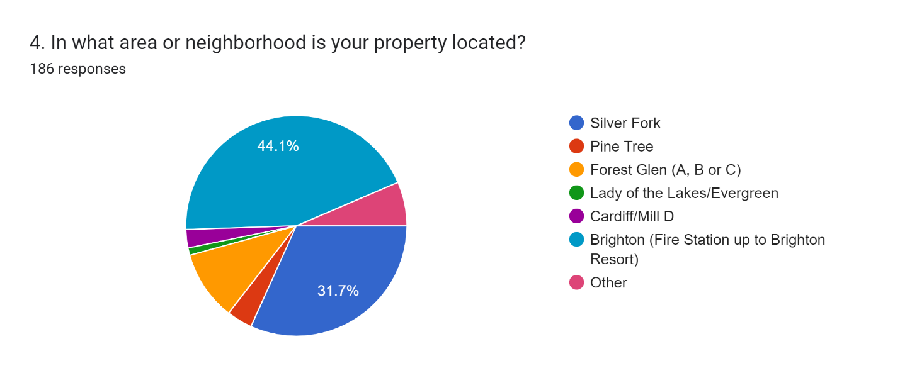
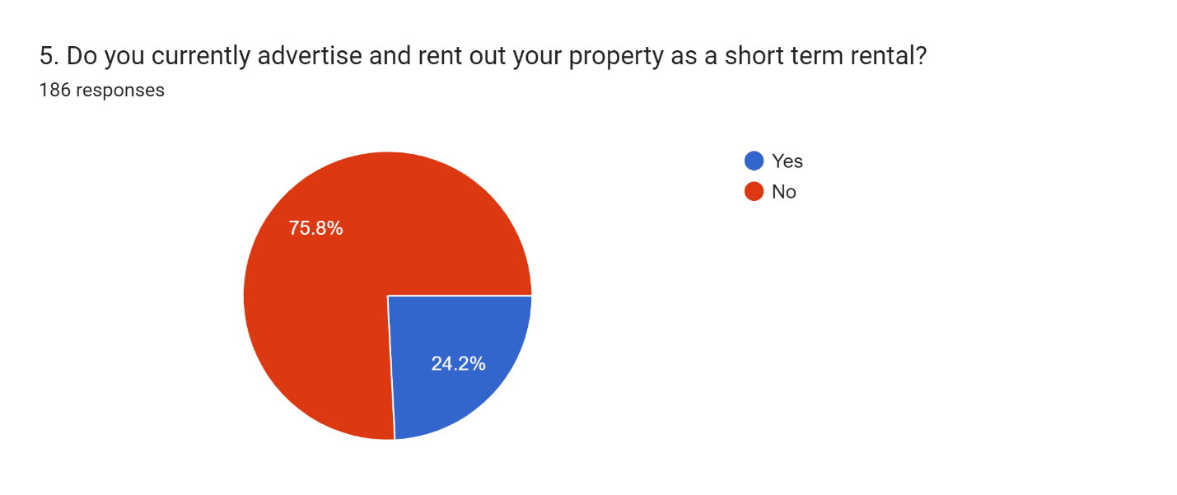
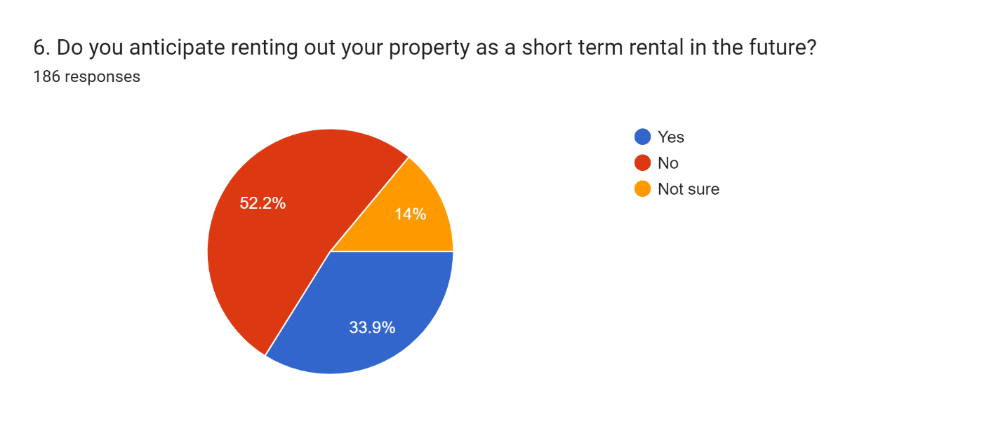
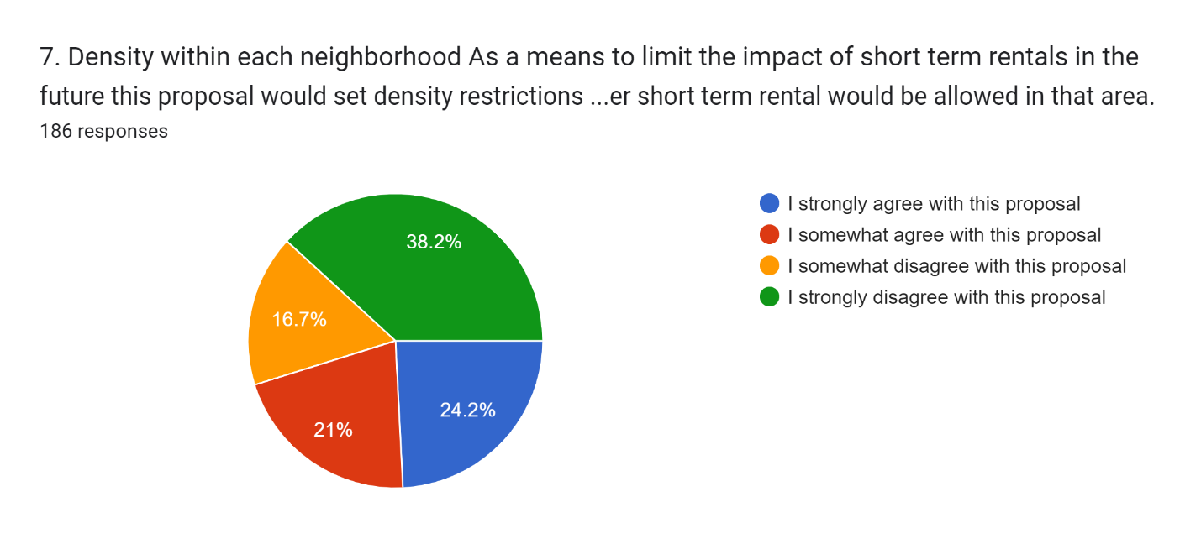
8. Please explain your reasoning for your answer to #7.165 responses (See below)
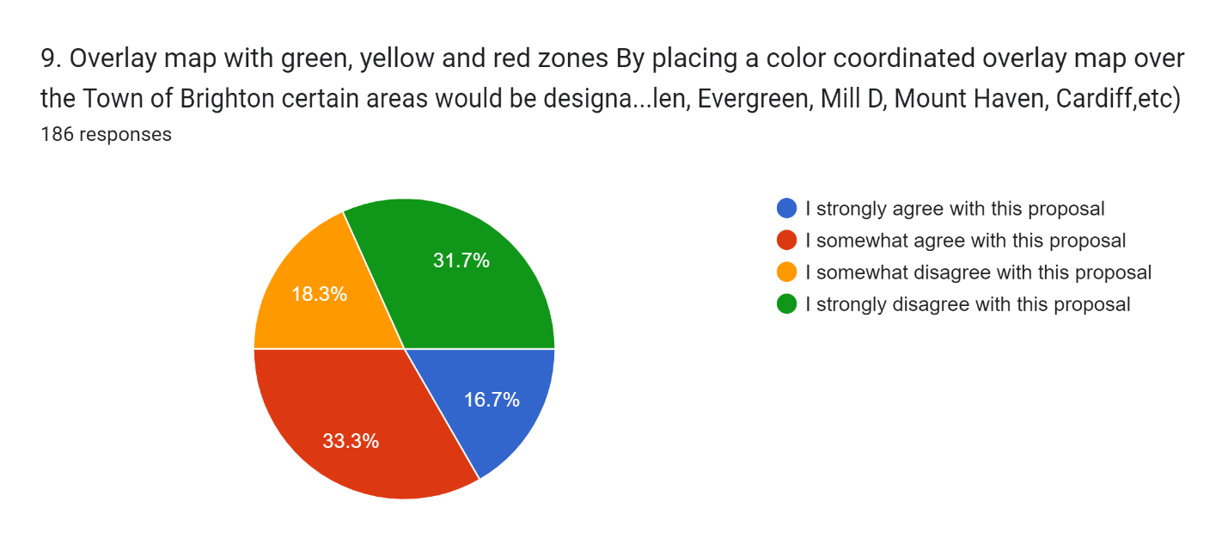
10. Please explain your reasoning for your answer to #9. (See Below)
159 responses
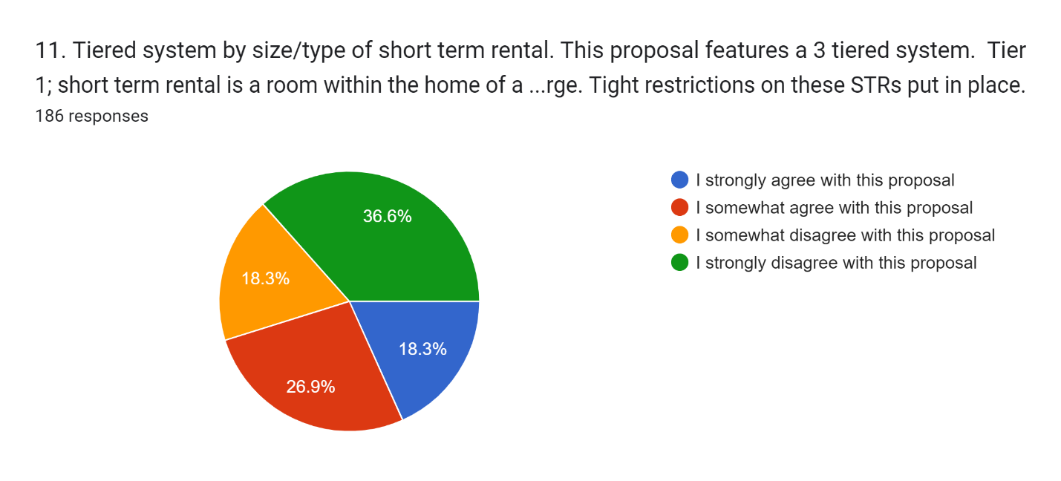
12. Please explain the reasoning for your answer to question #11. (See Below)
155 responses
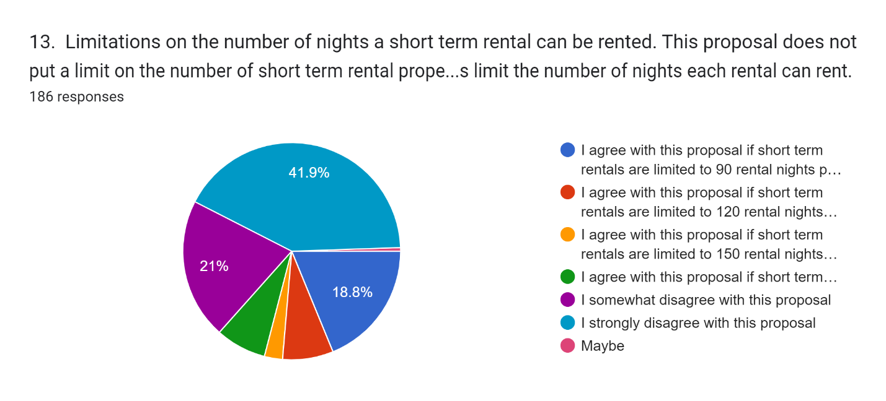
14. Please explain your reasoning for your answer to #13. (See Below)
155 responses
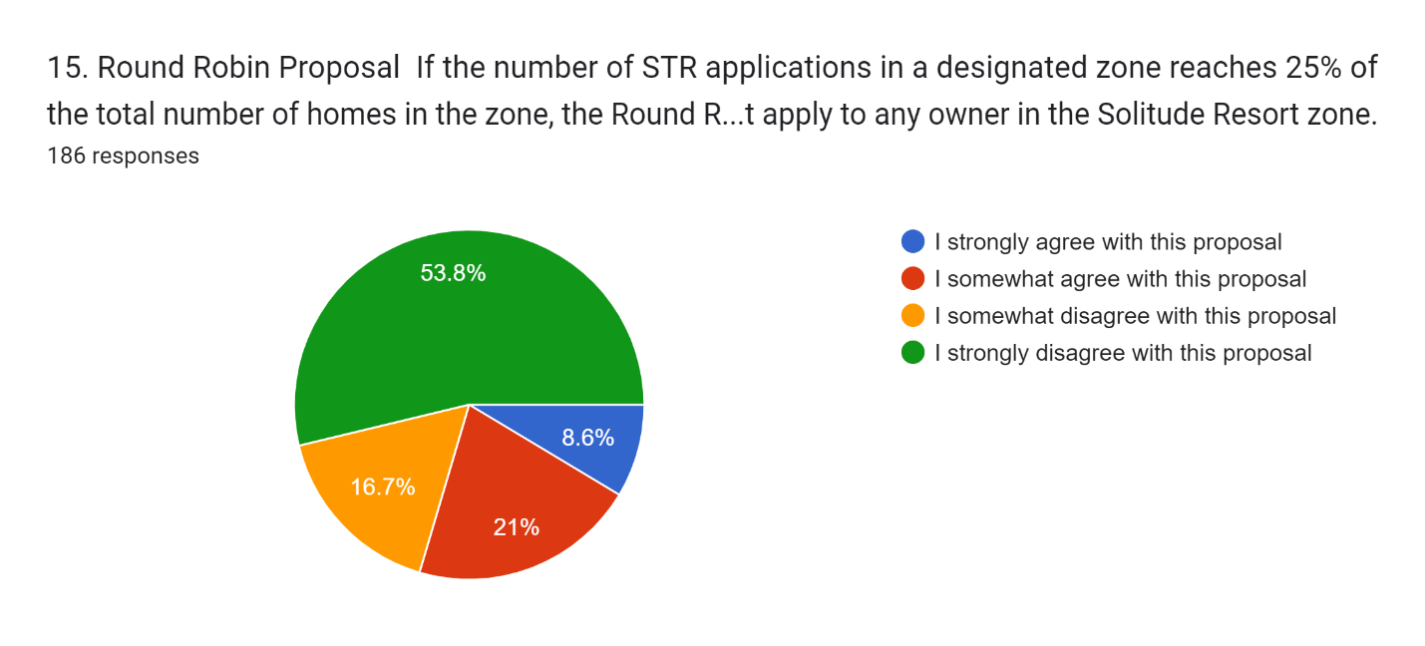
16. Please explain your reasoning for your answer to #15. (See below)
150 responses

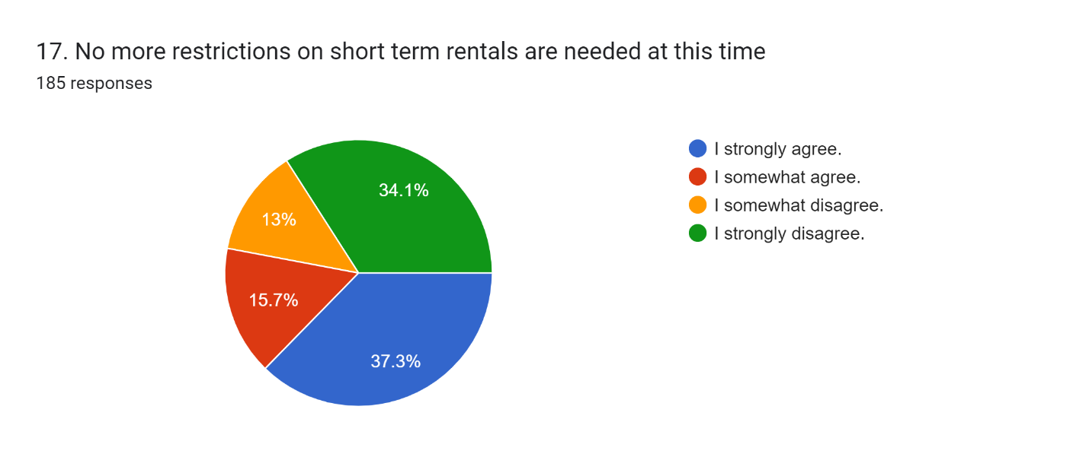
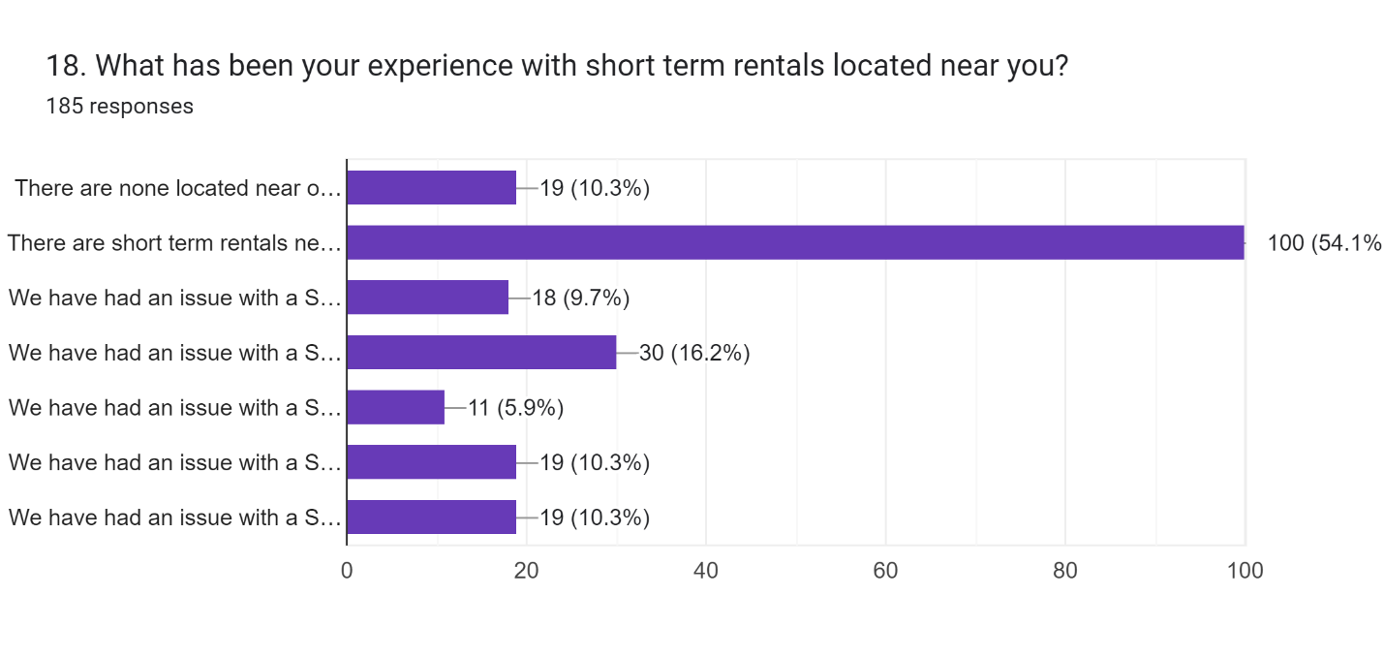
This is a question that allowed people to respond with more than one answer.
- There are none located near our property – 19 (10.3%)
- There are short term rentals near our property and we have never had an issue with them – 100 (54.1%)
- We have had an issue with a STR and it was resolved by speaking to the renters. – 18 (9.7%)
- We have had an issue with a STR and it was resolved by contacting the property owner. – 30 (16.2%)
- We have had an issue with a STR. We reported it to the Granicus complaint hotline. – 19 (10.3%)
- We have had an issue with a STR and the issue was not resolved.
- We have had an issue with a STR. There is still an illegal STR in our area.

#8 WRITTEN RESPONSES:
Parking, noise
USFS has a regulation to allow no more than 2 weeks/yr. I think that works and should be allowed to help defray $5,000 in taxes/lease fees/yr. I am less clear re. the landowners and would defer to them, although I strongly suspect there is a need to have more local folks to run things than to have everything as rentals.
All owners should be treated equally. If a property qualifies for STR, people should get in line and wait their turn if the max rentals have already been reached.
The fewer short term rental units we can allow is best.
I want to ensure the character of each neighborhood remains an intact community as is presently there and not a strip of motels/cabins of just visitors or owned for commercial purposes of earning incomes for outside investors. In other words I want to make sure that if a neighbor has a need, say of a meal when sick or when they may need help in some other way that they will have neighbors that they know and trust and love.
I want to make sure that each neighborhood has a say in the future of their neighborhood versus the canyon as a whole.
We need to protect the limited supply of available water and each water company understands their capacity more then outsiders.
Restrictions are necessary, but they should be very carefully balanced against the rights of property owners' rights to use their property.
Not fair. it violates the equal justice clause of the 14th amendment.
Allowing for some properties to have STRs while others don’t strictly based on who started it first does not seem fair to property owners.
I don’t like government intervention.
STRs tend to be more intrusive in neighborhoods with limited parking. Also there is a tipping point at which too many of them lessens the community.
I don’t want my neighborhood turning into a hotel district!
Brighton is a community first and a resort later. It is recognized that rentals can reduce traffic in the lower canyon but they do not reduce traffic in the town of Brighton.
Keep the peace.
Once a designated STR, always a designated STR ( I understand a cabin owner could remove their cabin or not use it as an STR if they were designated as an STR), does not seem fair. What if my financial fortunes changed and I had no other option but to use my cabin as a source of income? I would be prohibited because all the allowable STR slots had been claimed for the foreseeable future or forever. The STR designation should be for a specific period of time (5-10 years?), so that they could be rotated to other owners who could then choose to take advantage of that designation or not.
Water issues, noise, parties, parking
I strongly favor limiting the number of short term rentals. I haven't thought about what is the best way to do that, or talked to others to hear their views about it, so I'm reluctant to say I strongly agree with this particular proposal. It sounds very reasonable because it lets people closest to the affected area decide exactly how much to allow. Given time to think about it and hear other views, it might be something I would strongly support.
I'm in the area by Wasach Mountain Lodge , Rose Lodge along with Milly Lodge. Many night time activities that already create much noise at night. We all should be able to enjoy our national forests, but large parties outside with much noise and alcohol need to be regulated.
If you are over the limit - how do you determine who gets the STR? first come first serve, lottery? Not entirely fair to let a current STR take the space if a new owner wants to have a STR. I like the idea of a limit though.
we should be able to use our property as we choose. Limiting the number of STRs only drives up the value. Addtionally let teh free markets decide. Those rentals that are good will do well and those that dont will fail. There are requirements in place that are working now so why change. Those of use with STR's are small business owners that are abiding by the laws and ordinances that are in place
Individual property rights infringed upon and regulated simply by timing.
I agree with implementing limitations but this solution does not include any restrictions that prevent a single family from being surrounded by STR's.
Who decides which 15% get the permits? Maybe the 15% should cycle through all the properties. When it's your turn you can STR or not
We have lived with the impacts of STR's for example - Lake Tahoe. We do not want to live in a neighborhood over run by STR's for someone else's rental investment property.
Brighton would be so much better if short term rentals were permanently prohibited. This is the next best choice.
STR's are difficult to manage. They have no long term commitment to the community, don't pay the taxes, and often overuse the facilities they rent.
I don't even understand what neighborhood density means based on the given example.
There may be Six together in a neighborhood and none in another. Should be overall.
I am deeply worried about water consumption, and water availability for full- time residents. ...limiting STRs in a reasonable manner would go far for water conservation.
My second concern ....STRs, while advantageous to the property owner, do nothing for building neighborhood and community.
Also, the STR property owners near our residence consistently fail to warn renters of the difficult winter access,.Consequently we are dealing with stranded and lost renters ,blocking our roads and worse. Anything we could do to limit renters in our neighborhood is a good thing !
An owner should be able to do as they see fit with THEIR property.
While it is great to have a cap, it’s also nice to have some future flexibility, especially if all landlords follow the rules and totally dependent on water usage and availability.
I’m fine with short term rentals. Water usage would be my only worry.
I suspect current STRs would fill the 15% limit. What happens if a non STR wants to rent in the future? Would that be prevented? That would seem unfair.
I am planning on converting my property to a short term rental in the future
Short term rentals change the atmosphere of the neighborhood and increase water use.
Fairly and proportionally addresses legitimate community-specific concerns about STRs (e.g. quiet areas crowded with short-term renters who aren't as invested in the community, limited water/sewer resources) while still allowing for some regulated STRs
SHORT TREM RENTALS DETRACT FROM SOLITUDE AND AMBIENCE OF PROPERTIES. THE RENTERS DON'T CARE ABOUT PEACE AND QUIET OF THE NEIGHBORHOOD.
Some people might not want to be told how to live their lives and manage their property. I feel that but I agree that too many STRs in one area would be bad.
I think short term rental density should be controlled.
I like the idea, but would want the number even lower than 15%
STRs use more water than part time users. Parking is another problem especially in winter.
overall it makes sense but it would lead to a benefit to those renting out now, locking out others in the future if the cap is in play. consider if there can be an allowance for rotation of the benefit if the cap is reached.
This is a fair way to limit STR impacts to the neighborhood & the area resources
Don't want STR
This keeps the community from having too many transient guests.
Not sure of lots, or occupied lots or owners of lots (one owner multiple lots) is the correct denominator in this equation
I feel that STR increase property values and decrease automobile traffic in the area. With brighton ski resort, people can stay at a cabin and park there to go skiing. This alleviates some of the traffic on the road as people can then stay at the STR and walk to the ski resort and not use limited resources of parking and road use. Brighton ski resort is a very popular ski resort and traffic congestion is often heavy in winter with limited parking. STRs allow a secondary place for people to park and stay which helps with the existing parking problem. There are almost no other options for people who want to ski and stay near the resort. Parking is also very limited at Brighton Ski resort and STRs help quite a bit with that.
STR also bring in money to the town of brighton and it’s businesses. A STR visitor is more likely to stay in the area and visit a local restaurant or the brighton store, thereby increasing tax revenues and increasing money for the town of brighton and its residents.
Furthermore, STRs increase property values as property can be sold at a higher rate due to the income potential.
I am completely against this proposal. I fee this would damage property values and cause a decline in the area .i fee rather than limit the rentals, enforcement of existing STR statutes would be better. Require all STRe to get their license, be inspected and pay an annual fee. This will also bring in additional revenue to the town of brighton. On top of that, I would propose a rental surcharge on all STRs of 1-2 percent which could then be used to improve revenue for the town of brighton and also could be used to offset any expense associated by STRs management and license enforcement and would be a win-win for brighton.
This will help the families most impacted by short term rentals and give the community more say then we currently have.
It is the owners property. If they want to rent, they should be able to.
Our property is in Solitude
I don't think density restrictions are a good solution for a few reasons. First, STRs already seem to be self regulated to 9% near Brighton and 4% in Silver Fork/Pine Tree. I'm not sure that there is a reason to put a cap on STRs when it is unlikely to rise much higher anyway. Second, if a restriction was reached, how would you decide who is allowed to rent and who is not? Would it be the people who have owned property the longest? Most recently applied? Paid the most money?
If resources (such as water) are a concern then this needs to be a separate conversation, apart from STRs. There would need to be a density restriction implemented on full-time residents as well as STRs since full-time residents undoubtedly consume more resources than homes that allow STRs. Is a density restriction on number of full-time residents being discussed?
Setting the number of maximum STR units will ensure neighborhood cohesiveness , limit increased traffic noise and water usage. STR vehicles in Silver Fork frequently get stuck in our one ways streets causing ingress/egress issues.
I would like to see data on the reasoning behind this first - excessive use of the water/sewer, roads, etc
This creates an arbitrary timing issue with respect to the value of properties. Those that are able to rent out will generally have a higher intrinsic value. Based on timing of when rentals come in and out of the market property owners would not have a good sense as to whether their property would be allowed or not. Additionally the canyon does not have the infrastructure for future hotels but demand in the canyon has drastically increased. That means the existing properties and few new properties that can service that demand should be allowed to.
You can't give one person the right to rent their property and forbid the neighbor the right to rent thiers within the same zone/ area. This directly violates private property rights and is a lawsuit waiting to happen. Also there are challenges with enforceability on this one. I fail to see pros that out weigh the cons.
How could it be fair that some people can rent their property and others cannot? What if any property could be rented 15% to 20% of the time.
I believe that properties in Brighton are limited and little further growth is coming. So any property already present should be "grandfathered" into any future plan. We lived in Rbighton with no interest in renting out again but then life happened and we are now in New Zealand. To best survive our absence (financially as well as winter climate related), a short term rental agreement contract with a RESPONSIBLE MANAGER such as Carole McCalla is a win win for the home owner, the tourist, and the town on Brighton. Otherwise homes will fall into disarray or will be sold.
I believe in private property rights of an owner. If a property meets the county codes, HOA rules, and town's requirements, there is no need to further limit how an owner chooses to use their property. Let's stay away from Big Brother tactics. I have already heard that the town of Brighton is turning into an HOA on steroids... governments role is not to nuisance the private property rights of owners. If a property meets the requirements to rent STR and complaints are not being made... that should suffice. The role of Brighton should ONLY be to enforce ordinances and levy fines for those not in compliance...not try to fortune tell what the magic number of STR's and full time residents should be. Density restrictions are a bad idea and will hurt property values. You are in essence saying you don't trust an owner to rent out their property lawfully and in compliance... your are restricting their private property rights by putting an arbitrary number of how many uses an owner can enjoy their property. That is as "big brother" as it gets. I believe the town should deal with complaints when someone is not in compliance... not discriminate and restrict the private property rights of owners. PLEASE DO NOT further the discussion density control! The existing rules and regulations are already sufficient to prevent many properties from doing a STR, i.e. water, sewer, parking, etc. I am happy to discuss this topic with anyone who wants more information as to why I think it's a bad idea. My email address is damonlowe@msn.com.
We need less STR in the community. It's ruining the community and there are long term rental residents leaving the canyon in droves. There just isn't any place left for long term renters to live.
I like how Bishop, CA has handled their STRs. STRs are allowed if the owner is a full time resident and resides at the property. The STR can be an attached unit or a separate unit on the property. I don't want STRs from nonresidents as they may not be available to deal with issues that arise and I don't want companies buying properties to turn them into STRs. The property owner should be invested in the local community and available and aware of the local issues and conditions. Additionally, the property owner should be on site, impacted, and ready to handle any bad behavior of the renter.
I think that short term rentals add a lot of benefits to the Brighton area. Instead of people driving frequently up and down the canyon and parking alongside the roads, they are driving up and staying in one place. Therefore, decreasing the traffic congestion. They are spending their money to support the few local businesses in Brighton. An added benefit is the increase in property values for Brighton. If you are concerned about additional cost then just add an additional fee/tax to nightly rentals.
Might want to rent in the future.
Make the limit stricter. No more than 10% of lots can be STR eligible.
Seems reasonable but not a fan of STR in BCC
A percentage cap might be useful, however it would be manifestly unfair to allow the same property owners to establish a permanent claim to the available rentals once the cap has been reached. Licenses allowing rentals should be provided round robin or via an annual lottery to allow equal access to any property owner who desires to establish a rental business.
I think this is a good way to start. Allow for adjustment after trying it for a few years.
Short term rental of large houses promises to dramatically increase water consumption overall, and especially peak water consumption.
Keep Silverfork as is. An overabundance of str's would seem to commercialize it and diminish the quiet and natural beauty.
STR degrades a neighborhood
It incentivizes people to rent out their places “under the radar” if the capacity is already met and disincentives them to go through the permitting process. This will erode a feeling of community far more than allowing anyone who wants to rent their place out to do so. The free market will likely keep this number in check anyway. It’s hard work to run a nightly rental.
Parking and noise
I'd like to maintain consistent and conscientious community members in the canyon instead of visitors and tourists that may not have the best interest of the canyon in mind.
I would also say people need to renew on a regular basis- every 2 years? so that new STR could come into the pool, but the pool of STR would never exceed 15% of the overall community.
I knew as soon as you became at town regulations would start coming. I have sewer I have water and I am in compliance with everything. It’s tragic that Bureaucracy has now entered into our community. I don’t like it my taxes have gone from $500 originally to $8000.00 a year. Now you’re saying we can’t rent to make up the difference. The plowing the taxes the police that don’t come up for alarms trash have now become a part of the bureaucracy.
Short term renters do no respect the rights of others in particular property boundaries
They are here today and gone tomorrow so they don’t care
It does not matter how many rental there are as long as they are quite and any ordinance should be based on actual harm rather than perceived harm. This is solving a problem that does not exist. It is just horrible and penalizes people and their property
Concerns about having enough water.
Preserving the integrity & quality of our neighborhoods should be a priority. Limiting the number of short term rentals would help do this. There is no assurance that short term renters will care about these values.
Because it limits the number of STR
Some limits are a good idea depending on the neighborhood
A clear plan on how often STR permits are renewed to open up new spaces would be critical to the success of this option. Why is water availability a concern if each cabin has a water permit? In theory all owners could become full time residents.
We are moving into our property next month that we have been trying to build for approximately 7 years into a neighborhood where the community allows short term rentals. I believe that you would be destroying property values, making other properties more valuable that already do short term rentals, and causing more issues than good. I also believe that if people purchased their property knowing what was possible then that should be how it stays. I don't believe this is going to solve the problem. I believe it is taking away peoples property rights and what they purchased.
This is arbitrary and unfair and against property rights protected by law. As long as renters follow the already set guidelines they should not be a nuisance to anyone.
* I don't think it actually accomplishes anything valuable for the community
* this will be very difficult to regulate without expensive administrative costs
* this causes the potential for neighbors to be in conflict with another one another
* limiting the property uses devalues the properties
Caps are arbitrary, there is nothing to prevent someone who never intends to be an STR from locking up a permit to further limit STRs.
!5% is an extremely low number. How would you determine what properties can be rented? I think an annual limit on the days of short term rental for a property is reasonable.
Many owners will not be able to retain their properties if they can't maintain rental income. You will soon have properties that will need to be sold. Our quaint cabins will not be bought up by the uber wealthy. We don't want to be Park City. Let's not lose the Brighton charm.
Rentals don’t use more water. For example, if I live here full-time and I would use more water than a short term rental because they are not always occupied.
I would agree as long as it was rotated among owners who wanted to rent. Not fair if I do t rent now but chose to in future but nothing was available
Allocation of permits would need to flow to any new home desiring and prior year permits would need to expire. It could be 5 years before a unit may come back into the pool.
If a property is over the allowed density, but is a permitted STR, it should be allowed to continue. In many cases rental income went into the planning of financing the purchase. Also, I'm concerned about the mechanism of awarding new STR permits, with images of the scramble for bar licenses in Utah. With the exception of Solitude, there are limited spots for guests except in STRs. 15% also seems low for many areas. That said, some restrictions do seem reasonable, and certainly utility services could reasonable limit density.
It's taking away rights as a property owner, which is illegal.
While I do not rent my property for short term rental, limiting the number allows current short term rental owners to an elitist attitude. I would like the same opportunity should I decide to rent out my property in the future. I think that limiting short term rentals would be okay, but EACH short term property owner should have to reapply on an annual or biannual basis, allowing new short term rental owners the opportunity.
Water issues are a major concern and Brighton and surrounds was initially not intended for full time use. There just isn't enough water for unlimited use.
Private Property Rights - If all STR stipulations can be met (water, parking etc), should be no limit
The appeal of living in Brighton is the community and the space. If this is open to anyone then I fear we will see too many homes being built sitting empty for most of the year. Plus, it impacts the surrounding flora, fauna and animals.
There should be no restrictions
The ski resorts rely on tourism and limiting rentals would adversely affect the tourist market/income for the entire canyon.
we cannot overwhelm a neighborhood's water system for personal profit
Private property rights should not be infringed nor concentrated in the hands of a minority
I do not think this is fair to property owners that bought their properties with expectations of renting them to short term renters. Water is likely used at a higher rate by residents rather than short term rentals and thus this has zero face value. A better way of doing this would be metering the water and charging for high use.
Short term rentals in BCC are concerning. Congestion in areas and limited parking are my concerns. More than any other concern, I am worried about water availability and keeping water in the canyon available to owners, keeping the water pure and accessible to wild life. I am concerned we are driving wildlife out.
We have a short term rental nearby that regularly ignores any regulations currently in place (noise and over occupancy) so we favor restrictions.
I believe that if you have a license and met all regulations you should be allowed to do short term rentals
It is unclear how and how often the STR density limit would be set, and governance over the process. Would like more details before I make a decision.
I want to hear and support the needs and interests of my neighbors. We own a 2 unit that has been recognized by the County as 2 rental properties for over 20 years. We definitely want to keep the right for revenue and use in the future. We dont know what our neighbors want and needs are and want to support them too.
limits would be nice but how would this be decided as to who can rent and who cannot? Seems like this would create a management headache. Water rights should not be driving factor since theoretically all home could be occupied by full time residents using a full allocation of water. I strongly agree that homes not on sewer should not be allowed to have short term rentals.
Our neighborhoods have different characteristics and need different regulations. I would support restricting STRs to 10-20% of full-time residences within single family neighborhoods.
The value of my home will be effected if a homeowner is not able to choose how they use their property
The purpose of this question is not clear. It would seems fine, should it strictly serve as a means to assess the public opinion regarding STR's within each residential area. Otherwise, it would not seem to represent a quantifiable means to determine the density. Also, it's unlikely the water companies will be able to respond to such as letter, as many of the systems do not meter water use.
I am in favor of limiting the number of STR's.
Some density limit would be good. But I wouldn’t make it that limited.
The town would need to set some limits on what the owners in an area could do. The area should not be allowed to restrict the number below the existing number of licensed rentals.
We plan to spend more time at the cabin as we get older. If we were to move up full time that would consume more more than STR.
Short term rentals need regulated and limited. It seems out of whack for those of us who want the enjoyment of our investment of a second home, not a rental income investment.
I live in a neighborhood where the water is a big issue and I really don’t want short term rentals to adversely effect our water system. If too many people were using the water at once, it would be an issue.
I believe it should be less than that. Neighborhoods are for neighbors. I say 10% or less.
Air B&Bs are a nuisance very loud past 10 PM I feel it does need more regulation
Why are we overlegislating what people are doing with their properties? It makes sense to me to have rules for neighborly behavior from all in the area but determining how people can use their homes doesn’t make sense to me. Moreover, our property value may be reduced if rules become overly restrictive to newcomers.
This approach seems fundamentally unfair to us. It effectively decrees that certain properties will be able to run a profitable business for some absentee landlord while neighboring properties won't even be able to subsidize their mortgage with occasional rentals. Density restrictions without accompanying limits on number of nights rented, especially, will encourage this situation. It's a matter of the town of Brighton capriciously and somewhat arbitrarily shifting the free market in a way that will affect property values, lifestyles and finances for everyone who owns property in the town. To the benefit of some and the detriment of others.
Beyond all that, we think it will actually hinder the stated goals of this action. We all want to preserve Brighton's livable, local feel as much as possible. To a large extent, this is out of our hands, due to ski and summer traffic, regardless of STRs. But we can, and should, incentivize those running STRs to be locals who use their properties primarily and rent secondarily.
The percentage should be based on the number of cabins and not include vacant lots. If it is based on the number of cabins, this would be one important element in deciding how to balance short term rentals, but it is not sufficient. There are other issues, such as winter accessibility and road safety. Winter travel from the valley to Brighton Circle is a lot easier than into many of the neighborhoods that are accessible only via single lane roads; for example, that's why they close off Guardsman road.
Solitude mountain and Brighton mountain are not residential areas. They are the base of ski mountains. There is no elementary school, no middle school, no high school, and no full sized grocery store up the canyon. Any full-time residents knew they were moving into a vacation and ski base area when they did so. A change in zoning now, would be unfair to all of the other property owners, who need some level of short term rental to be able to afford their property, to pay taxes, mortgages etc. The water and sewer are real issues. But that is a different zoning question. Houses should have proper permitting, tanks and disposal at the time they are built. If those systems are not being maintained properly, that is a different issue than short term rentals.
Pinetree has limited water availability and full time residents should have priority on usage.
The water issue would need a deeper clarification for me to strongly answer one way or the other. If I have a water share in Silverfork, for example, it should have no bearing whether or not it’s a full timer, LTR or STR.
somewhat arbitrary
who determines which household gets to rent, lets say 10 homes= 1 1/2 homes gets to rent...you'll round up to 20 % which then =2 homes....I like the minimal aspect of this proposal but it would seem hard to enforce or regulate
1. I believe a property owner should have the right to rent their property.
2. Renting may provide necessary income that would enable a property owner to afford/keep their property.
Too complicated to administer fairly.
I don't want to see investors or companies buying up multiple properties strictly for rental businesses. I'd like to see some restrictions to prevent that.
Either allow everyone or no one. Maybe only current renters may rent if density is met. May not be good renters.
I feel that everyone should have the same opportunity to have their property a short-term rental if they choose, I also am for a harmonious community with guidelines and respect of neighbors. If these things are met, there should not be an issue. A governing committee could be created to make sure rules and regulations are followed and to deal with grievances, governance, and compliance. .
I feel that everyone should have the same opportunity to have their property a short-term rental if they choose, I also am for a harmonious community with guidelines and respect of neighbors. If these things are met, there should not be an issue. A governing committee could be created to make sure rules and regulations are followed and to deal with grievances, governance, and compliance. .
It’s not the towns responsibility to police short term rentals. Action in this direction will cause a change in leadership. Having advised the committee to make Brighton a town, this was never brought up in any discussion leading to us becoming a town. I wrote the slogan Preserve our Canyon with the understanding it was to preserve it from high taxes and give control back to the neighbors, not take it away from them. Home owners in Brighton pay some of the highest taxes in the state. It is each home owners right to make money from their property in the way they best see fit. Further, policing of this is not realistic. A law without enforcement is silly. If a homeowner sees fit to rent their home, I’m in favor of them doing so.
I can't think of any way to equitably allocate the density unless this is applied to purchasers of land/property that is purchased with full knowledge of the limitations AFTER the limitations are in force.
Prefer no short term rentals.
Limiting the number of strs will control the impact on full time residents, it will also limit the Town of Brighton's tax revenue.
Rules of usage for a privately owned property should be applied evenly to all property owners regardless of if someone wishes to use it as a a full-time residence or a part-time residence either by Occupying it personally or renting it out either on a long-term or short-term basis. The argument could be made that property owners who wish to occupy year-round consume more resources and public services So only 30% of the properties should be able to be used as full-time residences. Properties that are used as secondary residences or vacation homes are currently taxed at a higher property tax level therefore they should be entitled to more privileges than year around residences according to an equity equation.
If your argument is about water, short term rental properties are unlikely to be rented 365 days/year, so full-term residents will probably be the ones using more water. This is discriminatory and arbitrary. Properties are serviced by different water sources, so it doesn’t seem right to use this as the basis for restricting properties; for instance, our water comes directly from a spring which is used solely by us. Our water use affects nobody else!
Also, all Brighton properties are essentially in a resort area; it seems logical that property owners who buy land in Brighton would do so knowing they are in a resort community, where there are naturally going to be hotels, resorts and rentals by its very nature.
I think that some of the areas are different than others and it may not make sense to treat them all the same.
If lots qualify by meeting regulations they should not be limited by fiat.
It should be up to myself and my family how and what we do with are cabin.
That is a ridiculously small percentage of STRs in a community that is surrounded by 2 ski resorts. This is a resort community! What is Park City's "ratio" of STRs to residences? There should be many more STRs than that. It would lessen traffic congestion, because people wouldnt be driving up and down the canyon everyday. There should be no limit.
We do not want to give up anymore of our rights as a property owner.
Could be ok to limit STR's but people who want to use their property for short term rental may have a case that it would be illegal with regards to property rights. May be difficult to do retroactively.
Lots of us this is a second home and want the option of sometimes subsidizing taxes and expenses
I would not rather have no short time rentals in the forest Glenn area , without the sewer t
It would depend on the percentage.
This is an arbitrary means of who can provide STRs. This restricts my rights in how I use my property.
This first come, first serve method of limiting STRs is unfair and limits the rights of property owners and responsible renters on an arbitrary basis.
We have been loving, living, working, and a part of the Brighton community for almost 25 years. A few years ago, we were fortunate enough to be able to purchase a 2nd home at Brighton (on the loop). Our home was (and is) a dream come true.
The ability to rent our home short-term for part of the year enables us to own this home and be engaged with the Brighton community. If there was a limit to this ability, we would not be able to afford our home. It could then be easily purchased by an out of state investment company or some other entity that is not tied to, engaged with, and in love with Brighton.
Limiting or ending STRs will result in either empty homes (making areas more susceptible to theft and other issues) or large investors coming in to purchase many properties.
Furthermore, STRs (especially around the Brighton Resort) are a huge benefit to the community, resort, visitors, and locals. There are very limited options on places to stay up the canyon and we need solutions for reducing up and down canyon traffic. These customers also support local restaurants and businesses and these resort communities. The renters who use our home are wonderful, respectful, and also appreciate Brighton in tbe same way as us locals do.
Limits STRs overall, but still allows potentially very high density in certain areas. Areas would need to be small to prevent rental "clusters". (If those 30 units in the example above are all on your street, the neighborhood "feel" is gone.)
Also, this would concentrate rental "power" for those that signed up earlier (similar to coveted fishing permits or taxicab medallions) so not equitable for all property owners.
I think that this works, however I’m concerned that some residents or second home owners will obtain a license out of a scarcity need rather than actually renting their homes. Perhaps some additional language about ACTIVE rental would go a long ways in making this a great solution rather than a mediocre compromise.
The cap should be much higher
I don’t believe that lease length minimums should be determined by municipalities. I believe that people should be free to travel and live in a way unrestricted by government.
I just think we need to focus on the current regulations and make sure they are enforced and I am sure from time to time there will be an undesirable issue in the canyon weather it be on the road, at the ski resorts, or at a hotel/ condo or STR but if we can focus on abiding to the current regulations and just relax and see how things are going and revisit possible changes to STR’s in a future years as needed . No let’s get on with running the town! Can we talk traffic, parking, speeding, loud vehicles, etc! Go team!
When managed properly, STR's benefit ALL parties: FT residents, the town of Brighton and the environment.
*FT residents benefit from only having guests/neighbors part of the time, within the year. Also, noise ordinances are enforced, and renters are forced to be quiet.
*Brighton benefits from the tax revenue.
*The Environment benefits from reduced traffic and reduced pollution.
As a STR owner, I respect that operating a STR is a privilege and should be allowed to all owners who want to do so, as long as they obtain a business license, and follow taxation reporting etc.
Limiting rentals by density will only encourage "off the radar" rentals and create a divide in the community as is it unfair and unfeasible to not be able to rent out a property if that is the desire and financial need of the owners.
All current STR owners who are compliant, need to be exempt from any & all future restrictions.
Dont get lost in the regulatory morass. Keep it simple.
Rentals are good for the towns economy
I believe that many of the short term rentals are better taken care of cosmetically, and improve the feel of the area over some of the unkept non-rented properties.
I care about density in amount of properties in general but I don’t care if those properties are short, long, or permanent resident
I do not believe that Short Term Rentals impact the community any more than full time owners. They spend most of their time at the Ski Resort or down in the valley for the day. It is a drive in and drive out once a day. Folks that live there can go in multiple times a day.
I don't believe regulating STR will get the desired outcome. If people don't have an option to rent their cabins or homes when needed or desired, they may lose the ability to afford/keep their cabins/homes. When sold, It's more likely to be purchased as a second home then to bring in a family and build strong communities as described in the regulation above. Look what's happened to mountain towns across the West.
While the concept may sound good, I think the enforcement of such a limit will be problematic. Who will be keeping track of this. The only way would be through actual licensenses. What happens if someone has a license but doesn't use it? Does that count towards the 15%? Who will be responsible for enforcement? Will Brighton have staff to check on all the residents of a neighborhood to make sure they aren't renting a property short term? This will boil down to neighbors turning in neighbors (just like what happened with Dan and his weddings). Personally, I don't want fiascos like that taking place within Brighton. Without a clear indication about how Brighton will enforce restrictions, it will create an environment where neighbors will be responsible for implementing the ordiance in the neighborhoods. You can imagine how much mischief someone could create within our neighborhood if someone wanted to. Example, someone could get turned in by a neighbor for a one time short term rental for two weeks over the holiday's (how is a neighbor capable of determining whether this was a short term rental vs. a family get together or a donation to a family member? Does Brighton really want to stoke blood fueds between property owners. Just how will Brighton arbitrate such an accusation? How does a propety owner defend himself from such an accusation. I think that before considering the concept council needs to specify exactly how any restrictions on STRs would be enforced. Putting MSD in charge of enforcement woujld be a complete disaster. It will pit neighbors against neighbors and allow the coucil to sit back and watch the chaos. (Just like the wedding controversy). It would be irresponsible for the council to pass an ordinace to restrict STRs without a clear understanding of how the program would be administered and what it would cost the community. It is the resonsibility of the city council to treat everyone fairly and not set up a situation where a minority in our coummunity get to control everyone else. "
Also what consitutes a "lot?" With a structure or without a structure? How big of a structure will qualify the lot as part of the 300 structures in the pool. Why would you use all lots when many of those lots either don't have a structure or have a structure that wouldn't be eligible for STR. Also, certain lots can't be built on because of slope, sewer, water availaiblity etc. .
I have said it before, Brighton should go talk to the land use planners at Alta and see what their experience has been. It appears that they have zones where short term remtals are not allowed (based on objecctive criteria) but in the zones where STRs are allowed, they do not try and control the number. I'm guessing that they took this approach becuase of the problems of trying to enforce some sort of arbitrary percentage cap.
I think a better approach is to look at protecting the long term rentals in the community like paying the property owner a bonus to keep his property as a long term rental rather than converting it to short term. The bonus could be assessed to the ski areas who need housing for their employees.
As long as the property owner or manager is managing the guests in regards to following the rules of being a thoughtful neighbor, being quiet after a certain hour, parking cars where they should be parked, etc, there should not be a problem.
For the safety of residents and equal share of resources, I strongly agree with this proposal.
I plan on judiciously screening renters ( for use primarily in the ski season) to ensure that they strictly abide by noise and all other ordinances. I think that if this is done, then the community can remain orderly and still have short term rentals and not impact quality of life for all

#10 WRITTEN RESPONSES:
Parking and noise
The question stem is unclear, as it isn't clear this is a winter only policy. If winter only, it may make some sense re. USFS sites. Otherwise, same issue. If you have everyone as a rental, there's no community and you cannot get things done to run a city/neighborhood/etc.
One color or size doesn't fit all. Perhaps people in some green areas might not want STRs around them. Also it's not fair to prohibit STRs for some people and not others in the yellow areas. Red area is fine as is.
My answer to this would be the same as my answer to # 9 and I would want the input of each neighborhood and their water company in making that decision.
Restrictions are necessary, but they should be very carefully balanced against the rights of property owners' rights to use their property. Cardiff Fork does have year round water, winter access.
Not fair. it violates the equal justice clause of the 14th amendment in yellow areas
Same as above
Less government intervention
The further away from the ski resorts are more community based.
Unfortunate to the residents within a 1/4 mile of the resorts, but rentals where driving is not needed to access the resort is a plus for the community of Brighton.
Keep the peace.
This assumes that the only attraction of an STR is to skiers. Even a cabin that has seasonal access and water and is not on a sewer could be a seasonal STR for summer hikers, bikers, etc.
Closest to resort should also have similar limitations on density.
Afraid it would change to increased density in the future in Silver Fork
See my answer to the prior question.
Along with STR restrictions by area...Water Shed needs to be managed. Currently there are Not enough restrooms to handle thousands of people that go up the lake Mary trail!
The vendors that plan these activities should provide added restrooms, if they profite from these activities.
I like this better than the first, but no restrictions on STR seems like lost of rentals but would be good if everyone is really following the rules. -
same as above.
Leaves to much regulation in the hands of a few to make this decision. No sewer available makes sense, but otherwise to much restriction of individual property rights.
If you can say no STR's in one area you should say no to all areas.
No areas should have no restrictions
Density restrictions need to be used in all eligible STR zones. Having no restrictions near the ski resorts only promotes rental investment properties not communities.
Anything that limits STRs is a benefit.
This places more traffic and non-residents in my area.
The properties near the resort are already compromised by too many rentals.
Again confusing - where's the map?
Again, a home owner should be able to do as they see fit with THEIR property.
It’s easy for the green zone as the marketplace will set expectations. A bit more difficult in red zone where it may be a winter cabin lack of access (snowshoe in) that appeals to a rare breed. Shouldn’t restrict especially if they comply with basic issues such as water availability, parking, etc
It’s hard to limit property owners rights, but I’m not strongly opposed to it, if there has been a history of short term rental issues. It hasn’t bothered us.
This may work but I would be interested in understanding potential impacts to property values.
What you defined as the Brighton area should be in the "green zone"
Rentals close to the resort would not change the nature of the area. Not so in Silver fork and Pine Tree.
Too much focus on ski resorts and doesn't adequately address overall density or water concerns
SHORT TERM RENTALS RESULT IN MORE TRAFFIC IN THE CANYONS. WE DON'T NEEDTHAT.
Seems like the restriction should be applied equally. Everywhere.
I think we have to have some control over the number of people using our limited resources.
I don’t want any areas to be unlimited short-term rentals
STRs should be limitted in all areas.
Note my prior answer
Probably reasonable if close to the resorts.
All areas should have the same short term rental policy. This maintains the community atmosphere.
I do think there is a property rights issue that must be addressed if someone is in a yellow area, if there are water and sewer connections, why can one property owner live full-time on their property, and another cannot rent out their property part-time for STRs which should use less water and sewer. As a second property, one pays higher property taxes than a full-time resident, but you are considering taking away ones right to use property.
This makes sense as if a property doesn’t have proper accommodations for people such as water and sewer it would not be a good rental.
way too complicated
It is the owners property. If they want to rent, they should be able to.
This solution seems to make a lot of sense. It keeps the resort activity near the resort while allowing the residential areas to maintain their residential atmosphere. However, as mentioned above, this is already happening organically as green areas currently have about 9% STRs and yellow areas have about 4% .
Same as answer under #7
This seems to have better reasoning for adopting a neighborhood zone and a Commerical zone and could be looked up by a consumer like a zoning map.
You still have all of the problems with proposal #1. This is just an example of how proposal #1 would be implemented.
This approach has a rational approach and the details could be worked out for a fair resolution.
I agreee with the need for access to sewer system, water, winter access or other restrictions described in the STR Ordinance (examples would be Forest Glen, Evergreen, Mill D, Mount Haven, Cardiff,etc) BUT why not allow summer rentals. ALSO - If a completed plain ban is present, people will rent illegally
None of this is necessary. The existing rules and regulations by the county and town are sufficient to restrict STR's appropriately. Again... the town should not turn into another layer of "HOA type governance"... but rather trust that the county FCOZ and other studies were adequate when code was written and that the way it's been done for decades is sufficient.
I don't think there should be anymore STR allowed in the canyon. People are doing it illegally anyway and it needs to be more closely monitored,
For the restricted area, how would permits be distributed? How would future permits be distributed (for example, if someone sold their home would it go to the next person waiting the longest for a permit)?
Our cabin is one of the closets to the ski resort so this would resolve my concern.
Seems Reasonable
The green areas should;d be restricted as well. Greater restrictions to 10% for yellow areas.
I do feel there should be limits even close to the ski resorts unless a commercial property or zoned differently.
All properties should be subject to the same regulations if they have utilities to accommodate guests. I fail to see any egalitarian principal that suggests this solution. The impact to property owners is very unfairly distributed in this proposal.
I live in Mount Haven
Reduced density within each neighborhood would more equitably share the burden of STRs.
Again, less density is preferred.
no STR
Same answer as #8. We just don’t have a great enforcement mechanism from what I can tell.
Parking issues in an established well used areas, 1/4 mile
I'd like to maintain consistent and conscientious community members in the canyon instead of visitors and tourists that may not have the best interest of the canyon in mind.
I don't understand why this would be important.
I should be able to compete with SilverForkLodge and not have an overlay of any kind. Again bureaucracy is the crime of this Township. I wish it would never have taken place. I put a $20,000 Hook onto the sewer system to make my place more in compliance with the area.
My permanent home would be designated green
Meaning I can be surrounded by renters
If i can't rent my forest glen property why do you care if i don't bother my neighbors. This is beyond crazy and shortsided and I really wish you would stay out of people lives who are just going about their business
It really depends on the individual cabins.
Property owners close to the ski resorts might also want restrictions, perhaps at a different rate than those in the yellow.
SAA
STR permits should include requirements for year round access, fire safety, water, sewer etc. if color coding makes this easier, it could be a good option.
I still believe in property rights being taken away is not good for anyone. I understand what you are trying to do but I also have seen it go bad in the other direction that have caused people to loose a cabin that has been in their family for years because they no longer have the option to rent in bad times. If it was already allowed I believe you should continue to allow it but you could do more noise ordinance etc.
As long as renters follow the guidelines already set no other regulations should be necessary. We shouldn't make this too complicated.
It doesn't seem equitable to limit some homeowners, without understanding both the value we're trying to obtain and the harm we're trying to avoid. I don't understand either one. For example, a lack of sewer is listed. Why is the community regulating that? If a homeowner rents their property and it's used enough that they need a new septic system, isn't that the homeowner's issues to deal with? Why would the community suffer enough to need to regulate it?
Would need to see more on this proposal. My property essentially backs onto the Solitude ski resort, but due to driving distance would likely fall into restricted space. See previous objections to Prop. #1.
The distance from ski areas should be expanded to at least a half a mile. Off road parking should be a requirement for any rentals. Should sewer be a limting factor? If the owner is able to get their tank drained, this should not be a factor.
This makes sense. Not a great idea to have rentals in areas without good resources.
Think all areas should be regulated the same
Proximity is discriminatory against property owners further away
This seems like a reasonable approach, certainly for the green and red areas. The devil will be the details of the yellow - the boundaries (14 mi, 1/2 mi, 1 mile?) and the allowed density, as in question 8.
Not fair nor is it legal.
Please see my previous explanation for opposing these proposals. In addition, the ability to use a property for short term rental while others do not qualify would provide an added economic advantage to short term rentals, for income, an offset of recurring expenses, and also for property resale. THIS IS NOT FAIR FOR THOSE OF US WHO DO NOT RENT OUT OUR PROPERTIES. SHORT TERM RENTALS RUIN THE AMBIENCE OF BRIGHTON, AND THESE RESTRICTIONS REWARD THOSE WHO ALREADY HAVE SHORT TERM RENTAL STATUS. THERE SHOULD BE PENALTIES FOR SHORT TERM RENTAL OWNERS, RATHER THAN REWARDS
Why should ski resorts benefit from this without contributing more to the tax base?
No Sewer, no rental
I think the area around the ski resort is also a great place to hike and I worry this will create more homes being built near or on those trails.
There should be no restrictions
There is no need to regulate the different areas due to proximity to ski resorts because the law of supply and demand will do that naturally without any regulation whatsoever.
1/4 mile is too narrow of a limit - this should be increased to at least 3/4 mile (subject to the property also being attached to the public sewer system).
i dont agree with unlimited STR anywhere but i like the idea that if you dont meet minimum requirements then you cant rent at all
While I don't rent my home, nor do I intend on renting my home, whether or not I do is no business of anyone but myself. The use of my home and its impact on the community, regardless of the identity of the occupant, should be all that is relevant -- if renters use homes subject to the same restrictions as owners, then fine. But just because they're renters that shouldn't impair their ability to use my property like I would.
I do not think there should be limits imposed upon property owners that want to rent their property
We have a short term rental nearby that regularly ignores any regulations currently in place (noise and over occupancy) so we favor restrictions.
The 1/4 mile is too restrictive. I am about 1 mile from the resorts and should be in the green area for Brighton because that is where my renters dki
This appears to be a more clear proposal. I would still like more details over planning, governance, etc.
Works for us as we have historical licensed rental in the Green (Brighton loop) and seems to make great sense in each area described for both guests and traffic, resources, etc. But we dont know if that fits what other residents / owners want.
Agree with red areas. Do not agree that distance from resorts should be overriding factor in deciding rental status.
There are many benefits to lodging close to the resorts. These tenants may not even need a rental car. Both the base of Solitude and Brighton have a more commercial, rather than residential, feel. Solitude has added infrastructure (increased trash and security services) to manage short term tenants. I would like to see Brighton Resort add more services if there are no restrictions on short term rentals at their base.
If there is no winter access and no sewer then it is not a good idea to do short term rentals. If there is a problem the fire engines can’t get there.
It's a defineable and easy to comprehend concept utilized in other resort communities.
I am in favor of limiting the number of STR's.
Spread some of it out around the canyon so it’s not all rentals in one place.
But I'm concerned about what restrictions would be imposed in the yellow areas.
Water, sewer, and access are must haves to be a STR.
Allowing more rentals/congestion for those of us who invested to be close to the lifts again seems backwards. Just asking for respect for those of us who want to enjoy our home, not having to tame the wild west.
I would still want the areas closest to the resorts to have a day in how many STRs there could be.
I believe it should be based on the number of year round residents and/or non rental properties in each area. Only 10 percent of any neighborhood should be STR. As far as properties without sewage and water, those should not be rented. The fact that a neighborhood is closer to a resort should not increase it's STR density.
It does make good sense seeing that the ski resort proximity is a good way to regulate they are the primary use recreation of Airbnb rentals
I would need more context into issues with renting in the red areas. The concept of short- term rentals though is one I support. It gives people who can’t afford or can’t accommodate full-time living up the canyon a chance for a new experience. More off the grid experiences are really life changing. It seems like a lot of the anti-short term rental movements are based on class/racial/national discrimination (fear of people not able to live in an area being there part-time). As someone who has lived in metro areas and then moved to utah, I hope we can welcome more people into these otherwise exclusive areas.
This approach makes so much sense! Our canyon is comprised of varying locations and communities, with differences. People who live within walking distance to a ski resort (especially ski-in properties) need to expect a resort atmosphere, including wide-spread short-term rentals during tourist season. This is different from properties that are not immediately adjacent to tourist draws and which require renters to drive their vehicles to and from those areas.
I also like that Brighton Loop is being considered in the same zone as Solitude Village, as it has more in common with Solitude than it does with places like Silver Fork.
This is a good idea. It concentrates visitors closer to the resorts and thereby reduces community impact. It also reduces safety concerns associated with winter travel in less accessible parts of the canyon. Furthermore, this seems sustainable; new people moving to the area interested in STRs will purchase homes in the green zone, whereas those seeking more solitude will look to the yellow and red areas.
This is much better than banning all short term rentals. It seems to give houses on water and sewer systems and closest to the mountain full flexibility. I am less familiar with the other areas, but I am not sure why someone would want to rent a house not on the sewer or water systems anyway.
Some properties in Pinetree would fall under the red zone as they will not meet all requirements such as sewer hookup.
Does not seem fair to base this on proximity to resorts
And what happens if red area infrastructure changes? Does rezoning take place?
there needs to be a objective and compelling reason to limit STR‘s in certain areas. I believe lack of access during the winter, no connection to sewer or water are valid reasons.
this is not helping the homeowner at Brighton, each house now can be an STR, might as well live in the Solitude village ....who is going to patrol this area for parties, noice, light pollution, parking problems, crowds, Brighton is to disbursed with homes as Solitude is a condensed location , easier to patrol and regulate...STR's are not primary residences, therefore secondondary houses for people to make a buck with no regards to primary homeowners in the neighborhood (small percent but that doesn't mean we need to but up with the shenanigans of STR's)as for the red zone, that's a no brainer, but needs to be put in writing.
Brighton should not be granted more privilege than another area. This is discrimination. Silver Fork is relatively as close to the Solitude ski areas as the houses in the town of Brighton are to the Brighton ski areas.
STRs should either be allowed or prohibited in each neighborhood, based on suitability.
The original idea of Airbnb was the sharing economy. It was also a way for travelers to experience something completely different and more intimate than a hotel. If some one want's to rent out a house with no heat or one with an outhouse and the renter is fully aware and excepts the responsibilities set forth in the rental agreement then let them rent it. On Airbnb you can rent a cave, sleep in the trunk of some persons Tesla, or a tree house. Do you have any idea how many of my guest shovel the drive way? Probably half. It's a big part of the canyon winter experience and that makes them feel like they belong. If some one wants to rent out their camper, let them. The trick is to market to the right people.
I live close to resort and don't rent. Quality of renters can be very bad. Need restrictions everywhere.
I feel that everyone should have the same opportunity to have their property a short-term rental if they choose, I also am for a harmonious community with guidelines and respect of neighbors. If these things are met, there should not be an issue. A governing committee could be created to make sure rules and regulations are followed and to deal with grievances, governance, and compliance.
I feel that everyone should have the same opportunity to have their property a short-term rental if they choose, I also am for a harmonious community with guidelines and respect of neighbors. If these things are met, there should not be an issue. A governing committee could be created to make sure rules and regulations are followed and to deal with grievances, governance, and compliance.
We cannot ask residents to pay high property taxes after they’ve purchased their properties with a plan to pay taxes and provide income for their families. This sounds like a covid bill of shutting down small businesses. I cannot support this.
I only agree because my property would definitely fall into the green zone (I'm adjacent to Solitude). Realistically, the boundaries from Green to Yellow and Yellow to Red would be very difficult to justify to owners that are on the boundary. There would be a lot of moral hazard in drawing up the boundaries. Lots of politics, positioning and distrust.
This proposal will put most of the STR’s in the same zone as our cabin. Not fair to those in the green zone.
The distance of the property from the ski resort should not determine whether or not one could provide an str.
Every property has individual functional upsides and downsides based on the items listed above. The current criteria for short term rentals that are in place do a pretty good job of determining if short term renting is a reasonable use for each property. I think each property should be a evaluated on its individual qualifications for use as a short term rental instead of trying to allow other property owners to dictate what their neighbors should be allowed by law to do regardless of the neighborhood it is located in.
Current criteria does a good job in evaluating whether or not a property is a candidate for short-term rentals. Instead of restricting property owners’ rights, why not simply enforce the rules we have in place currently?
I agree 100% with the Green Zone around the resort because that is where the Manor is located. I also agree that if a house is not connected to year round utilities it obviously can't be rented when the utilities don't work. The owners in the yellow and red zones should decide on their respective zones.
Why does the town need to designate areas. The rental market will do this. The red areas are already denied or restricted by the STR regulations.
Agin its are cabin
I agree that the green area should have no restrictions. However I believe that at least a 1/2 mile radius would be a more reasonable area. I'm not even sure my cabin is within a 1/4 mile radius on Old Prospect Ave.
Don’t want to give up properly right no matter where property is located.
May be ok to have more density STR's in the areas closer to the resorts. But we don't need a "red" area since there is already a rule that encompasses the stated restrictions.
We have access to all of the described ordinances and is definitely needed to rent
I do not want short time rentals in Forest Glen driveways and road parking limited.
Too many people in the area can causes problems. Too many cars , blocking road
The green and red area designations make sense but the yellow does not. For those in the yellow area, this is an arbitrary means of who can provide STRs. This restricts rights in how people use their property.
This is a more reasonable approach to limiting STRs and respecting the rights of permanent owners, while also respecting the rights of those desiring to rent. It is less arbitrary and reflects a more reasoned designation process.
Of all the proposals this one seems to make the most sense, but overall I do not support further restrictions on STRs.
This scheme is quite similar to #7 above, with the added mechanism for variable densities depending on location. I like it better than #7, but have the same concerns as #8 above.
I agree, along with my suggestion for the limited areas to be ACTIVE rentals not just license holders. Again, I could see many people that do not actively rent their homes pursuing licenses just for the sake of having a license (or resell value). This would frustrate people like myself who actually try to follow the rules and license our rentals and find real value in owning property in the canyon.
The cap should be much higher
I don’t have a problem with requiring proper facilities for short term rentals, but proximity to resorts doesn’t seem to be a great way to prevent short term rentals.
Red areas as you defined are a whole other question as you mentioned they don’t meet current regulations. As far as the yellow and green areas I don’t think they need to be separated.
How did the colors of the map get created? Is it assumed the green areas have fewer FT residents, and therefore it's okay to have more STR's? Standards should be enforced to rent based on SAFTEY and RESOURCES only! I'm concerned these limits and restrictions feel very much like a "not-in-my backyard" type of feel which is an unfortunately common feeling in the community between STR owners and SOME FT residents...
All current STR owners who are compliant, must to be exempt from any & all future restrictions.
STR should be allowed in summer even if year-round water and access are not available
This would allow for
Location shouldn’t determine ability to rent
See my answer to #8. This color coding would not do anything for properties that may switch hands and turn to short term rentals with better maintenance outside of the allowable zones.
Short term renters aren’t bad. Properties are maintained
It seems that those that live closer to center are favorite children. Why should they have favored privileges. I do understand if there is no water or sewer or access. That automatically excludes them.
If a property does not have the facilities to accommodate guests (no sewer, water, etc.), then it's probably not a great STR option, and likely wouldn't do well on the STR sites. Does this kind of property need to be regulated by STR regulation? I think it's better managed by the water and sewer districts.
Red zones and Green Zones only. That is how Alta does it and is the most practical and easiest and objective to enforce.
It just makes sense
Hard to answer, since I cannot see a map with where the yellow area is, and if Mule Hollow Lane is in the yellow area
#12 WRITTEN RESPONSES: Tired System by size/type of STR.
Many new builds in the canyon are built with the intention of being a STR vs single family home
Parking
Renting a room is OK as long as the full-time owner is present.
The cabin across the street from me had a party last weekend, I counted 12+ people, cars parked in my driveway.
This would be a nightmare to enforce and monitor and could be an invasion of the property's owner.
Restrictions are necessary, but they should be very carefully balanced against the rights of property owners' rights to use their property.
tier 2 & 3 Not fair. it violates the equal justice clause of the 14th amendment
Seems to better limit impact while also allowing people to offset the high cost of ownership.
Less government intervention
The negative effects on the community from STR are traffic, parking, noise, and on sewer and water. These tiers run parallel to the effects on the neighbors.
Keep the peace.
Makes sense. Higher impact, more restrictions.
Suggest two tiers and combine Tier 2 and 3 to same restrictions. 8 renters in a home is still a lot.
There would be problems with parking in the winter. Trash would also be an issue. Our trash and recycling bins are already overflowing.
See my answer above.
Set boundaries and follow regulations.
does " a room" mean one room or that all rooms would be filled - ie have a 4 br house, could you have 3 short term renters?
in my opinion a home owner should not be allowed to rent out a portion or a single room. These are not the best and actually cause more conerns and problems than the others.
This makes more sense since its really affected by capacity of utilities...water, sewer, etc.
This seems reasonable
This seems logical per the community impacts.
Any limitation to STRs is better.
This limits the STR traffic
Fewer numbers mean less impact
Let the market be the guide.
Families have huge get together with sibs and grandkids. That affects the community just as much.
This proposal sounds fair and reasonable for all parties I like that there is a hotel license required for proprietors of larger rentals
Same as above.
A larger house has more potential impact on the community while renting out a room is easier as property owner is probably there to monitor.
This seems to make logical sense
This could be a good option. There should be a way for non-STR homes to be rented in the future, though. Otherwise current STRs may fill the tier and block others from renting.
We need to restrict the number of Tier 3 rentals
The families that are coming to rent a 3 plus bedroom are doing so because they don't want to stay in a hotel. I think these should be able to gather as they chose and enjoy the canyon.
Reasonable incremental policy to mitigate over loading neighborhoods.
Doesn't adequately address overall density or water concerns
IMPACT ON THE COMMUNITY IS ESSENTIAL TO CONSIDER. RESIDENTS HOULDN'T BE INCONVENIENCED BY RENTERS.
no comment
There is already a class system in America.
Let's not make it worse.
See answer 10 above
Sounds reasonable
The total number of STRs should be limitted in all tiers
Same
Hard to manage and control
Same as answer 10
I feel that STR increase property values and decrease automobile traffic in the area. With brighton ski resort, people can stay at a cabin and park there to go skiing. This alleviates some of the traffic on the road as people can then stay at the STR and walk to the ski resort and not use limited resources of parking and road use. Brighton ski resort is a very popular ski resort and traffic congestion is often heavy in winter with limited parking. STRs allow a secondary place for people to park and stay which helps with the existing parking problem. There are almost no other options for people who want to ski and stay near the resort. Parking is also very limited at Brighton Ski resort and STRs help quite a bit with that.
STR also bring in money to the town of brighton and it’s businesses. A STR visitor is more likely to stay in the area and visit a local restaurant or the brighton store, thereby increasing tax revenues and increasing money for the town of brighton and its residents.
Furthermore, STRs increase property values as property can be sold at a higher rate due to the income potential.
I am completely against this proposal. I fee this would damage property values and cause a decline in the area .i fee rather than limit the rentals, enforcement of existing STR statutes would be better. Require all STRe to get their license, be inspected and pay an annual fee. This will also bring in additional revenue to the town of brighton. On top of that, I would propose a rental surcharge on all STRs of 1-2 percent which could then be used to improve revenue for the town of brighton and also could be used to offset any expense associated by STRs management and license enforcement and would be a win-win for brighton.
This will increase owner responsibility for the behaviors of their short term renters
Too complicated and difficult to enforce.
It is the owners property. If they want to rent, they should be able to.
Our property is in Solitude
Again, I don't think density restrictions are the way to go for the reasons stated above.
Also, I'm not sure there is enough information given to make an informed decision on this proposal. For example, would the % of STRs allowed be the number of the tiered homes among homes in that tier, or among all homes? How is it enforced? Would other owners and full-time residents also have restrictions on the number of guests they can have at their homes?
Tier # 1 could still impact the community. Therefore, I believe the number should be restricted.
capacity for occupancy is not the same as actual occupancy. A large home may be rented less than 50% of the time, this proposal does not take that into consideration
Given the limited real estate in canyon, I believe it should be out to good use within the zones that would allow str.
Arguing that a room rented within a residence has a minimal impact on the community is misleading and false. There are more cars necessary at the residence when a single room is leased. Due to the fact that multiple families are using the residence at the same time. They are just as likely to get stuck in the snow or create more traffic. Although I do agree that larger parties can have a larger impact. I think enforceability on this one is tough as well.
Again, this seems more fair and the details could be worked out.
The impact on a community will be irrelevant to size of home. A small home with no parking may be worse than a large home with ample of parking and ammenities - that is not at all reflected in a 3 tiered system plan. We offer apple of parking, ski in and ski out .... yet may be considered Tier 3 .... while we have little to no negative impact
If the fines are big enough for non-compliance... that should be enough of a deterrence for an owner to rent out their property according to the rules.
Even with the tiers that just takes away potential homes or rooms from long term renters.
I think greater restrictions should be placed on STR. Tier 2 can have a big impact on neighbors even if it is smaller. I like the location restrictions better.
Too much oversight and over reach.
Homes in the community should be residences for owners, not small hotels or condo equivalent entities.
Makes sense considering the stipulations listed above
I further advocate that a community impact fee be charged depending on the rental tier.
This option has flexibility in it.
This proposal addresses both water use, and also impacts of short term renters due to travel on community neighborhood roads, waste production and sewer, trash production that will impact quality of life for neighborhood full/part time residents
Seems it would be difficult to enforce, although it might spread out the density.
no STR
Same answers as above.
More specific than the previous proposal
I think the administrative work for this would be too high
See answers from number eight and number 10. Same feeling.
Seems logical
Again why should you have any say what i do with my property as long as i follow laws and don't bother my neighbors. Please stay off my property.
I don't think we should have large home rentals at all.
The impact on our community should be a priority. Parking, plowing, emergency services, water usage, etc. are all affected by the density of occupancy. Also residents & property owners are much more likely to be aware of hazards (e.g. driving in winter conditions, the effects of altitude, or summer open fire restrictions).
Too complicated and difficult to enforce
It would be better to restrict a home to number of renters regardless of how many bedrooms it might have. Since Brighton doesn’t have any hotels and parking is extremely limited, it would be better to have this option in proportion to proximity to the ski hill. Ie: on the loop unrestricted, near the fire station, less of the high renter options.
Same answer ...you make the people that already have them more profitable and cause others that may need to do this to keep their property harder for them in the future. You also make it harder for them to sell their property in hard times.
Why do we need to involve ourselves in these details?! If a full time resident/owner has a big family they might be more crowd, noise source, nuisance than many renters. There should not be so many regulations, as long as renters follow the basic rules that should be enough.
The community benefits from these large rentals. They bring in tax revenue and revenue to local establishments. They also increase the value of the properties. I don't understand the value we're trying to capture of the harm we're trying to prevent and whether it's enough that it's worth allowing neighbors to regulate one another.
Current STR rules are sufficient for the impacts of larger STRs (under hotel level). Parking is the largest impact, and adequate parking is already addressed by current rules.
If a larger home has proper parking, why should they be limted?
This doesn’t make sense. As I listed above just because something is a rental doesn’t mean it would use more resources as what I’ve noticed as many of the rentals are vacant much of the year. Also having one that sleeps more than eight people is common in the area and a rule such as this would significantly impact most rentals
Renting out a room still increases water and resource use. Rotating permits will still be required. Consider fees for renting which are paid back to neighborhoods which increase based on number of complaints. One of Kei issues is what happens to STR when there is a water shortage like we had 10 years or so ago.
Again, it seems reasonable, but details matter.
Not legal to restrict these rights.
Please see my previous comments regarding my opposition.
You live there, have all the guests you want. Small place, small rental group. Large place, you are a Hotel
There should be no restrictions
Big Cottonwood Canyon relies heavily on tourism and I believe limiting the availability of rentals will not only bring down the interest in the canyon but it will dramatically increase traffic up and down the canyon because people will be forced to drive down the canyon every single visit
The only way this type of legislation should be allowed is if existing structures built prior to the ordinance were grandfathered.
its a nice idea but just because its listed as a resident doesnt mean they live there. people lie for profit.
See answers above. Address parking impacts, noise issues, etc. applicable to all property owners--not just renters.
I do not think there should be limits imposed upon property owners that want to rent their property
We have a short term rental nearby that regularly ignores any regulations currently in place (noise and over occupancy) so we favor restrictions.
I have a 4 bedroom home and my renters are screened Do not need more restrictions for those who are licensed and follow all restrictions currently in place
Zoning based on water access and winter access restrictions seems more feasible. Larger rentals are also important to the local economy.
Same as before…works for is but dont know impact to others.
large groups could have negative impact. Enforcement can be difficult. Who would be responsible for enforcement, the Brighton Rental Police?
I agree with minimal to no limitations on a room rental within a home, with the owner present. I am not sure that the impact from eight renters is significantly different from fifteen. I think both impact a community with up to three turnovers in a week and necessary cleaning crews etc..
Larger rentals are only a problem when rented for very short periods because often the purpose of the rental is for a celebration.
The concept seems plausible, as long as, the impact takes into consideration other determining factors such as the proximity to the resorts and other homes within the residential area.
I am in favor of limiting the number of STR's.
There is a need for larger group accommodations. Then you don’t have groups renting multiple places and meeting up at one in large group gatherings.
The devil is in the restrictions that would be imposed on Tier 2
We have relatives and kids all the time that put us over 8 people. That is common in every cabin in every region of the world. 8-15 isn't a hotel its a family retreat. Two very different things.
Makes some sense
I guess I don’t totally understand this proposal. Like would these tiers only be allowed in certain places?
I still believe the number of STRs should be regulated and that the size of them could determine the amount of them in any one area.
All for more regulation on illegal air B&Bs
So the goal here is to keep people with large homes from using their full capacity?
Will there be rules against how often people with large families can use their homes? Or extra city fees for people who are full-time vs part-time residents? Again, how much do we really want to get into an individual’s private use of their home?
I love Tier 1! It makes so much sense that someone who is living in their Brighton home as a primary residence should not be restricted in some of the ways that other STRs should be. Renting part of the house, while actively living in another part is such a great way to allow people to live and build equity in our increasingly expensive town; too many are being priced out. It also provides a way so that residents who are not CURRENTLY renting can have the option down the road without forcing them to rush for a permit now, just in case.
Importantly, Tier 1 renters will have a minimally negative impact on the town. After all, they are sharing walls with a resident/owner who will be aware of any problems before the other neighbors, and who will be supremely motivated to keep their neighborhood livable. Onsite management!
As far as Tier 2 vs. Tier 3, I'm not a fan. Seems like there are much more important distinctions than renter capacity. Is the home relatively secluded or right next to the neighbors? Are the renters in a hot tub by the road, or largely out of sight/sound? Etc.
I can see how these features are harder to track than number of bedrooms. Ultimately, I believe that the best approach to categorize STRs is when they cause actual problems, not when they happen to check boxes that are sometimes associated with problems.
8 renters is already a quite high number; think of the impact of having 4 additional cars traveling the neighborhood roadways and requiring parking spaces. Any significant density of these will greatly impact the neighborhood and quality of life therein. To house 15 renters, the cabin would require a sizeable parking lot. Furthermore, I fear that this system will encourage the building of larger cabins and the increasing in size of existing cabins, which will dramatically change the character of the neighborhoods and adversely impact the forest environment.
This is fundamentally un-American and discriminatory in multiple ways. First, larger homes are already taxed at a much higher rate, in line with their size. They pay for, an have more water rights, in line with their size. Telling the property owners who pay the most in taxes, and pay the most for water rights, that they get the least right to use their property freely, is wrong. This proposal also very much discriminates against families. A single room rental market only serves people without children. I don’t know why we would want to make the Solitude, Brighton area specifically less accessible to families? There is also a clear element of religious discrimination in segmenting larger homes from medium homes. The largest families with the most children, and the most multi-generational families, will require the largest homes. It is statistically true, and well known, in Utah that certain religious communities have, on average, larger family sizes. As a town, Brighton should not be engaging in any policy, where there is such an obvious and clear effect of discrimination against families and also on the basis of demographics and religion.
The community impact here might be parking issues as most individuals will have vehicles that need to be parked somewhere.
I cannot answer a question about “impact on the community” without it being described. Poorly written question
again somewhat arbitrary
tier one makes sense and allows winter workers an opportunity to find housing, allows community to grow with minimal impact, tier two also establishes reasonable sized group/family fun adventure experiences. tier 3 yes/as the homes in the Town of Brighton are super sized now, they seem to be mini motels rather than a single family dwelling !
I would need to know what the Tiered restrictions would be before agreement could be considered. There would only be a few properties that would qualify for Tier 3. Tier 3 properties may need some additional regulation other than what the Tier 1 and 2 properties have. I feel there is no need for further regulations for Tier 1 and 2 properties than are already in place.
Too complicated to administer fairly.
The idea of renting out one room of your home as a STR is beneficial to everyone. The home owner could be an older person that would enjoy company and needs to off set costs of living. The guest gains the benefit of having the perspective of a local and will leave better understanding the life style of our canyon. The tier two idea allows home sharing for small cabins and keeps the guest size very manageable. Matt & I designed and personally built our cabin specifically to share with short term renters and have been doing so (legally) for the past 11 years. We have always had a max capacity of 8 guests so I can speak from experience: that is a very easily manageable amount of people. We have NEVER had any problems nor have we ever had any complaints from our neighbors. I could give a class on how to vet guests to avoid any problems. The tier 3 is also a good idea. It seams like renting to larger groups is where a lot of the issues arise and by having tighter restrictions on the larger places may cut down on the bad reputation STR's have gotten as "party' places.
Should always have restrictions on all rentals.
A governing committee could be created and use this concept to create rules and regulations for Tier 2 and Tier3. The governing committee would deal with grievances, governance, and compliance.
A governing committee could be created and use this concept to create rules and regulations for Tier 2 and Tier3. The governing committee would deal with grievances, governance, and compliance.
We cannot ask residents to pay high property taxes after they’ve purchased their properties with a plan to pay taxes and provide income for their families. This sounds like a covid bill of shutting down small businesses. I cannot support this.
Further, this won’t prevent home rentals but it will push for families up here to subdivide their homes by month. It will not change the amount of water usage. The best thing the town can do is prepare the utilities and tanks.
It depends of the restrictions. Not enough information here.
This proposal has some good points but does nothing to limit total number of STRs.
the impact on the neighborhood is more a function of the number of vehicles on the property than the number of people.
The maximum number of rental occupants allowed should be based on the reasonable capacity of the property Similarly to what is currently being done. But with this measure, should we not Equally apply this equation to limiting the number of people who can occupy any given full-time residence using the same formula? Also, larger properties pay higher amounts of property tax In an effort to equalize their impact on a community.
The argument here again is based on the assumption that short-term rentals have a greater negative impact on the community than does a full-time resident. I would argue that full-time residents are using roads, utilities and community amenities more than do short-term guests, when looking at year-round daily use.
Owners of larger homes pay more taxes for their properties, as do short-term rental property owners, so restrictions such as this are arbitrary and injurious. Should we not apply this ruling to full-time residents who own larger homes with larger families? You have to apply the rule equally across the board. If you restrict larger short-term rentals, it’s only fair to apply the same rules to similarly sized full-time properties.
I can only speak to my specific property which is a 4 bedroom home that sleeps 8 people in beds and a few more on pull out beds. I would argue that the full time residents have a bigger impact on the community that our home which holds more people but is only occupied 20% ish of the year. I realize that some people put a lot more beds in their bedrooms and rent out their homes much more than we do which would have a greater impact on the community.
I don't like the idea of giving up any of are rights
Why does there have to be density restrictions on an STR with 3 bedrooms. I feel that the STR committee is working so hard to limit STRs to the point of excessiveness because they are full time residents that want no growth or STRs in the canyon. There needs to be an STR owner on the STR committee immediately. The fact that everyone who is making rules for STRs don't even own an STR is wrong.
Do not want more government regulation
The ordinance states owner can only have 4 bedrooms.
Family using this is just the same impact as rental use
No short rentals are supposed to be in Forest Glen C
The size/type should have nothing to do with who can provide STRs. This restricts my rights in how I use my property and penalizes me particularly if I happen to own a large home.
Again, this arbitrarily restricts STR rights based on structure size and necessarily limits the rental of units most valuable for rental purposes. This fails to serve the public interest and does nothing to help the supposed issues residents believe STRs are causing.
There is a great benefit to the community with (well managed) STRs. Reduced traffic, taxes paid to Brighton, customers on site to support local restaurants and businesses, and many others. None of these tiers make sense or are in sync with the actual beneficial services STRs support.
Limiting the impact of STRs on the community as a whole should be the priority - maintaining the fabric of neighborhoods is paramount. This becomes very difficult when a large, entitled transient population with few ties to the community dominates limited resources and access routes. This proposal makes sense, but
Would love to know more about the restrictions proposed on larger rentals. I think this could work very well, although much more thought needs to be given as to what these restrictions are and how it is enforced.
We should be able to rent as much as we like. This is our property
Why limit group sizes so long as there are proper parking and other facilities in place? Does Brighton wish to discourage traveling in large groups? Why?
I do not feel there is a need for this restriction as things are currently running pretty smoothly.
A Tier base system only encourages off the radar renting and inaccurate occupancy reporting which is a life-safety concern should a . Where is this concern coming from? The incidents that have occurred, were yes, at larger homes, but from my understanding, it was due to the type of guest that could've occurred at any property.
All current STR owners who are compliant, need to be exempt from any & all future restrictions.
The judgments leveled for each are too casually thrown out. Is it really true that impacts will be "large" . . larger than occupied home?
Too complicated
See above answers
Seems arbitrary
Most people don't want to do STR. Those who do should have that opportunity.
I think the tiers have merit, but I still don't agree with regulating STR. Say my family wants to come to the Wasatch and rent a VRBO for the weekend to enjoy the mountains. If we need four or more bedrooms, we would have very little option under this tier system and would have to stay at Solitude. These STR regulations appear to support the resorts more than the individual rights of the home owners.
Don't try and micromange something that will be a nightmare to enforce and give MSD complete power over our community. Brighton doesn't control MSD and MSD is in charge of code enforcemen at the present timet. If the code is not explicit, MSD will insert its interpretation of any general ordiance is passed by the town council. To the extremist, this is exactly what is intended by passing a general ordiance without the specific instructions on now to implement the ruile.
I don’t know a) how many people would be impacted by these restrictions, or b) how many people currently fall in these tiers that are renting . Is this information available?

#14 WRITTEN RESPONSES TO LIMITATIONS ON NUMBER OF NIGHTS:

Same issue re. USFS already has 2 weeks, so those properties should be at 2 weeks max. i have the same questions re. other rental areas and having them be filled with folks who aren't involved at all with running a city and neighborhood. It's occurring to me that if those are the case, there should be significant taxes/fees to pay for all those services etc., e.g., over 2 weeks/yr, the taxes are quite heavy.
Limiting the number of nights will help prevent commercial entities from taking over.
This would be a nightmare to enforce and monitor. Some would just rent uncover for how many days they want and just play the system and not report.
Restrictions are necessary, but they should be very carefully balanced against the rights of property owners' rights to use their property.
If the ordinance rules are followed, this is unnecessary
Less government intervention
Strs are very disruptive. Streets are narrow, parking is limited. I get very tired of explaining the situation to each wave of renters. I want them as limited as possible
I don't know the perfect numbers of nights that make sense to a property owner to balance the costs, nuisance, and income. Renting more than a certain number of nights stops being a family budget help but instead becomes a hotel business. Just like more than 15 guests becomes a hotel, perhaps more than 90 rental nights becomes a hotel business. Hotels belong on the resort rather than in the neighborhoods not zoned for commercial businesses.
STR's have to be limited.
Although I don’t like the idea of unlimited STR’s this proposal is democratic, treating everyone the same. 90-120 days means the cabin would not be rented and therefore quieter or less impactful the majority of the year.
Owners should use their properties a large portion of the year and not solely be an investment.
Parking, trash, noise and reducing the neighborhood feel of Silver Fork / Brighton
Same as above.
Brighton is not large enough to handle unrestricted nighttime activity.
you will potentially have STR rental every day/weekend in the areas near the ski resort with multiple cars and lots of turnover
the best properties will set themselves apart from the rest. Those of us that invest money to make our properties the best should not be penalized. We need to be allowed to make a return.
Either a facility can be rented or it can't. Who's going to monitor this?? Unrealistic.
This is a reasonable amount of rental days to allow someone to raise income on their vacation home without encouraging full time rental investment properties.
See above.
This limits STR
No limits.
It will limit the mentality of pack em deep and sell it cheap. 90 days is PLENTY! How will you regulate this?
Maybe I am being" stingy " by choosing to allow only 120 rental nights per year, but again, peace, quiet,and water conservation are my primary concerns.
Same as above
As long as the landlord is following the rule for STR, no limit. The marketplace will set the limit. However, there should never allow just a one night rental because of night parties.
I’m fine with longer term rentals. It’s the 1 night rental (just for a big party), I have a harder time with.
This seems to be a flexible option that limits any negative impact.
120 is a subjective assessment, but some limit should be set.
Doesn't adequately address overall density or water concerns
RESTRICTIONS ON THE NUMBER OF NIGHTS AVAILABLE IS ESSENTIAL AND AN EFFICIENT WAY TO LIMIT RENTALS.
no comment
Seems reasonable if it's applied equally.
Who tracks it??
I think the owners should have control over rental nights.
Anything to minimize this
The more nightly rentals results in more water useage.
I have personally seen the negative impacts of STR's on residents. This idea just makes more turn over & problems
Hard to manage. Don't want STR.
Limiting the nights is preferred.
See question 10
STRs provide a means for people to come and enjoy the town of brighton and actually decrease traffic in the roads as they can stay in the area with less travel up and down the canyon.
I would like to know how you are going to enforce this.
Encourage people to consider long term rentals instead of just short
Too complicated and difficult to enforce
It is the owners property. If they want to rent, they should be able to.
We don't handle the rental of our property. SLR is rental agency.
This proposal doesn't put arbitrary numbers on who can and who cannot rent out their home. There's no preferential treatment to who's been here the longest, or who applied first, or who has the most money - but yet it still restricts the total number of people who visit the canyon.
This proposal also discourages STR owners who don't have a vested interest in the canyon, who rarely visit and are just trying to maximize their ROI. It encourages STR owners who do have a vested interest in the canyon and spend a lot of time at their home there. These owners are using STRs to pay for their homes, which they otherwise may not be able to afford.
This opens the door to excessive numbers of STRs in each community
1. How would you enforce this 2. any restriction would force owners to mainly rent in the winter, so issues with traffic, etc would still stand
The market should decide supply and demand; we should not make arbitrary decisions on the number of days allowed.
I think this is the best solution thus far. A resident should be required to use the property for themselves at least 1 month of the year. I think people should be allowed to rent thier property up to 330 days of the year. (I think it will be much less in reality) but i think this is the minimum for someone to be considered a member of the community or even a part time resident. I feel the same way about the family cabins. If they aren't sleeping there for a month of the year then they aren't contributing to the community.
It would be hard to make a system that would be fair to everyone.
The wealthy, who can afford a hit of not renting out their property will be the winners here. Many not so well off will be driven out of the Brighton and forced to sell.
If an owner can operate and manage a property within the existing rules and not get complaints... why put arbitrary and silly quotas out there that are hard to enforce anyway. Are you going to ask for a revenue statement and spreadsheet at the end of each year? Again, private property rights are sacred and no need to treat people like juveniles saying they can't obey rules.
The amount of time it is rented out short term doesn't help people looking for long term rentals
I prefer caps on the number of STRs.
I don’t see why it matters how many nights a cabin is rented. Wether I am there or someone is staying in my house, I pay my taxes and fees the same as everyone else so why should I be told who and how we use our property. Too much government over reach.
Keeps the rental numbers down.
number of properties AND number of nights rented need rot beestricted,
Infrequent STR is more palatable
90 nights of short term rentals? Seems a gracious plenty. How about 55 nights? That’s 15% of all available nights in a year. Instead of a quota allowing 15% of property to rent, allow all properties to rent (subject to adequate utilities, licensing, etc) but only for 15% of available nights per year.
This makes it hard to rent out an investment property.
I anticipate that the other approaches described above will be more effective in limiting peak use by short term renters, which is the greatest concern for resource utilization and quality of life impacts for full time residents.
This doesn't address the problem of density. Potentially homeowners could rent property time after time and there would be no impact on controlling density.
nothing less than 30 days for a rental
It’s gonna be the same rationale with every one of these. You’re creating incentives to cheat.
Too many people in town if brighton
I don't think this needs to be limited- would rather the STR nightly stay have a minimum number of nights
She answers number eight and number 10 they apply here also.
Again seems logical number of nights
Why should you tell anyone how much they can rent their property. This is a form of theft and honestly this is theft. You may be able to do it but just think if you were an accountant and i said you can only practice accounting 120 days a year. You are robbing me of my income under the guise of law and its always wrong.
I don't like short term rentals for our canyon water supply.
I think the number/density of short term rental properties should be limited AS WELL AS the number of nights these properties can be rented per year. 90 rental nights per year would be almost every weekend.
Does not limit the number of STR
Gives flexibility for seasonal rental or year round at 50% occupancy. More than this could be better as long term rental. How would this be tracked and managed?
Same as my other
This is just more meaningless rules. If a house of renters is quiet after 10 and does not park on anyone else's property or road then no one else should be telling them how many nights they can rent.
This is the best of the proposals because it allows more freedom for the most people.
I do not understand what purpose such a proposal will serve.
What if we have the next great writer who wants the solitude of our canyon and wants to rent for 6 months to create their next great masterpiece? One person with a longer rental is a much smaller impact than a group of 6 coming in and out for 120 days..
This makes sense because it looks at actual rental days which is more consistent with impact
Don’t like new people come of ever night wish short term rentals had a minimum rental period of atleast 1 week
Unlikely houses will rent for more than 90 days in winter, so this isn’t really much of a cap.
The mechanics of renting are difficult, and there are vacancies even when offered for rent, so it's difficult to plan around this. However it may be possible to fuse this idea with the limits on number of permits, i.e., two at 175 nights/year = 1 full year permit. However, almost all would want to rent in ski season, to that would still strain canyon resources.
Taking away rights as a property owner
The more limits on renting out properties for short term rental, the better
We are really only dealing with the Ski Season
There should be no restrictions
Again, there is absolutely no need to regulate the number of days a property can be rented annually. This will be done organically by the law of supply and demand.
the shorter the better.
This is none of the community's concern. Be concerned with impacts, not identities.
I do not think there should be limits imposed upon property owners that want to rent their property
How would the town enforce this policy?
We have a short term rental nearby that regularly ignores any regulations currently in place (noise and over occupancy) so we favor restrictions.
While I do not rent my cabin more than the ski season, I feel that if the owner has done all the licensing requirements it should not limit the number of days they can rent their cabins
Not sure of impact or what neighbors want
If renting is OK, I don't see need to limit stays. Again, enforcement is my biggest concern. Who will be counting? Are we expecting residents to be part of enforcement against their neighbors? Seems as though this approach could create a lot of hard feelings between neighbors.
While this would likely be the most difficult to enforce, I feel it would bring the most balance in allowing families who want to rent a few weeks out of the year with minimal impact on their neighbors and also disincentivize buying a property solely as an investment with no community involvement or personal use.
How are you going to count up how many nights a home is rented for? Who will enforce this ?I for instance I rent intermittently. It’s not for only one four month period and is not fully booked during that period . I take what I can but for the most part do long term April- Nov.
There are no means to monitor the number of rental nights. In addition, it's unlikely restricting STR nights would serve any puporse other than some conversation of STR nights into Long Term Rental nights.
I am in favor of limiting the number of STR's.
Year round rentals that are dedicated to actually being rentals will be better about enforcing rules.
It sounds like this would be new restrictions on currently licensed rentals that do not currently have this restriction. Cutting back on what can be done currently is much more problematic than restrictions on new rentals.
This is all based on the type of Cabin, rooms in the cabin, bathrooms, and if it is being used or not by the owner. Why does it matter if the owner is adding value to the community and improving property values through improvements.
Still thinking on this one
I really worry about the impact on housing availability for people who work in the Canyon being taken up by STRs.
There should still be limits on STR density and a 90 day limit for rentals.
Needs to be more regulation not very respectful of some of these Airbnb‘s to rent out as many nights as possible loud noise to at least 1 AM usually no matter what
In line with previous answers. 180 nights is less than half the year. That seems like a lot of city control on private residents’ homes. And how much money do we plan to enforce this rather than using that money to maintain amenities/infrastructure?
I love this solution. Much more fair and equitable than limiting density. It literally treats all property owners the same, and avoids any arbitrary grandfathering type issues. Because everyone is treated the same, neighbors won't have opposing interests and resent each other so much (as they will with density restrictions).
In fact, this solution truly aligns the interests of those who run STRs with their neighbors. If you can only rent half the year (or less), then you won't buy a Brighton property primarily to rent; you will buy it only if you're looking for a lifestyle investment in a place you want to be. You will use at least half of the year, and rent as a secondary function. This allows those of us who are not independently wealthy to own and live in Brighton. This also keeps out absentee landlords, and ensures that those running STRs in Brighton are truly vested in the quality of our communities.
I don't see how this will have any effect in balancing STRs. The limits are from 1/4 to 1/2 a year. I suspect that current average yearly occupancy rates are already lower than this. Given that rental demand is likely highest during ski season, this means that the the rentals may well be fully booked, i.e., 100% occupancy, in the winter when accessibility, safety, and infrastructure concerns are the highest.
If we limit the number of nights that a home can be occupied by renters. Then we should limit the number of nights that full time residents can use their homes. We are all paying the same property taxes, the same water rights. We should all get the effective use of our homes for the same number of days a year.
However, I would rather have a limitation allowing 180 night per calendar year. Than some of the other proposals on this list. Some of the other proposals are even worse.
I would agree with this only if there is a limited percentage of STRs within each neighborhood as in your 15% density example. If there is no limit to the number of STRs in a neighborhood and each have the ability to rent up to 180 nights a year. The impact on quality of life for residents subjected to noise, traffic, parking and privacy within the neighborhood could be very high.
It does not seem fair to make an STR sit empty. I would rather have fewer STRs in the neighborhood than more STRs that sit empty for this arbitrary reason.
I see no reason to allow STR but on a limited nights basis. I would have to see a proposal of listed pros and cons to make an informative decision
very arbitrary and nonsensical
if you rent your house to a family for a year, this would not work
Every STR owner gets an equal opportunity to earn revenue. This is the most fair of all the proposals.
STRs should either be permitted or prohibited without limitation on the number of nights. STR Ordinance should be strictly enforced and repeated violations should result in loss of rental license.
This is a good idea. The home is still able to be enjoyed by the owners and they are able to be a part of the canyon community. The renters are there less than half the time and this uses way less recourses like water, sewer and roads then having a long term renter would. This also keeps investors out because there is no way to turn a profit with so few days of rentals.
90 days allows for most of the winter season. That should be plenty. Too many rentals destroys the character of the neighborhood. It's not for neighborhoods with any full time residents that don't rent.
I do not agree with limiting how much income someone's business generates. This limitation will also take away from local business revenue as well.
I do not agree with limiting how much income someone's business generates. This limitation will also take away from local business revenue as well.
We cannot ask residents to pay high property taxes after they’ve purchased their properties with a plan to pay taxes and provide income for their families. This sounds like a covid bill of shutting down small businesses. I cannot support this. If any change is adopted, will the town cut property taxes proportionately?
I don't know if 180 is the right number (maybe it is...maybe not) but I can agree to some limits on nights because my primary motivation for ownership is for personal use. However, I live in Florida and won't use my property more than 2-3 weeks per year, so I do want to supplement use with short term rentals even though the maximization of income is NOT my top priority.
Total number of STRs needs to be limited
It addresses the concerns of residents who spend time at their property, but want to mitigate the cost of owning a second home.
Again applying the rules equally, full-time residences should be held to the same standard as short term rentals and only be allowed to occupy their homes for the same number of nights per year that short term rentals are.
I very strongly object to this proposal, which severely limits property rights. Our purchase of our Brighton property was based on current rental laws, which we abide by, and this restriction would cause undo harm as it would not carry itself financially. This “taking” of rights by government is invasive and arbitrary. Again, why apply this law to short-term rental properties and not full-time residents?
Maybe this should also be done by area and the number of full time residents vs STR units in each respective area. To have a single solution that is applied to the various different area's and situations that exist doesn't make sense to me. I do believe that we need to be mindful and respectful of the full time residents but I am not sure this accomplishes that.
When you license a STR an they have met all conditions there should be no restrictions placed.
this is a family cabin that has been in are family for over 60 years and in that time we have never been able to use it its always been a rental for ski bums that work at the resorts using the cabin as a nightly rental are family can finally enjoy the cabin
I have been very vocal about this proposed restriction. This is a huge violation of the rights of homeowners. I should be able to rent out my cabin as much as I choose. My rental isn't bothering anyone.
Too much regulation
Is the end game to make it difficult to rent? May be hard to enforce.
I think it should be personal decision on how much it is rented or used by family
No rentals in Forest Glen C
Although this is better than proposals 1 and 3, rental nights per year should not be a factor on how I use my property. The income from the rental nights is what offsets the expenses of owning a home. Fewer nights, less income, less able to afford the expenses, maintenance and upgrades for the home.
This does not seem to fix any supposed problem with STRs, while arbitrarily capping an owner's right to rent and maintain his or her property.
There is a great benefit to the community with (well managed) STRs. Reduced traffic, taxes paid to Brighton, customers on site to support local restaurants and businesses, and many others. None of these limits make sense or are in sync with the actual beneficial services STRs support.
90 days a year is just about every weekend..... not very limiting. I don't think any of the rentals in our immediate neighborhood exceed 90 days. 30 to 40 days per year seems more reasonable, but how would this be enforced?
This seems to be an infringement on property rights. Many homes rely on the income and it may cause a lot of financial stress placed on the owners who can only afford a property in the canyon by relying on the rental income they provide. Also this will be very difficult to enforce.
We should be able to rent year round. This is absurd
I don’t see what this would accomplish besides just leaving homes vacant unnecessarily.
Why limit the amount of tax revenue the town can benefit from when all that is need is that everyone abides but the current regulations. And we want to avoid providing a reason for people to rent outside the typical platforms.
A limitation on the number of rental nights only encourages off the radar renting. This is already happening for some STR's that the town cannot get into compliance. How will you police even more...?
If there is a nightly rental cap limitation in ANY way, this will only increase off the market renting.
It is unethical for non-residents to pay over 2x+ the PROPERTY tax rate + if the property is also an STR, the owner also pays LODGING and TRANSIENT taxes, yet only to be limited by the town on how to use our property. (when in fact they should be grateful for us given the tax revenue we generate.)
STR's only benefit the FT residents, the Environment and town of Brighton in many ways as noted above in question 8.
All current STR owners who are compliant, need to be exempt from any & all future restrictions.
Let the limits be less restrictive.
The negatives of short term rentals are not negated by this proposal.
Impossible to regulate
Tied to above answers.
Let demand dictate it. Ski resorts get all the money?
It doesn't make sense. There is no more impact with STR than full time live ins.
Again, I'm not in favor of such regulation. However, I like this approach a lot more than the tiered system. In which case I'd support the 180 rental days option most.
Again, just how would such a restriction be implemented? Who enforces this? This is a receipe for disaster if MSD is put in charge of implementation and neighbors can file a complaint to MSD. MSD has a history of taking any complaints as truth putting the property owners accused with trying to prove his innocence. Basically unamerican and putting the property owner in the position of trying to prove a negative which is impossible. .
I look to rent primarily during the ski season and perhaps occasionally during non-ski season
#16 WRITTEN RESPONSES: ROUND ROBIN.
AGREE WITH ROUND ROBIN CONCEPT
- People should get in line and take turns to rent if the density limit is already reached.
- I don’t want strs in my neighborhood. If allowed, they shouldn’t always be the same properties
- Some mechanism is needed to distribute the STR permits. I have not studied this to know if this is the best method.
- Fairness
- Although I don’t like the idea of unlimited STR’s this proposal is democratic, treating everyone the same.
- Sounds fair so some homes would not hog up the available slots
- This answered my earlier question - but this seems like a lot of work for someone in the town to track - plus I think those who have has STR for a while will say screw it and just do it anyway
- 15% rather than 25%
- We agree that only one STR permit is allowed for individuals, families or other legal entities. We feel starting with a grandfathered list of STR permits. As permittees retire applicants on the wait list fill these retirees per seniority that will reassess every year. There should also be a minimum usage per year to keep your STR permit if there is a wait list.
- Anything that limits STRs is a benefit.
- The " Round Robin " is fair for all...that's a good solution.
- This gives all owners an option to rent, although it reduces revenue predictability since you may not be able to rent in any given year.
- Sounds sort of like a headache for somebody to keep track of.
- Limits STR’s to some extent
- If it takes decided to allow a percentage of properties to have short term rentals, Round Robin should go into effect as soon as the percentage cap is reached, whatever that is determined to be.
- This is an innovative way to deal with an abundance of str's applied for.
- I favor this proposal in conjunction with other strategies to limit STRs. This proposal addresses equity and discourages persistent utilization of BCC property for STR.
- No reason. Doesn’t affect or apply to me.
- This sounds like an equitable way to allocate permits. I'd be interested in hearing from communities that have tried this to see how it actually worked.
- Sort of agree, however eventually the owners won't be local and we'll have trouble running Brighton and the neighborhoods. We need to heavily tax those rentals.
- Think this is fair.
- Need to offer homes to those who previously did not utilize a chance to immediately get in line.
- This is more fair, so that everyone that wants to participate has a chance
- As fair as any system
- We have a short term rental nearby that regularly ignores any regulations currently in place (noise and over occupancy) so we favor restrictions.
- Same reasoning as the last question; it disincentivizes buying solely for investment. Not renewing a license for any violation would also support this type of system.
- A good rule but I think it should be applied at 10%
- If we have to have density restrictions (which I hope we don't, at least not in Brighton Loop), then we definitely need a system like this (waiting list) for people who want to do STRs, but can't. Not entirely sure I understand the explanation above, but the ability to rent STRs should NOT run with the land. That would be even more unfair than restricting STR density on a rotating basis! I'm glad that properties within 1/4 mile of resorts are being considered differently. Many of these homes have been and are being built to accommodate STRs well. It would be crazy to have a well-designed STR be unable to rent, due to density.
- I am not sure if I clearly understand this option. To be fair, the STR permit should be issued for the property not an individual, as many properties are jointly owned by several family members. Allowing the permit transfer for the STR from one family member to another each year keeping the property in rental status indefinitely would be a disadvantage for other STR single family ownership applicants waiting to move into the rental line up.
- This proposal would limit total STR’s but at too high level. May also discourage investment in the area solely as STR, which would be positive.
DISAGREE WITH ROUND ROBIN CONCEPT
- I can understand the reasoning of this idea of fairness but I think this would reek havoc to many of the host's financial model. I would bet that many of the hosts bought their cabins thinking this is how they could afford the cabin which is like a second home and many think of it more as a business and not extra cash. For that reason, I think there would be a huge outcry of the current hosts.
- Restrictions are necessary, but they should be very carefully balanced against the rights of property owners' rights to use their property.
- The only one STR per entity part might be hard to justify
- Less government intervention
- Either a facility can be rented or it can't. Again...who's going to monitor this...full time job.
- It is too complicated
- This prevents those that want to rent. Monopoly by the larger operators
- Could you make this any more confusing?!?
- If you rely on rental income to support the house, the year you don’t get to rent is a problem.
- A homeowner should be able to do what they want with their property
- Seems way to mgt intensive
- If you have purchased a property, planning on using it as a rental, it would be impossible to plan your budget, years ahead, if you were beholding to a round robin system.
- Overly complicated
- Not sufficiently predictable/stable over time for owners/neighbors
- Way too complicated and basically unfeasible.
- Seems so inconsistent, and you never know what you can plan on
- Too complicated.
- Properties are not created equally (i.e. proximity to neighbors, parking, etc.). This idea does not look at the whole picture
- The risk of having many properties near Brighton ski as rentals should be avoided. This would change the nature of the area to purely a money-making endeavor
- Terrible idea. When a property is at the back end (unrentable), is Brighton going to compensate the owner for the cost of maintaining up-to-date business licenses, advertising and maintenance contracts while the owner has to wait to get to an appropriate place in line? Reservations can happen months in advance, this seems unworkable and unreasonable.
- STRs provide a means for people to come and enjoy the town of Brighton and actually decrease traffic in the roads as they can stay in the area with less travel up and down the canyon.
- Too complicated and difficult to enforce
- It is the owner’s property. If they want to rent, they should be able to.
- This is easily the worst idea of all. First of all, I think the possibility of the % of STRs going from the current of about 6% all the way to 25% is almost none. Second, the reason owners do short-term rentals is so they can afford to have a home there at all. If I knew there was a possibility that there would be years that I couldn't rent, then I would not be able to afford to have a home in the canyon.
- Yeah, very strong NO on that one. If restriction on the number is needed, those who have licenses should be grandfathered. When we purchased the home, we had a STR license and are only able to afford the house if we rent it. It would be unjustly punitive to change that now.
- Why make this a game. Each home sits on private property and we should let property owners decide how to govern their own property as long as it does not affect the safety of others.
- The problem with this is the short-term rental booking is a contract. The owner will have to honor any bookings made in advance of April. So that complicates things.
- I don't understand enough to comment
- It feels like a lottery of luck system with no sustainable business sense.
- Lame idea. Again... the existing rules are adequate and self-limiting on their own. If you are getting a lot of complaints on noise, parking, or whatever... jack up the fines. To change how a property can be used outside of Century old statutes is a big deal. This is borderline discrimination in making an assumption that if someone does STR... they must not be as good as a full-time resident. All property owners pay taxes. There is a term in real estate called quiet enjoyment which more or less states: “The right of a property owner or tenant to enjoy his or her property without interference. Disruption of quiet enjoyment may constitute a legal nuisance. Leases and rental agreements often contain a “covenant of quiet enjoyment,” expressly obligating the landlord to ensure that tenants live undisturbed.” If the town starts dabbling in STR density restrictions they are opening up a can of worms. Just let people use and enjoy their property. Focus on fines for complaints when an owner or renter disturbs the peace or prevents someone from quiet enjoyment.
- This will only open things up for people doing things illegally.
- If the owner purchased the home for rental income this would be impossible to work with. I think owners should know if they can rent their property or not and not be in limbo every year.
- Whether I am there or someone is staying in my house, I pay my taxes and fees the same as everyone else so why should I be told who and how we use our property. Too much government over reach.
- 25% too high. If it were 10%, I'd agree with it.
- Seems complicated.
- No STRs
- It’s gonna be the same rationale with every one of these. You’re creating incentives to cheat.
- If STR are a source of needed income it would be difficult to not know each year if you would be in the pool
- I hate the idea of Robin Hood. I lived in the neighborhood in Texas where our tax money went to all the poor neighborhoods and we had to have fundraisers to keep our schools going. The schools that our money went to went to football stadiums and big athletic buildings And the population didn’t warrant this expense. It truly robbed from the rich and gave to the poor but it was poorly managed as government always does.
- How many bad proposals have you come up with please leave us alone
- It seems open to interpretation and bargaining.
- Too complicated
- Not sure this would work for someone who needs to know they will be able to receive a certain level of income each year.
- You should have proof that you are actively renting to maintain your permit each year rather than simply being kicked off the list because you’ve been renting the longest. For cabins that weren’t rented in a given year, they should be swapped out with new applicants to maintain the integrity of the program.
- You make the people that already have them more profitable and cause others that may need to do this to keep their property harder for them in the future. You also make it harder for them to sell their property in hard times.
- This is ridiculous, and is trying too hard to make this complicated.
- This prevents predictability, devalues the properties which are at the back of the line, and increases the value of the properties which are at the front of the line. It puts city administration in the business of managing a process which has tremendous consequences on property values, opening the city up to lawsuits.
- Such a system seems unnecessary at this point in time.
- This has significant economic impact on the owners.
- This sounds like high school. This is not the way to run a neighborhood. I think this would cause much angst.
- There should be no illegal restrictions attempted to be put in place.
- Anyone involved in property rental needs a predictable income stream. This won't work.
- This is working under the assumption that the City should be regulating STR numbers in the first place, which I think is a false narrative to start with. if any additional STR restrictions are enacted, it should not impact current STR license holders - they should be grand-fathered as it is not fair to change the rules after the fact when time and money has already been invested complying with current regulations.
- There should be no restrictions
- Again, there is absolutely no need to regulate the number of days a property can be rented annually. This will be done organically by the law of supply and demand.
- This is asinine and needlessly complex. You people should find more to do to occupy your time rather than come up with asinine proposals that solve nothing.
- I do not think there should be limits imposed upon property owners that want to rent their property
- Does this mean that one year I would not be allowed to rent? If an owner has followed the licensing requirements, it was granted and the owner continues to follow the procedure to renew; they should be allowed to continue doing short term rentals.
- Some with STR rely on the income to pay the mortgage, etc. Our income could not afford the cabin mortgage if denied historical ability to rent short term as occurred last 20+ years at the property.
- This is crazy! How can someone never know from year to year if they are going to be in the program or not. Often bookings come in a year in advance . Even if it’s once every ten years that you loose the right to rent for one winter what is the property owner supposed to do for income ? I am a Realtor and understand the logistics of real estate purchasing . This will not work.
- It would be difficult to implement and manage such a restriction. As is often the case, reservations for STR's extend out up to a year in advance. Therefore, the City cannot immediately transfer a STR status from one property to another. There are other complicating factors for both parties, such as licenses and permits, insurance and contractual obligations.
- I am in favor of limiting the number of STR's.
- This will again make things inconsistent and make rule following less consistent.
- Do not take away the right to rent from existing legally licensed rentals.
- Too much control.
- Seems overly complicated and a hassle to deal with every year.
- Again, this seems incredibly paternalistic and costly to inflict on residents in a community.
- The idea of a round robin, or possibly a lottery system, is good, but not sufficient by itself. As written, this proposal doesn't take into consideration the nature of the neighborhood; it simply caps the STRs at 25% for all neighborhoods. The round robin part then addresses how do grant the applications. Instead, the round robin could be used with the Overlay Map proposal in #9 as a means to fairly grant STRs in the green and yellow regions.
- This is administratively difficult and also random. If two houses are paying the same tax rate, they should not be limited in different ways. It is also economically unfeasible. Having a home that you can rent out one year but not the next, will create undue economic burden for people who depend on rentals to help pay for their mortgage, their heat, their taxes etc.
- This seems unfair to property owners if they can't plan for income from their STRs on a regular basis.
- So you would only be able to renew with the hope that not more people wanted to STR there home next year? We should do that with cars…
- Nonsensical
- sounds like a mess
- This is a bad idea on all levels!!!...administrative costs, bribery, complexity. I call this the Dodo Property. It should be extinct. This is America where everyone should have an equal opportunity!
- Too complicated to administer fairly. Also makes it difficult for property owners to plan.
- This is way too messy. First, that is a marketing nightmare. There are all ready those of us who have our budgets set and depend on offsetting costs of home ownership with STR revenue. We personally designed this home specifically as passive income for our retirement. Being un able to run our business for a whole year would be devastating. I also think it would force people that are in a similar situation to ours to have to switch to a long term rental situation. This is bad because that puts one more full time house hold using water & the sewer every day, driving in the canyon every day and the home owner is no longer part of the canyon community.
- Everyone or no one should be able to rent.
- I feel that everyone should have the same opportunity to have their property a short-term rental if they choose, I also am for a harmonious community with guidelines and respect of neighbors. If these things are met, there should not be an issue. A governing committee could be created to make sure rules and regulations are followed and to deal with grievances, governance, and compliance. I do not support the round robin idea. We all pay taxes and should have the opportunity to run a business if guidelines and regulations are met.
- That will never work. Lol. No one will be in favor of this.
- I don't like this because I think predictable rental income is more important than maximizing rental income. Hence my soft support for limitations described in #13.
- puts too much uncertainty for the home owner
- Full-time residence should be part of this round robin proposal to see if they can use their property in the manner they wish If property owners who wish to rent their properties need to comply by these requirements. This sounds a little ridiculous doesn’t it?
- Again, treat ALL property owners equally. Are you putting full-time resident properties in this “round robin” pool? Government should never place arbitrary, unequal restrictions on property owners. This proposal feels a lot like a lottery, in which property rights are tossed about according to arbitrary placement in a pool. This seems utterly inappropriate and should never have even been proposed; it’s ludicrous and offensive.
- Our home is in the loop and we bought it specifically with the intent of using it a legal, fully compliant STR each year. This proposal would take away our ability to run our business and would greatly diminish the resell value. I think the "Loop" should be exempt like Solitude is..
- This proposal is fraught with unfairness and over regulational intent. It assumes a much larger STR pool than exists.
- it should be up to me to use the cabin as we see fit
- Please stop! If I own 2 cabins, you are telling me I would only be able to rent out one? who is making these rules?
- No regulation.
- This proposal has too many moving parts and would be expensive to enforce. Not sure what the end game is for this--cut down on rentals?
- You would you never know where you were at and need the income to keep your property up
- This is completely arbitrary and violates my rights in how I use my home.
- This procedure would be rife with confusion and unfairness. It will result in an arbitrary limitation on property/rental rights based on who is most on the ball with getting in line.
- There is a great benefit to the community with (well managed) STRs. Reduced traffic, taxes paid to Brighton, customers on site to support local restaurants and businesses, and many others. None of these limits make sense or are in sync with the actual beneficial services STRs support.
- This proposal would protect the interests of the owners who want to rent without undue impacts on their neighbors. The zones would need to be designed small enough to prevent large clusters of rentals in a small area.
- This is my least favorite of all proposals.
- We should get a license and be able to continue to rent year after year
- This will discourage investment in Brighton properties and will harm current investors who have put money into properties at Brighton. Also difficult to enforce.
- If you understand how Airbnb and vrbo, for example, work is that it takes a while to become successful based on their systems. The longer you are advertising with them you can eventually earn a preferred rating through obtaining excellent reviews which is the only way to get your listing moved toward the front of the line. If you take away the ability to advertise on these platforms it could take years to gain current success. Penalizing those short term rentals that are currently excellent examples of what our community needs and possibly allowing a poor performer to enter the rental market for no reason and also significantly reducing the amount of tax revenue that could be collected.
- This is a horrible idea. Who will manage this? Wow. Just wow. IF you understand how STR's are prioritized on VRBO and Airbnb, we are given priority to be at the to of the searches based upon YEARS of our response rate by a QUALITY owner (this must be within 24 hours). Our property search being pushed at the top of searches is also based the quality and accuracy of our property. You cannot simply just toggle on/off on these websites and expect to get traction and bookings, as well as QUALITY guests. Also, this Round Robin limitation only penalizes current successful and quality STR owners, as it prioritizes new & unknown STR rentals, over a current rental who has had a successful history. This also opens the town up to exponential RISK for non-performing STR's and provides ZERO incentive for STR owners be good hosts if their listing is only going to get pulled in x number of years. Those STR's that are operating well, takes years to figure out. Like anything in life, those that do it well make it look easy. I invite the Town Council to interview more STR owners to truly understand how much we truly care about the town and the community, and how insulting it is to be scrutinized and potentially limited on how we manage our family's pride & joy of a ski property. Please call me if you ever want to chat. I've unfortunately never been contacted to provide any STR insight to those who have not managed or owned one. We can all walk in others shoes before judging.
- We must not jeopardize some one;s decision to risk investment just so that every one can have a turn.
- This makes it tough for properties that are set up primarily for STR
- Not fair
- Just let people short term but hold them to a high maintenance standards. Limit parking to appropriate lot size. Make them live near and respond in a timely fashion to issues
- It is too complicated.
- Again, I don't agree with the regulated proposal. It sounds like STR fees would go up to cover all the work it takes to manage these type of regulations.
- Even more of an enforcement nightmare and giving MSD more power over all of us. MSD can't be trusted as evidenced by the wedding fiasco. The only way for Brighton to consider passing a STR limitation ordinance is when Brighton gets out of the MSD. (That could be years). Implementation of this by MSD and the DAs office is completely unacceptable. If the town council takes this approach, I would recommend that the town be terminated since it is being managed by the same group of fascists as it was before incorporation.
- It just encourages owners to keep renting after their turn and doesn’t make much sense to me

19. What other comments would you like to add to help the Town Council make a decision on the best way to preserve our community in the future?
128 Responses.
FOR ADDITIONAL REGULATIONS:
- While an individuals property rights are important, someone looking to turn their property into a full time rental is NOT a resident and is not personally impacted by the consequences of their rental property. On the other hand, residents who do not rent out their property and are residents bear the burden of impacts in a very personal way should they turn negative. For all the talk about not interfering with property rights, rentals that have a negative impact on the surrounding community by definition infringe upon and degrade the rights of the property owners nearby. No one person's property rights (the desire to turn a property into an investment rental) supersedes the rights of neighboring property owners (to be free of parking, noise, and other impacts that can come with unregulated rentals). All rights exist only in so much as they do not infringe on the rights of others. Whatever the STR policy becomes, it needs to try to ensure that residents who live in the neighborhoods of BCC are not second class citizens in their own areas. Further, while an argument can be made that those owners who already own and who bought to create rentals would be negatively affected by a highly restrictive STR code, I have no sympathy for anyone who buys in the future, for the purpose of creating a rental property, if a restrictive STR code already exists. That is no different than buying a dry lot and then complaining that you can't get on the city water. In this case if Brighton adopts a policy to limit rentals and someone in the future buys with the intent of turning it into an AirBnB, too bad, the code preventing you from turning your property into a rental was already on the books, you knew it when you bought!

- Taxes/fees are the answers. They always work better than rules. Tax heavily too, as it won't be apparent how heavy the burdens are until much later on and it'll be hard to appropriately levy them later.
- Some steep access roads (10% + grade) should consider not renting in the winter.
- 1. For the question in the survey I needed to answer the affirmative for more than one selection but the survey would not allow me to do so. I would have click on the following:
We have had an issue with a STR and the issue was not resolved. and We have had an issue with a STR. We reported it to the Granicus complaint hotline.
In addition to capping STRs I want to also limit a owner/family/ corporation from having more than one STR in the entire town. In other words an owner could have say 10 cabins but only one could be a short term rental. This would keep major investors from taking over our neighborhoods as they have done in other resort communities. To do this we would need to have some language in the town's current ordinance changed.
- Restrictions are necessary, but they should be very carefully balanced against the rights of property owners' rights to use their property.

- the last choice in #18 is poorly worded. "and/or" should be between the 2 statements
- Brighton did just fine before this council was formed. Less is more. Not a fan of limiting my property rights. I feel there are some people that are just bored. We don’t need more restrictions. The property owners can solve problems on their own. There are already remedies for dealing with problems if they occur.
- This survey is admirable. You provided discrete issues with a range of answers and a justification comment window for each. Continue with this method when appropriate.
I look forward to Brighton resolving unlawful speed and noise issues on the highway.
Thanks you for the no parking signs though many of the signs point in only one direction which will immediately cause problems.
I hope that the town council discusses reservations and metered entry to the canyon or into the Town of Brighton. These methods are more just (fair) than tolling. Tolling uses wealth as a limiter rather than honestly setting limits. Limits can be applied more evenly. National parks in the west have proven that reservations and metered entry work, which nullifies U-DOT when they say they can't do it. Reservations (with limits) and metering entry cost far-far-far less than the gondola gimmick they have proposed. In the national parks, an entry permit is issued to those with campground reservations, similarly, residents of Brighton can be permitted open entry to the canyon and town. The parks have a history of success, U-DOT is good at engineering, so they can work it out or just copy the parks.
- Keep them in line, people loose their scruples when they go on vacation.
- Thanks for making the effort to get this input and let everyone voice their opinion.
- Please reconsider
- I view this is issue as part and parcel with the issue of limiting over-use of the Canyon. The Canyon should not be exclusive -- everyone should have the opportunity to use it -- but somehow we have to limit the number of people using it at any given time. If a measure helps move toward that goal, that fact is, in my view, a strong factor in support of the measure.
- Compliance - that is my real concern. Plus people have determined how to rent short term but calling it long term. A 30 day agreement but you only stay 3 days.
- honestly need to stop picking on those of us that have short term rentals. We have bigger issues as a city that need to be addressed and STR's should be the least of our worries. This seems to be an issue with a few. I see many people with dogs off leash walking around and this is an issue. The congestion in the canyon...lets work to address this. There are enough restrictions in place surrounding STR's. Addtionally STR's bring up neighboring values and bring more tax dollars into the city than normal residential.
- STR's should ALL be subject to the same conditions...available water, sewer, parking, noise limitation, etc. and not subject to the arbitrary discretion of a random bureaucrat. But, more importantly, ask why so many facilities are willing to offer STRs. Costs of maintaining a canyon property are becoming intolerable. Primarily property taxes. As a secondary residence, I pay almost double the property tax of what a full time resident pays, but have far less impact on the services the town and county offer. This has never made sense. The town should be concentrating their efforts on collectively fighting this method of taxation.
- My experience has been that there do not seem to ever be consequences for violations. This conversation does little good if there are not consequences.
- See above comments
- STRs care nothing about the community or the infrastructure which they can damage. Those who profit from STR should be assessed separately to cover utility and damages costs.
- With regards to question 18. I do not know who is on STR in my area but I see many different families come and go. I've had disrespectful tenants holding "block parties" and not respecting the canyon.
- I believe that there are more pressing issues in Brighton other than STR's. How about community wide access to water without a water share? Winter parking & canyon traffic are huge issues that have not been adequately addressed.
- Limit the size of groups to 12 or less and each home can absorb the sound and cars. More than that will feel like a party. We don’t want rental parties.
- Signage indicating STRs in our neighborhood ,along with stringent warnings that traction devices are absolutely required for winter access
- Mind your own business.
- Very difficult to restrict private property rights especially if the owner of the STR is complying with parking, waste, noise ordinance that have been set in place and established. The review Jeff gave at the summer meeting was very good and I applaud the efforts of the town council in establishing the rules and getting people in compliance.
- Just because we haven’t had any STR issues, I’m sure that they are happening, (which is why this survey has been developed). We are happy to listen to solutions, for those having problems. We’re all in this community together.
- Thank you
- WE NEED TO DO SOMETHING HERE NOW TO AVOID FUTURE PROBLEMS AND CALAMITIES.
- no comment
- Thanks for taking on this issue in a thoughtful way
- Sewer everywhere.
- See above
- Our issue with an STR was rectified when the mayor got involved because several members of the community reached out to him.
- I am a long term renter in the canyon. There are few of us, but we are a permanent part of the community, spending decades in the canyon. No question on this survey recognizes permanent residents who rent their homes. Please remember we exist and are voting members of the community, greatly affected by STR decisions.
- Please enforce the rules already in place before adding new rules.
- SLR handles my rentals. I really can't answer this question.
- I would be interested to see the total number of visitors that STRs add to the canyon. My guess is that it is pretty low compared to other overall visitors. For this, and the other reasons mentioned, I think that there has been an over emphasis on density restrictions.
I think the best course forward is to focus on encouraging responsible STR owners. Let's make sure that STR owners are involved with the community. Let's do things that encourage renters to be respectful of the neighborhoods they are visiting. I support solutions such as two-night minimums, noise restrictions, and other community rules. I would encourage the Town Council to pursue more of these types of solutions!
- Over 15- 20 years ago, Dean Roberts predicted that Short Term Rentals would become a scourge to our community. At the time, I didn't think much of his statement.... Boy, I sure think his prediction has validity today.
- The community is inherently a tourist destination located in proximity to two world class ski resorts, national forest, and recreation for a valley of millions of residents to enjoy. I would like to provide access to the greatest number of individuals to enjoy this outstanding area.
- One thing I would like to add. You touched on it in the round robin proposal. I think only one property should be able to be rented per family/ entity. If an entity is owned by a member of a family then if that entity rents a property then that counts. Every member of that family is not eligible to rent another property in Brighton since they would have a potential interest in that property. Also if a husband owns and rents a property then a wife or child would also be ineligible to rent another property. I think this will keep this from becoming to commercialized. Which I think is the main concern.
Also I think we need to figure out how we are going to enforce our current STR rules before we go make more regulation or restriction.
I indicated that I am not a full time resident but plan to be soon! I am about to start construction on my property in pine tree.
I am a real estate broker and involved with the salt lake board of Realtors quite heavily. I am the chairman of the greivance committee and see many complaints and cases in our local community on a monthly basis. I feel like I can be a resource to you. Please reach out! I'd like to see some policy come out of this that will protect both private property rights and the community through enforceable regulation!
I've seen several cases recently that have pertained to STRs and lack of enforceability and pending lawsuits.
- Thank you for doing this planning work.
- I think Brighton should demand proper care of neighbours and neighbourhoods by all owners, longterm and short term rentals alike. Al properties should be help to these standards (ie parking, noise pollution etc) - fines could be offered if rules are not followed. I believe that Carole McCalla has done a great job is an on site manager and there have not been issues with our home ever.
- I’m sorry if I am coming across grumpy on this issue. I just feel strongly that the measures taken over the last couple years are adequate and monumental. They have cleaned up a lot of non-compliance and hopefully helped everyone who enjoys the community. More restrictions and rules seems like over-stepping in my opinion and would really interfere with private property rights.
- Please incentivize long term rentals and try to curb short term at all costs. It's ruining the community and driving up prices. Soon there will be nowhere for the resorts to get their workforce from.
- I would like to keep STR to small property owners, not large corporations. I think restricting STRs to full time residents is best as they must be available to handle issues and are directly impacted by their and other's STRs. We don't want a community of STRs. We should impose significant restrictions to limit their impact. Ski resort employees already have difficulty finding lodging. We should severely limit STRs and allow for longer term rentals of people more invested in the community. STR must provide parking as well.
- There are only 16 rentals in Brighton. I don’t see what the problem is.
- STR's are a detriment to community dynamics. They are only beneficial to the owner and the renter. I don't see the benefit to the community at large.
- A tough issue, I would hate to see new construction with sole intent to function as a STR. Keep Brighton real
- Some issues are worse than others. Once you’ve heard gunshots in the night from an STR, you develop a somewhat more uncomfortable attitude regarding people in your neighborhood who are unknown to you. Is it really necessary to provide a source of revenue to your neighbors when that source reduces your own quality of life?
- Please restrict str's
- no STR
- You guys will recognize that I’m biased. We did rent our home as a STR for a couple of years and then purchased a condo up at Solitude which is now a STR so please take that into consideration while reading the following comments…
When we lived in Dwight O’Hara’s house on Burnt Flat, we had at least two renters/year from the STR immediately next door to us get stuck on the road and we helped them get out. I also had to go tell a bunch of college kids to turn down their terrible music once. I’m not sure why it doesn’t bother me, but my feeling is that we’re all privileged to live up here and others should have the opportunity to enjoy it as well. I also believe strongly in people’s property rights. I think some regulations around keeping out hedge funds/accredited investors may make sense, but I also think that those types of people only invest in businesses that make a ton of money. It’s hard to make a ton of money when property prices are high and the cost of managing STRs is as well.
Like I’ve already mentioned, I think some of the proposed regulations above will create perverse incentives. You want owners to want to get permitted and self-report things. They’re not going to want to do that if they’re “punished” for doing it. If our community was mostly nightly rentals disrupting things for those of us that are full-time, I may be more supportive of aggressive regulations. That just hasn’t been my experience, personally.
- Down on Maxfield Drive. Jeffrey Flamm recently leased out his entire property and buildings to a Kevin. He is the owner of the Gear Room. Kevin kicked out all the long term renters. 9+ years each and 4-5 of us. He intends on using the entire property and attached buildings for STR. It will be a significant influx of traffic and tourists and potential issues around an already consistently congested Storm Mountain area. There needs to be some permanence of protection and focus on preserving a welcoming and safe canyon.
- We have not had problems with nearby STR in part because other neighbors are closer to the property.
- By renting cabins out and allows us to upgrade and fix our cabins up. I have put over $100,000 into my cabin in the last four years. I could not have done this without Rentals. I made my place safer By compliance with all of Salt Lake’s rental requirements. Example alarms, railings, lighting, plumbing, exit strategies and other things to make it even more appealing. There are a lot of cabins that need to be torn down that people don’t even live there anymore. That’s where you need to keep your attention not the people that are trying to keep their places nice. There are many fire hazards up there.
- Town councils should help people not steal from them. Please stop proposing theft.
- What do we do when we run out of water?
- I am seeing our roads being overused by heavy trucks & lugged vehicles to build large residences that are slated to be used as income property. The cost of maintenance is shared by the community but the damage to the infrastructure is definitely caused by only a few.
- STR definitely have impacts on our small neighborhood mainly due to noise and leaving lights on all night. It would nice if there was a light ordinance as part of the STR ordinance too.
- Please focus on simplicity of permitting for upgrades to cabins to encourage more full time residents and other things that would entice more people to live here full time. What else can be done to encourage more people to live in the canyon full time? Services including busing? Socials? Groceries? Restaurants/food truck areas? Play areas for kids? Permits for residents to have dogs?
- You really are hurting people in the community if they need to sell in the future, if they need to rent it to keep their property, and if they purchased already knowing it was allowed they made that choice. It's a hard line when you do this because it tends to hurt people more than they know to take away their property rights.
- The fact is prices of homes around Brighton and especially construction costs have gone through the roof. Unless we allow people to do what they want with their property and rent as they see fit, we will only have millionaires living around Brighton and no one else will be able to live or own there. Allowing short term rentals keeps the cost of ownership down and is more equitable. The fact is renters are by and large good neighbors, because if they are not they will not be able to rent in the future from anyone else. A long term owner could be a worse neighbor.
- Short-term rentals allow more people to enjoy this beautiful area and increase property values. They increase tax revenue substantially. If someone were living here full-time (as we will some day) they would use the property/sewers/water as much or more as they would if they were renting the property out. Owners bought their homes with an expectation that they could rent them out when they wanted to. Removing or restricting this right is a violation of individual liberties. This is inequitable and opens us all up to litigation. Soon, we will not need to rent our place out for the income. In that case, we will continue to support short-term rentals for our neighbors as we feel it's fair, neighborly, and the best thing for the community.
- The town of Brighton has always had a resort level aspect that has slowly developed in the canyon. Solitude resort has been a big driver in getting canyon improvements in place up the canyon; the sewer being a primary example. Given the current state of laws and attitudes towards STRs in general, the Town of Brighton could find itself with unenforceable rules, or an expensive legal battle over these rules. Sticking with generally accepted rules, maintaining voluntary compliance, and addressing complaints and concerns as needed will better maintain the harmony of our little community.
- Short term rental brings people into neighborhoods that do not care for others private property they walk over private property and bring traffic continually onto our private roads
- Limited access on snowpacked roads created issues with cars off road and concerns on parking, with use as drug rehab clinic.
- We use our cabin about 6 weeks a year, and our kids and family another 4-6. It is offered for rental use other times, but with many vacant weeks, especially in spring and fall. We have increased the minimum rental days and installed a noise aware system (and informed guests). Our neighbors report a much improvement since we changed (the previous owner permitted one night rental). Increase number of minimum days rented to 3 could also be considered.
- We respect our neighbors and community, but these proposals will lead to unnecessary legal cost and tensions. I believe we can all continue to work together and make the canyon a safe place for many people to enjoy.
- Please see my oppositions above
- If additional STR rental restrictions are enacted, there also needs to be more flexibility within each community (silverfork, pinetree etc.) based on the actual property location within that community rather than simply percentages/density. For example. my property is next door to the commercial building right on the highway, users do not travel community streets, they park on my private land right on the highway, etc, and pose virtually no impact at all. Other property owners may have similar circumstances which also lower or negate any community impact. Just my 2 cents!
- As you create limitations on property rights there are unintended consequences
- Limiting rentals in the canyon will not only take away income from honest, hard-working property owners but it will drastically increase traffic and pollution in the canyon by forcing everyone to drive up and down the canyon every single day versus staying at a rental property.
- short term rentals are a cancer in the canyon. they cut worker and resident housing stocks and raise rents. they are usually over capacity and are a mess. in the summer they are party houses. if you do go ahead, you should put a short term rental tax of 20% of the gross revenue. just like the county does for hotel tax.
- There is an established need for STR to support the ski areas and tourism, which much of these communities depend upon. Restricting short term rentals will decrease this essential attribute of the community. The impact of STRs is minimal and while full time residents may complain somewhat because they simply don't want renters in the community, I do not think it is the town's right to restrict how owners use their homes.
- Owners should apply for a permit and be subject to restrictions. Repeated violations should result in progressive fines and revocation of the permit (after 3 violations).
- Thank you for looking into this matter. I wish those cabin owners who are not following licensing procedures are encouraged and then fined to become licensed. Is this where the complaints are coming from? I really appreciate Carole and Cottonwood Lodging Company for their help in monitoring my renters and being in the Canyon while there are renters here. (Are the complaints coming from short term rentals that do not have a person in the canyon to monitor complaints in a timely manner?).
- I appreciate the thought going into this proposal, but my biggest concern is execution and enforcement. I believe that many with the ability to rent short term will abuse the system or ignore the rules completely. What would be the penalties for noncompliance?.
- I would consider creating limits based on number of full-time residences rather than total number of properties. I believe the number of full-time occupied homes influences the character of our neighborhoods more than the number of vacant cabins. For example, Silverfork has 71 full-time residences but over 200 properties. Many of the properties are dry cabins and could not be occupied full-time. Having full-time residences creates a sense of community and belonging. It is wonderful to know, and rely on, our neighbors, and is the defining characteristic of our community here compared to many years renting in the Salt Lake Valley. I would advocate for a percentage of 10 to 15% with allowable short term rental permits. Some communities have made STRS all together illegal, others have limited them to 2 to 3%, and others (such as Cottonwood Heights) do not allow them in single family residential areas.
- I really think you are over thinking this process. Rentals for one or two nights are often a problem but three or more nights have never been an issue for me . I currently have a 4 night minimum in place . Any thing that is implemented will need to be policed and you are setting too high a standard .
- The Town Council should look into the successful incentive based programs utilized at some of the other resort communities, such as Aspen. These programs can incentive property owners, particularly, in those marginal STR areas, such as Silverfork, to convert their property from an STR to a low income subsidized long term rental property. The Town Council would better in a better position to influence property owner's decisions be taking the time to understand the economics of the STR marketplace in BCC.
- I am in favor of limiting the number of STR's.
- I think some sort of density limitation would be the most successful solution up there.
- A lot of work has already gone into the current regulations. Many rentals have spent significant time and money to comply with the rules and licensing. Do not take away the right to rent from those currently renting in compliance. And don't impose new, additional restrictions.
- Lets build Brighton and the experience to better rival neighboring canyons.
- There is no control over renters. They just pay air bnb and no vetting of guests that we are forced to be temp neighbors with. Again, the wild west.
- I worry about water usage in our canyon given the ongoing drought conditions. I would be in favor of some regulations on how much water a STR could use. But maybe this just needs to be up to each water company.
- Neighborhoods are for neighbors. We need more Long term housing in the canyon for employees and year round residents not increased STRs.
- It seems that there is a small and passionate group of people who want to end short-term rentals in Brighton. Rather than continually sending out surveys with new wordings/restriction ideas, it might be useful to get to the root cause of their fears with this and see if we can resolve those. Worried about noise? (That seems solvable with regulations on noise). It seems to make more sense to establish neighborly norms in the new city than to fixate on regulating a specific group, reinforcing this us vs them feeling.
- Thank you for these options, and for seeking community input! These are well-thought out options, and some could be combined. That said, even though we believe more restrictions may be needed in the future, it seems like we need to enforce the restrictions we have now, so we can better judge what, if anything, is needed.
BEST option:
- Red/yellow/green system, with no density restrictions for properties 1/4 mile from resorts
GOOD options:
- Limit STR days per year to 180/year
- Allow rooms or interior accessory dwelling units to be rented within primary residence homes without density restrictions
BAD options:
- limit density
- differentiate rentals based on potential occupancy (tiered system)
Inadequacies of survey:
- We haven't built yet, so we're not yet Full Time Residents. We selected "Owner of non-primary second property" but this isn't quite accurate either. We're planning for this to be our primary residence, once built.
- The Current Rental Data reference seems to be misleading. The Current STRs number for Brighton seriously understates the number that should be considered: the number of properties that were purchased and planned to host STRs (many of them still in the process of being built). On my street alone (Willow Loop Road) this includes 8 properties, though I suspect only 3 of them are included in your count of 16 total Brighton STRs. Properties that were purchased and homes that were designed to serve as STRs should be considered in this number, even if they're not far enough along in the county process to be considered "grandfathered."
My personal dog in this fight is that we figured out a way to finance and cash-flow this home while relying on occasional STRs. We did our due diligence, we were bid up on our lot by an out-of-state STR investor, we designed our home to accommodate STRs, and we don't yet have a building permit. So we're not on this list of current STRs to be grandfathered in, and we expect a density cap could well be reached before we would be.
Thanks for your concern and consideration!
- I live in a neighborhood that does not allow STRs. But I have experienced impacts from visitors to the neighborhood that are unfamiliar with and/or don't have the proper equipment for winter driving in Big Cottonwood, particularly off of Rt 190. There have been a number of stuck vehicles over the winter that prevent ingress and egress to the neighborhood, which is particularly concerning in the case of an emergency. This is one of reasons that I ask the Town Council to take into consideration the location, nature, and character of the various Brighton neighborhoods in their deliberations. The other reason is that Brighton combines both a resort that draws many visitors and a natural forest area that draws residents for its beauty and solitude. I think it is possible for these to coexist if the process for determining STRs aims to put like-with-like; that is, try to steer the STRs, and those that want to pursue STRs closer to the resorts and keep very low impact on regions farther from the resorts.
- Given that Brighton and Solitude are ski base areas without schools and without grocery stores, the effort to limit short term rentals is quite surprising, and would seem to be very much against the interest of the vast majority of the property owners? It is a vacation and rental area. It is not clear to me, who or what is really behind this? Are we sure that there is not any outside interests involved here? Given how nice the mountains of Solitude and Brighton are, and how underserved the area is by hotels, are we sure that there are not economic interests being represented here, with the intent to cause hardship to the current rental property owners, to cut off their rental income, and then be able to buy property more cheaper and re-develop it?
- I believe the quality of life for the residents of our community should be first and foremost. Many of our full time residents chose to move up the canyon to enjoy nature, wildlife, fresh air, and the hope of peace and quiet. ( not often possible these days) I also believe that we all should have the right to do with our property what we like as long as it is legal and does not infringe on others within the community. This would include STR’s. Setting fair and reasonable standards now to preserve our community in the future is the right thing to do.
- A publicly available list of the town's STRs with address and contact info for each owner would be useful
- Why is there no desire to hear my explanation for my answer to question #17? This doesn’t come off as a skewed survey at all! I believe that just answering questions without all the subject information does not provide an accurate answer. Try again
- since the STR's took affect last season 21/22 there certainly were less troubling issues...certainly less wedding activity at private cabins....as for the mega mansions in the resort areas they seem to be rented out to companies not family functions...but it certainly has been a positive impact thus far by the Town of Brighton having a hand in these matters...thank you !
- 1. Everyone should have equal opportunity.
2. Allow everyone to rent if they so choose.
3. For some, this may be the only way for them to afford to keep their property.
4. Keep it simple, Don't over regulate until there is a real problem.
- Stringently enforce existing STR regulations including stopping illegal STRs.
- The license process is like pulling out my teeth. It's crazy that there is no path for those of us who have been doing STR for over a decade with out ANY complaints or issues to be grandfathered in or to be able to roll over our current business license. It's like having to go through the building permitting process all over again. Who is this benefiting? It's a complete waste of time for everyone involved for us to have to find our site plans, and see if the home has a sewer. My process has been a nightmare.
- The Town already has a strong Short Term Rental Ordinance in place and is still working on compliance issues. I would hope that the Town Council would take the time to work through these enforcement issues before jumping into more regulation.
- I believe it is essential to have a governing committee over short term rentals in the canyon to manage the structure, regulations, compliance, policies, procedures, and future growth in the canyon.
- I believe it is essential to have a governing committee over short term rentals in the canyon to manage the structure, regulations, compliance, policies, procedures, and future growth in the canyon.
- Our town slogan Preserve Our Canyon was designed with intent to enable others to enjoy our canyon. We are lucky stewards who have invested a significant amount of resources to be able to enjoy it at will. I am in full support of cutting down on road travel (up and down in one day) by allowing people to have access to sufficient lodging in our community. We have some special nooks in our community. I’ve met many short term and long term rentals. Folks who work in the canyon, and folks just visiting. The communities that coexist and do this well encourage a contact number on a property that is being rented so if there is a problem someone nearby can contact the owner. That said, it is not our responsibility to police short term rentals. It also cuts down on property values.
If any proposal is adopted, property taxes need to be proportionately cut.
- Do not implement any restriction that is subjective or arbitrary (STR zone) or that doesn't apply evenly to existing property owners, regardless of whether or not they are currently in a rental program. This will hurt valuations for some and help valuations for others. I do not recommend any uneven restriction but if necessary, I would grandfather ALL existing land/property owners. That said, any restrictions on future owners will impact valuations of current owners. Sheesh...what a shitstorm that would create!
- We have recently had a STR started near our cabin. Although the owner is advertising all the proper rules, the renters don’t care. (dogs, quiet hours, parking, fireworks, etc.) Town Council would do well for the community to make strongest restrictions on STR’s it can.
- I applaud this effort to gather feedback from all of the property owners possible. As a community I think it is very possible to work together to solve problems without making up a bunch of new rules that Could possibly restrict property owners reasonable rights and cause a lot of contention between neighbors. It may be good to make reasonable adjustments to the current short term rental requirements So that properties are being used in a reasonable and appropriate way by the renters. However these requirements should also apply to the full-time residences as applicable And not be discriminatory against any group.. The town Council needs to be very careful to apply restrictions equally to all property owners regardless of how they choose to legally use their property. Failure to do so could result in huge and unnecessary legal cost to defend justifiable lawsuits Brought by Property owners to defend their property ownership rights.
- We are all property owners taking this survey, and thus, should all have personal property rights according to what was legal when we purchased the property. We invested a huge amount of money to create a lovely short-term rental property; to have this use limited or taken away is a violation of our property rights and could cause harm and financial injury.
To preserve our community, simply enforce the rules currently in place. Brighton is a resort community; as such, it’s expected to have a large number of rental properties. Instead of placing sweeping restrictions on all property owners, could we look at current laws and tweak as needed? From our viewpoint, the current laws seem to be working very well if they are properly enforced.
- I am new to the neighborhood so I likely don't fully understand all of the issues but the word around town is that there are a small handful of STR units that cause the majority of the problems. I think that addressing the specific problems and enforcing the existing STR rules and regulations should be sufficient for now. If we have bigger and more problems down the road we could make the changes at that time. We all want a nice community to be a part of and respecting each other and being willing to communicate in a friendly way will help us get there.
- Qualifying for a STR is already properly regulated. Over restrictions proposed are rightful concerns by adjacent neighbors. But property rights can be regulated but not overridden by public clamor
- we have a large family and this is the only way we can enjoy the cabin as a family.
we are retired and this is part of are retirement and monthly income we are a fixed income and could use the money from sharing what we have worked hard for to help take care of are needs and the needs of are family
- Please stop putting so many restrictions on STRs. It's overkill considering there are only 26 licensed STRs in the canyon. Leave us alone until there is actually a problem. And make sure the STR owners are properly represented on the STR Committee.
- We don't need to address this issue yet
- Limit short term rentals.. Get sewer in forest Glen
- I would like to remove the inability of those property owners on septic who are currently unable to rent their properties. If managed properly, there is no reason why a septic is unacceptable as a short-term rental. It's obviously in the owner's best interest to make sure there are no issues with their septic just as much as the community.
- Brighton can remain a strong community without imposing restrictions on STRs. In fact, STR's help us to keep our homes in better condition, thereby increasing the value of all our properties. We want to stay a part of the Brighton community but need to be able to afford to do so. STR's are good for the ski resorts which are part of the community.
- An additional important consideration is if STRs are so limited or eliminated (made illegal by Brighton), rentals will still continue in some fashion. However, the town will loose the ability to regulate meaningfully or gain and tax revenues from these homes. It will be an important lost service and a missed opportunity. Brighton is not the “small” town it was 20, 30, 40 years ago— it’s a resort area that needs infrastructure and services. STRs are not to blame for this— it’s increased in popularity due to Salt Lake’s population boon and of course the IKON pass. That is a better focus for the town council— the negative impact of the IKON!!
——————————————-
Reiterating from above:
We have been loving, living, working, and a part of the Brighton community for almost 25 years. A few years ago, we were fortunate enough to be able to purchase a 2nd home at Brighton (on the loop). Our home was (and is) a dream come true.
The ability to rent our home short-term for part of the year enables us to own this home and be engaged with the Brighton community. If there was a limit to this ability, we would not be able to afford our home. It could then be easily purchased by an out of state investment company or some other entity that is not tied to, engaged with, and in love with Brighton.
Limiting or ending STRs will result in either empty homes (making areas more susceptible to theft and other issues) or large investors coming in to purchase many properties.
Furthermore, STRs (especially around the Brighton Resort) are a huge benefit to the community, resort, visitors, and locals. There are very limited options on places to stay up the canyon and we need solutions for reducing up and down canyon traffic. These customers also support local restaurants and businesses and these resort communities. The renters who use our home are wonderful, respectful, and also appreciate Brighton in tbe same way as us locals do.
- STRs are a for profit business. Most other allowed home businesses are restricted so as to limit increased traffic, noise, parking issues, infrastructure use, etc. so as to minimize neighborhood disruptions.
Long term rentals are not as lucrative, but are much less disruptive to the community, and long term tenants are typically much more invested in their neighborhoods.
A combination of the proposals (round robin, plus red-yellow-green, plus tiered-based density limits) appears to be the fairest solution for all.
At some point, water use needs to be quantified. Do STRs use more or less or the same amount of water? Can short term rentals be required to be metered?
Thank you for addressing this difficult issue.
- This is very much a resort community. The ski resorts are growing ever larger and so is the demand for STR in the area. We personally own a property in Silverfork that is a licensed STR. We abide by all laws and regulations and are VERY careful about our guests. This is a larger property (sleeps 16) and we have never once had a complaint. We love the property and use it often for personal use during the year. We would not be able to afford the property without the income it provides.
I understand it’s a complicated issue and a compromise needs to be made for the permanent residents. As an owner I’d be willing to contribute to a “STR regulation police” in charge of penalizing the irresponsible STR owners who do not follow the rules. Or some kind of similar program that actually address the root of the problem, but doesn’t infringe on the rights of the property owners. Clearly I am biased toward STR but more so toward maintaining the rights of owners to use their property how they wish. I think the licensing program as requiring by the county has been great and if it were policed heavier, many issues like parking and noise could be prevented.
- This will build your tax base and improve this area
- I firmly believe that the current regulations are sufficient, and no more should be added.
- Is this really the biggest issue in our community? I think there are many other things we could focus on to make Brighton a better community than to get so worked up over STRs
- There are currently plenty of regulations on STR's in Brighton.
I would like to see the town focus on getting the few unlicensed STR's into compliance as has been voiced for the past 4 years....
As an STR owner, how is it fair for us to be:
*legal
*tax paying
*compliant
yet, also be the only ones who are also scrutinized and potentially limited in the future!?!?!
This is maddening on every level!
additional rules will only hurt current STR owners who are currently compliant. We are the ones who care.
Those who are not compliant don't care and likely never will.
STR regulations appear very self-serving to the FT residents of the canyon. This is obvious to all who attend the meetings.
I would like to see Brighton focus on issues that impact & benefit ALL users of the canyon equally, residents and non-residents alike.
For example: Noise ordinance, tool booth, parking, carpooling, toilets, trails, as well as infrastructure for support and rule enforcement.
Have you considered regulating the type of person who is allowed to ski in the canyon, or at the resort? Perhaps you should consider that as well as it is similarly justified in why your are limiting STR's.
If the Town Council is considering limiting the # of days an STR can rent, perhaps we can also limit the # of skiers per day? No we cannot, as Brighton Resort if a private business.
An STR is also a private business and should not be limited if it abiding by the taxation rules.
In addition, if there are STR density laws, perhaps there could be skier-density laws enforced on powder days...
No we cannot, as Brighton Resort if a private business.
An STR is also a private business and should not be limited.
Together we can create a WIN/WIN! I urge the Town of Brighton to focus on greater issues that impact everyone who uses the canyon and the environment.
- Keep it simple and hold owners accountable. . . change rules as we learn how thing go.
- Strs are useful for our economy and strs are better taken care of cosmetically than permanent residents. The level of care is much higher.
- We do not need any new restrictions at this time.
- Limit development don’t limit what owners do with existing properties
- It is a fundamental right in America to own property and decide what to do with it. Whether a family lives in a home for a week or a year I don't believe there is any difference in the impact to the community.
- I support putting resources towards building a stronger community. Things like supporting the outdoor school, or building a community center. Regulating STRs appears like a NIMBY attempt to control change in the community, and it doesn't seem fair when STR are allowed at Solitude. As stated above, I worry that the families that want to stay part of the mountain town community should have the right to rent part or all of their property as a STR if they choose or need to. I can get behind reasonable proposals to build community, but this feels like an over reach.
- I live near the Silverfork Lodge. I have never had a problem. I also had no issue with weddings but that didn't stop certain individuals making a problem about the weddings. A complaint to MSD produced a very expensive process for Dan to continue his wedding business. We need MSD out of our life not give it more power. Do not try and control short term rentals until Brighton is out of the MSD. I suggest that the city council defer any consideration of an ordiance on short term rentals until after Brighton leaves the MSD.
Also, this survey doesn't give an opportunity to identify a property owner
- I think there needs to be some sort of interaction at check in with the guests in order to see who is checking in, how many guests, make sure they are not just a group of kids ready to party! The only way to do this is to actually have the owner or property manager check in All guests.

