Kanosh Town Corporation held the regular council meeting on Wednesday, October 12, 2022, electronically and in the town office at 7:00 p.m.

Members present:
Mayor Scott McDonald, Council members: Neil Shumway, Hayden George, David Whitaker, Brandon Stephenson, Kanosh Town Clerk: Cindy Turner. Kanosh Town Treasurer DeniAnn Whitaker.

Others in attendance: Town Employee Lorin Shumway, Planning and Zoning Chairman Stoyan Kolev, Stan Koyle, CERT Captain Geri Minton, Travis Kesler, Jim Kooy, Bart Whatcott, Brad Freeman, Val Nafus, Stan Koyle, Shonda Robison, Star Cummings, Jonathan Barney, Josh Whitaker, Deb and John Hogan, Penny Paulson, and Kanosh Town Attorney Justin Wayment.

Councilmember David Whitaker offered the opening ceremonies through an invocation.

Councilmember Brandon Stephenson led everyone in attendance in the Pledge of allegiance.

Mayor Scott McDonald opened the council meeting and welcomed all in attendance.

Minutes of the September 2022 meeting were read and approved through a motion by Councilmember Neil Shumway, Councilmember Brandon Stephenson provided a second to the motion, and all Council members voted in favor as noted below:
Mayor Scott McDonald Aye
Council members:
David Whitaker Aye
Neil Shumway Aye
Hayden George Aye

Warrants for October 2022 were read, discussed, and approved to be paid through a motion by Councilmember Brandon Stephenson, Council member David Whitaker seconded the motion, and all Council members voted in favor as noted below:
Mayor Scott McDonald Aye
Council members:
David Whitaker Aye
Neil Shumway Aye
Hayden George Aye

CERT:
Kanosh CERT Team Captain Geri Minton reported the CERT team members are working on getting their medical supplies updated and replaced.

The CERT conference will be scheduled in March.

Fire Department:
Fire Chief Lorin Shumway stated the fire department has nothing new to report at this time.
Planning and Zoning Commission:
Chairman Stoyan Kolev: Submitted building permits for

Randy Wilkinson garage
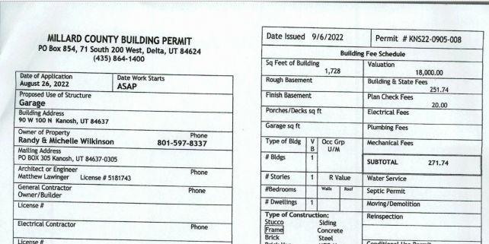
Travis Kesler building permit single family dwelling new water and power application
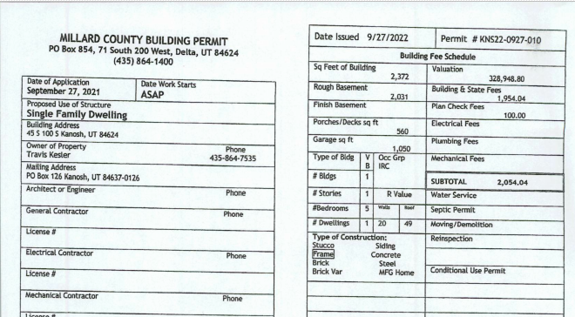
Jim Kooy: new water application 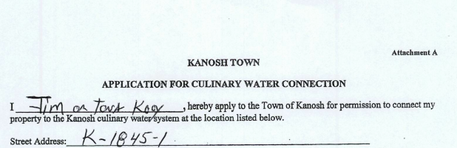

Councilmember Hayden George motioned to approve all permits as submitted, Councilmember David Whitaker provided a second to the motion, and all Council members voted in favor as noted below:
Mayor Scott McDonald Aye
Council members:
David Whitaker Aye
Neil Shumway Aye
Hayden George Aye

*Planning and Zoning member Stan Koyle:
Mr. Koyle questioned if the Shonda Robison property on the west side of town was determined to be a buildable lot or not. Part of the property is outside of the city limits and therefore We need to set a policy for everyone.
No action tonight.

Council members were each given a draft copy of the purposed new utility hook-up forms
The language was still the same however there will be an addition of a Dixie Power signature indicating where the electrical connection will be as well as the town employee Lorin Shumway will work out the location of the service with the property owner and Dixie Power.

*Kanosh Water and Power Fees
New application for culinary water connection. New connection fee of $1650.00 up from $900.00. Note: Fees can be set by resolution except for water, in Utah code 10-8-22 the community has a right to participate.

Effective 1/1/2021 10-8-22 Water rates.
(1) As used in this section:
(a) "Designated water service area" means the area defined by a municipality in accordance with the Utah Constitution, Article XI, Section 6, Subsection (1)(c).
(b) "Large municipal drinking water system" means a municipally owned and operated drinking water system serving a population of 10,000 or more.
(c) "Retail customer" means an end user: (i) who receives culinary water directly from a municipality's waterworks system; and (ii) whom the municipality described in Subsection (1)(c)(i) bills for water service.
(2) A municipality shall fix the rates to be paid for the use of water furnished by the municipality. (3) The setting of municipal water rates is a legislative act. (4) Within the municipality's designated water service area, a municipality shall:
(a) establish, by ordinance, reasonable rates for the services provided to the municipality's retail customers;
(b) use the same method of providing notice to all retail customers of proposed rate changes; and
(c) allow all retail customers the same opportunity to appear and participate in a public meeting addressing water rates.
(5)
(a) A municipality may establish different rates for different classifications of retail customers within the municipality's designated water service area, if the rates and classifications have a reasonable basis.
(b) A reasonable basis for charging different rates for different classifications may include, among other things, a situation in which:
(i) there is a difference in the cost of providing service to a particular classification;
(ii) one classification bears more risk in relation to a system operation or obligation;
(iii) retail customers in one classification invested or contributed to acquire a water source or supply or build or maintain a system differently than retail customers in another classification; (iv) the needs or conditions of one classification:
(A) are distinguishable from the needs or conditions of another classification; and
(B) based on economic, public policy, or other identifiable elements, support a different rate; or
(v) there is a differential between the classifications based on a cost of service standard or a generally accepted rate setting method, including a standard or method the American Water Works Association establishes.
(c) An adjustment based solely on the fact that a particular classification of retail customers is located either inside or outside of the municipality's corporate boundary is not a reasonable basis.
(6)
(a) If more than 10% of the retail customers within a large municipal drinking water system's designated water service area are located outside of the municipality's corporate boundary, the municipality shall:
(i) post on the municipality's website the rates assessed to retail customers within the designated water service area; and
(ii) establish an advisory board to make recommendations to the municipal legislative body regarding water rates, capital projects, and other water service standards.
(b) In establishing an advisory board described in Subsection (6)(a)(ii), a municipality shall:
(i) if more than 10% but no more than 30% of the municipality's retail customers receive service outside the municipality's municipal boundary, ensure that at least 20% of the advisory board's members represent the municipality's retail customers receiving service outside the municipality's municipal boundary;
(ii) if more than 30% of the municipality's retail customers receive service outside of the municipality's municipal boundary, ensure that at least 40% of the advisory board's members represent the municipality's retail customers receiving service outside of the municipality's municipal boundary; and
(iii) in appointing board members who represent retail customers receiving service outside of the municipality's municipal boundary, as required in Subsections (6)(b)(i) and (ii), solicit recommendations from each municipality and county outside of the municipality's municipal boundary whose residents are retail customers within the municipality's designated water service area.
(7) A municipality that supplies water outside of the municipality's designated water service area shall supply the water only by contract and shall include in the contract the terms and conditions under which the contract can be terminated.
(8) A municipality shall:
(a) notify the director of the Division of Drinking Water of a contract the municipality enters into with a person outside of the municipality's designated water service area, including the name and contact information of the person named in each contract; and
(b) each year, provide any supplementing or new information regarding a contract described in Subsection (8)(a), including whether there is no new information to provide at that time.public hearing prior to the meeting

Just before the regular November meeting, Kanosh Town will hold a public hearing to discuss the ordinance raising the culinary water hook up fees. Councilmember David Whitaker will draft a new water connection ordinance and email it to the attorney to go over.

*Water Impact fee ordinance: Councilmember Hayden George will contact Mr. Lynn Wall about getting the impact fee updated.

*Electric Impact fees: would need to decide on what the base fee is and how to administer it. Past discussions have included a flat fee and Dixie Power giving an estimate, and collection upfront before they ever begin. The current flat fee is $2600.00 plus whatever additional fee is incurred from Dixie Power. There are so many variables that have to be considered, an average cannot be established. Kanosh Town Attorney Justin Wayment commented we could use line extension agreements, it might be a good idea to get this in place. Mr. Wayment will provide the Town with a copy of the line extension agreement to review.
Discussion over an impact fee for the electrical dept. it is estimated that the study required for an impact fee for the electrical department would cost somewhere around $30,000.00. We would not require an impact fee if we charged a hookup fee that reflects the employee time and everything Kanosh Town is currently not charging for.
The assignments were reviewed:
A copy of the current documents will be given to our attorney, letting him review and make suggestions, including a check box indicating they are ready to move forward regardless of the costs or getting the cost estimate before moving forward.
Councilmember Neil Shumway will oversee everything with the Electrical issues.
Councilmember David Whitaker will oversee everything with the Water issues.

The last Form reviewed was the Residential utility service agreement: This form was created by Town Employee Lorin Shumway. There are a few things that require "ironing out" specifically the security deposits and the connection fees.
When the deposits are being refunded we need to let them know why they are getting it, just a note of explanation. The clerk will attach the following to the customer refund check:
* Security Deposit-All new customers require a deposit, with town policy establishing the amount of the deposit. If a homeowner has been current in payment of all utility bills for two years the deposit shall be applied as a credit on the utility bill or refunded in check form. The deposit cannot be applied to the utility bill to avoid delinquency. The Town will not pay interest on any security deposit. The Town may use the security deposit to settle the customer's account upon termination.
There is a piece of property just west of the Indian building, Revon Yuti's place, there is an individual who wants to put a water connection into the property. They have not provided Planning and Zoning with any water connection form.. The property is about 3 acres, about one acre of which is in the town. They want to put their mobile home on the property and have a water connection. There has been no talk of power. The main line for the water goes along 300 south, east, and west. We need the landowner to weigh in. Mr. Koyle noted, at this point, it is only talk there is no application.
Mrs. Shonda Robison
The property of discussion is located on the west side of Town, at 200 West. When the property was first acquired, she and her husband were advised that it was a buildable lot as long as it had access from the road. There is enough acreage in the property to build on, part of the parcel is in the county. Mrs. Robison stated it is being taxed as town property. She just wants to ensure that the City would agree that it is a buildable lot.

Council members would like to help Ms. Robison in this matter, however, in doing so they are setting a policy for everyone. Since Ms. Robison plans to sell the property as a buildable lot, she is not vested herself, Council members cannot promise what a future council would permit.

Annexation could help this dilemma. Annexation is a process, The first thing to proceed is the Notice of Intent letter to the affected entities. You will have to get a survey of the property for annexing the property from any engineering firm, you would have to get the property surveyed, get a plat map, and petition for annexation. Kanosh Town Attorney Justin Wayment provided the following information for the Council review.

See the Annexation flow chart below:

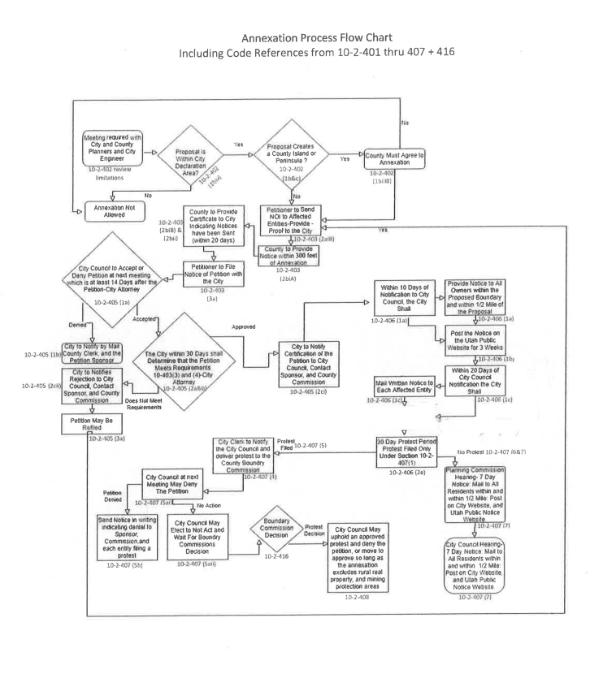
Kanosh Tow Attorney Justin Wayment prepared the following Petition of Annexation for Kanosh Town:

Kanosh Town
Petition for Annexation
I/We the undersigned owner(s) of certain real property lying contiguous to the present municipal
limits of Kanosh Town hereby submit this Petition for Annexation (“Petition”) and respectfully
represent the following:
1. That this Petition is made pursuant to the requirements of U.C.A. §10-2-403, 1953, as amended (U.C.A.);
2. That the property subject to this Petition is unincorporated area contiguous to the boundaries of Kanosh Town and the annexation thereof will not leave or create an unincorporated island or peninsula.
3. That the signatures affixed hereto are those of the owners of private real property that:
a. Is located within the area proposed for annexation;
b. Covers a majority of the private land are within the area proposed for annexation;
c. Is equal in value to at least 1/3 of the value of all private real property within the area proposed for annexation; and
The property subject of this Petition lies contiguous to the present boundary of Kanosh Town’s limits (describe approximate location) ________________________________ more specifically described as follows (legal description):
SEE EXHIBIT “A”
4. A copy of an accurate and recordable map, prepared by a licensed surveyor in accordance with U.C.A. §17-23-20 of the proposed annexation is included with this Petition along with the copy of the notice of intent to annex mailed to each affected entity and a list of all mailed entities is included with this Petition.
5. That all owners of the property being annexed have signed this Petition as a Sponsor, (one of whom should be designated as the contact sponsor (“CS”), with the mailing address of each sponsor being indicated:
6. That this Petition does not propose annexation of all or a part of an area proposed for annexation in a previously filed Petition that has not been denied, rejected, or granted;
7. That this Petition does not propose annexation of an area that includes some or all of an area proposed to be incorporated in a request for a feasibility study under U.C.A. §10-2-
413, if:
a. the request or Petition was filed before the filing of the annexation Petition; and
b. the request, a Petition under Section 10-2-109 based on that request, or a Petition
under Section 10-2-125 is still pending on the date the annexation Petition is filed;
8. That the Petitioners have caused an accurate plat or map of the above-described property to be prepared by a licensed surveyor, which plat or map is filed herewith to be delivered to Millard County.
9. That the property (does) (does not) have any improvements whatsoever on it; and
10. That the Petitioners request the property, if annexed, to be zoned _______________ WHEREFORE, The Petitioner(s) hereby request that this Petition be considered by the
governing body at its next regular meeting, or as soon thereafter as possible; that a resolution be adopted as required by law accepting this Petition for Annexation for further consideration; and that the governing body take such steps as required by law to complete the annexation herein
Petitioned.
DATED this ______ day of __________________, 20_____.
PETITIONER(S) (name(s) as it/they ADDRESS/TELEPHONE NO.
appear(s) on county tax roles):
CS:_____________________________________________________________
S: _____________________________________________________________
S: _____________________________________________________________
S: _____________________________________________________________
CS - Contact Sponsor S - Sponsor
NOTICE: A property owner who signs an annexation petition may withdraw the owner’s
signature by filing a written withdrawal, signed by the property owner, with the town clerk
no later than 30 days form the municipal legislative body’s receipt of the notice of
certification.
(Attach additional sheets if necessary)
RECORD OWNER NO. OF ACRES MILLARD COUNTY TAX NO.

Mr. Wayment reviewed the following Variance Utah Code:(10-9a-702)
Board of adjustments: appointed by the council.
2. Standards of Review. The standards that must be met before an Appeal Authority can grant a variance are narrow and difficult to meet. The State code is very clear. There are five conditions, of which ALL must be met before a variance can be granted. Not one or two, all five! The conditions are: (a) literal enforcement of the ordinance would cause an unreasonable hardship for the applicant that is not necessary to carry out the general purpose of the land use ordinances;
(b) there are special circumstances attached to the property that do not generally apply to other properties in the same zone;
(c) granting the variance is essential to the enjoyment of a substantial property right possessed by other property in the same zone;
(d) the variance will not substantially affect the general plan and will not be contrary to the public interest; and
(e) the spirit of the land use ordinance is observed and substantial justice done.
This may sound like a lot of “legalese” so it is important that, at some training session, each of these is discussed more fully and in clearer language. The state code goes on to further clarify that in order for the petitioner to claim an “unreasonable hardship” the following standards must apply.
The hardship: • Must be associated with the property. (It cannot be 16 Handbook for Appeal Authorities that the people who will live on the property cannot do the work themselves, or afford to comply with the standards); • Must be peculiar to this piece of property and one that is not general to the neighborhood; • Cannot be purely economic or self-imposed. (The hardship cannot exist because of something for which the owner of the property is responsible); •
Cannot be a “use” variance (No variance can change the general purpose of the property. A variance cannot be used to allow a commercial use in a residential zone, nor a duplex in a single home residential zone).
The exact language detailing these standards for an unreasonable hardship is: 10-9a-702. Variances.
(b) (i) In determining whether or not enforcement of the land use ordinance would cause unreasonable hardship under Subsection
(2)(a), the appeal authority may not find an unreasonable hardship unless the alleged hardship:
(A)is located on or associated with the property for which the variance is sought; and
(B) comes from circumstances peculiar to the property, not from conditions that are general to the neighborhood.
(ii) In determining whether or not enforcement of the land use ordinance would cause unreasonable hardship under Subsection
(2)(a), the appeal authority may not find an unreasonable hardship if the hardship is self- imposed or economic.
(c) In determining whether or not there are special circumstances attached to the property under Utah League of Cities and Towns 17 Subsection
(2)(a), the appeal authority may find that special circumstances exist only if the special circumstances:
(i) relate to the hardship complained of; and
(ii)deprive the property of privileges granted to other properties in the same zone. It is also important to note that a variance runs with the land, not with the property owner and that the burden of proof for meeting all of the standards outlined above rests with the petitioner.

Bart Whatcott American Legion post 61:
In the past years' members of American Legion post 61 have gone to all of the communities and businesses soliciting support to help with the veterans' dinner on the 11th of November. Councilmember Neil Shumway motioned to approve $150.00 for the veterans' dinner, Councilmember Brandon Stephenson seconded the motion, and all Council members voted in favor as noted below:
Mayor Scott McDonald Aye
Council members:
David Whitaker Aye
Neil Shumway Aye
Hayden George Aye

Ratify action to refund the charges of opening/closing of the grave to Mrs. Liz Whitaker:
Councilmember Hayden George to refund the opening/closing grave of Mr. Chad Whitaker, Councilmember Neil Shumway seconded the motion, and all Council members voted in favor as noted below:
Mayor Scott McDonald Aye
Council members:
David Whitaker Aye
Neil Shumway Aye
Hayden George Aye

Departmental Reports:
Park: Nothing new to report
Cemetery: Nothing new to report
Electrical Department: Councilmember Neil Shumway noted even more street lights out, he will get on that this week.
Roads:
*Councilmember Brandon Stephenson stated, "we are closer to snow fly"! The town employees are getting the plow ready.
*We need to pursue a contract with someone to come and treat for goat heads. We had the inmates n digging goat heads and hauled a whole truckload off.
Council member Hayden George stated that the irrigation company wants to clean the ditch by Cornell Atkinson's and would like to know if the town help haul the trash off. The Irrigation company has the prison crew coming to help.
Water:
Councilmember David Whitaker reported the purchase of a lot of water meters this month.

Utility Delinquency Review:
Council members reviewed the monthly delinquency list. It was determined, again, to handle those accounts in arrears according to established Town policy.

Meter Deposit refunds:
Kanosh Town Treasurer presented names of individuals who have met the requirements to receive their meter refund.

Public comment:
*Deb Hogan: addressed the Council members about a Christmas Tree lighting for the Town. There will be a coloring contest for ages 1-5 and 6-12 with a small cash prize for the 1st, 2nd, and 3rd place in each age group. The lighting of a Tree, bonfire, Christmas Carols led by Tara Batt, Hot Chocolate and Cookies (request to use the concession stand to serve from), Possible 8-foot tree placed in the park for families to place a family ornament or in memory of a loved one. Council members agreed this would be an excellent community event. The date for this celebration is scheduled for 12/5/2022@7:00. Mrs. Hogan also noted that her husband, John, is willing to get a committee together that is willing to restring and repair any park decorations that need to be done if they could be delivered to their home within the next couple weeks.
*John Hogan: Questioned if Kanosh is still doing a well, it is in the process? Mr. Hogan was talking to Jim Stephenson in Holden about the Well they are digging west of Holden town and the cost is roughly 9-12 million dollars. Mayor McDonald noted that the location for the Kanosh Well will be located up near the chlorinator. There were two possible locations discussed the other would be near the arena on the north end of town. So we do not have to file again if something did go wrong, we have filed for approval of both locations, so if one does not work at one location we can go to the other. We are not digging it, there is a process that has to be gone through and we are working our way through it, but it is not going to be fast.
*Jim Kooy: We spoke about the street lights, I noticed we have a lot of low-hanging wires.
The other thing we have talked about was the trailer I have, rental or buy, I don't care, either way, I am open to discussion, ideas, thoughts.
Councilmember David Whitaker commented that we will be going a different route by purchasing a c-container, at the cost of around $9,000.00. Council member Whitaker has collected several cost estimates as noted below:
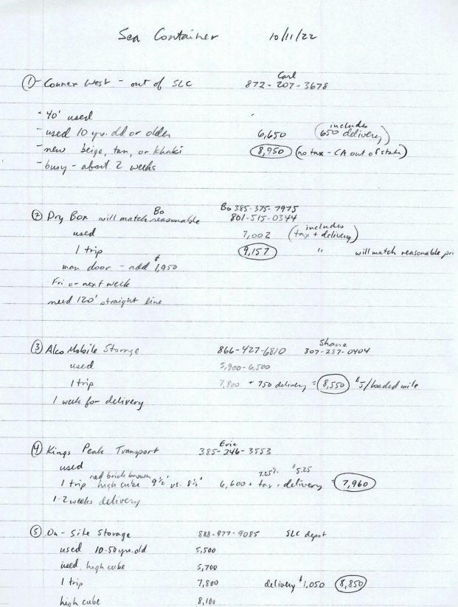

Council member Hayden George motioned to move forward with the purchase of a c-container at Councilmember David Whitaker's digression, Council member Brandon Stephenson, all Council members voted in favor as noted below:
Mayor Scott McDonald Aye
Council members:
David Whitaker Aye
Neil Shumway Aye
Hayden George Aye
Kanosh Town Attorney has created a draft ordinance addressing storage containers if Kanosh Town would like to look at it.
Old Business:
*Corn Creek update:
Mayor Scott McDonald stated the project is not dead in the water, but pretty much-treading water. in acquiring easements required the cost will exceed what Kanosh can afford.

Kanosh Town attorney Justin Wayment suggested the Council contact the state senators before they go into session, they may have money available. Derrin R. Owens is our state senator.

*Culinary Well Project:
The water right has been segregated. We have applied for the change order, which was sent back, and wanted it worded differently. It has been re-done and re-submitted, there is a protest period.

*Drones:
About the drone issue, Kanosh Town Attorney Justin Wayment noted there is already a law in place under Utah Code 76-6-206. So basically you need to call the police, this is enforceable by law.

Effective 5/4/2022
76-6-206. Criminal trespass.
(1) | As used in this section:  (a) "Enter" means intrusion of the entire body or the entire unmanned aircraft.  (b) "Remain unlawfully," as that term relates to an unmanned aircraft, means remaining on or over private property when: (i) the private property or any portion of the private property is not open to the public; and (ii) the person operating the unmanned aircraft is not otherwise authorized to fly the unmanned aircraft over the private property or any portion of the private property.

(2) | A person is guilty of criminal trespass if, under circumstances not amounting to burglary as defined in Section 76-6-202, 76-6-203, or 76-6-204 or a violation of Section 76-10-2402 regarding commercial obstruction:  (a) the person enters or remains unlawfully on or causes an unmanned aircraft to enter and remain unlawfully over property and: (i) intends to cause annoyance or injury to any person or damage to any property, including the use of graffiti as defined in Section 76-6-107; (ii) intends to commit any crime, other than theft or a felony; or (iii) is reckless as to whether the person's or unmanned aircraft's presence will cause fear for the safety of another;  (b) knowing the person's or unmanned aircraft's entry or presence is unlawful, the person enters or remains on or causes an unmanned aircraft to enter or remain unlawfully over property to which notice against entering is given by: (i) personal communication to the person by the owner or someone with apparent authority to act for the owner; (ii) fencing or other enclosure obviously designed to exclude intruders; or (iii) posting of signs reasonably likely to come to the attention of intruders; or  (c) the person enters a condominium unit in violation of Subsection 57-8-7(8).

(3) | (a) A violation of Subsection (2)(a) or (b) is a class B misdemeanor unless the violation is committed in a dwelling, in which event the violation is a class A misdemeanor.  (b) A violation of Subsection (2)(c) is an infraction.

(4) | It is a defense to prosecution under this section that:  (a) the property was at the time open to the public; and  (b) the actor complied with all lawful conditions imposed on access to or remaining on the property.

(5) | In addition to an order for restitution under Section 77-38b-205, a person who commits a violation of Subsection (2) may also be liable for:  (a) statutory damages in the amount of three times the value of damages resulting from the violation of Subsection (2) or $500, whichever is greater; and  (b) reasonable attorney fees not to exceed $250, and court costs.

(6) | Civil damages under Subsection (5) may be collected in a separate action by the property owner or the owner's assignee.

Council member Brandon Stephenson motioned to move into closed session to discuss personnel and mental health issues, Council member Hayden George seconded, and all Council members voted in favor through a roll call vote as noted below:
Mayor Scott McDonald Aye
Council members:
David Whitaker Aye
Neil Shumway Aye
Hayden George Aye

The regular Kanosh Town meeting resumed at 9:40, there was no action to be taken from the closed session.

Council member Brandon Stephenson motioned to move into closed session to discuss the dam and governmental immunity issues, Council member Hayden George seconded, and all Council members voted in favor through a roll call vote as noted below:
Mayor Scott McDonald Aye
Council members:
David Whitaker Aye
Neil Shumway Aye
Hayden George Aye

The regular Kanosh Town meeting resumed at 10:45, and there was no action to be taken from the closed session.

There being no further business to come before the board, the meeting adjourned.

Scott McDonald Cindy Turner,
Kanosh Town Mayor Kanosh Town Clerk

Ordinance regarding the culinary hook up fee
Impact fees?
line extension agreements

