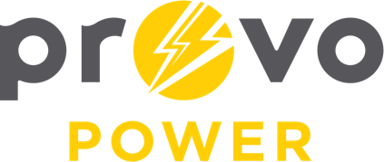
AGENDA
ENERGY BOARD MEETING
PROVO POWER
251 W 800 N
Monday, November 14, 2022
4:00 P.M.

- Welcome & Introductions - Chairman Ned Hill
- Review & Approval of Minutes – October 3, 2022
- Financial Report – Charlie Fuller
- KPI Report – Charlie Fuller
- Manager Report – Travis Ball
- Calendar & Scheduling
  - Thanksgiving Luncheon: November 16th @ 12:00pm
  - Christmas Luncheon: December 14th @ 12:00pm
  - Next board meeting: January 9th, 2023

A copy of the agenda was posted in the Civic Center, and the Provo City Library, on November 9, 2022, and also delivered to the Mayor,
City Council Members, required news media, and adjacent cities in
compliance with the Utah Code 52-4-202

