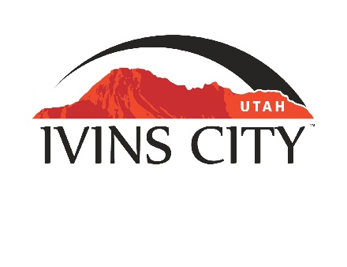
IVINS CITY

COUNCIL MEETING

AGENDA

August 18, 2022

Mayor Chris Hart

City Council Members

Lance Anderson

Jenny Johnson

Dennis Mehr

Adel Murphy

Mike Scott

City Manager/Attorney:

Dale Coulam

The Ivins City Council will hold a regular meeting in the City Council Chambers, 85 N. Main St., Ivins, UT, on Thursday, August 18, 2022. The meeting will begin at 5:30 P.M.

NOTICE: This meeting will be held in person and electronically. You may watch the live audio and video feed by going to www.ivins.com under “Upcoming Events”. When the meeting is live, it will reflect “In Progress” – click on the “In Progress” link to watch the meeting live. The Mayor and/or City Council Members may attend via telephone conference if they are unable to attend in person. The anchor location will be the Ivins City Council chambers located at 85 North Main Street, Ivins City, Utah 84738.

Note: The order of items discussed on this agenda is subject to change

- WELCOME AND CALL TO ORDER
- Acknowledgement of Quorum
- Flag Salute
- Invocation
- Disclosures

- REPORTS, PRESENTATIONS AND APPOINTMENTS
- Wreaths Across America Committee report – Sharon Gillespie
- Concept Plan Report for Desert Cliffs Subdivision located at approximately Kwavasa Drive between Center Street and 450 North. Kayenta Development Inc-Owner. Lance Anderson-Applicant
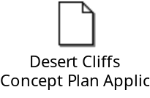
- Presentation regarding surveying residents as it relates to updating the General Plan - VCBO
- Department Reports: Building Department; Public Works/Engineering; Finance
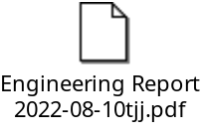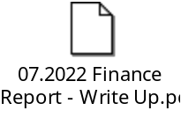
- Planning Commission Report

- CITIZEN REQUEST FOR FUTURE AGENDA ITEMS REGARDING ORDINANCES, POLICIES OR OTHER LEGISLATIVE ITEMS
Any person wishing to bring a legislative item not otherwise on the Agenda to the attention of the Mayor and City Council may address the City Council at this point by stepping to the microphone and giving their name and address for the record. Citizen Request for Future Agenda Item forms should be filled out in advance and given to the City Recorder. Remarks should be limited to no more than two minutes, unless the Governing Body allocates additional time. The Mayor and City Council will take no action this evening.

- PUBLIC HEARING AND ACTION ITEMS - NONE

- DISCUSSION AND POTENTIAL ACTION ITEMS
- Discuss and consider approval of Resolution No. 2022-16R, a Resolution of Ivins City, Utah, appointing a Heritage Days Parade Grand Marshal
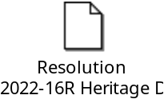
- Discuss and consider approval of Resolution No. 2022-15R, a Resolution of Ivins City, Utah, appointing an Administrative Services Director
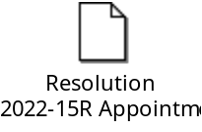
- Discuss and consider approval of a Proclamation regarding the 2022-2023 School Year as an Alcohol-Free School Year for Youth
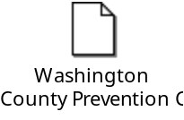
- Continued discussion on the Planning Commission’s recommendation for a Zone Amendment per the amended Project Plan for the SITLA parcel located at approximately Puerto Drive and 400 South. School Institutional Trust Lands Administration-Owner. Jerry Miyahara-Applicant
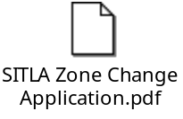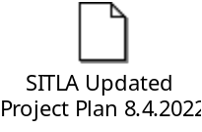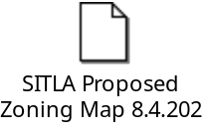

6) CONSENT AGENDA
- Approval of expenditure for purchase of water meters in FY2023
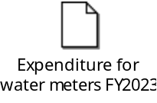
- Approval of City Council Meeting Minutes for July 21, 2022
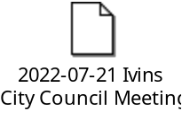

7) CONSENT AGENDA ITEMS FOR DISCUSSION

8) REPORTS
- Council
- Mayor
- City Manager/Attorney Dale Coulam
- Items to be placed on future agendas

9) CLOSED MEETING

10) ADJOURNMENT

Reasonable accommodation: Ivins City will make efforts to provide reasonable accommodation to disabled members of the public in accessing City programs. Please contact the City Recorder at least 24 hours in advance if you have special needs.

I hereby certify that I have posted copies of the agenda in the following public and conspicuous places on August 11, 2022. Ivins City Hall, the Ivins Post Office, SCI Center Street Fire Station, Ivins City UNITY Park and Ivins City Animal Shelter. I have also sent a copy of this agenda to St. George News and posted it on the Utah Public Notice website.

Kari Jimenez, MMC
City Recorder

