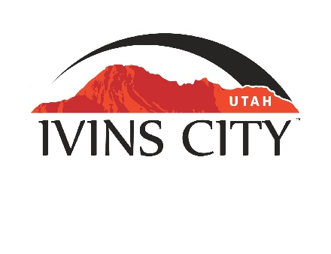
IVINS CITY

COUNCIL MEETING

AGENDA

July 21, 2022

Mayor Chris Hart

City Council Members

Lance Anderson

Jenny Johnson

Dennis Mehr

Adel Murphy

Mike Scott

City Manager/Attorney:

Dale Coulam

The Ivins City Council will hold a regular meeting in the City Council Chambers, 85 N. Main St., Ivins, UT, on Thursday, July 21, 2022. The meeting will begin at 5:30 P.M.

NOTICE: This meeting will be held in person and electronically. You may watch the live audio and video feed by going to www.ivins.com under “Upcoming Events”. When the meeting is live, it will reflect “In Progress” – click on the “In Progress” link to watch the meeting live. The Mayor and/or City Council Members may attend via telephone conference if they are unable to attend in person. The anchor location will be the Ivins City Council chambers located at 85 North Main Street, Ivins City, Utah 84738.

Note: The order of items discussed on this agenda is subject to change

- WELCOME AND CALL TO ORDER
- Acknowledgement of Quorum
- Flag Salute
- Invocation
- Disclosures

- REPORTS, PRESENTATIONS AND APPOINTMENTS
- St. George Regional Hospital update
https://www.youtube.com/watch?v=q1cpwP2gC6Y
- Department Reports: Building Department; Public Works/Engineering; Finance [TAB A]
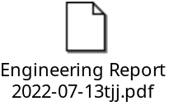
- Quarterly Finance Report [TAB B]
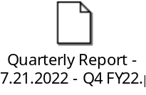
- Planning Commission Report

- CITIZEN REQUEST FOR FUTURE AGENDA ITEMS REGARDING ORDINANCES, POLICIES OR OTHER LEGISLATIVE ITEMS
Any person wishing to bring a legislative item not otherwise on the Agenda to the attention of the Mayor and City Council may address the City Council at this point by stepping to the microphone and giving their name and address for the record. Citizen Request for Future Agenda Item forms should be filled out in advance and given to the City Recorder. Remarks should be limited to no more than two minutes, unless the Governing Body allocates additional time. The Mayor and City Council will take no action this evening.

- PUBLIC HEARING AND ACTION ITEMS - NONE

- DISCUSSION AND POTENTIAL ACTION ITEMS
- Discuss and consider the Planning Commission’s recommendation to approve a Preliminary Plan for Falcon Park Subdivision, located at approximately 225 East and 800 South. Kevin Petersen and Jared and Megan Bringhurst-Owner/Applicant [TAB C]

- Discuss and consider the Planning Commission’s recommendation to approve a Preliminary Plan for Vista Estates, located at approximately 200 West and Red Vista Drive. Sunshine Seven, LLC and Bench Seven Series, Owner. Jared Madsen-Applicant [TAB D]

- Discuss and consider the Planning Commission’s recommendation to approve a Preliminary Plan for Black Desert Golf Village, located at approximately 1500 East Black Desert Drive, north of the horse roundabout. Enlaw, LLC-Owner. Jared Madsen-Alpha Engineering-Applicant [TAB E]

- Presentation and discussion on the Planning Commission’s recommendation for a Zone Amendment per the Project Plan. Located at approximately Puerto Drive and 400 South. School Institutional Trust Lands Administration-Owner. Jerry Miyahara-Applicant [TAB F]
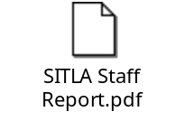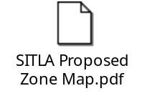
- Discuss and consider the Planning Commission’s recommendation to approve a Preliminary Plan for Kwavasa Phase 2, located at approximately Evening Star Drive. Kayenta Development (SITLA)-Owner. Lance Anderson-Applicant [TAB G]
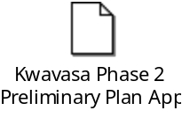
- Continued discussion regarding availability of water and approval of Acknowledgement of Water Supply form [TAB H]

- Continued presentation and discussion on the Planning Commission’s recommendation on the city-wide Sandbox Land Use Plan. Ivins City-Applicant [TAB I]

- Continued discussion regarding ideas and activities to celebrate Ivins City’s 100 year anniversary

6) CONSENT AGENDA
- Approval of City Council Meeting Minutes for June 16, 2022 [TAB J]

7) CONSENT AGENDA ITEMS FOR DISCUSSION

8) REPORTS
- Council
- Mayor
- City Manager/Attorney Dale Coulam
- Items to be placed on future agendas

9) CLOSED MEETING

10) ADJOURNMENT

Reasonable accommodation: Ivins City will make efforts to provide reasonable accommodation to disabled members of the public in accessing City programs. Please contact the City Recorder at least 24 hours in advance if you have special needs.

I hereby certify that I have posted copies of the agenda in the following public and conspicuous places on July 15, 2022. Ivins City Hall, the Ivins Post Office, SCI Center Street Fire Station, Ivins City UNITY Park and Ivins City Animal Shelter. I have also sent a copy of this agenda to St. George News and posted it on the Utah Public Notice website.

Kari Jimenez, MMC
City Recorder

