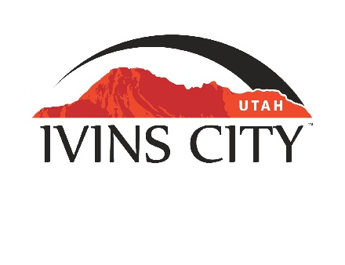
IVINS CITY

COUNCIL MEETING

AGENDA

September 16, 2021

Mayor Chris Hart

City Council Members

Sue Gordhammer

Jenny Johnson

Derek Larsen

Cheyne McDonald

Dennis Mehr

City Manager/Attorney:

Dale Coulam

The Ivins City Council will hold a meeting in the City Council Chambers, 55 N. Main St., Ivins, UT, on Thursday, September 16, 2021. The meeting will begin at 5:30 P.M.

*NOTICE: This meeting will be held electronically and in person. City Hall will be the anchor location for the electronic meeting. You may listen to the live audio feed by going to www.ivins.com under “Upcoming Events”. When the meeting is live, it will reflect “In Progress” – click on the “In Progress” link to listen to the meeting live.

For those desiring to attend electronically through the Zoom platform, you can sign into the following Zoom Webinar link:

https://us02web.zoom.us/j/84032004907

Webinar ID# 840 3200 4907

Note: The order of items discussed on this agenda is subject to change

- WELCOME AND CALL TO ORDER
- Acknowledgement of Quorum
- Flag Salute
- Invocation
- Disclosures

- REPORTS, PRESENTATIONS AND APPOINTMENTS
- Presentation and discussion by the Washington County Water Conservancy District regarding water conservation in new development – Zach Renstrom

- Department Reports: Building Department; Public Works/Engineering; Finance [TAB A]

- Planning Commission Report

- CITIZEN COMMENT & REQUEST FOR FUTURE AGENDA ITEMS
Any person wishing to bring an item not otherwise on the Agenda to the attention of the Mayor and City Council may address the City Council at this point by stepping to the microphone and giving his or her name and address for the record. Speaker forms should be filled out in advance and given to the City Recorder. Remarks should be limited to no more than two minutes, unless the Governing Body allocates additional time. The Mayor and City Council will take no action this evening.
- Citizen requests to be placed on a future agenda

- PUBLIC HEARING AND ACTION ITEMS - NONE

- DISCUSSION AND POTENTIAL ACTION ITEMS
- Status of Impact Fee Facilities Plan and Impact Fee Analysis for Public Safety [TAB B]

- Discuss and consider approval of Ordinance No. 2021-15, an Ordinance of Ivins City, Utah, regarding Small Wireless Facilities [TAB C]

- Discuss and consider approval of a Software Services Agreement with OpenGov Inc. [TAB D]


6) CONSENT AGENDA
- Approval of City Council Meeting Minutes for September 2, 2021 [TAB E]

7) CONSENT AGENDA ITEMS FOR DISCUSSION

8) REPORTS
- Council
- Mayor
- City Manager/Attorney Dale Coulam
- Items to be placed on future agendas
- Possible request/motion to reconsider the Planning Commission’s recommendation to approve a Special Height Exception within the Resort Commercial Zone for Black Desert Resort

9) CLOSED MEETING

10) ADJOURNMENT

Reasonable accommodation: Ivins City will make efforts to provide reasonable accommodation to disabled members of the public in accessing City programs. Please contact the City Recorder at least 24 hours in advance if you have special needs.

I hereby certify that I have posted copies of the agenda in the following public and conspicuous places on September 10, 2021. Ivins City Hall, the Ivins Post Office, SCI Center Street Fire Station, Ivins City UNITY Park and Ivins City Animal Shelter. I have also sent a copy of this agenda to St. George News and posted it on the Utah Public Notice website.

Kari Jimenez, MMC
City Recorder

