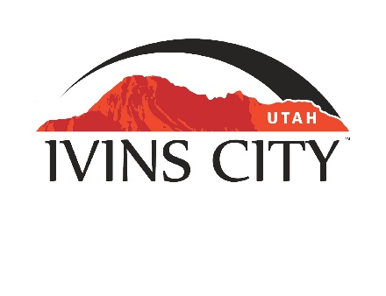
IVINS CITY

COUNCIL MEETING

AGENDA

August 19, 2021

Mayor Chris Hart

City Council Members

Sue Gordhammer

Jenny Johnson

Derek Larsen

Cheyne McDonald

Dennis Mehr

City Manager/Attorney:

Dale Coulam

The Ivins City Council will hold a meeting in the City Council Chambers, 55 N. Main St., Ivins, UT, on Thursday, August 19, 2021. The meeting will begin at 5:30 P.M.

*NOTICE: This meeting will be held electronically and in person. City Hall will be the anchor location for the electronic meeting. You may listen to the live audio feed by going to www.ivins.com under “Upcoming Events”. When the meeting is live, it will reflect “In Progress” – click on the “In Progress” link to listen to the meeting live.

For those desiring to attend electronically through the Zoom platform, you can sign into the following Zoom Webinar link:

https://us02web.zoom.us/j/83670560037

Webinar ID# 836 7056 0037

Note: The order of items discussed on this agenda is subject to change

- WELCOME AND CALL TO ORDER
- Acknowledgement of Quorum
- Flag Salute
- Invocation
- Disclosures

- REPORTS, PRESENTATIONS AND APPOINTMENTS
- Presentation by SPIN regarding scooters in Ivins City
- Department Reports: Building Department; Public Works/Engineering; Finance [TAB A]

- Planning Commission Report

- CITIZEN COMMENT & REQUEST FOR FUTURE AGENDA ITEMS
Any person wishing to bring an item not otherwise on the Agenda to the attention of the Mayor and City Council may address the City Council at this point by stepping to the microphone and giving his or her name and address for the record. Speaker forms should be filled out in advance and given to the City Recorder. Remarks should be limited to no more than two minutes, unless the Governing Body allocates additional time. The Mayor and City Council will take no action this evening.
- Citizen requests to be placed on a future agenda

- PUBLIC HEARING AND ACTION ITEMS
- Public Hearing on the Planning Commission’s recommendation on a proposed Zone Change from RA-5 (Residential Agricultural, minimum lot size 5 acres) and RA-1 (Residential Agricultural, minimum lot size 1 acre) to RE-15(Residential Estates District, minimum lot size 15,000 sq ft, with SLA (lot averaging) and R-1-5 (Residential Single Family, minimum lot size 5,000 sq ft) on approximately 18.495 acres located at approximately 600 West to 800 West and Highway 91. Kayenta Development and Red Mountain Ranch, LLC-Owner/Applicant [TAB B]
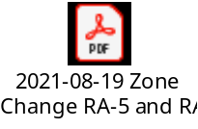
- Discussion and consider approval of Ordinance No. 2021-16, an Ordinance of Ivins City, Utah, regarding a zone change from RA-5 and RA-1 to RE-15 (with lot averaging) and R-1-5 on approximately 18.5 acres [TAB C]
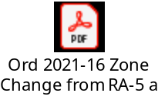
- Public Hearing regarding proposed amended Outdoor Lighting Ordinance [TAB D]
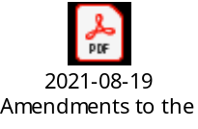
- Discuss and consider approval of Ordinance No. 2021-12, an Ordinance of Ivins City, Utah, further updating regulations for Outdoor Lighting [TAB E]
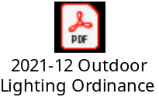

- DISCUSSION AND POTENTIAL ACTION ITEMS
- Canvass returns from the Municipal Primary Election pursuant to section 20A-4-301(2)(a) of the Utah Code

- Discuss and consider approval of Ordinance No. 2021-17, an Ordinance of Ivins City, Utah, Certifying the information contained in the canvass report of the Municipal Primary Election held on August 10, 2021 [TAB F]
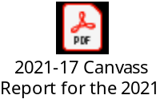
- Discuss and consider the Planning Commission’s recommendation on Hidden Springs RV Resort Class V Conditional Use Permit [TAB G]

- Discuss and consider the Planning Commission’s recommendation on a Special Height Exception within the Resort Commercial Zone for Black Desert Resort [TAB H]
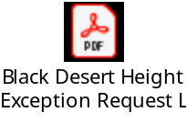
https://www.dropbox.com/s/qr5fljnix01rt1h/BDR%20Resort%20Center%20Visual%20Impact%20Study%2021.0714.mp4?dl=0
- Continued discussion to consider approval of Ordinance No. 2021-11, an Ordinance of Ivins City, Utah, amending Chapter 9 of the Zoning Ordinance & Chapter 4, Part 5 of the Subdivision Ordinance regarding Development Agreements [TAB I]

- Continued discussion to approve a Right-of-Way Construction and Maintenance Agreement with Enlaw LLC [TAB J]
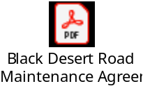

6) CONSENT AGENDA
- Approval of City Council Meeting Minutes for August 5, 2021 [TAB K]


7) CONSENT AGENDA ITEMS FOR DISCUSSION

8) REPORTS
- Council
- Mayor
- City Manager/Attorney Dale Coulam
- Items to be placed on future agendas

9) CLOSED MEETING

10) ADJOURNMENT

Reasonable accommodation: Ivins City will make efforts to provide reasonable accommodation to disabled members of the public in accessing City programs. Please contact the City Recorder at least 24 hours in advance if you have special needs.

I hereby certify that I have posted copies of the agenda in the following public and conspicuous places on August 13, 2021. Ivins City Hall, the Ivins Post Office, SCI Center Street Fire Station, Ivins City UNITY Park and Ivins City Animal Shelter. I have also sent a copy of this agenda to St. George News and posted it on the Utah Public Notice website.

Kari Jimenez, MMC
City Recorder

