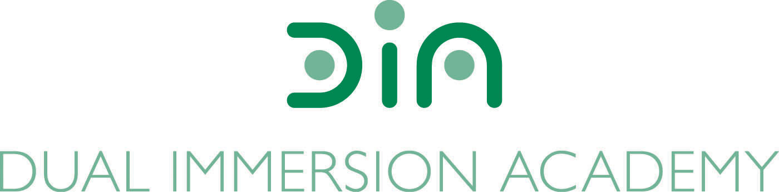

DIA Board of Directors Agenda
November 8, 2022
Dual Immersion Academy

Begin at 5:30 pm
In-person/Virtual Meeting
Roll Call

- Budget Report by Nate Adams, Red Apple

- DIA Remodeling Project – Abe Neilsen, FFKR Architects

- Board Candidates/Membership

- DIA Board Meeting Expectations

- Policy Audit (discussion)

- TSSA Plan & Budget Framework / Vote

- Follow-up Board Retreat Action Items

- Board Training

- Director’s Report by Angela Fanjul
  - Preschool student issue (discussion of issue requested by Shannon Sanchez)
  - 22-23 Data Update/Exit from CSI Info - Suzie Ramos and Gloria Tapia
  - DIA 15th Anniversary (update)
  - Feria de las Culturas – November 3, 2022 - Report

- Closed Session under UT 52-4-205 (as needed)
Re-open the meeting for board vote (as needed)

- Approval of minutes: October 1, 2022

- Motion to close the meeting

Conclude meeting by 7:00 pm

NO BOARD MEETING WILL BE HELD IN DECEMBER

Next meeting: January 10, 2023, at 5:30 pm

