Minutes Of the Regular Meeting of The Mayor and Town Council
Central Valley Town, Sevier County, Utah
September 21, 2022

A regular meeting of the Mayor and Town Council of Central Valley Town was held on Wednesday, September 21, 2022 at the Central Valley Town Hall, 50 West Center Street, Central Valley, Utah at the hour of 7:30 pm after due and timely notice had been provided pursuant to Section 52-4-6, UCA, 1953 as amended.
MAYOR & COUNCIL MEMBERS PRESENT:
Mayor Gary Barney, David Nielson, Susan Outzen, Charles Evans, Kody Winkel
STAFF MEMBERS PRESENT:
Treasurer: Shelley Brown
Maintenance: Joey Luna
PUBLIC PRESENT:
Terri Sorenson, Mary Kaye Thornton, John Thornton, Charles Billingsley
AGENDA:
- Meeting called to order
Mayor Barney welcomed those in attendance and excused Town Clerk for an out-of-town training. Mayor led The Pledge of Allegiance and offered the Invocation.

- Approval of Minutes: Date: August 17, 2022
Charles Evans made a motion to approve the minutes of August 17, 2022. David Nielson second the motion. Voting: David Nielson voted aye; Susan Outzen voted aye; Kody Winkel voted aye; Charles Evans voted aye. Motion carried. Minutes of the August 17, 2022 Meeting were approved.

- Review and Approval of Monthly Expenditures: August
The finances for August 2022 were reviewed by the town council. David Nielson made the motion to approve the monthly finances. Kody Winkel second the motion. Voting: David Nielson voted aye; Susan Outzen voted aye; Kody Winkel voted aye; Charles Evans voted aye. Motion carried. August 2022 finances were approved.

- Code/Zoning Enforcement Officer: Charles Billingsley: Discussion and Approval
Mr. Billingsley presented his program and procedure. He stated his program works well for most towns and cities; he explained how he gets his authority from the Utah Code; Central will need to amend parts of their Nuisance code to follow Utah Code.
It was decided to reschedule this matter for the October town council meeting, during the interim, the council will review his handouts. The matter can then be addressed and if the council decides to use Mr. Billingsley’s services, it can be authorized by passing a resolution.

Handouts are attached at the end of the minutes.

- New Town Attorney Discussion & Approval
The mayor has visited with Jared Peterson, an attorney located in Richfield; Mr. Peterson does not want to work on retainer basis but he would agree to hourly charge of $175 per hour. He also stated if appointed he would not take on any case/s that would conflict with his representation of Central Valley Town matters. The council recommended appointment be on a trial basis to determine the money value between retainer appointment and hourly basis.
Motion to appoint Mr. Peterson was made by David Nielson; 2nd by Susan Outzen. Voting: David Nielson voted aye; Susan Outzen voted aye; Kody Winkel voted aye; Charles Evans voted aye. Motion carried.

- Fence Project Deadline Discussion & Approval
Mr. Pearson appeared by telephone; Charles reported the ground preparation would be completed within a couple of days. Mr. Pearson stated he would have the work done within timeframe the council set.
David Nielson made a motion to set the deadline for November 30, 2022; 2nd by Kody Winkel. Voting: David Nielson voted aye; Susan Outzen voted aye; Kody Winkel voted aye; Charles Evans voted aye. Motion carried. Deadline is November 30, 2022.

- Discussion to revise FY2022-2023 Budget: Water Fund 51
Mayor stated a solution to paper track the process has been reached; the town clerk is aware of how to complete the process. This agenda matter is closed.

- Department Concerns and Council Member Reports
Susan: Planning commission has 3 public hearings set for their Oct. meeting.
(1) amendment of Yardley Conditional Use Permit and Mitigation list
(2) Conditional Use Permit and Mitigation List for Infiniti Mines, and
(3) Public hearing to inform citizens of commissions intent to update the current General Plan.
David – no report
Kody – no report
Charles: Good water samples again this month; he and Joey are working to get the ground preparation completed so the fencing project can commence; the downtown well is now being used on a regular basis and seems to be working as planned.
Mayor: The town maintenance man has completed his CDL certification; on September 27th the mayor, clerk and council will meet with a representative from the 6 County Government to discuss possible funding avenues for replacement of park restrooms; Charles has been using his own equipment for preparing the ground for the fence project – he needs to be reimbursed for equipment use.

- Adjournment
David Nielson made a motion to adjourn. Charles Evans second the motion. David Nielson voted aye; Susan Outzen voted aye; Kody Winkel voted aye; Charles Evans voted aye. Motion Carried. Meeting Adjourned.

Next town council meeting: October 19, 2022 @ 7:30pm

Minutes prepared by Town Clerk, Sheyenne Tenney, with the help of Council Member, Susan Outzen, in the clerk’s absence.

Approved: ___________________

_________________________________ Gary Barney, Mayor

Attest:

____________________________ seal
Sheyenne Tenney, Town Clerk

Attachments 1-4: Agenda Item 3

Attachment 1

INFINITI MINES – Cameron Linford
CENTRAL VALLEY TOWN Conditional Use Permit Mitigation List
(Physical Location of property – 392 W Center, Central Valley UT)
Dated: October 19, 2022

- Infiniti Mines must comply with all mitigation terms contained in the amended Kasey Yardley Mitigation List dated October 19, 2022.

In addition, Infiniti Mines must comply with the following:

- NO EXCESSIVE NOISE: No noise measurable beyond 70 Decibels.
- MOBILE DATA CENTER CONTAINER FOUNDATION: Long term placement of Mobile Data Centers shall comply with Sevier County Storage Ordinances, ie, (1) concrete base on all 4 corners; or, (2) placement on a minimum of 4 inches of gravel; or, (3) solid cement slab/s.
- STATE FIRE & SAFETY CODE: Infiniti Mines must comply with all State Fire and Safety Codes.
- LICENSING REQUIREMENTS: Infiniti Mines must obtain and keep current (1) all Licensing required by the State of Utah; (2) a valid Central Valley Town Conditional Use Permit; (3) any required business permits (State, County and/or Town); (4) any required building permits (County and/or Town).

Attachment 2

KASEY YARDLEY STORAGE YARD
Central Valley Town Conditional Use Mitigation Checklist
(Physical Location of property – 392 W Center, Central Valley UT)
Amended by Central Valley Town Council October 19, 2022
- SECURITY: Two (2) entry gates – one on center, one on HWY 118 – with coded locks.
- HOURS OF OPERATION: Five (5) o’clock am to ten (10) o’clock pm.
- SURVEY OF PROPERTY: Savage Engineering.
- SIGNING: Per Sevier County Business Signing Regulations.
- FENCING: Six (6) foot chain link with two (2) stands barb wire on top.
- LAND PREPARATION: Grading, then pit run, then road base, then gravel.
- WEED CONTROL: Monthly maintenance.
- LIGHTING: Solar LED lights on every container box.
- DRAINAGE CONTROL: Placement of culverts and grading in concert with adjacent land owner/s.
- CONTAINER BOXES: Must be uniform in color and comply with Central Valley Town Storage Container Ordinance. No stacking of container boxes.
- CONTAINER BOX FOUNDATIONS: Long term placement of boxes ((ie., six (6) months or more), will comply with Sevier County Storage Ordinances.
- LANDSCAPING: South and West fence lines will be lined with decorative rocks.
- GARABAGE/WASTE RECEPTACAL: Provide an adequate garbage/waste receptacle and weekly disposal of garbage/waste.
- PARKING AND ROADWAYS: Provide adequate space to accommodate parking, loading and unloading traffic in and around container boxes and stored items.
- HAZARDOUS MATERIAL STORAGE: Prohibited.
- UNSIGHTLY STORAGE, ie. Wrecked vehicles etc.: Prohibited.
- SCRAP METAL BINS: Prohibited.
- HUMAN HABITATION: Prohibited.
- SECONDARY BUSINESSES: Amended October 19, 2022: Owner may sublease to Infiniti Mines for placement of Mobile Data Units. Infiniti Mines is subject to all conditions of this mitigation list
- DISRUPTIVE ACTIVITIES, ie., Yard/garage sales of stored materials: Prohibited

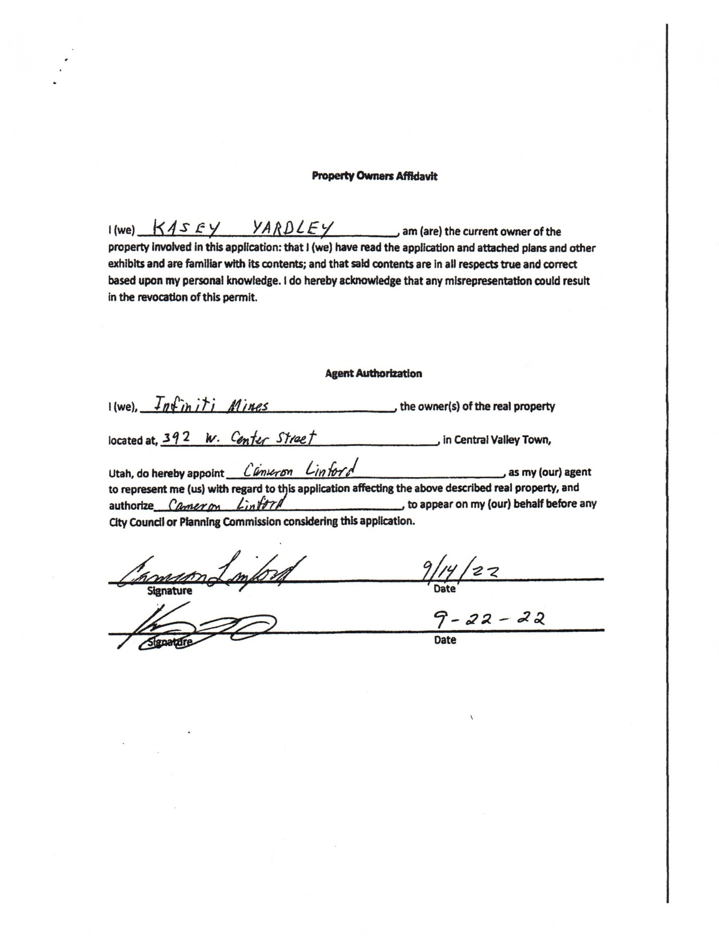
Attachment 3

Attachment 4

