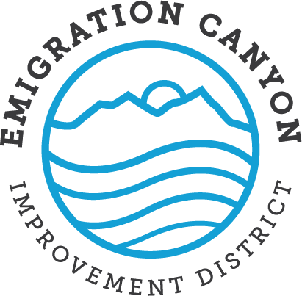
Notice of Proposed Rate Increase for Emigration Canyon Water Subscribers
22 September 2022

The purpose of this letter is to detail the reasons for a proposed increase in water rates for the Emigration Improvement District and explain the amount of the proposed rate increase.

The District’s last increase in water rates was nine years ago. Since then, inflation has risen by about 27%, which obviously affects what it costs the District to pump water from our wells and to maintain our system (leaks and other problems). In addition, for the last eight years the District has been required to defend against a series of meritless lawsuits filed by a former resident of Emigration Canyon named Mark Tracy. All of the various actions have been decided in favor of the District; the District has been awarded over $100,000 in attorney fees against Mr. Tracy (which we unfortunately do not expect to collect); and Mr. Tracy has been deemed a ‘vexatious litigant’ by the State courts. Nevertheless, these lawsuits have required us to divert funds that would have been used for operations and maintenance into legal fees. Finally, although we strongly support and promote water conservation, these efforts have resulted in a decrease in water usage by residents and less revenue for the District. The combination of these factors has caused a steady erosion of our cash reserves over the last couple of years.
We currently charge $3.50 for the first thousand gallons of water use, with an incremental charge of ten cents for each additional thousand gallons. Thus, the next thousand gallons costs $3.60, the one after that $3.70, and so on. This will be changed to a charge of $25 per month for the first 5,000 gallons. The next thousand gallons would cost an additional $3.50, rising to $3.65 for the next thousand (a fifteen-cent increase), and so on for each additional thousand gallons. The proposed increase will result in a monthly additional payment of $10-15 for low water users (5,000 gallons or less). Those who use 10,001-20,000 gallons will pay $11-19 a month more, and those who use 30,001-40,000 will pay an extra $30-40. Surcharges for those who use more than 40,000 gallons a month will remain in place. The increase affects heavier users more, which is consistent with our efforts to encourage water conservation.

The District is operated in an open and conservative manner, with meeting minutes available online and financial details reported to the State of Utah. The trustees don’t receive any discount, so when we raise rates, it affects us the same way as every other water subscriber. Furthermore, although we recognize that any increase in rates negatively impacts residents, all the other water systems that we surveyed have raised rates in recent years to keep up with rising costs, so our rates will remain among the lowest rates for comparable systems.
We appreciate your support in our continued efforts to provide safe and reliable water for culinary use and fire suppression in our community. If you have any questions or you would like more information about the operations of the District, we encourage you to attend our monthly board of trustee meetings.

