Kanosh Town Corporation held the regular council meeting on Wednesday, September 14, 2022, electronically and in the town office at 7:00 p.m.

Members present:
Mayor Scott McDonald, Council members: Neil Shumway, Hayden George, David Whitaker, Kanosh Town Clerk: Cindy Turner. Kanosh Town Treasurer DeniAnn Whitaker. Councilmember Brandon Stephenson was unable to attend this meeting.

Others in attendance: Town Employee Lorin Shumway, Planning and Zoning Chairman Stoyan Kolev, CERT Captain Geri Minton, Jim Kooy, Bart Whatcott, Josh Whitaker, Stan Koyle, Kellen Gillins, Shonda Robison, Kyle Stott.

Councilmember Neil Shumway offered the opening ceremonies through an invocation.

Councilmember Hayden George led everyone in attendance in the Pledge of allegiance.

Mayor Scott McDonald opened the council meeting and welcomed all in attendance.

Minutes of the August 2022 meeting were read and approved through motion by Councilmember Hayden George, Councilmember Neil Shumway provided a second to the motion, and all Council members voted in favor as noted below:
Mayor Scott McDonald Aye
Council members:
David Whitaker Aye
Neil Shumway Aye
Hayden George Aye

Warrants for the month of September 2022 were read, discussed, and approved to be paid through a motion by Councilmember Hayden George, Council member Neil Shumway seconded the motion, and all Council members voted in favor as noted below:
Mayor Scott McDonald Aye
Council members:
David Whitaker Aye
Neil Shumway Aye
Hayden George Aye

CERT:
Kanosh CERT Captain Geri Minton reported they had a meeting last Wednesday and are planning on a mini-conference in March 2023. The date is currently set for the 25th of March. They are planning to have a state speaker and a few classes, by October everything should be solidified.

The CERT team is looking into purchasing some medical supplies, but a lot of the inventory has become outdated.

Fire Department:
Kanosh Fire Chief Lorin Shumway had nothing new to report at this time.

Planning and Zoning:
*Planning and Zoning member Geri Minton presented the building Permit for Terron and Sara Hunt. The existing resolution states the setback should be 25 Feet from the front and 25 feet for the side, however, the contractor has requested they be allowed to only go 15 feet from the side.
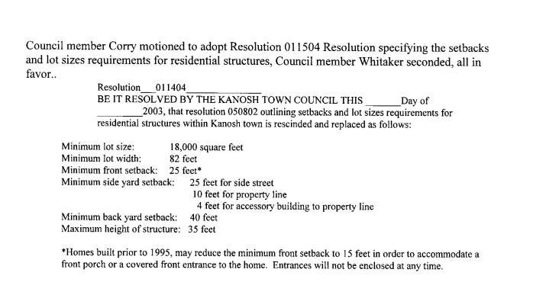
Council member Hayden George motioned to approve the building permit with the 25' set back on the side as outlined in resolution 011404, Councilmember David Whitaker seconded the motion, and all Council members voted in favor as noted below:
Mayor Scott McDonald Aye
Council members:
David Whitaker Aye
Neil Shumway Aye
Hayden George Aye
Note: this decision can be revisited and reevaluated if needed.

*Planning and Zoning member Stoyan Kolev addressed the council members on behalf of Brad Freeman, with a building permit complete with drawings, however missing a signature, so it is incomplete. The planning commission approved a variance from the 25' set back allowing the new structure to line up with the existing home.

Council member Hayden George motioned to approve the building permit as presented at the recommendation of the planning and zoning with the variance as long as it does not exceed the front of the existing house, Councilmember Neil Shumway seconded the motion, and all Council members voted in favor as noted below:
Mayor Scott McDonald Aye
Council members:
David Whitaker Aye
Neil Shumway Aye
Hayden George Aye

*Planning and Zoning member Stan Koyle addressed the council:
When you talk about variances that are really the board of adjustment issue. First, you have the rules that you are willing to stick by and not cater to somebody's wishes, you got your rules, got your board of adjustments who grants variances (Kanosh's Board of Adjustment was abandoned), We need some really good training on this whole issue of Planning Zoning, Board of adjustment, variances, what you can do and what you can't do.

Shonda Robinson's lot, is a flag lot see the yellow arrow below:
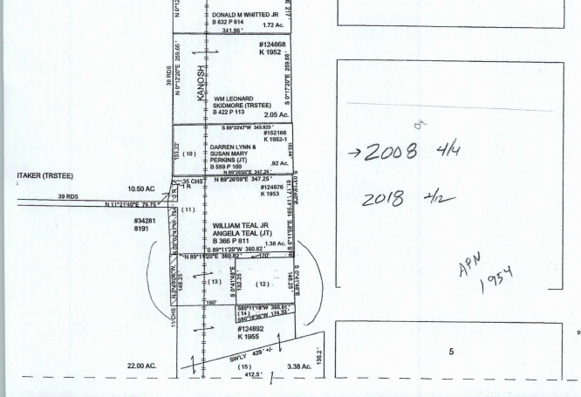

Number 12 is a rental property purchased from the Attwoods, #13 was purchased by the Robison's, which is now a flag lot it has 16 feet of street frontage, the subdivision ordinance states that you have to have 30. This was created before the subdivision ordinance. It's like the one we talked about last month. Planning and Zoning believe it looks like it's a buildable lot. The Robinsons are asking if it is a buildable lot. Previous Councils have turned down building permits for people requesting the same.

When one of the previous council members suggested making a nice clean line, Kanosh was threatened with lawsuits at the suggestion of annexing their property.

This may be another indication of needed legal training. There was a discussion of asking everybody along this boundary if the property owner wanted to Annex all their property in this town, we do a blanket annexation policy.

It was pointed out that the tax assessments are being issued as Kanosh Town Property.

In the past there have been disagreements over providing water to buildings outside of the city limits, it was suggested that we should get legal advice, in an effort of trying to clarify various issues. Council members agreed to consult our attorney and provide Mrs. Robinson with the answer next month.

The following will serve as an agenda item for the October 2022 meeting:
Fee Schedules utility hookup fees.
Impact fees.. (supposed to be adjusted every year).
Approval of new Application for electrical power connection flat fee form include Dixie power
Approval of new Water connection flat fee form
Current utility connection fees:
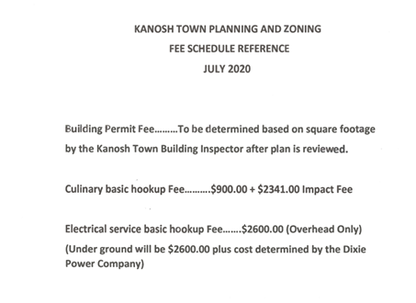
Fees can be set by resolution.

*Ordinance Creating a Planning and Zoning Commission page 2:
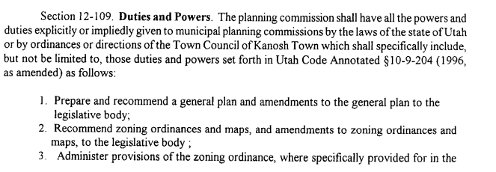
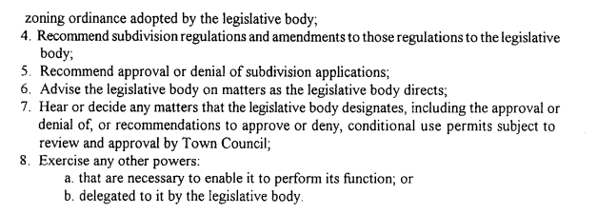

The planning commission would like to meet with the council members to discuss what the Council members want P&Z to work on.

Lane Jensen, Fransen Engineering:
Mr. Jensen addressed the Council members about the current status of the Dam Project, the flood channel, flood control, the historical channel, etc.

There have been countless discussions about the flood channel, where it has to go, how far it has to go, and what they consider the historical channels.

The State NRCS and the National NRCS are looking at things a little differently, not uncommon when you are dealing with people back East it is common they do not understand the geology or geography here. With that, there has been a lot of discussion between the local representatives of the NRCS and the National representatives, they are going back and forth about the question of where the channel can be. The latest answer was that the water had to be taken to the sink, beyond I-15. The engineers have to plan for a "100-year event" of flooding, with an estimated 2000 CFS. It seems kind of arbitrary, but that is the standard and these events do happen. Fransen Engineering has put together a few alternate models to route flood waters away from the town. One model is to use the existing flood channels, however, the NRCS came back and indicated they would probably not let that fly. They then modeled one that takes it past the highway and then lets it go through the Hatton ditch. So one channel would take it north of town get it past the highway and then let it go over and would follow the Hatton ditch. These models are very complex and they take sometimes weeks to run. For the flood channel, they talk about it having to pass the qualifications of a 100-year event, the dam has to pass what is called a Probable Maximum Flood or 10,000-year event.

Mr. Jensen noted it all comes down to liability.

Fransen Engineering will continue to update the Council on any new developments. Kanosh Town Council members verbalized their appreciation to Mr. Jensen for all he has done and will continue to do on behalf of the Town of Kanosh and this project.

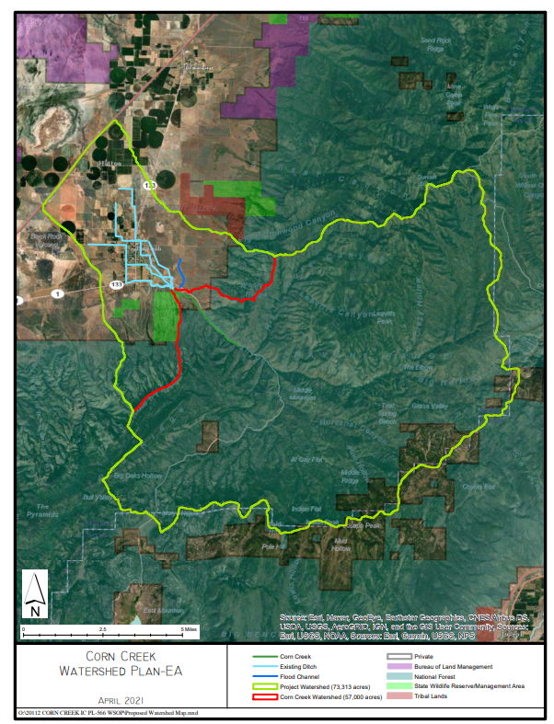

Lighting at the arena:
Several people are using the arena and they would like to have the benefit of lighting. Neul Chlarson has poles and lights that he would donate, but the issue is how are you powering them up. We should get a bid from Dixie Power. It would also be a great benefit to find a grant that would allow us to fix it up and have it functioning so more people can use it. Council members were in favor of looking into this idea further. There is the possibility of accessing recreational funding through the County, this will also be researched further.

Park:
There has not been any new Vandalism reported this month.

Will be trimming trees and getting rid of the dead ones.

The park Bathrooms are open from dawn to dusk.

Cemetery:
Councilmember Hayden George made the recommendation to refund the cost of opening and closing the grave for Chad Whitaker. Liz Whitaker has served the town as the sexton for years; she has done a great service to the town. This action will serve as an agenda item for October and be ratified through a motion at that time.

Electrical:
We need to have a Dixie Power on-call number for Kanosh. People are calling Dixie Power and being told "you are not our customer". Councilmember Neil Shumway will follow up on the number we should use. The number on the Kanosh Town Website goes directly to the manager Durand Robison. If you call the office number there is a recording that states which number to call.
743-6214 office number this is the Kanosh Town account # 697663. We will make sure the Kanosh Town Web site is updated.

We have a customer who paid their deposit to have their electrical hooked up and then they got a big charge after they had closed on their house. They agreed to make the payments on it because they were not able to get it included on the loan for their home. Now they are asking for a refund for everything they have paid and also that they do not owe any more. We will have to look into it further and provide her with proof that it is her bill.

Roads:
Nothing to report at this time.

Perry Watts came in earlier and believes the window in his suburban was taken out by a rock when we were mowing. He didn't seem upset, just concerned that we get whatever kind of safety equipment we need to contain as much of the debris as possible.

Water:
Councilmember David Whitaker commented favorably on the water conservation plan recommendations presented in last month's meeting.

Councilmember Whitaker will also get with the Town Employee Lorin Shumway on the Conex container.

Utility Delinquency Review:
Council members reviewed the monthly delinquency list. It was determined, again, to handle those accounts in arrears according to established Town policy. The Town waived the late fees for the billings this month.

Meter Deposit refunds:
Kanosh Town Treasurer presented names of individuals who have met the requirements to receive their meter refund.

Public comment:
Bart Whatcott
*In years past Kanosh Town has helped with the Veteran's day dinner through a donation to help cover the cost, it is hoped Kanosh will again help through a donation this year.
*There will be a Bemis Tribe reunion taking place next July 27 - 30, they will be renting and reserving the entire park.
*Did the band get reserved for the 24th next year? Councilmember Hayden George will take care of it.

Jim Kooy:
*Drones, is there any ordinance addressing drones? The issue is privacy, "I feel like they are scoping out my place". This is a fairly constant event. There is a drone dropping down in people back yards, around private vehicles, and one that has followed our Town Employee in and out of private residences while reading meters. To date, there is not an ordinance in place.
*Questioned if there is an agreement with the gas company to provide everyone in town with a gas connection, Questar wants around $10,000 for a hookup. The ordinance with Mt. Fuel will be mailed to Mr. Kooy, however, it is doubtful there is a clause allowing everyone in town a hookup.
*Mr. Kooy has offered his semi-Trailer to the Town at the cost of $13,000.

Stan Koyle:
*Questioned the status of the Encroachment letter. Mayor McDonald stated; unsent, unwritten. Council members agreed to look at this again next spring.

Lorin Shumway:
*Town Employee Lorin Shumway pointed out that the Town is in dire need of a truck. The truck that is currently being used is unsafe and tops out at 38 mph on the freeway. Mr. Shumway pointed out he has used his vehicle on countless occasions. He has also used his father’s truck for the benefit of the town. Council members noted that the purchase of a truck had been built in the FY23 budget. Mr. Shumway will work with the mayor on finding a truck within our price range and one that will meet the need of the Town.

Well Project:
We now have the water right segregated. Currently, we are filing the well application to the well site, we are filing for two different well sites at the same time, one up by the spring (the preferred site) and also filing on the arena site.

Council member Hayden George motioned to move into a closed session to discuss pay raises as well as hiring an additional employee, Council member Neil seconded the motion all Council members voted in favor through a roll call vote as noted below:
Mayor Scott McDonald Aye
Council members:
David Whitaker Aye
Neil Shumway Aye
Hayden George Aye

10:17 Kanosh Town Council resumed the regular meeting, there will be no action from the closed session.

There being no further business to come before the board, the meeting adjourned.

Scott McDonald Cindy Turner,
Kanosh Town Mayor Kanosh Town Clerk

Fee Schedules utility hookup fees.
Impact fees.. (supposed to be adjusted every year).
Approval of new Application for electrical power connection flat fee form include Dixie power
Approval of new Water connection flat fee form

Shonda Robison lot if it is a building lot or not

Legion: $150.00 donation

The planning commission would like to meet with the council members to discuss what the Council members want P&Z to work on.
Review 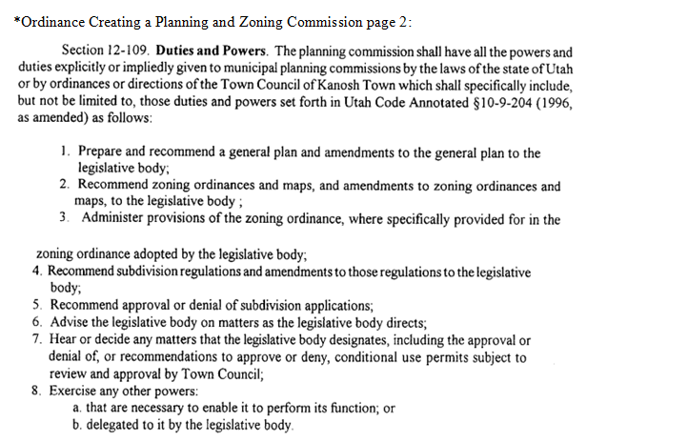
Refund Liz Whitaker 300 AGENDA

Conex container.

