AMERICAN FORK CITY
PLANNING COMMISSION MINUTES
AUGUST 17, 2022
REGULAR SESSION

The American Fork City Planning Commission met in a regular session on AUGUST 17, 2022, at the American Fork City Hall, 31 North Church Street, commencing at 7:00 pm.

Present: Chairman Woffinden
Christine Anderson
Bruce Frandsen
Jenny Peay
Rodney Martin
Chris Christiansen
Harold Dudley
David Bird * Mr. Bird was a part of the discussion but did not vote.

Absent:

Staff Present: Patrick O’Brien Development Services Director
Ben Hunter Engineer
George Schade IT Director
Cherylyn Egner City Attorney
Megan Crowley Administrative Assistant
Travis Van Ekelenburg Senior Planner

Others Present: Ginger Romriell, Ken Burg, Will Jones

Chairman Woffinden led the “Pledge of Allegiance”

- Hearing, review, and action on a Final Plat for Stonecreek Plat J, located in the area of 1000 S 400 W, in the PR-3.0 zone.
Patrick O’Brien: This is for Stonecreek Plat J. It’s part of the overall Stonecreek development its 9.8 acres which is part of the166 acres of this development. It’s one of the 11 plats that are being phased in. There are 25 proposed lots, for a total of 33 units. A number of the corner lots are going to have duplexes on them per the requirement of the code. The property is accessed off of 910 South. After conducting a thorough development review there were no staff comments or conditions that need to be attached to this. Staff recommends approval.
John Woffinden: Engineering any comments?
Ben Hunter: No, they have addressed all of our comments. They meet all of the requirements for the engineering division, and we recommend approval.
Bruce Frandsen: I’ve walked this plat and I know that one of our requirements is that the applicant will submit a sketch of all water rights within a one-mile radius. I am hoping we can amend that to say: applicant will submit plat with all of the points of diversion within their proposed development area. There is a couple of them in here, but they don’t show on the water rights map. They are changing the direction of water in this development and my family is being affected. I think if in the future we said show us the points of diversion within your development that would tell us if they’re going to be affecting, positively or negatively, water rights, where just getting a one-mile radius doesn’t. I have no concerns with this one, I’ve actually talked to the developers and know what’s happening and we’re ok with that. I think in the future it would be a good data set to have. I think we probably have to amend a code which says give us the one mile plus points of diversion. Points of diversion is anywhere in a ditch if the water is coming down and now it turns and goes that way. It’s on a map and the state engineer knows that and the developer is not allowed to change that without approvals. But we can’t see that now. It’s something to think about I think it’s something we ought to consider.
Ben Hunter: We can look at doing some modifications to make sure they are not having an impact. That’s the main point behind that section of code.
Patrick O’Brien: I’ve taken note of that as well. That’s something we can sit down with as a team and talk about grabbing some language and bringing it back to you guys as an amendment in the future.
John Woffinden: Is the applicant here?
Ginger Romriell: This is phase 9 out of 11 it’s just a continuation of amazing things. They are single family residences.

Public Hearing Opened

No public comment

Public Hearing Closed

Christine Anderson motioned to recommend approval of the Hearing, review, and action on a Final Plat for Stonecreek Plat J, located in the area of 1000 S 400 W, in the PR-3.0 zone. Harold Dudley seconded the motion.

Voting was as follows:

Chairman Woffinden AYE
Harold Dudley AYE
Christine Anderson AYE
Bruce Frandsen AYE
Jenny Peay AYE
Rodney Martin AYE
Chris Christiansen AYE
The motion passed

- Hearing, review, and action on a code text amendment to Section 17.4.608, titled Transit Oriented Development Zone amending the certain elements related to definitions and lot type assignments.

Patrick O’Brien: This one is from section 5 of TOD code, specifically to the block plan section. Generally, the areas of the TOD code that Planning Commission and City Council will be more involved in is the district framework plan. The lot plan and block plan sections are an administrative approval that staff signs off on. This section is to amend .4 of part E of section 5 that would allow the different lot types that exist in TOD area to transition across thoroughfares. They all have different ranges of weights that go with all different lot types. Right now, you have a lot type 4 on one side of an alleyway it couldn’t transition to a lot type 5 on the other side. This would remove that and allow an applicant to meet the intent of the TOD zone. Which is to have a variety of different lot types throughout it rather than constraint it to a specific lot type, unit, development, and product. Staff supports the recommendation that the applicant has. We didn’t see any concerns with it and we’re happy to answer any questions.
Jenny Peay: I’ve seen where they have the private lanes in the back, I like it because it reduces traffic on the main road thoroughfares.

Public Hearing Opened

No public comment

Public Hearing Closed

Jenny Peay motioned to recommend approval of the Hearing, review, and action on a code text amendment to Section 17.4.608, titled Transit Oriented Development Zone amending the certain elements related to definitions and lot type assignments. Subject to any conditions found in the staff report. Bruce Frandsen seconded the motion.

Voting was as follows:

Chairman Woffinden AYE
Harold Dudley AYE
Christine Anderson AYE
Bruce Frandsen AYE
Jenny Peay AYE
Rodney Martin AYE
Chris Christiansen AYE
The motion passed

- Hearing, review, and action on a code text amendment to Section 17.7.502, titled Planned Unit Development - Flexible Lot Projects amending the average lot size requirements.
Patrick O’Brien: This request is staff initiated off the back of Bridges at Fox Hollow. One of the requirements is that the applicant needs to meet an average lot size of 9,000 square feet. The way the code is written that not possible. Staff was recommending bringing it to what that minimum range would be but also providing a range that can go a little bit above that as well. The way the code is written it seems like you need to meet 9000 square feet as the average lot size and if you are above or below that technically you don’t meet the average lot size requirements. Staff is recommending a range of 9,800-12,000 square feet. That’s the only change that’s being recommended. It relates to .1 of G3 of 17.7.502. This would help a number of other projects and also that range of lot sizes is similar to surrounding community. It would fit in with the existing community with that average size.

Public Hearing Opened

No public comment

Public Hearing Closed

Rodney Martin motioned to recommend approval of the Hearing, review, and action on a code text amendment to Section 17.7.502, titled Planned Unit Development - Flexible Lot Projects amending the average lot size requirements. Subject to any conditions found in the staff report. Harold Dudley seconded the motion.

Voting was as follows:

Chairman Woffinden AYE
Harold Dudley AYE
Christine Anderson AYE
Bruce Frandsen AYE
Jenny Peay AYE
Rodney Martin AYE
Chris Christiansen AYE
The motion passed
- Open and Public Meetings annual training.
Cherylyn Egner led the commission on open meetings training.
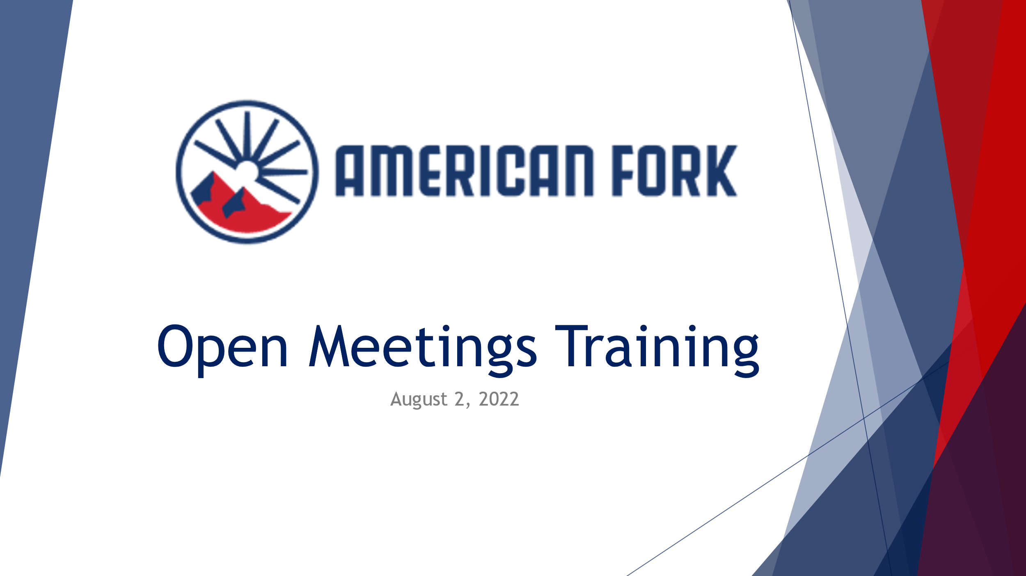
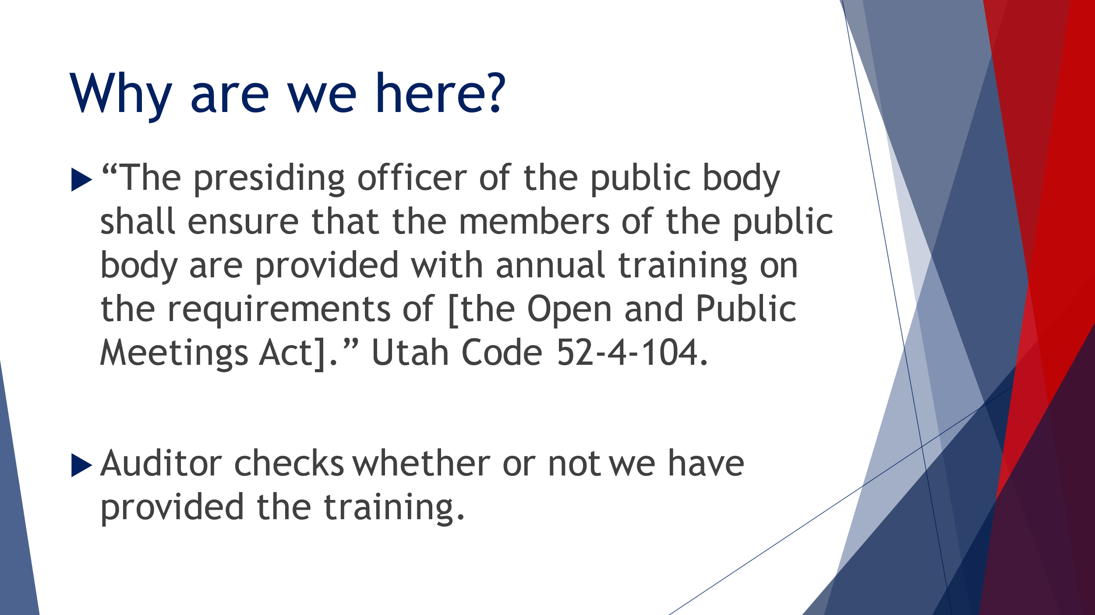
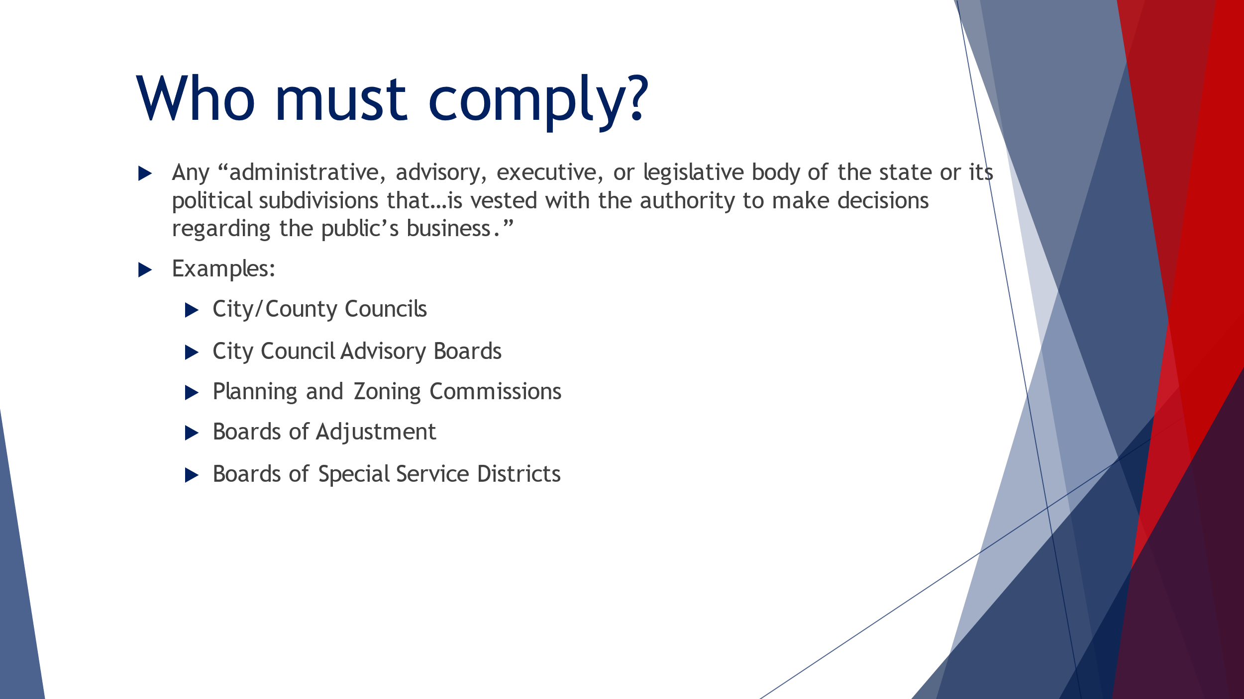
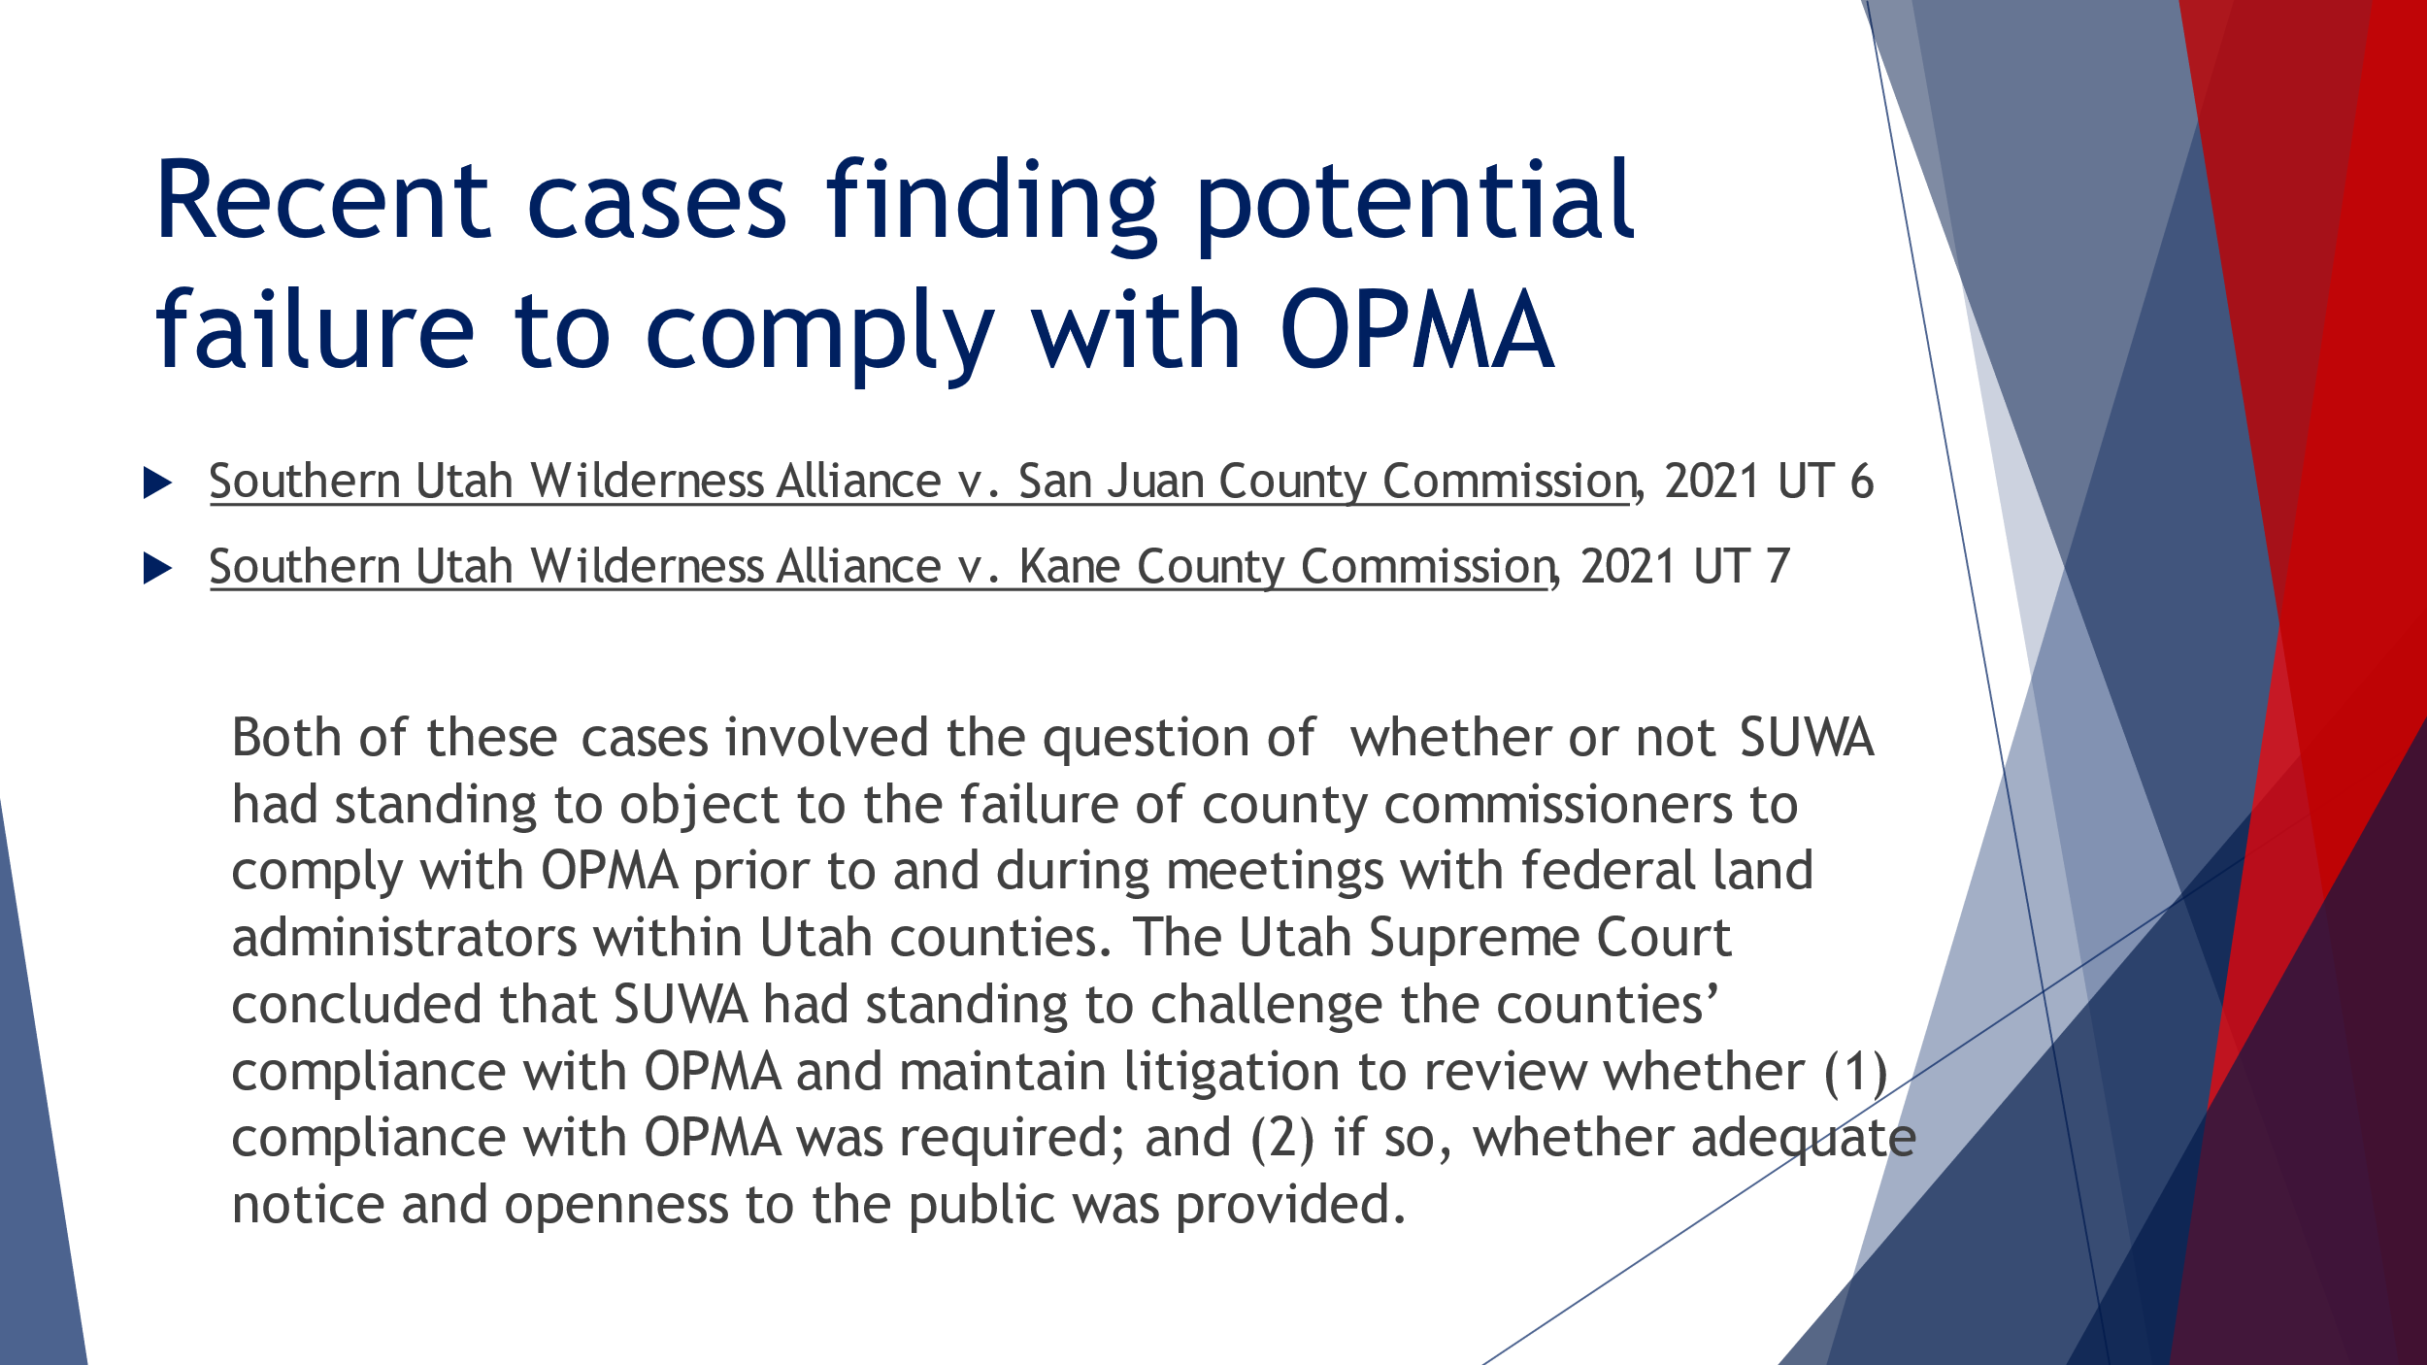
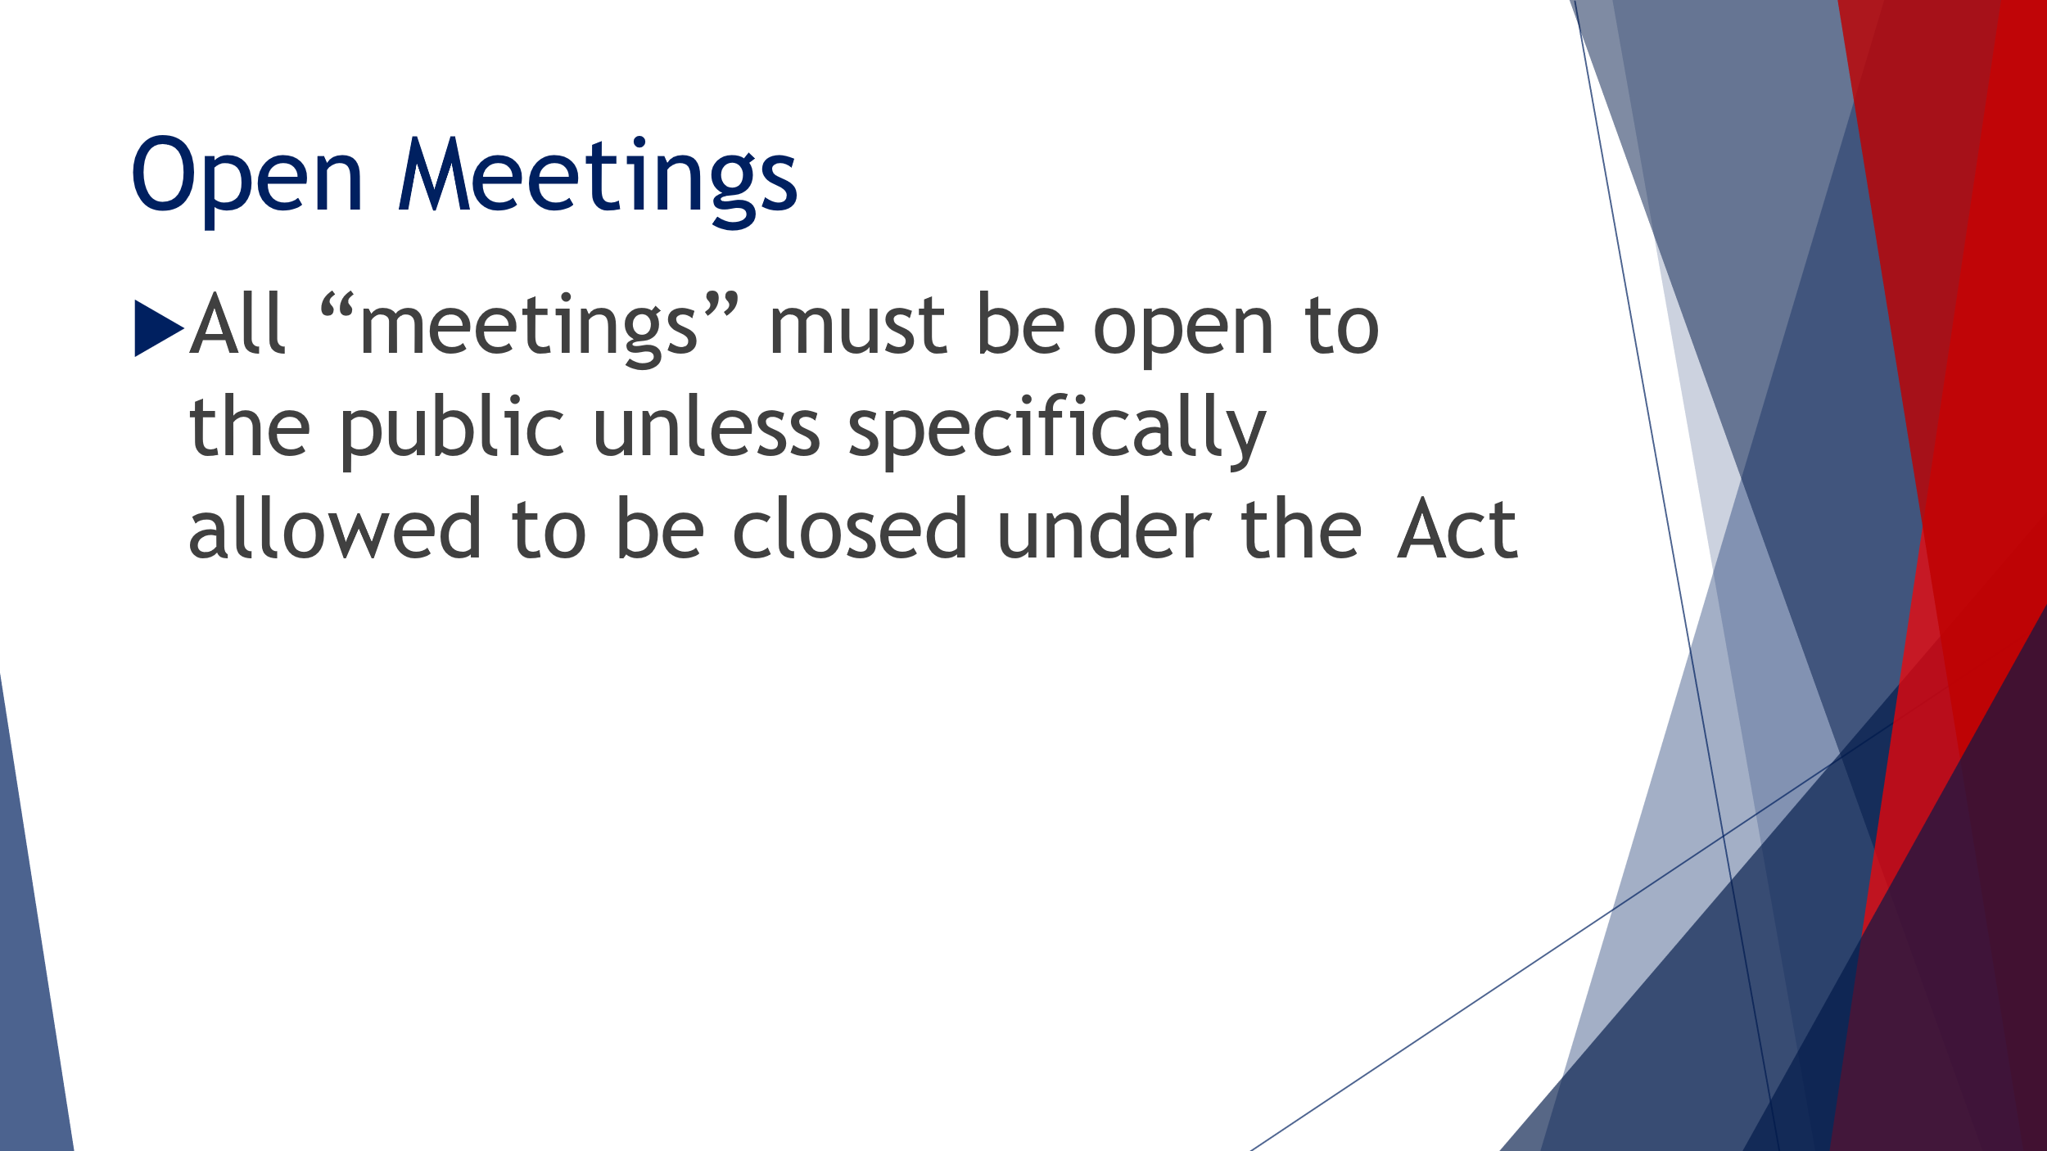
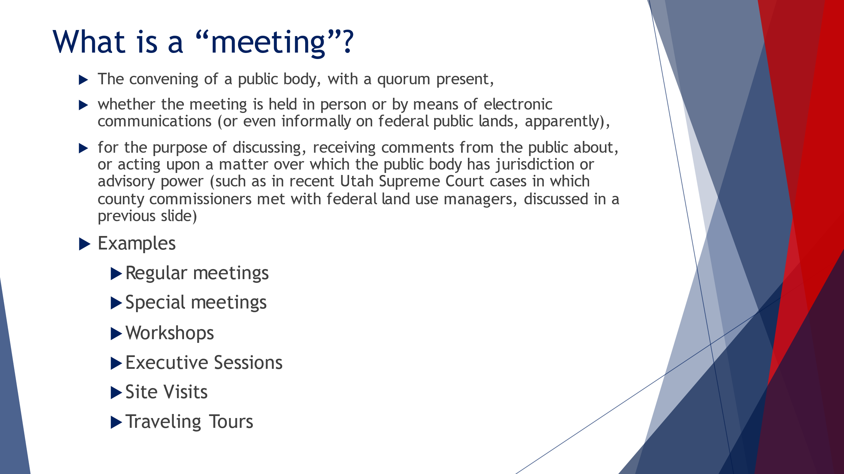
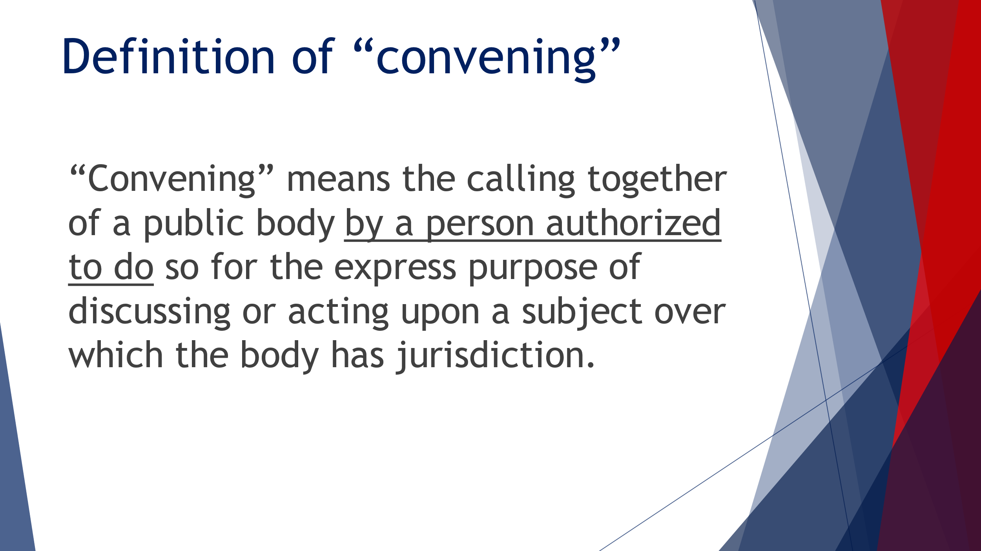
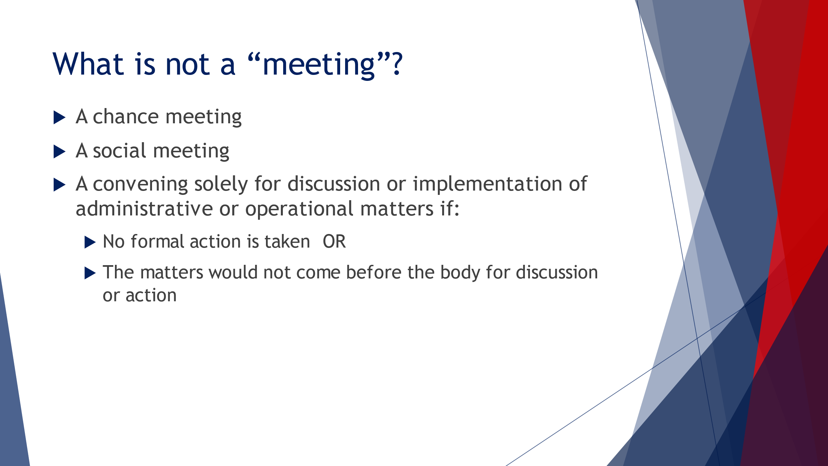
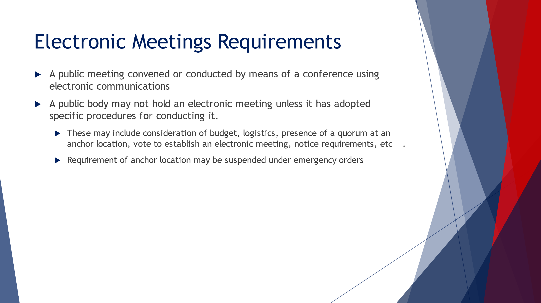
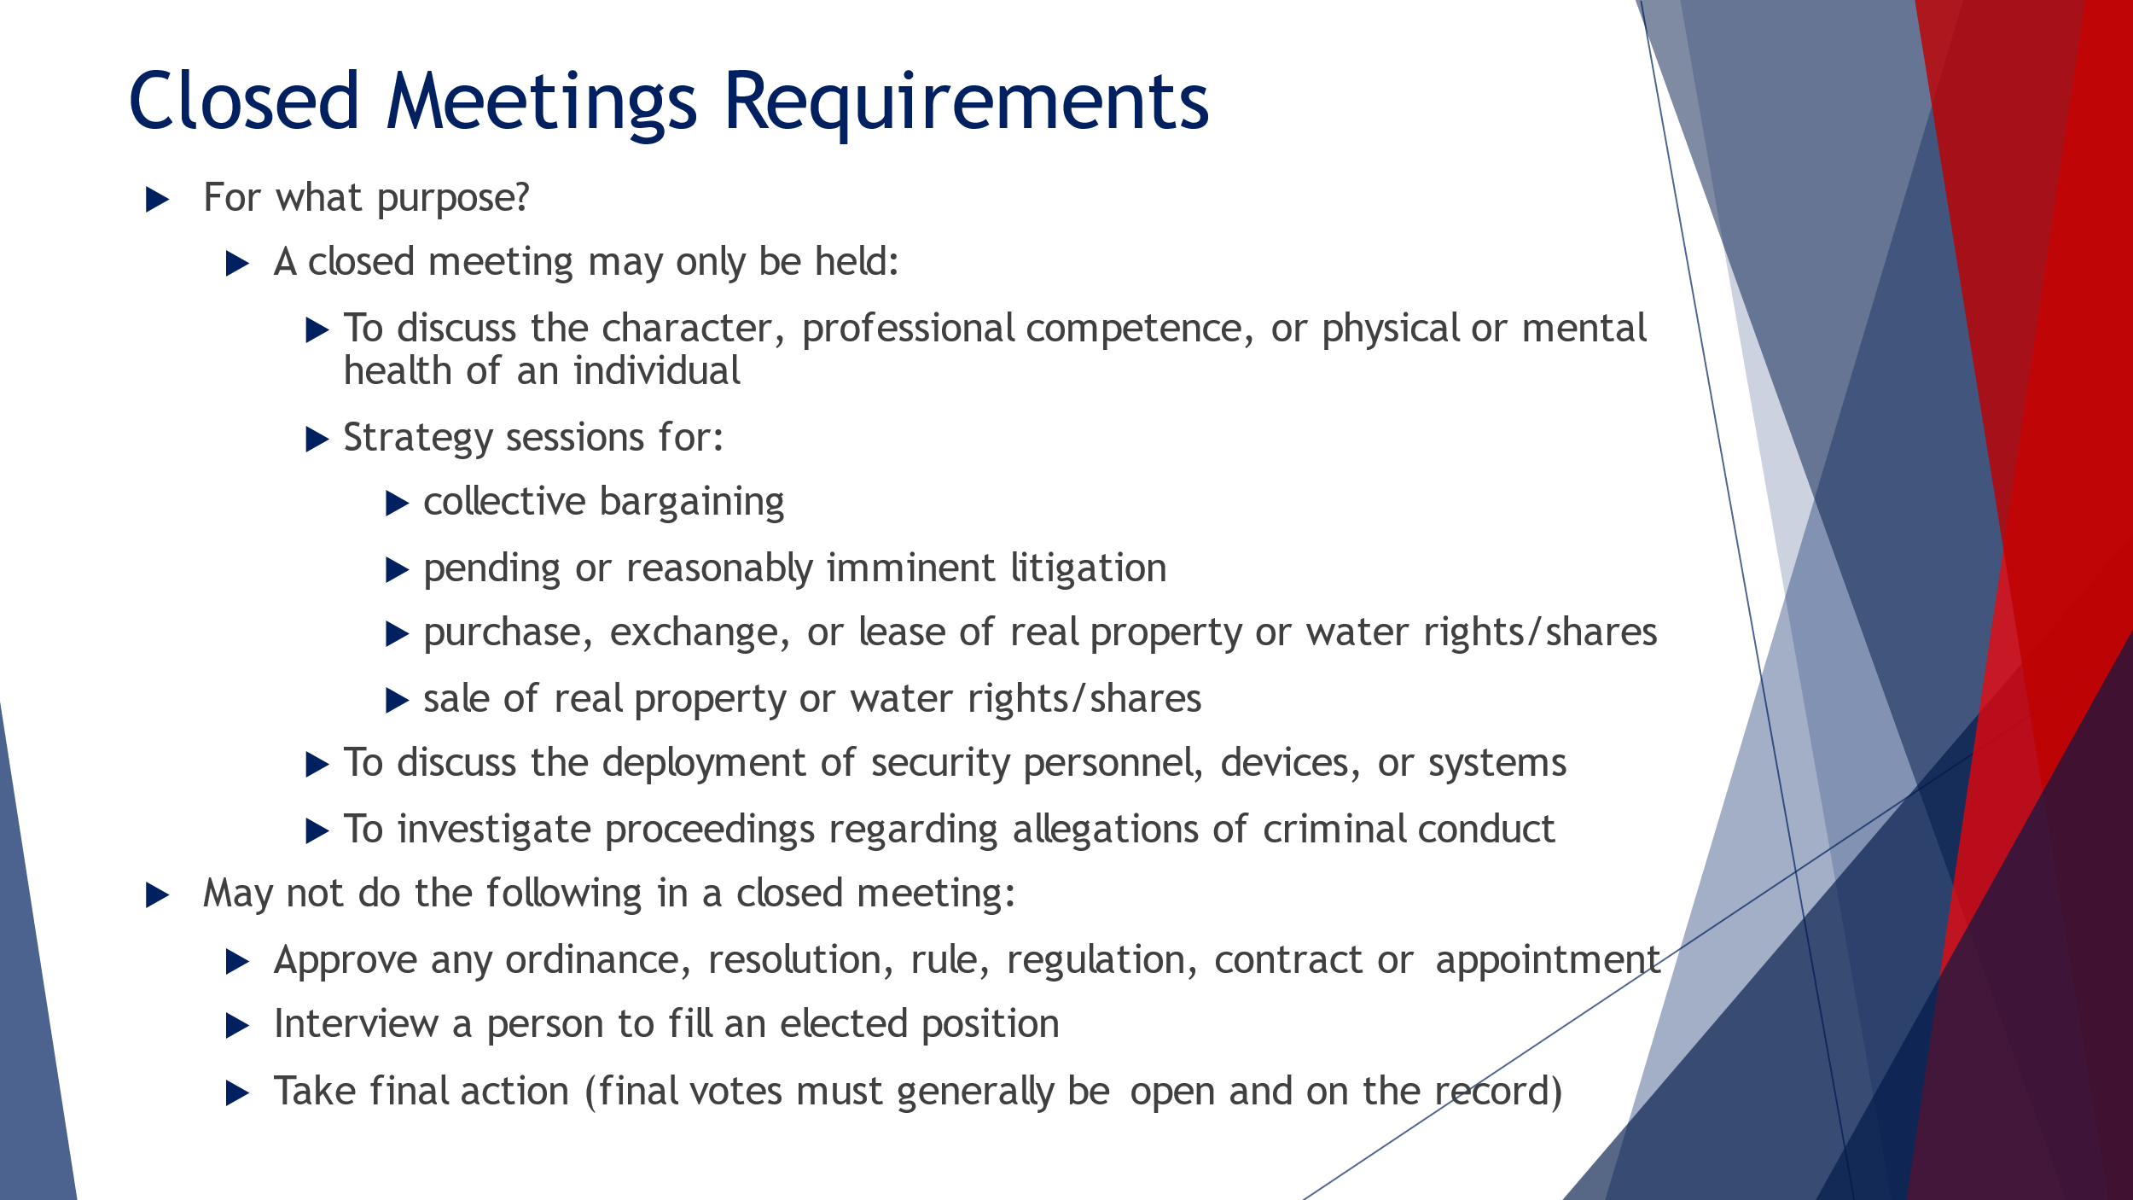
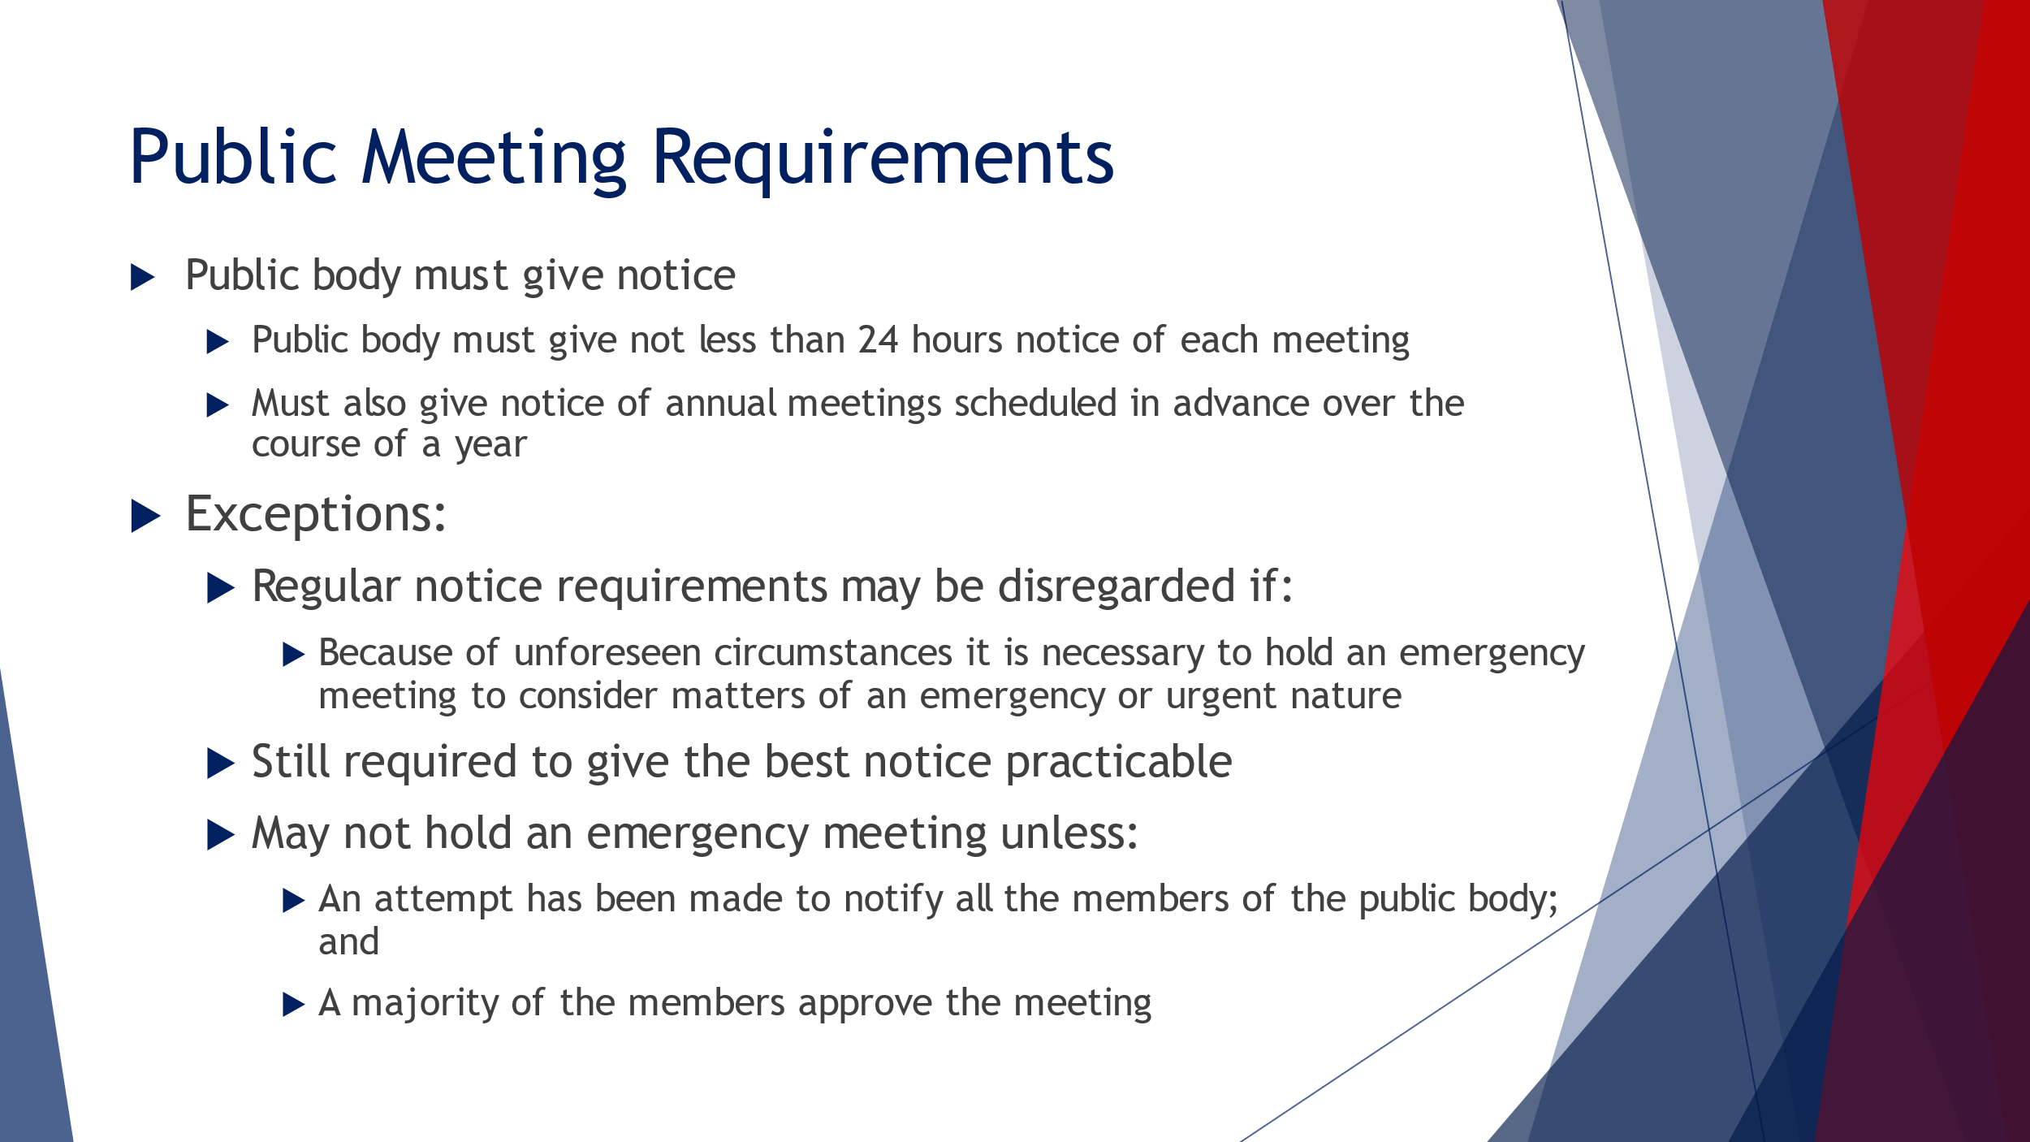
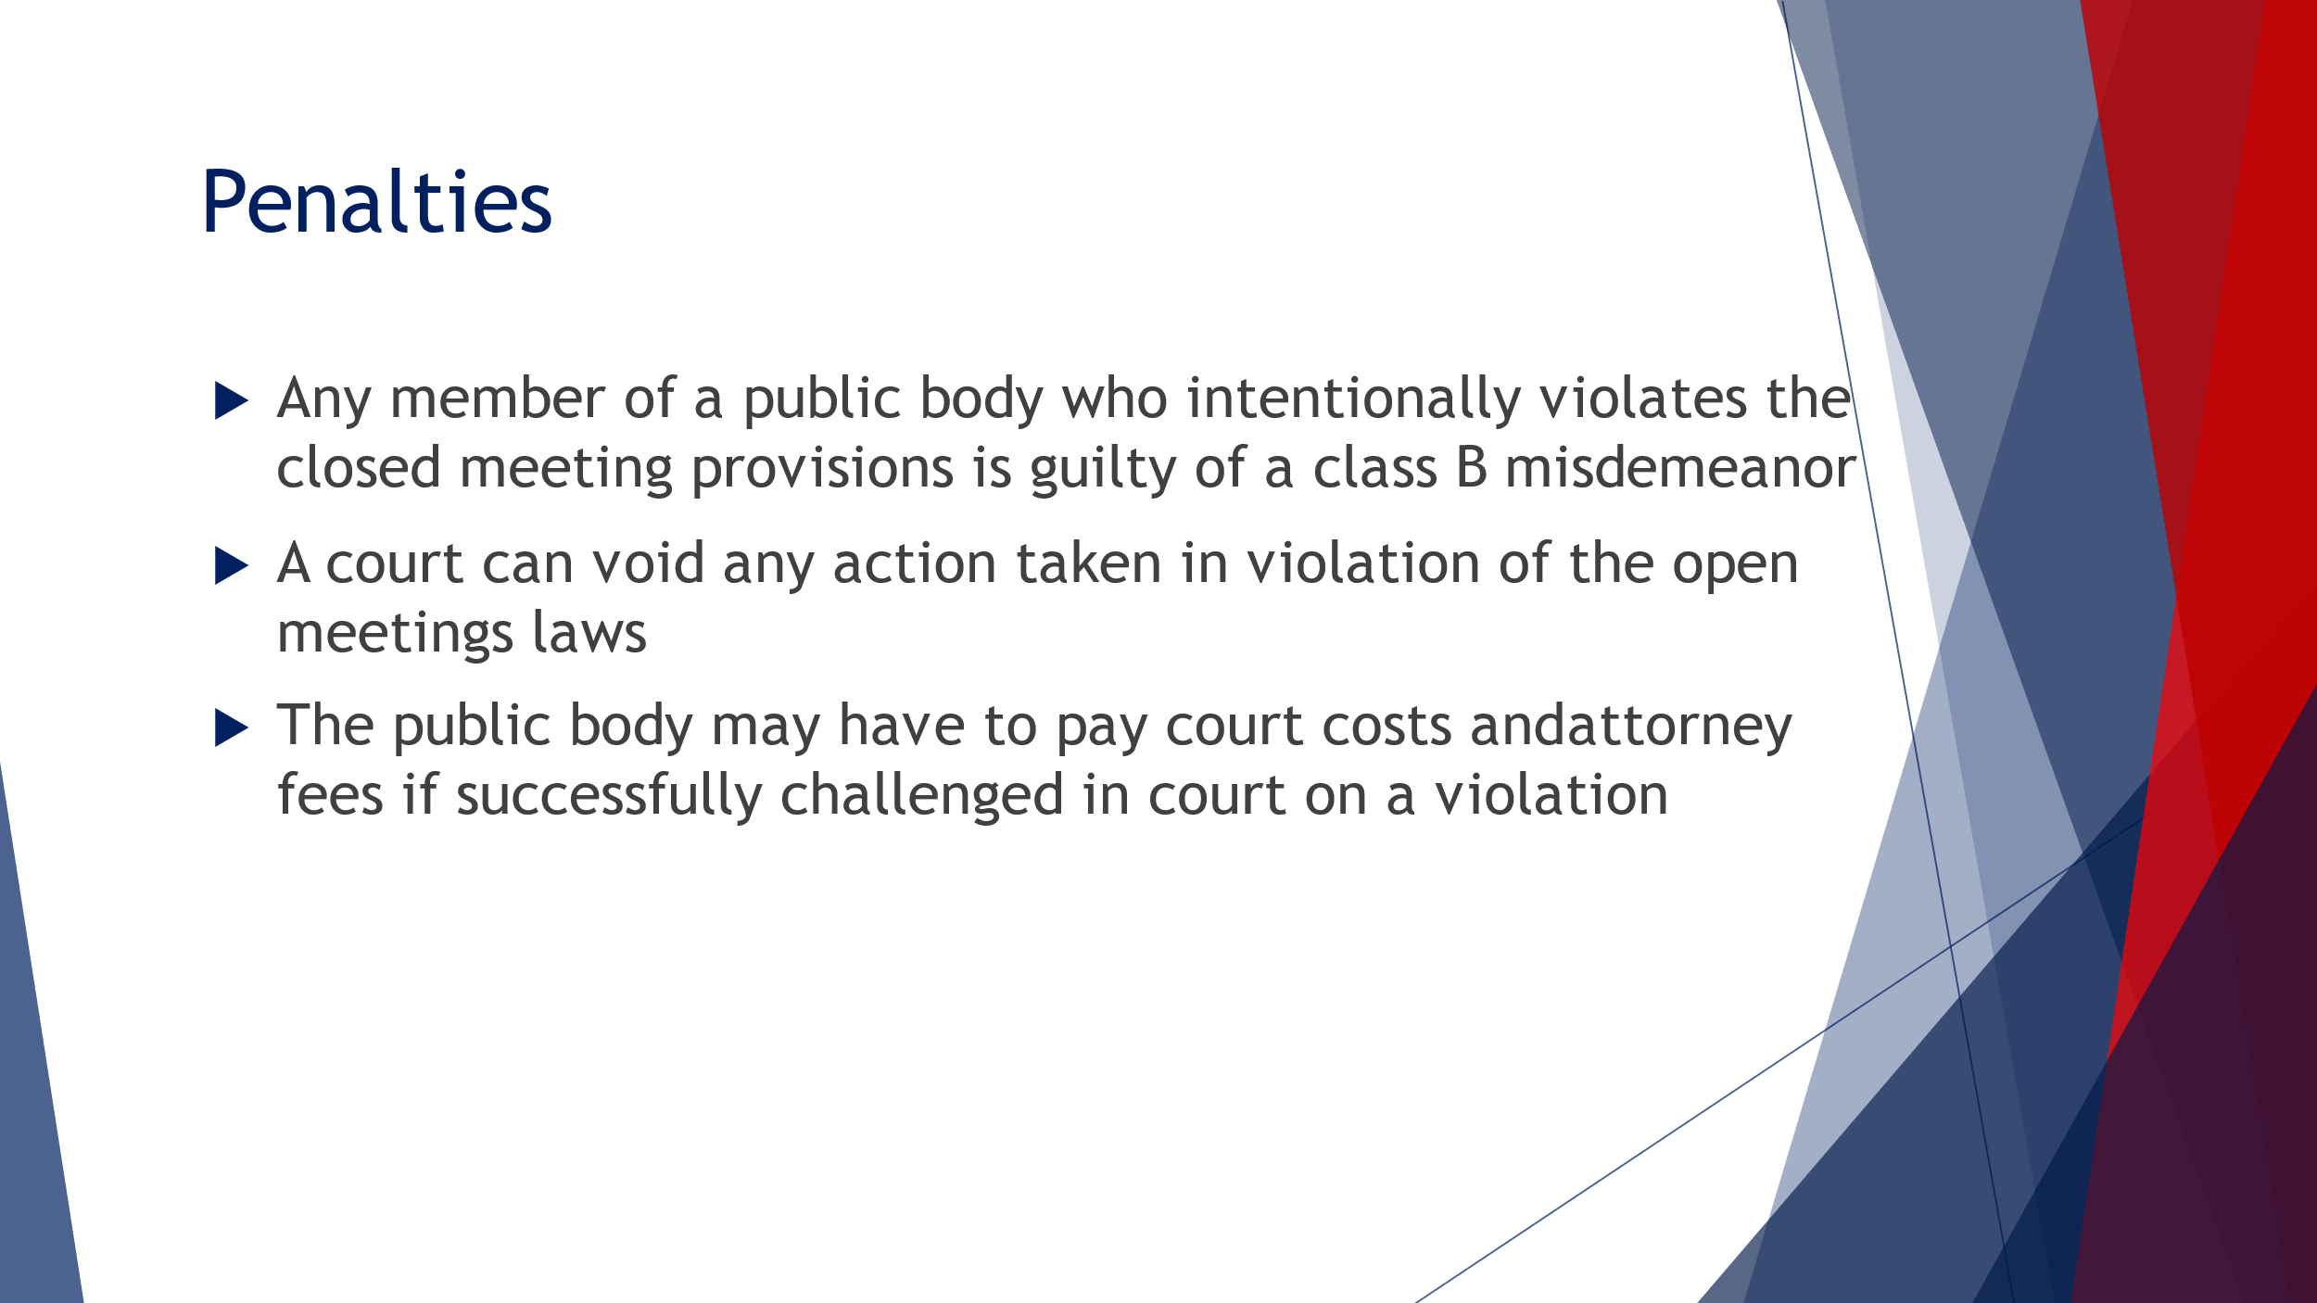
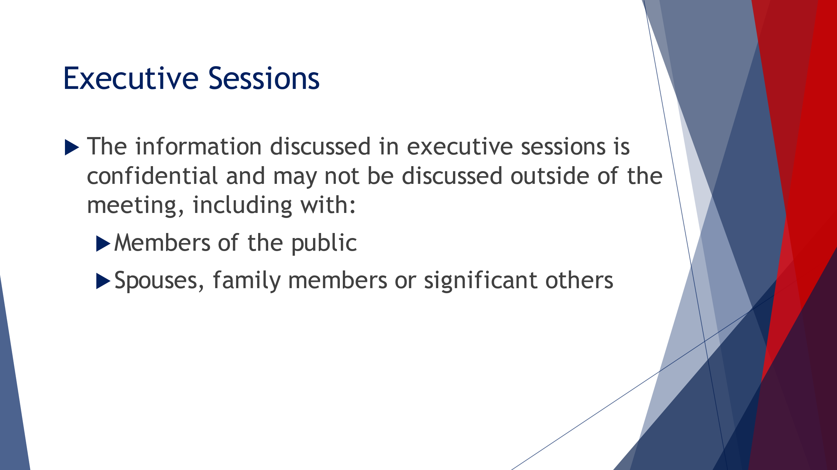
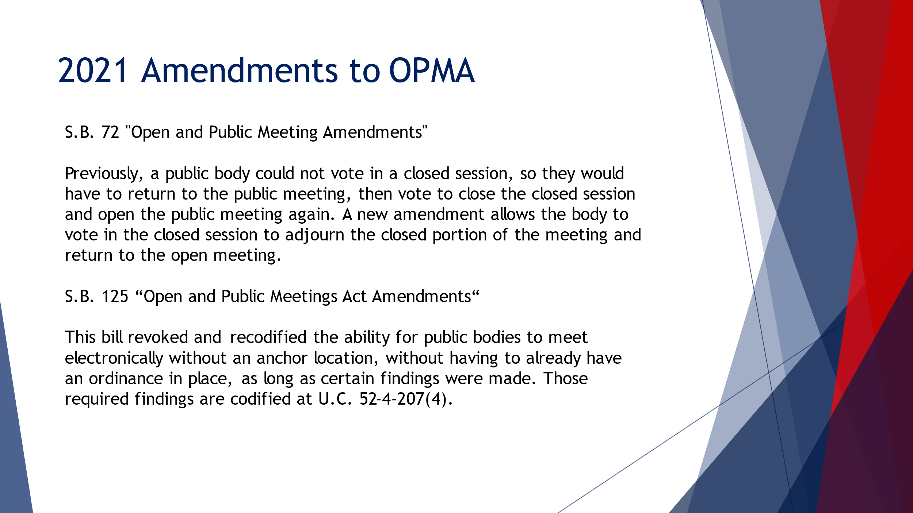
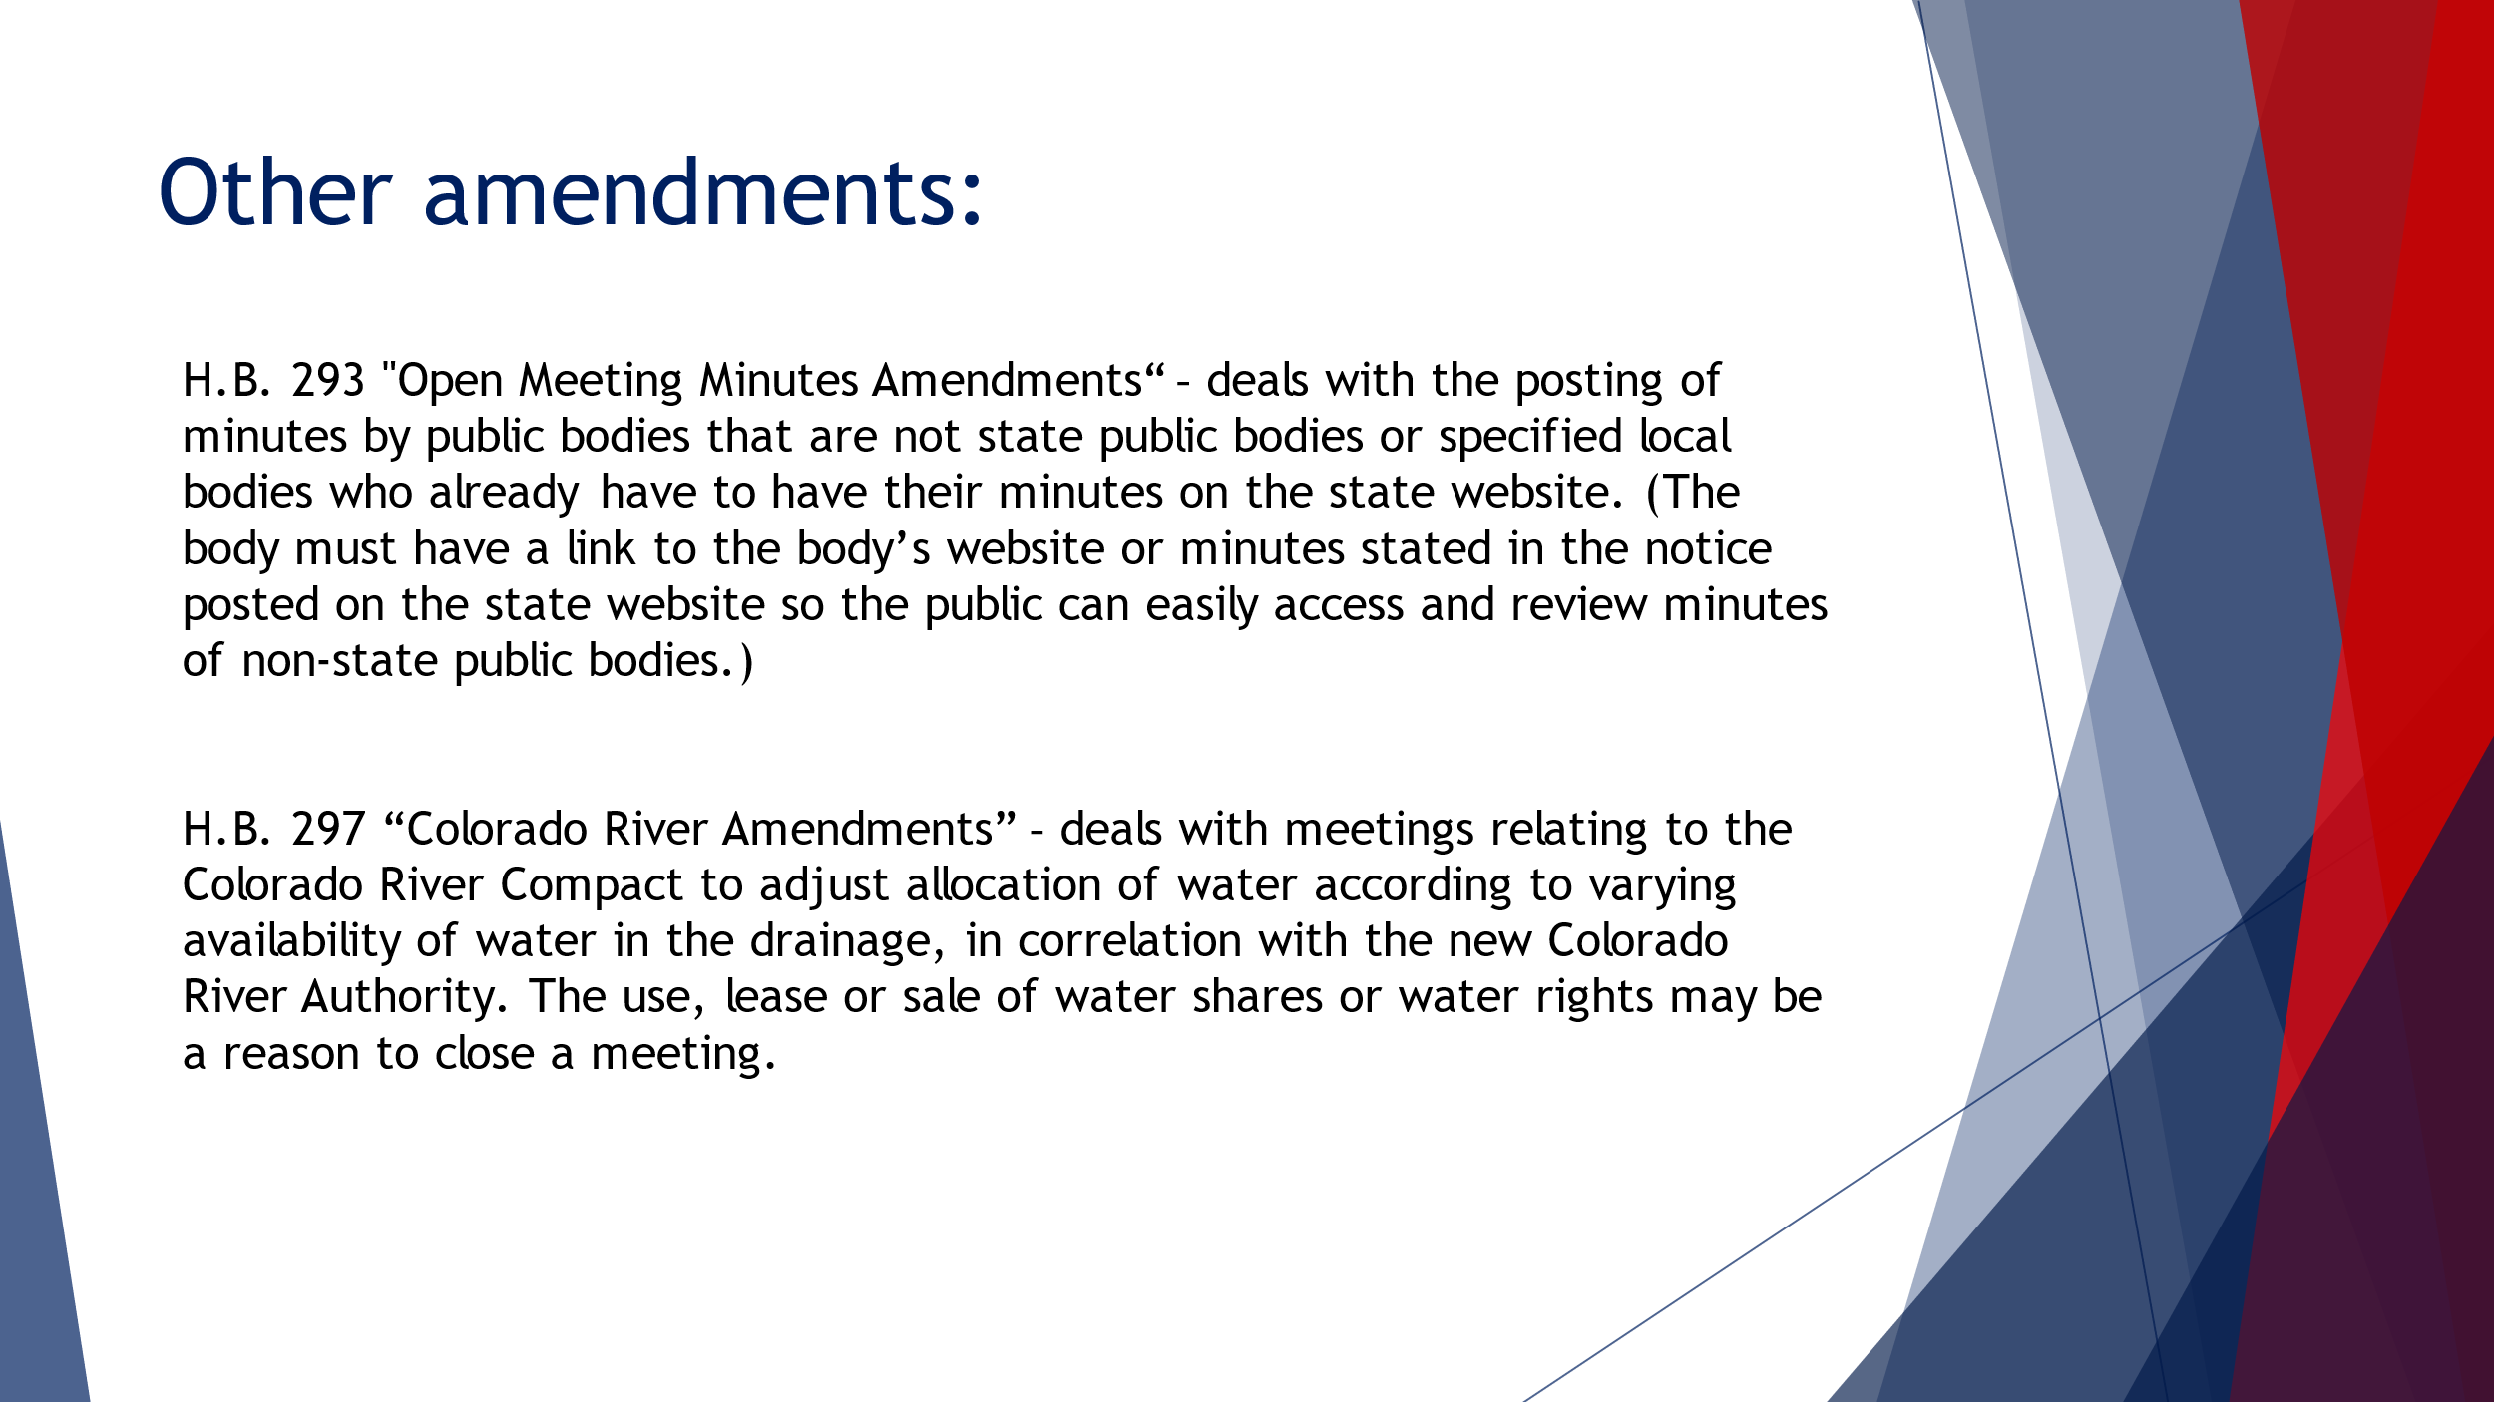
- Review and action on the minutes of the August 03, 2022, Planning Commission Regular Session
Christine Anderson moved to approve minutes August 03, 2022, Planning Commission Regular Session. Chris Christiansen seconded the motion.
Voting was as follows:

Chairman Woffinden AYE
Harold Dudley AYE
Christine Anderson AYE
Bruce Frandsen AYE
Jenny Peay AYE
Rodney Martin AYE
Chris Christiansen AYE
The motion passed

- Concept Plan Report & Upcoming Projects

Patrick O’Brien: Things are looking good we are noticing a bit of a slowdown in the number of permits that we’re issuing. We’re still 40% up from two years ago so it’s still a little bit insane. All things are good on the project front we will be bringing projects from previous agendas back to Planning Commission as they work through issues. The Edgewater project, Bridges at Fox Hollow, those types of projects. We’ve been working through code and engineering issues that they were able provide some of the information. We’re still working on that as a team. Those should be coming back in the next couple meetings. We also have the modern income housing plan which will be an amendment to our general plan, it will be adopted per state requirement. Travis and Cody have both been working on that. That is due to come before you in the next meeting and give you an overview of what we need to do. There are a number of criteria that are outlined in the state code, and we need to pick 6 of them. As a community that has a front runner station, we are required to have a station plan element to that. We are going to meet all of those and couple of the other things to do. Looking at the direction the city is going in that will be brought before you. We need to have that adopted by October 1. We’re cutting it close but we’re trying to get as good of plans together as possible.

Christine Anderson: How many did you say each city picks?

Patrick O’Brien: Depending on the city’s sizes and their class as a city they have different numbers that they need to meet. Most cities around our size are picking 5 but because we have a fixed transit station, we need to have an additional one and it’s a specific one. We need to prepare a station area plan for the area within a half mile radius of our fixed transit station. We’re working with Mountain land Associations of Governments as well. That station area plan will come at a later point, it’s a component of this. We’re working with Mountain land Associations of Governments to get everything together they’ve got technical assistants funding and a couple of other technical assistant support staff that we’re able to utilize as a community. We’re hoping that will be a four-month project. It’s a 5-year plan for our community to address modern income housing with 30 -80% AMI and even below the 30% for our area meeting income. We need to do an annual report on the progress of how we have implemented the procedures that we’ve outlined in our plan. The plans won’t come before you but we will give you a report once we do that.

- Other Business

Bruce Frandsen, Rodney Martin, Jenny Peay, and Cherylyn Egner briefly discussed the work session from the previous night.

Patrick O’Brien: Introduced Travis to the Commission.

Travis Van Ekelenburg: Introduced himself briefly to the Commission.

Patrick O’Brien: Mentioned the Planning Commission summer BBQ at the end of the month.

- Adjournment

Christine Anderson moved to adjourn the meeting. Harold Dudley seconded the motion.
Voting was as follows:

Chairman Woffinden AYE
Harold Dudley AYE
Christine Anderson AYE
Bruce Frandsen AYE
Jenny Peay AYE
Rodney Martin AYE
Chris Christiansen AYE
The motion passed

The meeting was adjourned at 7:46 p.m.

