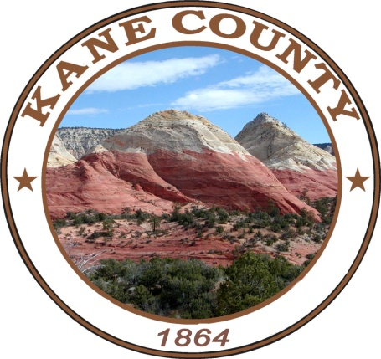

ATTENTION
Kane County Voters
General Election
November 8, 2022
7:00 a.m. to 8:00 p.m.

Last day a voter can register to vote for the General Election by mailing a
Registration form, Online or in-person is October. 28, 2022
The Kane County Clerk’s Office is open from 8:00 a.m. to 5:00 p.m.
Public Logic & Accuracy Testing will take place on October. 14, 2022 at 10:00 a.m.
Board of Canvassers will meet on November. 22, 2022 at 3:00 p.m.

*****************************************

Early Voting will begin on October 25, and ends on November 4, 2022, from 8:00 a.m. to 5:00 p.m. at the County Clerk’s Office, 76 North Main Street.
All Voters will need a photo ID

*****************************************
If you choose not to vote your "Absentee/By Mail" Ballot you may vote in person at the "Kanab Election Center" located at the "Kane County Courthouse" 76 North Main on Election Day or at the "Valley Vote Center" located at the "Kane County North Event Center" located at 475 East State Street on Election Day. You will need to bring in your "By Mail Ballot" to the election center with you where you will be issued a "PAPER BALLOT".

You can also choose to vote early in person at the Kane County Clerk/Auditor's Office by bringing in your "By Mail Ballot" to cast your vote in person on a "PAPER BALLOT".

New Ballot Drop Box Locations: 76 N Main St in Kanab; 11 1st W ST in Alton; 60 Aaron Burr in Big Water; 90 E Center St in Glendale & 425 E State St in Orderville. Ballot Drop Box’s will be available beginning October 18, 2022 at 8:00 A.M and Closing November 08, 2022 at 8:00 P.M.

*****************************************
SAMPLE BALLOTS
Races that will be on the General Election

Federal Office Races | Kane County Commission Seat B  Vote for One | Shall PAIGE PETERSEN be retained in the office of Justice of the Supreme Court of Utah?
U.S. Senate  Vote for One | Kane County Commission Seat B  Vote for One
U.S. Senate  Vote for One | CELESTE MEYERES REP | YES
EVAN MCMULLIN UNA | PATRICK HORNING DEM | NO
JAMES ARTHUR HANSEN LIB | WRITE-IN: | Shall BRODY L KEISEL be retained in the office of Judge of the Juvenile Court of the Sixth Juvenile Court District?
MIKE LEE REP | Kane County Attorney  Vote for One
TOMMY WILLIAMS IAP | Kane County Attorney  Vote for One | YES
WRITE-IN: | ROBERT VAN DYKE REP | NO
U.S House District 2  Vote for One | Kane County Clerk/Auditor  Vote for One | Proposed Constitutional Amendments
U.S House District 2  Vote for One | Kane County Clerk/Auditor  Vote for One | Constitutional Amendment A
NICK MITCHELL DEM | WRITE-IN: | Shall the Utah Constitution be amended to change a provision relating to special sessions of the Utah Legislature that are convened by the president of the Utah Senate and speaker of the Utah House of Representatives:  - To increase the limit on the total amount of money the Legislature may appropriate during the session from an amount equal to 1% of the total amount appropriated during the preceding fiscal year to an amount equal to 5% of the total amount appropriated during the preceding fiscal year; and  - to exclude from the 5% limit:  - an appropriation of money that the state receives from the federal government to address a fiscal year, public health, or other emergency or crisis; and  - an appropriation that decreases the amount of money previously authorized to be spent.
JAYMAC MCFARLAND UUP | Kane County Sheriff  Vote for One
CASSIE EASLEY CON | Kane County Sheriff  Vote for One
CHRIS STEWART REP | TRACY D. GLOVER REP
State Offices | Nonpartisan Local School Board
State Treasurer  Vote for One | Precincts: KA1:A-B-C, BW, CW:C
State Treasurer  Vote for One | Kane County School Board 4  Vote for One
MARLO M. OAKS REP | Kane County School Board 4  Vote for One
THOMAS ALAN HORNE UUP | LORAL G LINTON
WARREN T ROGERS IAP | MARC GROW
JOSEPH GEDDES BUCHMAN LIB | Precincts: AL:A-B-C, CM, GL:A-B, OR:A-B
State House District 69  Vote for One | Precincts: AL:A-B-C, CM, GL:A-B, OR:A-B
State House District 69  Vote for One | Kane County School Board 5  Vote for One
PHIL LYMAN REP | Kane County School Board 5  Vote for One
DAVINA SMITH DEM | BRIAN C. GOULDING
County Office Races | JARAD BRINKERHOFF
Kane County Commission Seat A  Vote for One | Judicial Retention
Kane County Commission Seat A  Vote for One | Visit judges.utah.gov to learn about the Judicial Performance Evaluation Commission’s recommendations for each judge.
PATTY A. KUBEJA REP |  | FOR
WRITE-IN: |  | AGAINST

