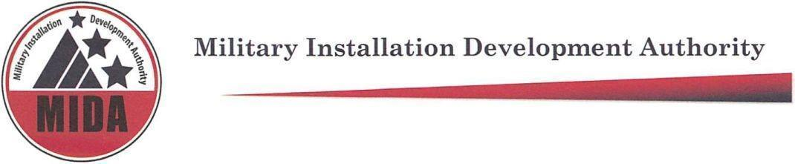
MIDA Board Meeting Pending Minutes October 4 2022 @ 9:30 am
To hear the audio recording of this meeting please go to:
https://www.utah.gov/pmn/sitemap/notice/785017.html

Board Members Present: Gary Harter, Steve Farrell, Jerry Stevenson, Mark Shepard, Mike Ostermiller, Stuart Adams

Board Members Excused: Gage Froerer, Ryan Starks^

^Non-voting board member
*Arrived late

Welcome: Stuart Adams

Agenda Item (1) Approval of minutes from the September 13, 2022, Board Meeting

Steve Farrell: Motion to Approve September 13, 2022 minutes.

Mark Shepard: Second

Gary Harter, Steve Farrell, Jerry Stevenson, Mark Shepard, Mike Ostermiller, Stuart Adams vote “aye” in favor of approving minutes from September 13, 2022. None are opposed. The motion passes.

Agenda Item (2) Consideration of Resolution 2022-15 Skier Services Site Plan in the Military Recreation Facility Project Area.

Kurt Krieg: Introduction of Skier Services Site Plan and timeline (3:00 - 5:22)

Erik Anderson and Kurt Krieg: Overview of Skier Services Site Plan (6:06 - 15:43)

Paul Morris: Discussion regarding DRC approval and design standards and accomplishments (16:12 - 22:31)

Steve Farrell and Kurt Krieg: Discussion regarding hotel rooms ownership and rental pool availability (22:47 - 23:53)

Gary Harter: Motion to Approve of Resolution 2022-15 Skier Services Site Plan in the Military Recreation Facility Project Area with recommendations approved by Design Review Committee.

Steve Farrell: Second

Gary Harter, Steve Farrell, Jerry Stevenson, Mark Shepard, Mike Ostermiller, Stuart Adams vote “aye” in favor of approving Resolution 2022-15 Skier Services Site Plan in the Military Recreation Facility Project Area. None are opposed. The motion passes.

Agenda Item (4): Adjourn meeting.

Jerry Stevenson: Motion to adjourn

Meeting adjourned at: 9:56

Meeting Attendees: Sara Turner, Ashley Burr, Lisa Dudley, Ariana Farber, Richard Catten, Heather Kruse, Michelle Jensen, Kurt Krieg, Erik Anderson, Brooke Hontz, Paula Eldredge, Cory Shupe, Kristin Williams, Rob Donigan, Josh Jensen, Roger Henrikson, Robert McConnell, Hannah Hoffman, Kent Fawcett, Paul Morris, Michael Wagstaff, Tyler Aldous, Jason Przybyla, Taylor Woodbury, Jack Johnson, Michelle Yohe, Mark Dalton, Tim Johnson, Craig Libby Bill Coleman, Glen Clement, W James Tozer Jr, Michael Kosakowski, Thomas Leavens, Brett Christensen, Paul Persell, Allison Aafedt, Wade Budge, Brent Hall, KPCW Radio, Marcella Staff, Extell Staff

