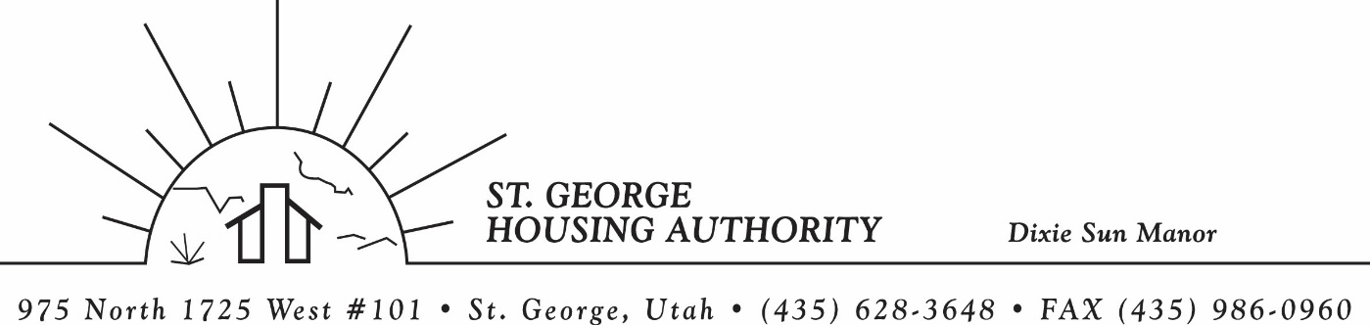
BOARD MEETING
DIXIE SUN MANOR 975 N. 1725 W. # 101
Tuesday August 9, 2022

PRESENT: Mike Barben, Greg Whitehead, Jimmie Hughes, Tom Cover, Gloria Shakespeare

EXCUSED: Jane Fehrenbacker, Kenny Miller

MINUTES: Minutes of Board Meeting held June 14, 2022 were reviewed. Motion made by Tom Cover to approve minutes as reviewed, motion seconded by Jimmie Hughes. Motion carried.

Review current 2020-2021 budget: Mike Barben handed the board a copy of the fiscal year 2022-2023 SGHA budget. The board was able to see how the SGHA is doing in the current fiscal year budget. Mike reported that for the most part, SGHA was right on budget, and let the board ask questions on any of the items on the report. The board has asked Mike to provide and present the most recent budget accounts at each board meeting. By providing the current budget monthly, the board can see how the SGHA is keeping up with the current budget throughout the whole year. The board thought it would be great to ask questions and be on top of what the SGHA is doing financially. Mike agreed to do this.

Review Housing Assistance Report for July / August 2022: Mike Barben handed out the HAP reports for July/August 2022. Board members were able to see the money spent for the months on rental assistance, see the average unit cost, and verify the units leased for the month. The board was also able to ask questions and have a discussion about portability, C of C, VASH, EHV, & Mainstream Vouchers. Each board member present signed off on the HAP payments and month end totals.

Report on new FSS Admin Plan: Mike Barben reported that a Family Self Sufficient program came out with a final rule of the program and Housing Authorities are required to update their Admin plan. Mike reported that Nan McKay had a training to update SGHA admin plan. Mike paid for the training and has updated the FSS admin plan. Mike reported that the new admin plan must be open for public comment for 45 days and a notice for public comment was poste in the Spectrum Newspaper on July 25th-26th. Mike said the new admin plan would need to be approved by the SGHA board in September’s board meeting. After which Mike would submit to HUD for approval. The board was great with the training and approved the cost of the training.

Discuss Executive Director Pay Increase: To months ago, the board asked Mike Barben to arrange evaluation documents to assess/grade Executive Director position. Mike provided the documentation from the City of St. George HR department, which coincides with SGHA Executive Director pay schedule. The board met privately on June 21st at 8:30 to rate and grade Executive Director. The board agreed to increase the director $20,000 based off of comparable’s from the city. Mike thanked the board for their generosity. The increase will take place immediately.

SGHA applied for more Mainstream Vouchers: Mike Barben reported that the SGHA was awarded 10 new Mainstream Vouchers effective 9/1/22. Mike reported that he had applied for the maximum amount of 20 vouchers, but was awarded 10. Mike explained that these vouchers are specifically for those that are non-elderly and disabled. The board was very excited about getting more needed vouchers for our community. Mike said he would be pulling these 10 individuals from the waiting list for those that qualify.

2022 Unforeseen Set-A-Side Funding: Mike Barben reported that he had applied for more funding for unforeseen circumstances. SGHA was awarded $32,030 due to Per Unit Cost increases. Mike reported that with all the rent increases due to shortage of housing, more and more landlords and property management agencies are raising the rents. This is why the average unit cost has gone up so much. HUD awarded SGHA this amounts to help with agency’s loss of funds. Mike reported that this will help the agency’s budget moving forward.

Jane Fehrenbacker report on DSM: Jane was excused for this meeting. This is las months report from Jane: Jane reported that Dixie Sun Manor was doing very well. She reported that a community garden was built and all tenants are excited about it. Jane is a great friend and neighbor and keeps an eye on DSM tenants. Jane said she absolutely loves living at Dixie Sun Manor and feels all the residents feel the same way. Jane reported one vacancy this month. Mike Thanked Jane for all her contributions to DSM.

Report from Jimmie Hughes on City of St. George: Jimmie reported that the city has been in discussions about taxes. Most likely tax increases are coming to St. George’s community. The board all agreed that wages for our law enforcement officers and firefighter are too low and trying to hire these important positions is almost impossible when other cities are paying $10 more an hour. Raising taxes is one of the ways to help pay these important positions.

Motion made by Jimmie Hughes to close the meeting. Gloria Shakespeare seconded the motion. Motion carried. Meeting adjourned at 9:45 a.m.

Next board meeting will be held August 9, 2022 at 8:30 a.m. at the St. George Housing Authority office. July board meeting cancelled due to board members being out of town.

