MINUTES OF
HARRISVILLE CITY COUNCIL
Work Session
August 09, 2022
363 West Independence Blvd
Harrisville, UT 84404

Minutes of a regular Harrisville City Council meeting held on August 09, 2022 at 7:00 p.m. in the Harrisville City Council Chambers, 363 West Independence Blvd., Harrisville, UT.

Present: Mayor Michelle Tait, Council Member Blair Christensen, Council Member Max Jackson, Council Member Kenny Loveland, Council Member Steve Weiss (via Zoom), and Council Member Wilhelmsen.

Staff: Jennie Knight, City Administrator
Maria Devereux, City Recorder
Justin Shinsel, Public Works Director (via Zoom)
Jill Hunt, Treasurer
Mark Wilson, Police Chief
Bryan Fife, Parks and Recreation Director

Visitors: Arnold Tait, Kevin Karras, Diana Wilhelmsen, and Cindy Quercia.

1. CALL TO ORDER - CITY COUNCIL WORK SESSION

Mayor Tait called the meeting to order and welcomed all visitors.

2. OPENING CEREMONY

Mayor Tait led the pledge of allegiance.

3. BUSINESS ITEMS

  - Discussion of the proposed increase, to levy a tax rate that exceeds the certified tax rate for Harrisville City.

Mayor Tait advised no action will be taken at the meeting, and stated the purpose; a Work Session to discuss the proposed increase.

Jennie Knight, City Administrator, presented an overview of the challenges and needs within the city and provided a Council update and the need for an increase to the certified tax rate. She explained the timeline; beginning with a wage study performed to address the turnover in staffing (Dec. 2021), city growth, facility needs and bonding for a Recreational facility (discussed April 2022), City Hall and Police Department, a Parameters Resolution was adopted (May 2022) authorizing the bonding of up to $15M for these facilities, and issued $6M of sales and franchise municipal bonds to build the Public Works facility (end of June 2022), the City has completed the RFP process and is meeting regularly with the architects designing the new Public Works Building. The City is experiencing the growth of 18 proposed developments instead of the nine developments as previously discussed. In May 2022 when the tentative budget was adopted the City had not yet completed the bonding process, therefore the increase to the certified tax rate was based on the projection to balance the budget. With the issuance of the bonds and proposed certified tax increase it helps the City balance the budget and address the needs of the City, including to stabilize our existing staff.

Jennie Knight reviewed the Truth In Taxation presentation, originally presented at the prior meeting. (Complete presentation found on www.cityofharrisville.com) She explained the many changes being adopted this year vs. last year in Weber County overall.
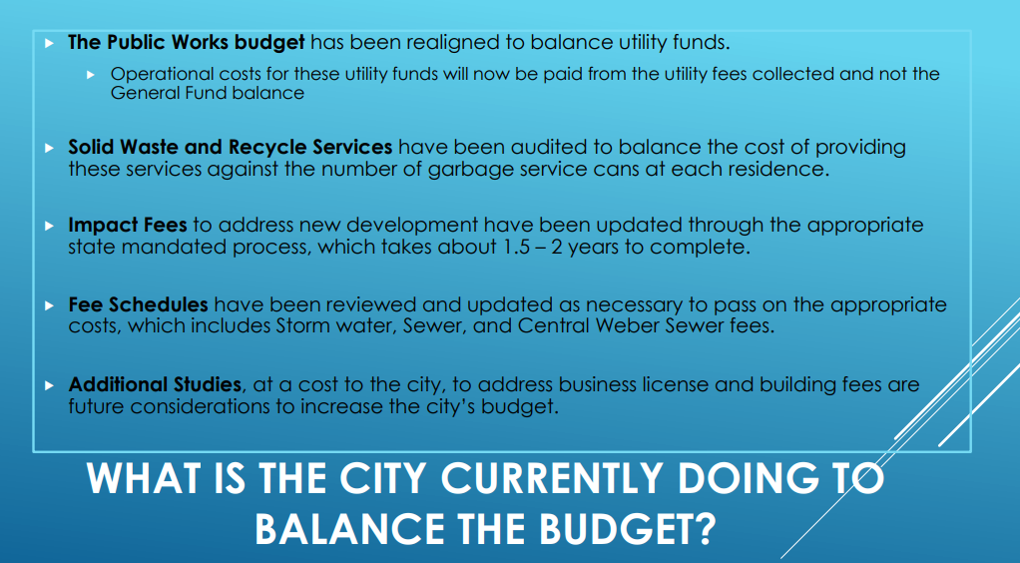
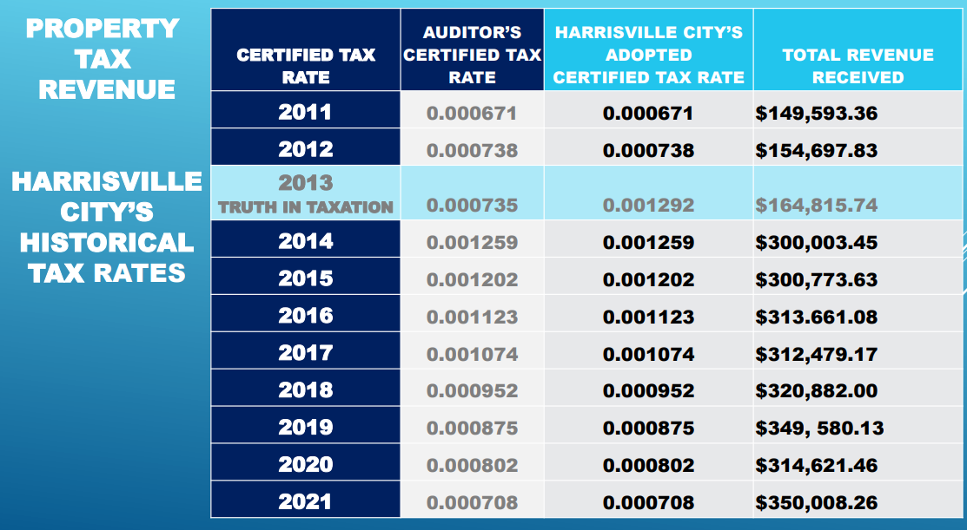

Mark Wilson, Police Chief, gave an overview of the Police Department tentative budget, needs, examples of salaries and wages, turnover the department has experienced, needed position – evidence technician (p/t), proposed an increase to holiday pay and leave to accommodate coverage, travel and training budget (to cover mandatory training), he explained inflation has increased expenses substantially from printing services, cost of fuel, ammunition, memberships, uniform allowance, equipment and critical incident needs.

Mark Wilson expressed the need for the City to conduct a wage study annually for staffing purposes, retention, and explained surrounding cities are implementing the same.

Council Member Weiss explained the City cannot be in a continued deficit. The amount the City is asking for, though a substantial increase, is a very small percentage of the overall County increase. He explained Truth In Taxation is a process moving forward in nearly every city. Harrisville City has the ability to get out of debt and continue to move forward responsibly. The extremely tight budgets of administration, Police Department, Parks, and Public Works are in need of funding.

Mayor Tait and Council Member Wilhelmsen asked for clarification in regard to adopting less than the proposed certified tax rate.

Jennie Knight clarified, unless the full amount of the proposed certified tax rate is adopted, the budget will be in a deficit. The City can hope for other revenue sources but those sources are not guaranteed to come in. Jennie Knight reminded the Council of how impact fees are distributed and how they are required to be specifically designated, per project.

Council Member Loveland asked how information can be disseminated to the residents of Harrisville City.

Jennie Knight explained the City is transparent in noticing and follows requirements. Residents are encouraged to sign up for the newsletter, read information posted on the website, the City shares information on social media, on the marquee, Bona Vista statements, and will take calls and provide information as residents inquire.

Mayor Tait stated she is grateful for a supportive council and staff working together cohesively.

ADJOURNMENT

Mayor Tait closed the meeting at 8:38PM.

___________________________________________________
MICHELLE TAIT
Mayor

ATTEST:

____________________________________________
MARIA DEVEREUX
City Recorder
Approved this 9th day of August, 2022

